Install JDK 1.6 in both ONM server and ONM client machine- JDK comes with some debug tools to capture thread dump and application profiles which will help us debug the issue. Installing additional JDK separately does not interfere with the ONM application.

Solaris Installation

* FTP jdk-6u22-solaris-sparc.sh in binary mode to the solaris server machine.
* Create a jdk directory and copy jdk-6u22-solaris-sparc.sh to this directory and run ./ jdk-6u22-solaris-sparc.sh from the bash prompt
* Once all the files are extracted there will be a message “Press Enter to continue”. Press enter and wait for a few seconds for bash prompt to come back.
* This should create a jdk1.6.22 directory under the current working directory.

Windows Installation

* Create a jdk directory and unzip the attached jdk1.6.0_31.zip in it.

When this issue occurs (when the client is unable to connect to the server and hangs on loading), do the following before restarting the ONM server or before killing the ONM client java process.

* Note the approximate timestamp when this issue was first noticed.
* Backup server logs and the client logs to another directory.
  + The server logs are present under onm_server/OptelianNetworkManager/logs directory and onm_server/OptelianNetworkManager/apache/tomcat/logs directory
  + The client logs are present under onm_client/OptelianNetworkManager/clientlogs directory.
* Note the ip addresses of the ONM server machine and the ONM client machine.
* In both ONM server and ONM client machines, run netstat command for the following ports and save the results
  + netstat –an | grep 9090
  + netstat –an | grep 8005
  + netstat –an | grep 7000
  + netstat –an | grep 7001
* Take thread dumps and heap dumps through jvisualvm tool. To start jvisualvm in the ONM server machine, cd to jdk1.6.22/bin directory and run ./jvisualvm
* In the GUI that comes up, the left side tree will have the list of java processes that are running in the server side. Double click on the com.adventnet.nms.startnms.NmsMainBE process which will bring up a new tab titled “com.adventnet.nms.startnms.NmsMainBE” on the right hand side.
* Right click on the com.adventnet.nms.startnms.NmsMainBE process in the left side tree and you should see a list of options as shown below.

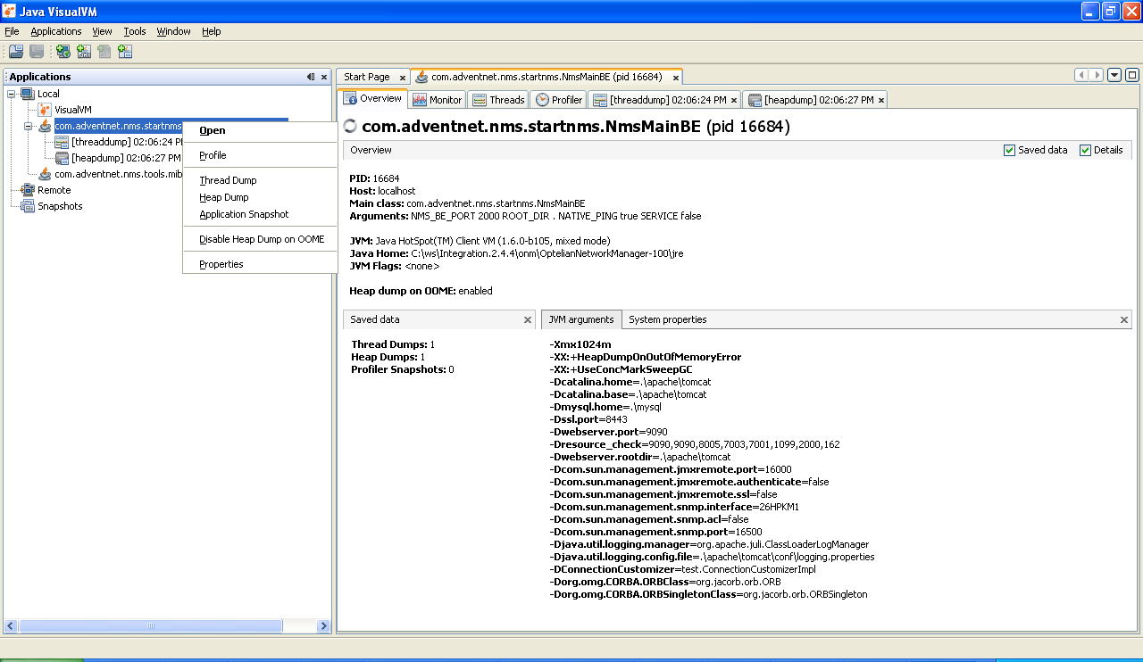

* Click on “Thread Dump” option to take a thread dump and click on “Heap Dump” to take heap dump. Take one more thread dump again after 1 minute (By this time you should have 2 thread dumps and 1 heap dump). Do not close this tool at this point.
* Start jvisualVM on the ONM client machine. If there is a java process named “com.adventnet.nms.startclient.WebNMSClient”, double click on it to connect to it. Follow the process given for ONM server machine to take 2 thread dumps and 1 heap dump. Click on “Application snapshot” option on the left side tree which will create a new entry under snapshots tree. Right click on the newly created snapshot and select “Save As” to save the snapshot.

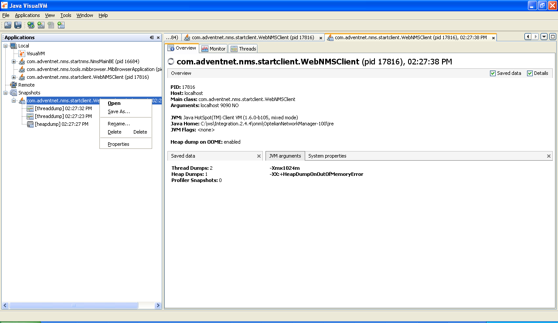

* Kill the ONM client java process that is hanging.
* Repeat netstat commands in the server and client machines as given above.
* Wait for a minute and take one thread dump and one heap dump from the jvisualVm in onm server machine. Click on “Application snapshot” option on the left side tree which will create a new entry under snapshots tree. Right click on the newly created snapshot and select “Save As” to save the snapshot.
* Finally send us all the information you have collected so far.