EMS Development

WebNMS HA scenarios

Abstract
This document describes failure scenarios for WebNMS configured as a high availability system in an attempt to discuss the state of each WebNMS server configured.

Contents

1 Introduction 1
2 HA Configuration sunny day scenario 2
3 Host 1: Primary Server Shut Down – MySQL remains running 2
4 Host 1: MySQL is shutdown while Primary Server is running 3
5 Host 2: StandBy Server Shut Down – MySQL remains running 4
6 Host 2: MySQL is shutdown while StandBy Server is running 4
7 Host 1: Looses connectivity with the network 5
8 Host 2: Looses connectivity with the network 5
9 Host 1 and 2: Loose connectivity with the network 6
10 Host 1 looses power 7
11 Host 2 looses power 7
12 Both Host 1 and Host 2 loose power 8

List of Figures

Figure 1 Sunny Day Scenario – Configuration setup discussion 2
Figure 2 Host1: Primary server is shut down, MySQL running 3
Figure 3 MySQL is shutdown, WebNMS running 3
Figure 4 StandBy server is shut down, MySQL running 4
Figure 5 MySQL is shutdown, WebNMS Standby is running 4
Figure 6 Host 1 looses connection to network 5
Figure 7 Host 2 looses connection to network 6
Figure 8 Host 1 and 2 loose connections to network 6
Figure 9 Host 1 looses power. 7
Figure 10 Host 2 looses power 8
Figure 11 Host 1 and 2 both loose power. 8

Introduction
This document serves to present failure scenarios for a set of WebNMS servers configured to provide high availability “HA”. The intent is to provide scenarios of failure conditions and stimulate discussions with the vendor (AdventNet) of what the expected behavior of the framework will be in each scenario.

HA Configuration sunny day scenario
This scenario provides the starting point for describing the configuration set up for WebNMS running in a HA environment. This is the sunny day scenario in which one WebNMS comes up as the primary server another WebNMS comes up as the standby server as show in the following figure.
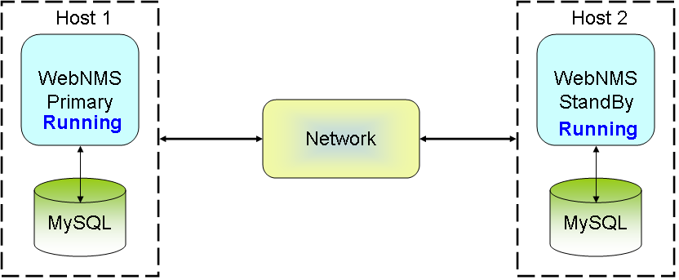
Figure 1 Sunny Day Scenario – Configuration setup discussion
In Figure 1 two host machines constitute the bases of the WebNMS HA environment. Unless specifically stated the configuration discussed in this sunny day scenario will be valid for all failure scenarios presented in later sections. For this configuration the following holds true;
- Each host machine is running one instance of WebNMS 4.7.0 SP3, and MySQL 5.0 on the same host.
- The MySQL databases are set up in replication mode.
- Each MySQL database maintains several NE configurations. Consider this database well populated.
- Provisioning rate of NE is high, implying many transactions, and modifications to the original configurations is being done.

In this scenario if no external event takes place the WebNMS server’s retains their primary and standby states.

No additional input is required from AdventNet for this scenario.

Host 1: Primary Server Shut Down – MySQL remains running
In this scenario on Host machine 1 the primary WebNMS server is shut down, but the MySQL database is left running, as show in the figure below.
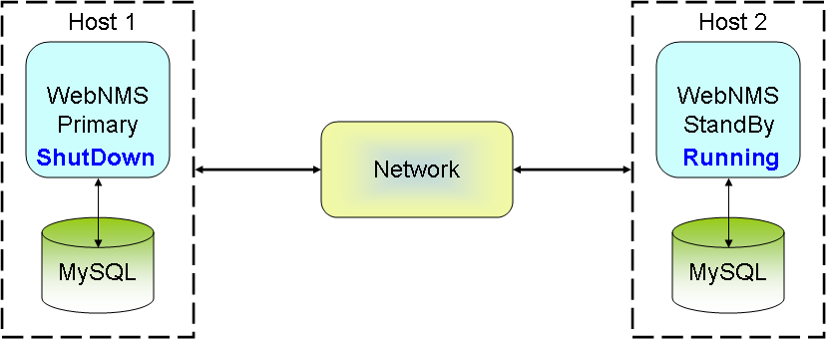
Figure 2 Host1: Primary server is shut down, MySQL running
AdventNet inputs are required for this scenario to explain what happens;
- To the WebNMS server on Host 2?
Ans :: Now Host2 becomes Primary server and updates LASTCOUNT in DB and take care of clients.

- To the WebNMS server of host 1 when it is re-started?
Ans :: Now Host1 becomes Statndby after starting WebNMS manually.

Host 1: MySQL is shutdown while Primary Server is running
In this scenario on Host machine 1 the MySQL database is shut down, but the WebNMS server is left running, as show in the figure below.
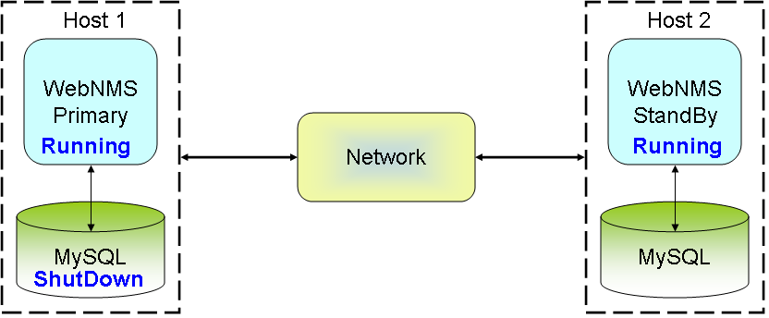
Figure 3 MySQL is shutdown, WebNMS running
AdventNet inputs are required for this scenario to explain what happens;
- To the WebNMS server on Host 2?
Ans :: Host2 becomes Primary server.
- To the WebNMS server on Host 1 when MySQL is re-started?
Ans :: Host1 goes down when it lost connection to the database with the message that connection to the database is lost. After restarting the MySQL(using master-master replication process) and WebNMS manually, host 1 becomes Standby server.
- If on Host1 MySQL is down for 30 minutes?
Ans : Host1 cannot be started up to 30 minutes as MySQL is not running. Once MySQL is started(master – master replication process), Host1 can be manually started as standby server.

Host 2: StandBy Server Shut Down – MySQL remains running
In this scenario on Host machine 2 the standby WebNMS server is shut down, but the MySQL database is left running, as show in the figure below.
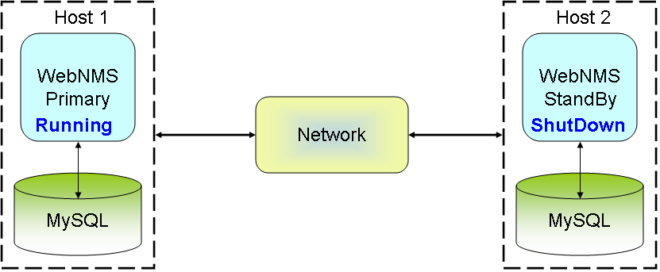
Figure 4 StandBy server is shut down, MySQL running
AdventNet inputs are required for this scenario to explain what happens;

- To the WebNMs server on Host 1?
Ans :: Host1 remains running as Primary server.
- To the WebNMS server on Host 2 when it is re-started?
Ans :: Host2 registers as standby with the primary server after restarting WebNMS manually.

Host 2: MySQL is shutdown while StandBy Server is running
In this scenario on Host machine 2 the MySQL database is shut down, but the WebNMS server is left running, as show in the figure below.
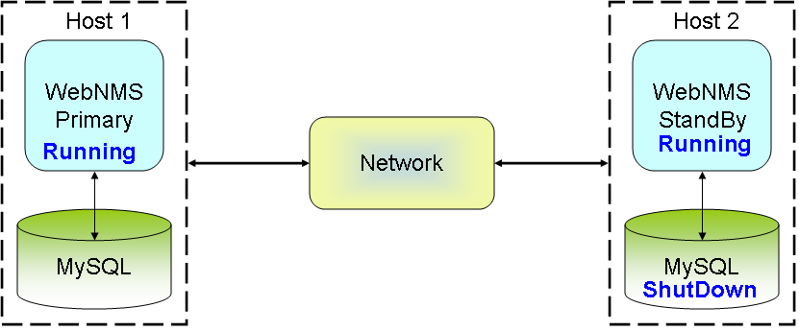
Figure 5 MySQL is shutdown, WebNMS Standby is running
AdventNet inputs are required for this scenario to explain what happens;
- To the WebNMS server on Host 1?
Ans :: Host 1 remains running as Primary server.
- To the WebNMS server on Host 2 when MySQL is re-started?
Ans :: WebNMS Host2 has to be shutdown manually and MySQL has to be re-started as master-master replication. Now Host2 registers as Standby server with Primary server.
- If on Host2 MySQL is down for 30 minutes?
Ans :: Host2 cannot be started upto 30 minutes as MYSQL is not running. Once MYSQL is started, Host2 can be started manually as standby server.

Host 1: Looses connectivity with the network
In this scenario on Host 1 WebNMS and MySQL are running but the machine looses connectivity with the network, i.e. cable disconnected etc., as shown in figure below.
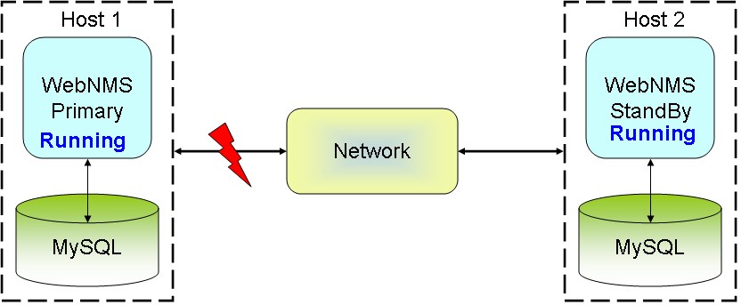
Figure 6 Host 1 looses connection to network
AdventNet inputs are required for this scenario to explain what happens;
- To the original WebNMS server on Host 1?
Ans :: WebNMS still be running, but it is recommended to shutdown as there is no network.
- To the original WebNMS server on Host 2?
Ans :: Host2 becomes Primary server.
- What happens when the connectivity is restored to Host 1?
Ans :: Host1 becomes Standby when it is manually restarted.
- What happens when the connectivity is restored to Host 1 after a considerable length of time?
Ans :: Host1 becomes Standby when it is manually restarted.

Host 2: Looses connectivity with the network
In this scenario on Host 2 WebNMS, MySQL are running, but the machine looses connectivity with the network, i.e. cable disconnected etc., as shown in figure below.

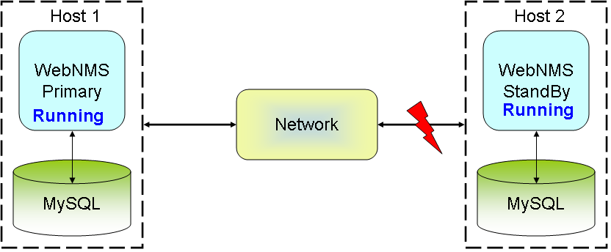
Figure 7 Host 2 looses connection to network
AdventNet inputs are required for this scenario to explain what happens;
- To the original WebNMS server on Host 1?
Ans :: Host 1 remains running as Primary.
- To the original WebNMS server on Host 2?
Ans :: Server will still be running but it is recommended to shutdown the server since the network is not available.
- What happens when the connectivity is restored to Host 2?
Ans :: Host2 becomes Standby after starting WebNMS manually.
- What happens when the connectivity is restored to Host 2 after a considerable length of time?
Ans :: Host2 becomes Standby after starting WebNMS manually.

Host 1 and 2: Loose connectivity with the network
In this scenario on Host 1 and 2 WebNMS, MySQL are running, but the both machines loose connectivity with the network, i.e. cable disconnected etc., as shown in figure below.

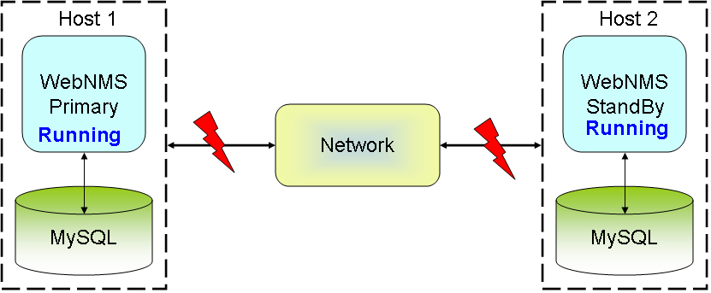
Figure 8 Host 1 and 2 loose connections to network

AdventNet inputs are required for this scenario to explain what happens;
- To the original WebNMS server on Host 1?
Ans :: Server will still be running, It is recommended to shutdown the server since there is a network loss .
- To the original WebNMS server on Host 2?
Ans :: Server will still be running, It is recommended to shutdown the server since there is a network loss.
- What happens when the connectivity is restored to both Host 1 and 2?
Ans :: Server which starts WebNMS first(manually) will becomes Primary and other Standby.
- What happens when the connectivity is restored after a considerable length of time?
Ans :: Server which starts WebNMS first(manually) will becomes Primary and other Standby.

Host 1 looses power
In this scenario Host 1 looses power as shown in figure below.

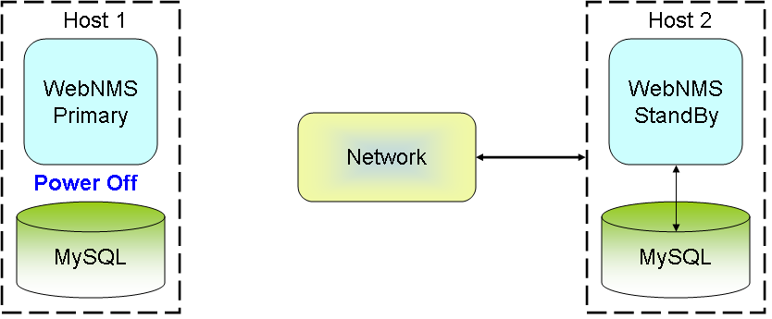
Figure 9 Host 1 looses power.
AdventNet inputs are required for this scenario to explain what happens;
- To the WebNMS server on Host 2?
Ans :: Host 2 becomes Primary server.
- What happens when the power is restored to Host 1?
Ans :: Host 1 registers as Standby with the Primary server after restarting WebNMS manually.
- What is the recommended startup procedure for WebNMS and MySQL when power is restored?
Ans :: Some data may lost, but it won't corrupt the data in WebNMS. So WebNMS can be warm started (without reinitializing). MySQL should be set up as two-way replication.
- What happens when the power is restored after a considerable length of time?
Ans :: Host 1 registers as Standby after starting WebNMS manually.

Host 2 looses power
In this scenario Host 2 looses power as shown in figure below.

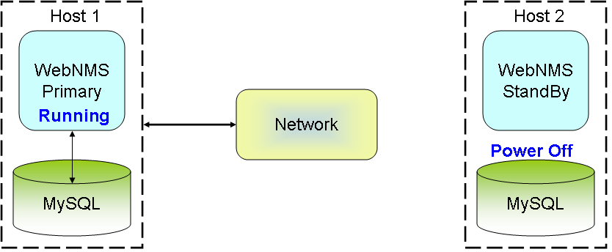
Figure 10 Host 2 looses power
AdventNet inputs are required for this scenario to explain what happens;
- To the WebNMS server on Host 1?
Ans :: Host1 remains running as Primary server.
- What happens when the power is restored to Host 2?
Ans :: Host 2 registers as Standby server after restarting it manually.
- What is the recommended startup procedure for WebNMS and MySQL when power is restored?
Ans :: Some data may lost, but it won't damage the data in WebNMS. So WebNMS can be started with Warm start (without reinitializing). MySQL should be set up as two-way replication.
What happens when the power is restored after a considerable length of time?
Ans :: Host 2 becomes Standby after starting WebNMS manually.

Both Host 1 and Host 2 loose power
In this scenario both Host 1 and Host 2 loose power as shown in figure below.

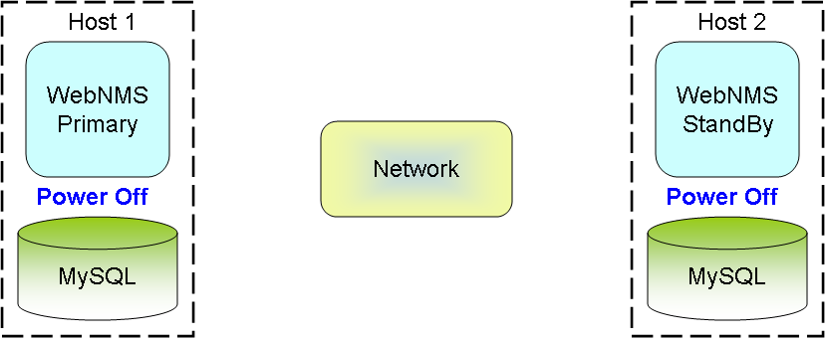
Figure 11 Host 1 and 2 both loose power.

AdventNet inputs are required for this scenario to explain what happens;
- What happens when the power is restored to both Host 1 and Host 2?
Ans :: If WebNMS on Host1 is manually started (first) then it becomes Primary and other becomes Standby. i.e which ever server starts first will become Primary Server.
- What is the recommended startup procedure for WebNMS and MySQL when power is restored on both Host 1 and Host 2?
Ans :: Some data may lost, but it won't damage the data in WebNMS. So WebNMS can be started with Warm start (without reinitializing). MySQL should be set up as two-way replication.
What happens when the power is restored after a considerable length of time?
Ans :: Which ever WebNMS server starts first will becomes Primary.

