PROJECT REPORT

Digital Naturalist-AI Enabled
Tool For Biodiversity
Researchers

Submitted by

Abishek. S -730919106004

Jeevitha. P -730919106033

Kaleeswari. G -730919106036

Jenifer Vinothini. P -730919106068

TABLE OF CONTENTS

1 INTRODUCTION

1.1 PROJECT OVERVIEW

1.2 PURPOSE

2 LITERATURE SURVEY

2.1 EXISTING PROBLEM

- 2.2 REFERENCES

2.3 PROBLEM STATEMENT DEFINITION

3 IDEATION AND PROPOSED SOLUTION

3.1 EMPATHY MAP CANVAS

3.2 IDEATION & BRAINSTORMING

3.3 PROPOSED SOLUTION

3.4 PROBLEM SOLUTION FIT

4 REQUIREMENT ANALYSIS

4.1 FUNCTIONAL REQUIREMENTS

4.2 NON- FUNCTIONAL REQUIREMENTS

5 PROJECT DESIGN

5.1 DATA FLOW DIAGRAM

5.2 SOLUTION & TECHNICAL ARCHITECTURE

5.3 USER STORIES

6 PROJECT PLANNING AND SCHEDULING

6.1 SPRINT PLANNING AND ESTIMATION

6.2 SPRINT DELIVERY SCHEDUL

7 CODING & SOLUTIONING

7.1 FEATURE 1

7.2 FEATURE 2

7.3 DATABASE SCHEMA
8 TESTING

8.1 TEST CASES

8.2 USER ACCEPTANCE TESTING

9 RESULTS

9.1 PERFORMANCE METRICS

10 ADVANTAGES & DISADVANTAGES

ADVANTAGES

DISADVANTAGES

- CONCLUSION

- FUTURE SCOPE APPENDIX

SOURCE CODE GITHUB PROJECT DEMO
CHAPTER 1

INTRODUCTION

1.1 PROJECT OVERVIEW

A naturalist is someone who studies the patterns of naturalist, identifies a different kind of flora and fauna in nature. Being able to identify the flora and fauna around us often leads to an interest in protecting wild spaces, and collecting and sharing information about the species we see on our travels is very useful for conservation groups like NCC.

When venturing into the woods, field naturalists usually rely on common approaches like always carrying a guidebook around everywhere or seeking help from experienced ornithologists. There should be a handy tool for them to capture, identify and share the beauty to the outside world.

Filed naturalist can only use this web app from anywhere to identify the birds, flowers, mammals and other species they see on their hikes, canoe trips and other excursions.

In this project, we are creating a web application which uses a deep learning model, trained on different species of birds, flowers and mammals (2 subclasses in each for a quick understanding) and get the predication of the bird when an image is been given.
1.2 PURPOSE

- AI image classifiers can create biodiversity datasets from social media imagery.
- Flickr hosts many images of plant; some can be accurately classified to species by AI.
- Images are spatially aggregated around tourist sites and under- represent native species.
- Images focused on a single, non-horticultural, plant are most reliably identified.

Recent report of global biodiversity it more important than ever to monitor biodiversity so that we can detect changes and infer their drivers. Online digital media, may be a new source of biodiversity observation, but they are far too numerous for a human apply an AI image classifier, designed to identify plants from images, to assess this method as a way to generate new biodiversity observation. We find that this approach is able to generate new data on species occurrence but that there are biases in both the social media data and the AI image classifier that need to be considered in analyses.
1
CHAPTER 2

LITERATURE SURVE

The increasing availability of digital image, coupled with sophisticated artificial intelligence techniques for image classification, presents an exciting opportunity for biodiversity researchers to create new datasets of species observation.

Career path recommendation framework:
In north east india biodiversity hotspots that are flora and fauna such as the hoolock gibbon and the phayre’s leaf monkey, a Bengaluru- based research organisation has been gathering data on plant diversity and animal group as well as mapping the ecosystem.
The article was published in Feb 19,2019 02:45pm
Job recommendation:
IBM, too, has jumped on to bandwagon and is aiming to reach out to as many as
3.5 million famers through its agri tech apps. “We agri tech as a Rs 5000- crore Copportunity in the next five years. We are also working with niti aayog to develop crop- yield predication mode using AI to provide real-time advisories to famers in backward districts, “says himanshu goyal, india business leader, the weather company,IBM.
2.1. Existing Problem:
Problem statement-1:
- I am hiking guide
- I am trying to guide customer as good as possible in forest hiking
- But It is hard to teach about all the animals and plant
- Because lack of information about the animal
- Which makes me feel overstressed
Problem statement-2
- I am ayurvedic shopkeeper
- I am trying to selling of ayurvedic herbs and medicines
- But cant run store in efficient manner
- Because not having about some rare herbs
- Which makes me feel Confused.
Problem statement-3
- I am Archaeologist
- I am trying to finding of fossils and skull under the ground
- Because not having idea about some animal skull
- Which makes me feel anxiety.
2
Problem statement-4
- I am forest department
- I am trying to protect commoner from animal attack
- But It id not an easy task to protect from animal attack

- Because to identify the species with unclear picture from CCTV
- Which makes me feel Scared.
Problem statement-5
- I am professional trekker
- I am trying to used to trek over different forests
- But it is hard know the footprint of animal in the forest
- Because lack of knowledge in animal footprint impression
- Which makes me feel p
2.2. Reference:
Article:
- AI Naturalists might hold the key to unlocking biodiversity data in social media imagery.
- UK centre for Ecology and hydrology, Benson lane, Crowmarsh Gifford, Wallingford, Oxfordshire OX10 8BB, UK.
- INRIA Sophia- Antipolis-ZENITH team, LIRMM-UMR 5506-CC 477,161 Rue Ada, 34095 Montpellier Cedex 5, France.
- AMAP, Univ Montpellier, CIRAD, CNRS, INRA, IRD, Montpellier, France.
- CIRAD, UMR AMAP, Montpellier, France.
Received 29 May 2020, Received 4 August 2020, Received 7 September 2020, Available online 9 October 2020, Version of Record 9 October 2020.
Published: October 9, 2020.

Journal Article:
The Extended Specimen Network:
- A strategy to enhance US biodiversity collection, promote research and education.
- Bioscience, volume 70, Issue 1, January 2020,.
https://dio.org/10.1093/biosci/biz140
A correction has been published Bioscience, volume 70, Issue 2, February 2020.
https://dio.org/10.1093/biosci/biz165
Biodiversity collection have historically consisted of physical objects and the infrastructure to support those object (Bradley et al. 2014). However, the last tow that has reshaped the collection paradigm to include digital data and infrastructure (Nelson and Ellis 2018), Opening vast new areas for integrative biological research (e.g., s )
3
single plant specimen mounted on an herbarium sheet may ne analyzed in multitude ways to yield data on flower systematic studies to genome sequences, and isotopes for analyses of nitrogen to understand for analyses phonology in relation to nitrogen uptake).

In During the last several years, the Biodiversity collection network has led an effort to gather input from primary stakeholder communities regarding future directions for collection and their use in research and education. The effort culminated in a workshop held from 30 October through 1 November 2018 at Oak Spring Garaden in Upperville, Virginia, during which a strategy was developed to maximize the value of collection for future research and education that builds on and leverages the accomplishments of the ADBC program. The strategy that was informed by stakeholders, refined by workshop participants, and vetted through public comment from scientific community is presented in the present article.

2.3. Problem Statement
A problem is a statement about an area of concern, a Condition to be improved
upon, a difficulty to be eliminated, or a troubling question that exists in theory or in Practice that points to the need for meaningful understanding and deliberate investigation.
The environmental issue:
The earth is experiencing a mass extinction of species that is unparalleled in its history, with species being lost at perhaps 100 to 1000 times that rates before human dominance of the planet (Vitousek etal. 1997). At lest 200 bird and mammal species have gone extinct within the past 200 years. More importantly, the extinction rate of plants and animals is accelerating dramatically as a function of a burgeoning human population and associated degradation or loss of natural habitats. Edward O. Wilson places the current extinction rate for invertebrate species at over 50,000 per year (Wilson, 1989). Jared Diamond estimate that 20-50% of the plant’s species will be lost over the next 50 years (Diamond, 1990).The establishment of large, representative natural reserves is the most viable and cost-effectives means of minimizing the rate of species extinctio

The first step is to identify and prioritize the most vulnerable species and ecosystems and then to identify candidate reserve localities that will provide their long-term persistence. This required ecological inventory and modeling over heterogeneous areas much larger than those traditionally studied by ecologists and wildlife biologists. Installation of an effective reserve network to minimize future loss of biodiversity will required coordinated conservation assessment at international, national, regional and local levels. Such assessments already rely heavily on advanced mapping technologies and computing systems for spatial data analysis and display. The USGS-Biological Resources Division GAP Analysis Program (Gap) is a nationwide (and potentially international) conservation inventory. The objective of Gap is to map the RESULT.
4
to identify areas where new reserves would be especially effective in protecting biological resources at risk. The term “gap analysis” refers to the overlaying of biological distribution data on a map of existing biological reserves to identify gaps in existing reserve system (Scott et al. 1987). Investigative teams in individual states are compiling moderate-resolution digital maps of vegetation, vertebrate species distribution, and land ownership. There state databases will ultimately be combined to conduct gap analysis within nature ecological regions. A major component of the research that we proposed was in support of the U.S. Gap Analysis Program and related efforts. Mapping and spatial analysis. Specifically:
- Biogeographers and conservation biologists do not have adequate computing resources to analysis the large volumes of data involved in conservation assessments.
- Data management system in general use are poorly designed for manipulation of heterogeneous biogeographic data.
- There is practically no coupling among database management systems and analytical software used in biodiversity analysis.
- It is difficult to visualize biogeographical data sets and model output with existing display tool.
- Spatial modelling and decision support are constrained by inadequate hardware and cumbersome protocols for conducting sensitivity and
error propagation analysis.

5

CHAPTER 3

IDEATION AND PROPOSED SOLUTION
3.1 Empathy map:

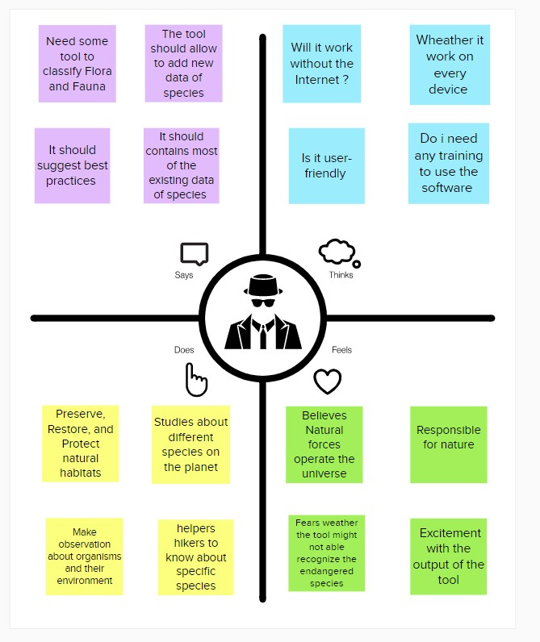

6

3.3 Proposed Solution Template:
Project team shall fill the following information in proposed solution template.
S. No. | Parameter | Description
 | Problem Statement (Problem to be solved) | We investigated whether an AI plane species classifier could extract previously unexploited biodiversity data from over media photos. We found over 60,000 geolocated images tagged with the keyword “flower” across an unbar and rural location in the UK and classified these using AI, reviewing these and assessing the representativeness of images. Images were predominantly biodiversity focused, showing single species. Non-native garden plant dominated, particularly the urban setting. The AI classifier performed best when photos were focused on single native species in wild situations but also performed well at higher taxonomic level even when images substantially deviated from this. We present a checklist of questions that should be considered when under.

7

 | Idea / Solution description | When venturing into the wood, field naturalist usually real on common approaches like always carrying a guidebook around everywhere or seeking help from experienced ornithologists. There should be a handy tool for them to capture, identify and share the beauty to the outside world. Field naturalists can only use this web app from anywhere to identify the birds, flowers, mammals and other species they see on their hikes, canoe trips and other excursions. In this project, we are creating a web application which uses a deep learning model, trained on different species of birds, flowers and mammals and get the predication of the bird an image is been given.
 | Novelty / Uniqueness | Peering in on the microbial world of nectar in one lab and modelling government programs in protected portions of the Amazon in another, Stanford’s on biodiversity is, itself, diverse. Our researchers being to light fundamental discoveries that help us define biodiversity and explore why species disappear. They also offer unique perspectives on how to conserve the natural world, taking into account how it is now and how it will likely be in the decades and centuries to come.

8
 | Novelt/ Uniqueness | Peering in on the microbial world of nectar in one lab and modelling government programs in protected portions of the Amazon in another, Stanford’s on biodiversity is, itself, diverse. Our researchers being to light fundamental discoveries that help us define biodiversity and explore why species disappear. They also offer unique perspectives on how to conserve the natural world, taking into account how it is now and how it will likely be in the decades and centuries to come.
4. | Social Impact / Customer Satisfaction | Stanford undergraduates study links between human and natural system through an interdisciplinary seminar in palau. With abundant data on plant, large animals and their activity, and carbon soli levels in the amazon, Stanford research suggests that large animal diversity influences carbon stocks and contributes to climate mitigation. Stanford’s community ecology lab has found that microbes in nectar can affect and inset. Now, scientists have shown these genetic clues can be used as forensic markers to accurately and easily survey marine life in complex deep-water environments. Scientists used tree cover maps and on-the-

 | Business Model (Revenue Model) | Businesses are increasingly called upon to contribute to efforts to protect biodiversity and natural capital. Our article presents the results of an action research conducted with a major company in the environmental with innovative services dedicated to ecosystem management. We show the specific organizational and social challenges this strategy due to its path dependency to its historical value creation model, and to the collective action issues that characterize biodiversity.

9
CHAPTER 4

REQUIREMENT ANALYSIS

Requirement analysis, also called requirements engineering, is the process of determining user expectations for a new or modified product. These features, called requirements, most be quantifiable, relevant and detailed. In software engineering, such requirements are often called functional specifications.

4.1 Functional Requirement:
Current charge in biodiversity and their functional consequences for ecosystem processes matter for both fundamental and applied reasons. In most places the most important anthropogenic determinate of biodiversity is land use. The effects of type and intensity of land use are modulated by climate and atmospheric change, nutrient deposition and pollution and by feedback effects of changed biologic processes. However, it is whether the genetic and species diversity of land-use change in similar ways. Moreover, consequences of changing diversity for ecosystem processes have almost exclusively been studied in model experiment of limited scope. Clearly, there is an urgent scientific and societal demand to investigate the relationship between land use, biodiversity and ecosystem processes in many study sites in the context of actual landscapes. Furthermore, these studies need to be set in long-term frameworks. Moreover, because monitoring and comparative observation cannot unravel causal mechanisms they need to be complemented by manipulative experiments. In the ‘Exploration for our experience has several implications for long-term ecological research and the necessity of formulating common research questions, applying modern tools for meta-analysis or quantitative review and developing standardised experimental and measurement protocols for facilitating future data synthesis
4.2 Non- Functional Requirement:
Requirement engineering are in a unique position to encourage the consideration of sustainability at a formative phase in the software development life cycle. In this paper, we look at how can develop sustainability as a non- functional requirement (NFR). We describe an NFR framework that is informed by sustainability models and discuss how it can be used to appropriately elicit and describe sustainability related requirement of the software system to be developed. We outline a roadmap for how we may integrate sustain- ability in requirements engineering from a NFR framework to an applicable software quality and relevant software standards.

10
CHAPTER 5

PROJECT DESIGN

- Non- functional requirement or NFRs are a set of specifications that describe the system’s operation capabilities and constraints and attempt to improve its functionality.
- Performance and scalability.
- Portability and compatibility.
- Reliability, maintainability, availability.
Project design is an early phase of the project lifecycle where ideas, processes, source a
and deliverables are planned out. A project design comes before a project plan as it’s broad overview whereas a project plan includes more detailed information.

5.1 Data flow:
Data Flow Diagrams:
A Data Flow Diagram (DFD) is a traditional visual representation of the information flows within a system. A neat and clear DFD can depict the right
amount of the system requirement graphically. It shows how data enters and leaves the system, what changes the information, and where data is
stored.
Simplified DFD:
1. User uploads the image of flora / fauna.
2. The Python application sends it to IBM Cloud.
3. The CNN model accepts the image as the input to test the model.
4. The CNN model predicts the name of the species.
5. The output is returned to the application.
6. The application displays the received information.

11
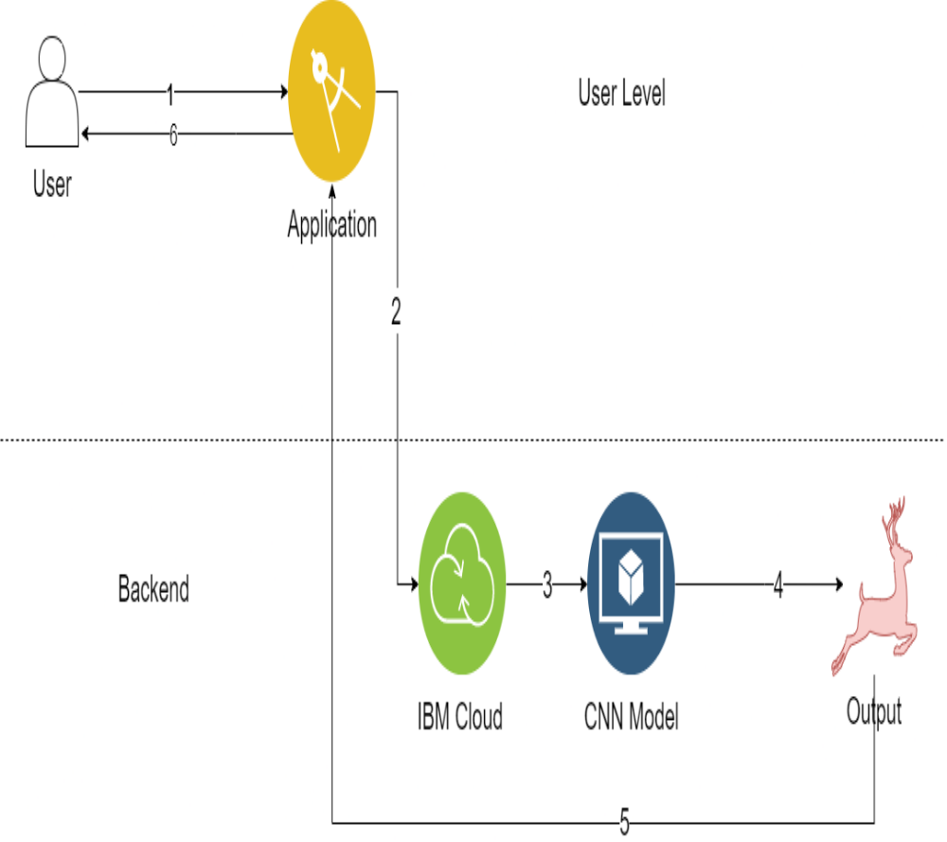

12

DFD Standard :

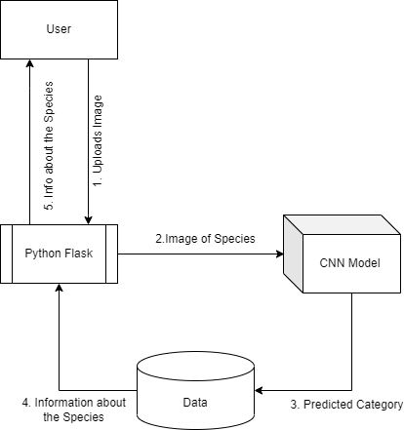

13

2 Solution & Technical Architecture:

Solution architecture is a complex process-with many sub-processes-that bridges the gap between business problems and technology solution, it’s goals are to.
- Find the best tech solution to solve existing business problem.
- Describe the structure, characteristics, behavior, and other aspects of the software to project stakeholders.
- Define features, development phases, and solution requirement.
- Provide specifications according to which the solution is defined managed, and delivered.

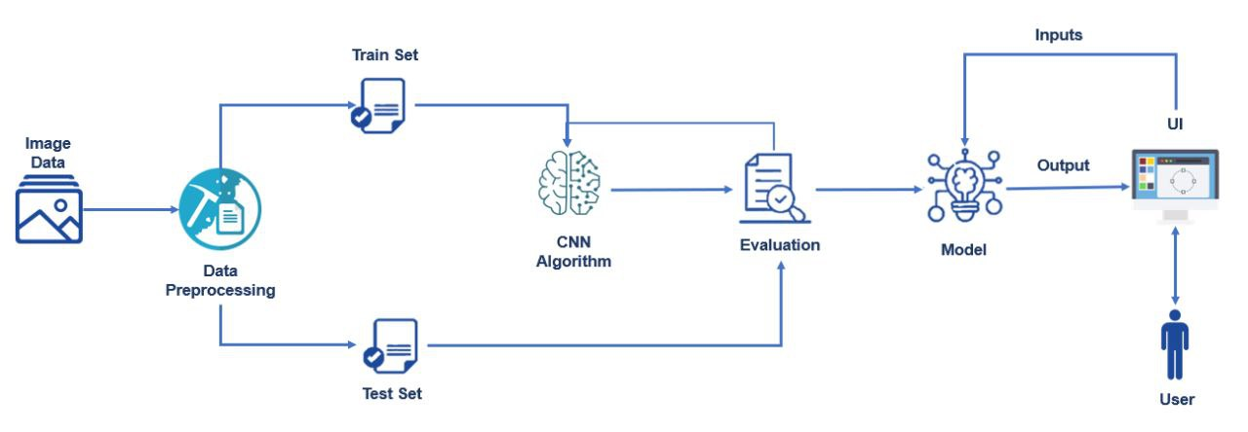

14

5.3 User Store :

Who?  Who used biodiversity? | Biodiversity refers to all different kinds of species living together on plant earth.
What?  What is the intention of biodiversity? | To preserve the diversity of species sustainable utilization of species and ecosystem. To conserve life-supporting system and essential ecological processes.
Why?  What is the value for the customer? | Biodiversity provides vital ecosystem functions such as soil fertilization, nutrient recycling, pest and disease regulation, erosion control and crop and tree pollination.

15

CHAPTER 6
PROJECT PLANNING

The process of planning deals with selecting the appropriate policies and procedure in order to achieve the objectives of the project. Scheduling converts the project action plans for scope, time cost and quality into an operating timetable.

6.1 Sprint planning:

Objective | P. Jeevitha  P. Jenifer
Project flow | P. Jeevitha
Pre-Requisites | G. Kaleeswari
Prior knowledge | S. Abishek
Data collection | P. Jenifer

16

6.2 Sprint Delivery Schedule:.
Product Backlog, Sprint Schedule, and Estimation (4 Marks)
Use the below template to create product backlog and sprint schedule

Sprint-1/ | User Registration | USN-1 | As a user, I can register for the application by entering my email, password, and confirming my password. | 2 | High | Jenifer vinothini, Jeevitha,  Kaleeswari,Abishek.
Sprint-1 |  | USN-2 | As a user, I will receive confirmation email onceI have registered for the application | 1 | High | Jenifer  vinothini,  Jeevitha,  Kaleeswari,Abishek.
Sprint-2 |  | USN-3 | As a user, I can check the eligibility criteria for various universities by uploading the necessary documents | 2 | Low | Jenifer vinothini,  Jeevitha  Kaleeswari,Abishek.

17

Project Tracker, Velocity & Burndown Chart: (4 Marks)

 | Total Story Points | Duration | Sprint Start Date | Sprint End Date (Planned) | Story Points Completed (as on Planned End Date) | Sprint Release Date (Actual)
Sprint-1 | 20 | 6 Days | 24 Oct 2022 | 29 Oct 2022 | 20 | 29 Oct 2022
Sprint-2 | 20 | 6 Days | 31 Oct 2022 | 05 Nov 2022 | 20 | 05 Nov 2022
Sprint-3 | 20 | 6 Days | 07 Nov 2022 | 12 Nov 2022 | 19 | 12 Nov 2022
Sprint-4 | 20 | 6 Days | 14 Nov 2022 | 19 Nov 2022 | 20 | 19 Nov 2022

18

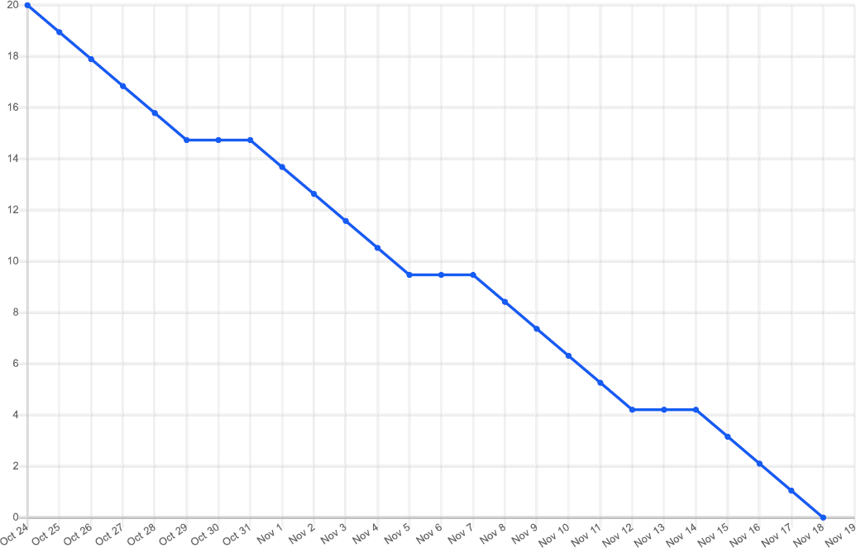
Burndown Chart:

19

  - 6.3 Reports From JIRA:

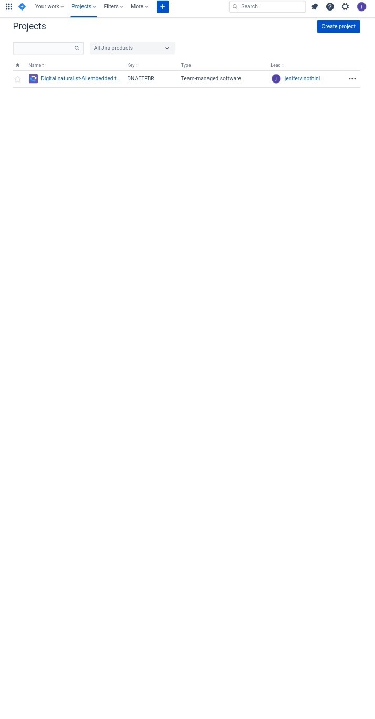

20

CHAPTER 7

CODING & SOLUTIONING

Coding is the process of transforming ideas, solution, and instructions into the language that the computer can understand- that is, binary-machine code. Coding is how humans are ale to talk with computers.
7.1 Feature 1
In [3]:
import os, gc, glob, random
import numpy as np
import matplotlib.pyplot as plt
import pandas as pd
import tensorflow as tf
import keras
from PIL import Image
from keras.layers import Dense,Flatten
from keras.models import Model
from keras.applications.inception_v3 import InceptionV3, preprocess_input
from keras.callbacks import ModelCheckpoint, EarlyStopping
from keras.utils.np_utils import to_categorical
from sklearn.model_selection import train_test_split

Using the InceptionV3 pretrained model
In [4]:
base_model InceptionV3(input_shape=(224,224,3),include_top=False)
Downloading data from https://storage.googleapis.com/tensorflow/keras-applications/inception_v3/inception_v3_weights_tf_dim_ordering_tf_kernels_notop.h5
87910968/87910968 [==============================] - 5s 0us/step

Freezing the weights in the pretrained model
In [5]:
for layer in base_model.layers:
layer.trainable = False

21

Flatening and adding dense layer
In [6]:
X = Flatten()(base_model.output)

#using sigmoid function as activation funciton
X = Dense(units = 6, activation = 'sigmoid')(X)

Compiling the model
In [7]:
model = Model(base_model.input,X)
#using adam as the optimizer
#accuracy is set as the metrics to judge the performance of the model
model.compile(optimizer = 'adam',loss = keras.losses.binary_crossentropy,metrics=['accuracy'])

#summarizing the model
model.summary()

loading the train and test dataset
In [20]:
#initializing the datagenerator
datagen = tf.keras.preprocessing.image.ImageDataGenerator()

#loading the train dataset from the directory
traindata= datagen.flow_from_directory(directory="/content/Train Data",target_size=(224,224),batch_size=100)

#loading the test dataset from the directory
testdata= datagen.flow_from_directory(directory="/content/Test Data",target_size=(224,224),batch_size=100)
Found 2916 images belonging to 6 classes.
Found 1427 images belonging to 6 classes.
In [17]:
#listing the found classes from train dataset
traindata.class_indices
Out[17]:

22
{'Corpse_AUG': 0,
'GIB_AUG': 1,
'LS_Orchid_AUG': 2,
'LS_Pangolin_AUG': 3,
'SPS_AUG': 4,
'SW_Deer_AUG': 5}

loading the train and test dataset
In [20]:
#initializing the datagenerator
datagen = tf.keras.preprocessing.image.ImageDataGenerator()

#loading the train dataset from the directory
traindata= datagen.flow_from_directory(directory="/content/Train Data",target_size=(224,224),batch_size=100)

#loading the test dataset from the directory
testdata= datagen.flow_from_directory(directory="/content/Test Data",target_size=(224,224),batch_size=100)
Found 2916 images belonging to 6 classes.
Found 1427 images belonging to 6 classes.
In [17]:
#listing the found classes from train dataset
traindata.class_indices
Out[17]:
{'Corpse_AUG': 0,
'GIB_AUG': 1,
'LS_Orchid_AUG': 2,
'LS_Pangolin_AUG': 3,
'SPS_AUG': 4,
'SW_Deer_AUG': 5}

Model Checkpoint and Early Stopping
In [18]:
# Creating a model checkpoint which monitors the accuracy of the model and saves the checkpoint
mc = ModelCheckpoint(filepath = "./model.h5",
monitor = 'accuracy',
verbose = 1,
save_best_only = True)

23
# Creating a earlystopping object which stop training once the model performance stops improving on a hold out validation dataset
es = EarlyStopping(monitor = "accuracy",
min_delta = 0.01,
verbose = 1)

call_back = [mc,es]

Model fitting
In [25]:
# Fitting the model
modelHistory = model.fit(traindata, steps_per_epoch=60,epochs = 30,callbacks=call_back,validation_data=testdata)
Epoch 1/30
30/60 [==============>...............] - ETA: 6s - loss: 1.1722 - accuracy: 0.9098
WARNING:tensorflow:Your input ran out of data; interrupting training. Make sure that your dataset or generator can generate at least `steps_per_epoch * epochs` batches (in this case, 1800 batches). You may need to use the repeat() function when building your dataset.
Epoch 1: accuracy improved from 0.86831 to 0.90981, saving model to ./model.h5
60/60 [==============================] - 13s 208ms/step - loss: 1.1722 - accuracy: 0.9098 - val_loss: 0.6965 - val_accuracy: 0.9636

Exporting the model
In [21]:
# Exporting the model to json
model_json = model.to_json()
with open("DigitalNaturalist.json", "w") as json_file:
json_file.write(model_json)

# Exporting the model weights

model.save_weights("DigitalNaturalist")
print("Saved model to disk")
Saved model to disk

Testing the model
In [30]:
#Testing the model
predictions = ["Corpse Flower",
"Great Indian Bustard",
"Lady's slipper orchid",
"Pangolin",
"Spoon Billed Sandpiper",
"Seneca White Deer"
24
]
path = '/content/Test Data/GIB_AUG/aug_download (1)_0_2011.jpg'
ime = tf.keras.utils.load_img(path,target_size=(224,224))

i = tf.keras.preprocessing.image.img_to_array(ime)

i = preprocess_input(i)
input = np.array([i])
pred = model.predict(input)
predictions[np.argmax(pred)]
1/1 [==============================] - 0s 39ms/step
Out[30]:
"Great Indian Bustard"

  - Feature-2:

<!DOCTYPE html>
<html lang="en">
<head>
<meta charset="UTF-8">
<meta name="viewport" content="width=device-width, initial-scale=1.0">
<meta http-equiv="X-UA-Compatible" content="ie=edge">
<title>DIGITAL NATURALIST</title>
<meta name="description" content="">
<meta name="keywords" content="">
<link rel="icon" type="image/x-icon" href="https://img.icons8.com/fluency/48/000000/natural-food.png">
<link href="https://fonts.googleapis.com/css?family=Source+Sans+Pro:400,700" rel="stylesheet">
<link rel="stylesheet" href="/static/style.css">
</head>
<body class="leading-normal tracking-normal text-gray-900" style="font-family: 'Source S
25
ns Pro', sans-serif;">
<div class="h-screen pb-14 bg-right bg-cover">
<!--Nav-->
<div class="w-full container mx-auto p-6">

</div>
<!--Main-->
<div class="container pt-24 md:pt-48 px-6 mx-auto flex flex-wrap flex-col md:flex-row items-center">
<!--Left Col-->
<div class="flex flex-col w-full xl:w-2/5 justify-center lg:items-start overflow-y-hidden">
<h1
class="my-4 text-3xl md:text-5xl text-green-800 font-bold leading-tight text-center md:text-left slide-in-bottom-h1">
<p class="leading-normal text-base md:text-2xl mb-8 text-center md:text-left slide-in-bottom-subtitle">
An Artificial Intelligence powered tool for Bio-Diversity Researchers</p>
<p class="text-blue-400 font-bold pb-8 lg:pb-6 text-center md:text-left fade-in">Trouble identifing a
animal,plant or bird,<br>Upload the picture<br>Sit back<br>Relax<br>We will find it
<!DOCTYPE html>
</p>
<div class="flex w-full justify-center md:justify-start pb-24 lg:pb-0 fade-in">
<form action="/predict" id="upload-file" method="post" enctype="multipart/form-data">
<input type="file" name="uploadedimg" id="uploadedimg" required accept=".jpg, .png, .jpeg, .gif, .bmp, .tif, .tiff|image/*" >
<input type="reset" value="Reset" class="upload">

26
</form>
</div>
</div>
<!--Right Col-->
<div class="w-full xl:w-3/5 py-6 overflow-y-hidden">
<img class="w-5/6 mx-auto lg:mr-0 slide-in-bottom" src="https://i.ibb.co/vwhxYCg/animals.png">
</div>
<!--Footer-->
<div class="w-full pt-16 pb-6 text-sm text-center md:text-left fade-in">
<a class="text-gray-500 no-underline hover:no-underline"

href="https://github.com/IBM-EPBL/IBM-Project-46326-1660745221">&copy; Digital Naturalist</a>
</div>
</

</div>
<script>

function validateFile(){
const allowedExtensions = ['jpg','png'],
sizeLimit = 1_000_000;
const { name:fileName, size:fileSize } = this.files[0];
const fileExtension = fileName.split(".").pop();
if(!allowedExtensions.includes(fileExtension)){

this.value = null;
}else if(fileSize > sizeLimit){
alert("file size too large")
this.value = null;
}
27
CHAPTER 8

TESTING
  - Test cases:
White Box Testing :
White box testing is a testing in which in which the software tester has knowledge of the inner working, structure and language of the software, or at least its purpose. It is purpose. It is used to test areas that cannot be reached from a black box level
Block Box Testing:
Block box testing is testing the software without any knowledge of the inner working, structure, or language of the module being tested. Block box test, as most other kinds of tests, must be written from a definitive source document, such specification or requirements document, such as specification or requirement document. It is a testing in which the software under test is treated, as a block box, you cannot “see” into it.
Unit Testing:
Unit testing is usually conducted as part of a combined code and unit test phase of the software lifecycle, although it is not uncommon for coding and testing to be conducted as two distinct phase test phase of the software lifecycle, although it is not uncommon for coding.
8.2 User acceptance testing :

Test strategy and approach:
Field testing will be performed manually, and functional tests will be written in detail.
Test objectives:
- All field entries must work properly.
- Pages must be activated from the identified link.
- The entry screen, message and responses must not be delayed.

Feature to be tested:
- Verify that the entries are of the correct format.
- No duplicate entries should be allowed.
- All links should take the user to the correct page.

Integration testing :
Software integration testing is the incremental integration testing of two or more integrated software components on a single platform to produce failures caused by interface defects.

28
Test Result:
All the test cases mentioned above passed successfully. No defects encountered.

Acceptance testing:
User acceptance testing is a critical phase of any project and requires significant participation by the end user. It also ensures that the system meets the functional requirements.

29
CHAPTER-9
RESULTS

  - Performance metrics:
Whittaker described three common metrics used to measure species-level biodiversity, encompassing attention to species richness or species evenness. Species richness- the simplest of the indies available. Simpson index. Shannon-Wiener index.

30
CHAPTER 10

ADVANTAGES & DISADVANTAGES

Advantage:
A healthy biodiversity offers many natural services
- Ecosystem services, such as protection of eater resources. Soils formation and protection.
- Biological resources, such as. Food. Medicinal resources and pharmaceutical drugs.
- Social benefits, such as. Research, education and monitoring. Recreation and tourism.

Disadvantage:
- Land use change, pollution, poor water quality, chemical and waste contamination, climate change and other cases of ecosystem degradation all contribute to biodiversity loss and, can pose considerable threats to human health. 03-jun-2015.

31
CHAPTER 11

CONCLUSION
In this project, we are creating a web application which uses a deep learning model, trained on different species of birds, flowers, mammals. There is great diversity among naturalist, but some common ground too. All naturalism beginwith an admiring attitude towards science and its achievements. In many cases this admiring attitude is combined with a contempt or distrust for the way that philosophy has been or is conducted. The combination of views has a long history. Many of the advocates of first philosophy, Descartes, kant and carnap, shared the same admiration of science or nascent science and distrust of philosophy.

32

CHAPTER 12

FUTURE SCOPE:
Essentially, the proposed guidelines treat statistical comparison if ML based quality estimators as a multi-dimensional problem. Accordingly, we seek to assess the predicators more holistically in terms of their local performance on species test conditions, their leaning ability and the magnitude of treatment effect (to quantify the practical significance of the observed differences). In contrast, the current approach tends to reduce this task to binary and global statistical decision making and does not reveal systematic weaknesses (or strengths) of the predictors. In order to provide a tool for practical use, software implementing the proposed guidelines is made publicly available.

APPENDIX

SOURCE CODE

GITHUB

http://github.com/IBM-EPBL/IBM-Project-7558-1658891422

PROJECT DEMO

http://bitly.ws/wpyi

33

