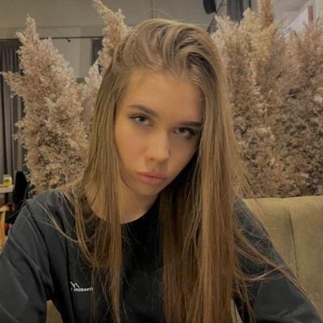

**Kaleeva Alina**

**QA Engineer**

**Details**

Minsk

Belarus

+375 44 733 03 67

kaleeva.fam@mail.ru

DATE OF BIRTH

07.06.2001

**Links**

[**Resume**](https://kaleevaalina.github.io/QA_resum/)

[**Linkedin**](https://www.linkedin.com/in/alina-kaleeva-82a051207/)

[**Telegram**](https://t.me/Allin_k)

[**Email**](mailto:kaleeva.fam@mail.ru)

**Skills**

HTML & CSS

Git

Functional Testing

API Testing

Manual Testing

SQL

Postman

Non-functional

Test design techniques

Selenium IDE

DevTools



**Language**

English B1+



Russian



**Hobbies**

I like music. I play many instruments and sing! I also exercise regularly.

**Proﬁle** [**Resume**](https://kaleevaalina.github.io/QA_resum/)

I am engaged in testing financial blockchain projects. In total, i tested 8 blockchain projects: blockchain banking, crypto wallet application, online store, blockchain explorer, blockchain game, company website application, blockchain investment project.The projects arewritten in React js, React Native, NodeJs and use mongodb databases.

My achievements: built testing processes that increased the quality of projects.

I am part of the company's project support team.

**Employment History**

**QA Engineer, SCRUMP, Minsk**

JUNE 2021 — PRESENT

Testing web application both client and server parts:

• Searching bugs, bug reporting (Jira);

• Creating and reviewing checklists and test cases

• Experience with git version control system, cloned and run locally applications for testing with VsCode editor using node package manager (Yarn);

• Functional, non-functional testing;

• Mobile testing (Android Studio) and real devices;

• Working with API (Postman);

• Interaction with the development team.

**Education**

Belarus State Economic University, Minsk,

specialization: finance and credit.

SEPTEMBER 2018 — JULY 2022

**Courses**

**Web development(HTML, CSS), IT SHATLE**

2020 — 2021

**Web development(HTML, CSS), Beonmax**

2020 — 2021

**QA courses from It Academy, STORMNET**

MAY 2021 — JUNE 2021

**Сorporate English lessons**

PRESENT

**Test Automation with Selenium and Python, Stepik.org**

NOVEMBER 2022 — PRESENT