# Say Hello to markdown

Markdown is an **easy to use** format for writing reports. It resembles what you naturally write every time you compose an email. In fact, you may have already used markdown *without realizing it*. These websites all rely on markdown formatting

* [Github](www.github.com)
* [StackOverflow](www.stackoverflow.com)
* [Reddit](www.reddit.com)

Here's some code

dim(iris)

## [1] 150 5

##eval = FALSE只将代码放入  
dim(iris)

## [1] 150 5

hist(iris[[2]])

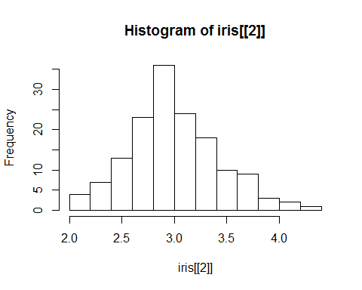

# 行间代码

嵌入R代码到文本当中，在代码的两侧用点’来包围 Two plus two equals 4.