Kalem-4-Channel-Isolated-PNP-Output
  - Isolated 4-channel 12–24 V PNP output module
3.3/5 V MCU interface with optically isolated 12–24 V high-side (PNP-style) outputs.

1. Overview
The Kalem-4-Channel-Isolated-PNP-Output is a compact output module providing four optically isolated high-side (PNP-style) outputs for 12–24 V DC loads. Each channel uses a P-channel MOSFET to source the positive supply to the load, while the low-voltage control side interfaces directly with 3.3 V or 5 V microcontrollers or PLCs.

The module integrates reverse-polarity protection, TVS surge protection, flyback diodes for inductive loads and status LEDs for each channel and the board supply. Galvanic isolation between MCU and load side is provided by per-channel optocouplers.

2. Features
- Supply voltage: 12–24 V DC
- 4 high-side P-channel MOSFET outputs (SP40P18P8)
- Recommended continuous load current up to 2 A per channel (cooling dependent)
- Optocoupler isolation on each channel (LTV-817S series, typical 3.75 kVrms)
- Compatible with 3.3 V and 5 V MCU logic on control inputs
- Reverse-polarity protection on VIN (SS34) and TVS surge clamp (SMBJ33CA) on the supply
- Flyback diode (SS34) per channel for inductive loads
- Per-channel output status LED and global power LED
- Separate MCU_GND and GND_BOARD with optional jumper link
- KF128-5.0 screw terminals for VIN and four load outputs
- 2.54 mm pin header for MCU control signals
- Compact PCB footprint suitable for panel or DIN-rail enclosures

3. Order Information
Order code: Kalem-4-Channel-Isolated-PNP-Output
Description: Isolated 4-channel 12–24 V PNP (high-side) output module with MOSFET outputs, per-channel flyback diodes, TVS and reverse polarity protection, designed for easy connection between microcontrollers/PLCs and industrial 24 V loads.

4. Pinout and Connections

4.1 MCU-side pin header (H3, 2.54 mm, pin 1 to pin 6):
- MCU_CTRL_1 – Channel 1 control input (active HIGH)
- MCU_CTRL_2 – Channel 2 control input (active HIGH)
- MCU_CTRL_3 – Channel 3 control input (active HIGH)
- MCU_CTRL_4 – Channel 4 control input (active HIGH)
- MCU_VCC – Logic supply for control side (3.3–5 V)
- MCU_GND – Ground reference for MCU side

4.2 Power and load screw terminals (KF128-5.0 series):
- VIN connector (2-pin, from left to right): V+ (12–24 V), GND_BOARD
- LOAD1 connector (2-pin): LOAD_OUT_1, GND_BOARD
- LOAD2 connector (2-pin): LOAD_OUT_2, GND_BOARD
- LOAD3 connector (2-pin): LOAD_OUT_3, GND_BOARD
- LOAD4 connector (2-pin): LOAD_OUT_4, GND_BOARD
- H1 jumper: connects MCU_GND to GND_BOARD when fitted (use for non-isolated operation)

5. Output Control and Operation
Each MCU_CTRL_x signal drives the LED of the corresponding LTV-817S optocoupler through a series resistor. When MCU_CTRL_x is driven HIGH from the microcontroller, the optocoupler transistor turns on and activates the MOSFET gate driver network (resistor and protection zener). The P-channel MOSFET then connects V+ to LOAD_OUT_x, sourcing current into the connected load.

When MCU_CTRL_x is LOW (or left floating), the optocoupler LED is off, the MOSFET gate is pulled up towards V+ and the channel is turned OFF. The channel status LED is wired to indicate the ON state of each output.

6. Application Guidelines
- Connect each load between LOAD_OUT_x and GND (system ground). The module sources V+ to the load.
- Use appropriate wire gauge and connector tightening for the expected load current.
- For fully isolated operation, keep MCU_GND and GND_BOARD separated and leave jumper H1 open.
- If you need a shared reference between MCU and load side, fit jumper H1 to connect MCU_GND and GND_BOARD.
- Observe the maximum continuous current per channel and total current to avoid overheating the PCB and connectors.

7. Mechanical Dimensions
- PCB size: see technical drawing (Section 9.4) for exact dimensions.
- Connector pitch: 5.0 mm for power/load screw terminals, 2.54 mm for MCU header.

8. Absolute Maximum Ratings (summary)
- V+ (VIN to GND_BOARD): –0.3 V to +30 V
- MCU_VCC (MCU_VCC to MCU_GND): –0.3 V to +6 V
- Channel output voltage (LOAD_OUT_x to GND_BOARD): up to V+
- Output current per channel (peak, non-continuous): up to 5 A (limited by thermal management)
- Recommended continuous current per channel: up to 2 A
- Isolation voltage (MCU side to load side): up to 3.75 kVrms (per optocoupler rating)
- Operating ambient temperature: –20 °C to +70 °C (board-level, depending on load current)
- Storage temperature: –40 °C to +85 °C

These are stress ratings only. Prolonged operation at or near the absolute maximum ratings is not recommended.

9. Board Views and Mechanical Drawing
9.1 Top view
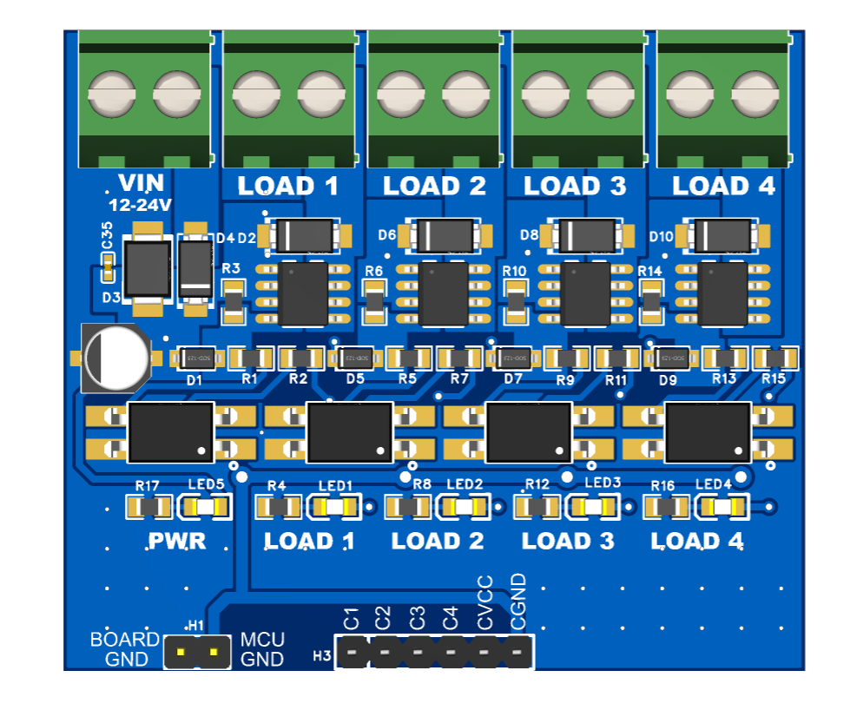

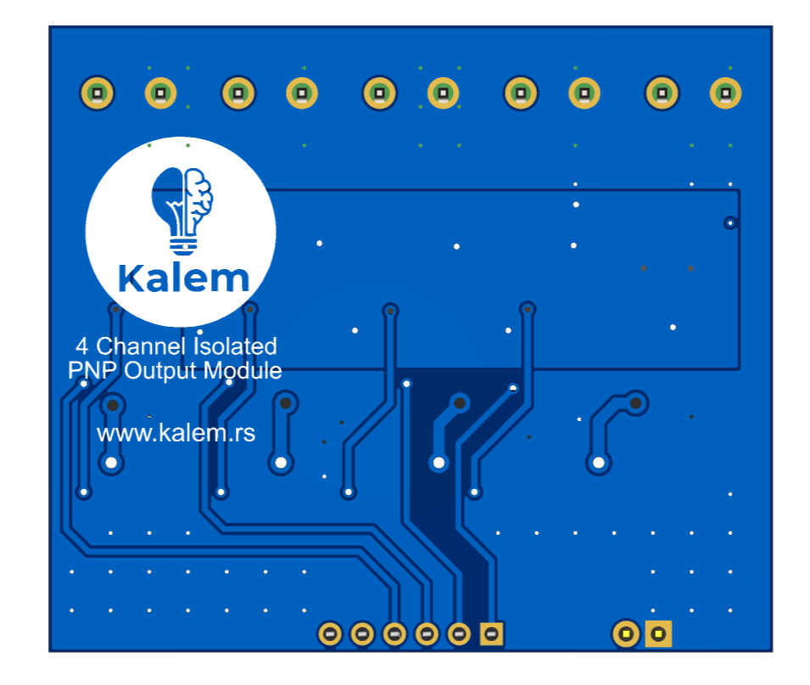
9.2 Bottom view

9.3 Side view

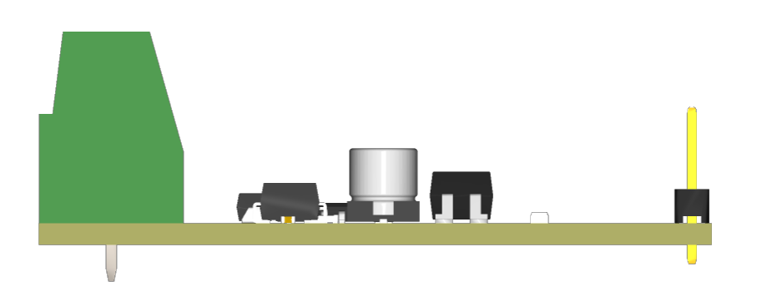

9.4 Technical drawing
