

**The Experiment Report of**

***Deep Learning***

**College Software College**

**Subject Software Engineering**

**Members**   **黄海南**

**Student ID 201720145150**

**E-mail 1969561063@qq.com**

**Tutor**   **Mingkui Tan**

**Date submitted** **2017. 12 . 7**

**1. Topic: Linear Regression, Linear Classification and Gradient Descent**

**2. Time: 2017-12-07**

**3. Reporter: 黄海南**

**4. Purposes:**

**（1）** **Further understand of linear regression and gradient descent.**

**（2）Conduct some experiments under small scale dataset.**

**（3）Realize the process of optimization and adjusting parameters.**

**5. Data sets and data analysis:**

**（1）Linear Regression uses Housing in LIBSVM Data, including 506 samples and each sample has 13 features.**

**（2）Linear classification uses australian in LIBSVM Data, including 690 samples and each sample has 14 features.**

**6. Experimental steps:**

**Linear Regression and Gradient Descent**

1. **Load the experiment data.**
2. **Devide dataset.**
3. **Initialize linear model parameters. You can choose to set all parameter into zero, initialize it randomly or with normal distribution.**
4. **Choose loss function and derivation.**
5. **Calculate gradient G toward loss function from all samples.**
6. **Denote the opposite direction of gradient G as D.**
7. **Update model: $W_{t}= W_{t+1}+ηD.$ ηis learning rate, a hyper-parameter that we can adjust.**
8. **Get the loss $L_{train}$ under the training set and ${ L}_{validation}$ by validating under validation set.**
9. **Repeate step 5 to 8 for several times, and drawing graph of $L_{train}$ as well as $L_{validation}$ with the number of iterations.**

**Linear Classification and Gradient Descent**

1. **Load the experiment data.**
2. **Divide dataset into training set and validation set.**
3. **Initialize SVM model parameters. You can choose to set all parameter into zero, initialize it randomly or with normal distribution.**
4. **Choose loss function and derivation.**
5. **Calculate gradient G toward loss function from all samples.**
6. **Denote the opposite direction of gradient G as D.**
7. **Update model: $W_{t}= W_{t+1}+ηD.$ ηis learning rate, a hyper-parameter that we can adjust.**
8. **Select the appropriate threshold, mark the sample whose predict scores greater than the threshold as positive, on the contrary as negative. Get the loss $L_{train}$ under the trainin set and $L_{validation}$ by validating under validation set.**
9. **Repeate step 5 to 8 for several times, and drawing graph of $L_{train}$ as well as $L_{validation}$ with the number of iterations.**

**7. Code:**

**Show in the ClassificationExperiment.ipynb and the RegressionExperiment.ipynb.**

(Fill in the contents of 8-12 respectively for linear regression and linear classification)

**8. Selection of validation (hold-out, cross-validation, k-folds cross-validation, etc.):**

**（1）Linear Regression and Gradient Descent: hold-out**

**（2）Linear Classification and Gradient Descent：hold-out**

**9. The initialization method of model parameters:**

**（1）Linear Regression and Gradient Descent: normal distribution**

**（2）Linear Classification and Gradient Descent：normal distribution**

**10. The selected loss function and its derivatives:**

**（1）Linear Regression and Gradient Descent:**

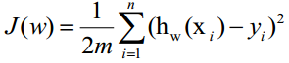

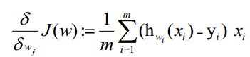

**（2）Linear Classification and Gradient Descent：**

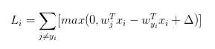

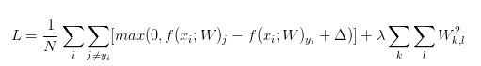

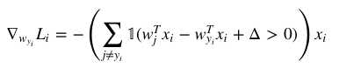

**The function of 1(x) is the indicator function. If x is true, it is equal to 1, and if x is false, the function is 0.**

**11. Experimental results and curve:**

## Hyper-parameter selection (η, epoch, etc.):

1. **Linear Regression and Gradient Descent:**

η=0.01

epoch=30

1. **Linear Classification and Gradient Descent：**

η=0.01

epoch=30

regularization_strengths = 1

## Assessment Results (based on selected validation):

**（1）Linear Regression and Gradient Descent:**

**（2）Linear Classification and Gradient Descent：**

## Predicted Results (Best Results):

**（1）Linear Regression and Gradient Descent: Gradient Descent**

**（2）Linear Classification and Gradient Descent：Gradient Descent**

## Loss curve:

1. **Linear Regression and Gradient Descent:**

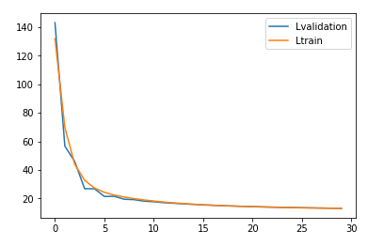

1. **Linear Classification and Gradient Descent：**

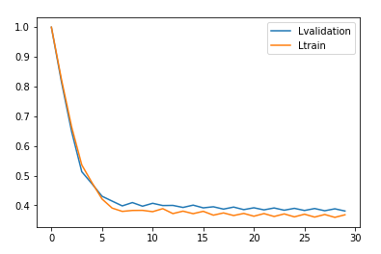

**12. Results analysis:**

**（1）The convergence is about the same.**

**（2）Linear Regression just started out with a big loss error while Linear Classification started out with a small loss.**

**13. Similarities and differences between linear regression and linear classification:**

**Linear Regression is on the basis of regression while Linear Classification is based on the classification.** **Their loss function is different.** **But the solution to the problem is similar.** **And then we can get a better solution in the end.**

**14. Summary:**

**Linear Regression is on the basis of regression while Linear Classification is based on the classification.** **Their loss function is different.** **But the solution to the problem is similar.** **Results are affected by parameters.And then we can get a better solution in the end.**