In my experiment on the Relax challenge data, I was tasked to find what features contribute to user adoption. An adopted user is defined as a user that has logged in to the service within a seven day span of time.

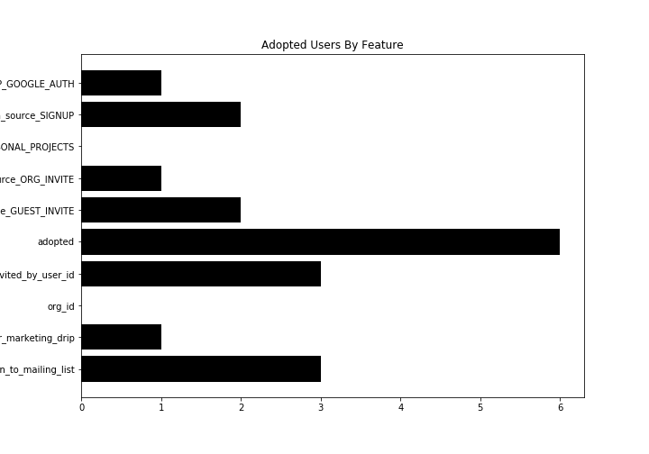
The data was in two separate sources, one with logged user activity and the other with user account information. The first job was to code in the adopted user column using the log in activity. Once completed, I merged the adopted column with the user data on the user ID. This allows us to tell who the adopted users are. With this information, we were able to count the adopted users by each feature. This revealed a feature to adoption value count seen in the bar chart below.

The process was cpu intensive, so I only spent the time to process 2500 observations. This revealed very few adopted users, six in total which can be fully counted in the “adopted” column of the bar chart. Of these features, the email marketing drip and invited by user features create the most adopted users. In fact, 50% of the 6 adopted users are in one of these columns or both. It is also revealed that personal projects and organizations reveal no adopted users, at least none in the small amount of data that was processed here.

This data set contains over 20,000 observations. Which is a start, but will take some time to process using these methods here. From here, we should work on performance enhancements to process more data. Once the range in change of values begins to steady, begin pilot programs to increase user activity in the features that have the highest adoption rate.

