

CHAITANYA BHARATHI INSTITUTE OF TECHNOLOGY
(AUTONOMOUS)

DEPARTMENT OF ARTIFICIAL INTELLIGENCE AND DATA SCIENCE

CampusPulse – Student Engagement & Dropout Risk Analytics
Student Outcome Prediction and Explainability Using R

Case Study Report submitted in partial fulfillment of the Requirements for the Award of
the Degree of
BACHELOR OF ENGINEERING
in
ARTIFICIAL INTELLIGENCE AND DATA SCIENCE
By
Kaleru Sriniketh
160124771041
Under the Mentorship of
Mrs. P. Greeshma

DEPARTMENT OF ARTIFICIAL INTELLIGENCE AND DATA SCIENCE
CHAITANYA BHARATHI INSTITUTE OF TECHNOLOGY
HYDERABAD – 500075
October 2026

CHAITANYA BHARATHI INSTITUTE OF TECHNOLOGY
(AUTONOMOUS)
DEPARTMENT OF ARTIFICIAL INTELLIGENCE AND DATA SCIENCE
CERTIFICATE
This is to certify that the course case study report entitled “CampusPulse – Student Engagement & Dropout Risk Analytics” is being submitted by
Kaleru Sriniketh 160124771041
in partial fulfillment for the award of the Degree of Bachelor of Engineering in Artificial Intelligence and Data Science to the Chaitanya Bharathi Institute of Technology, Hyderabad, carried out under my mentorship and supervision during the academic year 2026–27.
The results presented in this case study report have not been submitted to any other university or institute for the award of any degree.

Mrs. P. Greeshma
Assistant Professor

CampusPulse – Student Engagement & Dropout Risk Analytics
Student Outcome Prediction and Explainability Using R

1. Introduction and Problem Statement
Student continuation and academic success are important concerns for higher education institutions. Students may discontinue their studies or remain enrolled without completing their programmes within the observed period. Identifying patterns associated with these outcomes can help institutions understand student engagement and plan timely academic support.
CampusPulse is a data-driven case study developed in R using student academic, demographic, application and financial information. It analyses the factors associated with three observed outcomes—Dropout, Enrolled and Graduate—and compares classification models under two prediction scenarios. The project also uses feature importance and LIME to make model behaviour easier to interpret.
The project is intended as an analytical decision-support exercise. Its predictions should not be treated as definitive judgements about individual students or as a substitute for human review.

2. Objectives
- Explore the student dataset and describe the distribution of the three outcome categories.
- Prepare and clean the dataset for supervised classification.
- Compare Multinomial Logistic Regression and Random Forest models.
- Evaluate admission-time prediction (Scenario A) against prediction using first-semester information (Scenario B).
- Assess performance using accuracy, macro-precision, macro-recall, macro-F1 and confusion matrices.
- Interpret model behaviour using Random Forest feature importance and LIME.

3. Dataset
The study uses the UCI Machine Learning Repository dataset titled “Predict Students' Dropout and Academic Success” (Dataset ID 697). The dataset contains 4,424 student records and 37 columns, comprising 36 predictor variables and one target variable.
Attribute | Description
Dataset | Predict Students' Dropout and Academic Success
Source | UCI Machine Learning Repository, Dataset ID 697
Records | 4,424 students
Columns | 37 (36 predictors and 1 target)
Target | Dropout, Enrolled, Graduate
Missing values | 0 in the dataset used for this study
Dataset DOI | 10.24432/C5MC89

The outcome distribution is shown below. Graduate is the largest category, followed by Dropout and Enrolled.
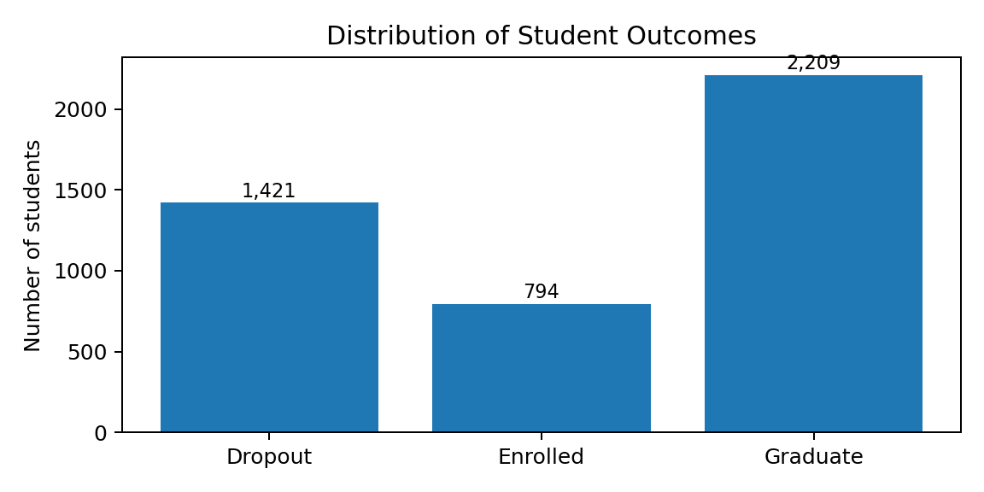
Figure 1. Distribution of student outcomes in the dataset.

4. Data Preparation
The original comma-separated dataset was imported into R. Column names were standardised using janitor::clean_names() to make them consistent and easier to reference in code. The target variable was retained as a three-class outcome. The dataset used in the analysis contained no missing values.
Step | Description
Data import | Read the UCI CSV dataset using comma separation.
Column names | Standardised using clean_names().
Missing-value check | Checked all columns; no missing values were found.
Target | Dropout, Enrolled and Graduate.
Scenario A | Admission-time and background predictors; first- and second-semester performance excluded.
Scenario B | Scenario A predictors plus first-semester academic performance.
Data split | Stratified training/test split; same split logic and seed used for comparison.

Two prediction scenarios were created to examine how the availability of early academic performance changes predictive performance. Second-semester variables were excluded from both scenarios to avoid using later information in the prediction exercise.
students <- read.csv(dataset_url, stringsAsFactors = FALSE)
students <- janitor::clean_names(students)
students$target <- factor(students$target)

5. Exploratory and Statistical Analysis

5.1 Outcome distribution
Outcome | Number of students | Percentage
Dropout | 1,421 | 32.12%
Enrolled | 794 | 17.95%
Graduate | 2,209 | 49.91%
Total | 4,424 | 100.00%

5.2 Summary of selected variables
The following values are the observed group averages calculated during exploratory analysis.
Outcome | Average age at enrolment | Average admission grade | Average first-semester grade
Dropout | 26.1 | 125.0 | 7.26
Enrolled | 22.4 | 126.0 | 11.1
Graduate | 21.8 | 129.0 | 12.6

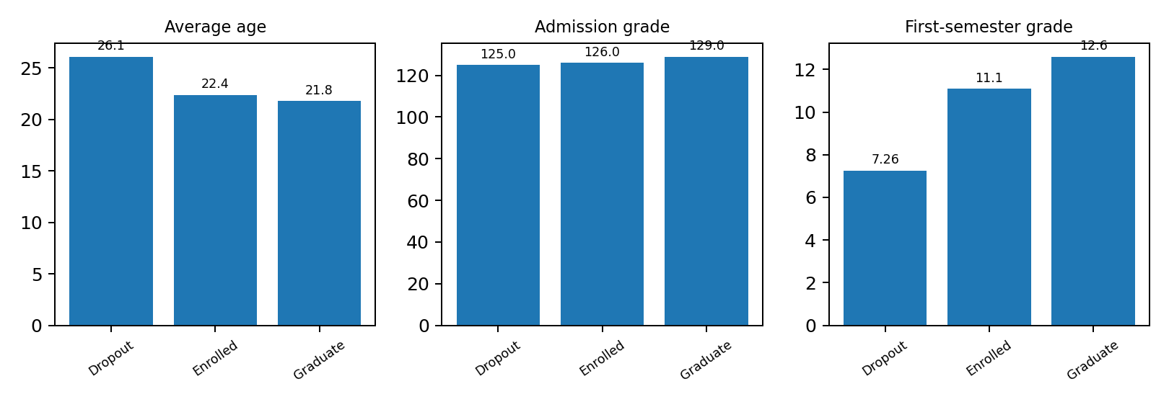
Figure 2. Average age, admission grade and first-semester grade by student outcome.
In this dataset, the Dropout group has the highest average age at enrolment and the lowest average first-semester grade among the three groups. The Graduate group has the highest average admission grade and first-semester grade. These are descriptive associations and do not establish causal relationships.

6. Visualization
Visualizations were generated using R plotting libraries to communicate the outcome distribution, selected group averages, model performance and feature importance. Figures 1 and 2 present the dataset-level patterns. The model comparison and feature-importance visualizations are presented in the Results section to keep each figure close to its interpretation.

7. Prediction Models

7.1 Prediction scenarios
Scenario | Information available to the model | Purpose
Scenario A | Admission-time/background information | Estimate outcome without first-semester performance.
Scenario B | Scenario A information plus first-semester academic variables | Estimate outcome after early academic performance becomes available.

7.2 Algorithms
Two classification algorithms were compared in both scenarios:
- Multinomial Logistic Regression: a statistical classification model used to estimate probabilities across the three outcome categories.
- Random Forest: an ensemble learning method that combines multiple decision trees to model potentially non-linear relationships.
A consistent train/test evaluation approach was used for the four model runs. Performance was assessed on the held-out test data using accuracy and macro-averaged precision, recall and F1-score. Macro-averaging gives each outcome class equal weight in the overall metric.

8. Results

8.1 Model performance comparison
Scenario | Model | Accuracy | Macro Precision | Macro Recall | Macro F1
A | Multinomial Logistic Regression | 64.21% | 56.08% | 53.59% | 53.25%
A | Random Forest | 65.80% | 59.25% | 54.24% | 52.95%
B | Multinomial Logistic Regression | 73.61% | 65.52% | 63.92% | 63.84%
B | Random Forest | 74.97% | 68.72% | 64.13% | 63.90%

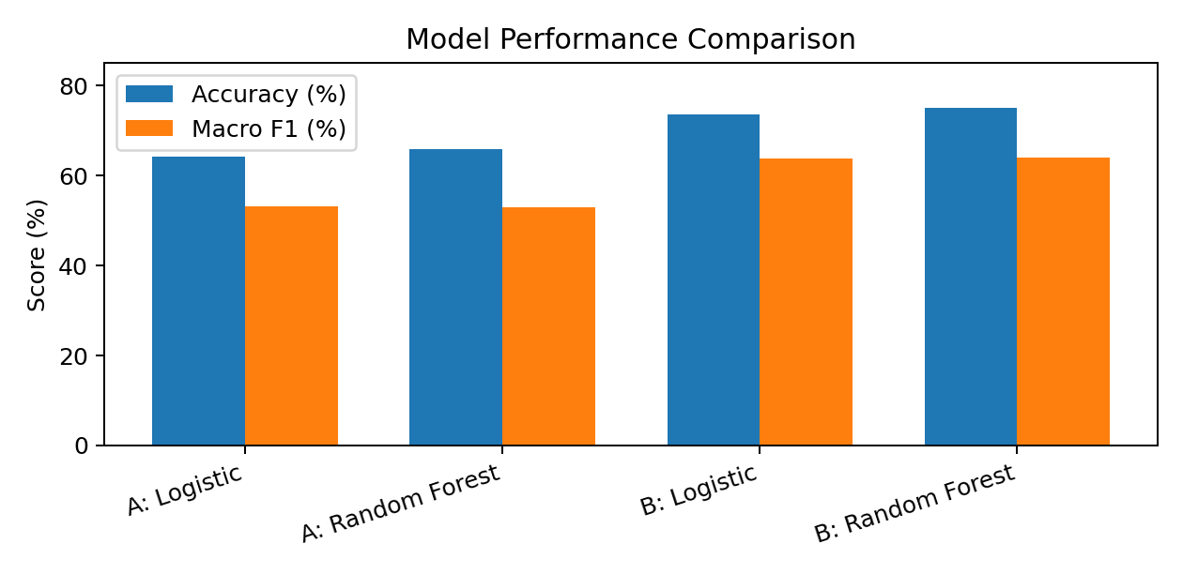
Figure 3. Accuracy and macro-F1 comparison across the four model configurations.
Scenario B Random Forest achieved the highest accuracy (74.97%) and the highest macro-F1 score (63.90%) among the evaluated configurations. Adding first-semester information improved accuracy by 9.17 percentage points for Random Forest and 9.40 percentage points for Multinomial Logistic Regression. The macro-F1 scores indicate that class-wise performance remains more challenging than the overall accuracy alone may suggest.

8.2 Class-wise evaluation
The Scenario B Random Forest confusion matrix is shown below. Rows represent predicted classes and columns represent actual reference classes.
Predicted \ Actual | Dropout | Enrolled | Graduate
Dropout | 227 | 52 | 27
Enrolled | 16 | 34 | 13
Graduate | 41 | 72 | 401

Class | Recall
Dropout | 79.93%
Enrolled | 21.52%
Graduate | 90.93%

The model identifies Graduate and Dropout cases more effectively than Enrolled cases. Enrolled recall is 21.52%, indicating that many actual Enrolled records are assigned to another predicted category. This is an important limitation and shows why class-wise evaluation is necessary.

8.3 Feature importance
Random Forest feature importance for Scenario B ranked first-semester approved curricular units highest, followed by first-semester grade, course, father's occupation and tuition-fee status.
Rank | Feature | Importance
1 | curricular_units_1st_sem_approved | 337.54
2 | curricular_units_1st_sem_grade | 219.15
3 | course | 162.96
4 | father_s_occupation | 130.39
5 | tuition_fees_up_to_date | 111.06

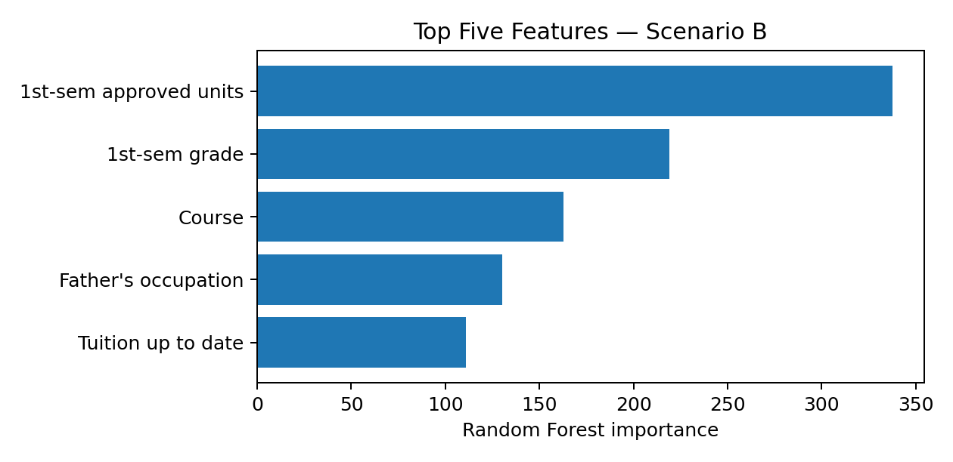
Figure 4. Top five Random Forest features in Scenario B.
The importance results indicate that first-semester academic variables are strongly used by the Scenario B model. Feature importance describes predictive contribution within this fitted model; it does not demonstrate that a feature causes a student outcome.

8.4 LIME explanation
LIME was applied to one individual prediction from the Scenario B Random Forest model. The model predicted Dropout with a model score of approximately 86.16% for the selected case.
Feature | LIME weight | Direction for Dropout prediction
tuition_fees_up_to_date | 0.2567 | Supports
curricular_units_1st_sem_approved | 0.2055 | Supports
nacionality | -0.0975 | Opposes
curricular_units_1st_sem_grade | 0.1080 | Supports
scholarship_holder | 0.0662 | Supports
debtor | -0.0490 | Opposes
international | -0.0430 | Opposes
educational_special_needs | -0.0285 | Opposes

For this individual case, the absence of approved first-semester curricular units and the tuition-fee status were among the strongest contributions supporting the Dropout prediction. Negative weights contributed in the opposite direction. Binary values in the explanation are encoded values; their natural-language meaning depends on the dataset's coding. The 86.16% score is a model output for this case, not a guarantee of the student's future outcome.

9. Conclusion
CampusPulse demonstrates an end-to-end student outcome classification workflow using R, beginning with dataset preparation and exploratory analysis and continuing through model comparison and explainability. The study used 4,424 records from the UCI student dropout and academic success dataset and compared Multinomial Logistic Regression with Random Forest under two prediction scenarios.
Scenario B, which includes first-semester academic information, produced the strongest overall results. The Scenario B Random Forest achieved 74.97% accuracy and a macro-F1 score of 63.90%. Its class-wise recall was 79.93% for Dropout, 21.52% for Enrolled and 90.93% for Graduate. First-semester approved curricular units and first-semester grade were the leading features in the Scenario B Random Forest importance ranking. LIME provided a local explanation for one selected prediction.

Limitations
- The Enrolled category is difficult for the selected models to identify; its recall is substantially lower than the recall for Dropout and Graduate.
- The reported results are based on one train/test evaluation and may vary with a different split or external dataset.
- Feature importance and LIME explanations describe model behaviour, not causal effects.
- The LIME explanation concerns one selected test record and should not be generalised to all students.
- The model should be treated as a decision-support aid and not as an automated basis for high-impact decisions about students.

Future Work
- Investigate methods to improve recognition of the Enrolled class, including class weighting and resampling.
- Evaluate the models using repeated cross-validation and, where possible, an external institutional dataset.
- Test calibration and threshold-based approaches suited to early student-support workflows.
- Validate explanations with academic advisors and domain experts before operational use.

10. References
[1] UCI Machine Learning Repository. Predict Students' Dropout and Academic Success. Dataset ID 697. https://archive.ics.uci.edu/dataset/697/predict+students+dropout+and+academic+success
[2] Realinho, V., Machado, J., Baptista, L. and Martins, M. V. (2022). Predicting student dropout and academic success. Data, 7(11), 146. https://doi.org/10.3390/data7110146
[3] R Core Team. R: A Language and Environment for Statistical Computing. https://www.R-project.org/
[4] Liaw, A. and Wiener, M. (2002). Classification and Regression by randomForest. R News, 2(3), 18–22.
[5] Kuhn, M. (2008). Building Predictive Models in R Using the caret Package. Journal of Statistical Software, 28(5).
[6] Ribeiro, M. T., Singh, S. and Guestrin, C. (2016). “Why Should I Trust You?” Explaining the Predictions of Any Classifier. Proceedings of the 22nd ACM SIGKDD International Conference on Knowledge Discovery and Data Mining.
[7] Wickham, H. et al. (2019). Welcome to the tidyverse. Journal of Open Source Software, 4(43), 1686.

