*The orientation of the body frame with respect to the reference frame is given by satellite's attitude.*

*This orientation is represented by a proper orthogonal matrix called as rotation matrix or attitude matrix.*

**COURSE I:**

**1. Performed Attitude Method:**

+ A minimum of three coordinates is required to describe the relative angular displacement between two reference frames.

$$⇒coordinates=degree of freedom+constrants$$

|  |  |  |  |  |  |
| --- | --- | --- | --- | --- | --- |
| Parameter-  ization | Dimen-sion | Attitude Matrix | Kinematic Equations | Singularities | Constraints |
| DCM $$C=\left[C_{ij}\right]$$ | 9 | $$C=\left[C_{ij}\right]$$ | $$\dot{C}=-\left[\tilde{ω}\right]C$$ | None | $$C^{T}C=I$$ |
| Euler Angles $$θ=(θ_{1},θ_{2},θ_{3})$$ | 3 | $$C=$$ $$\left[C(θ_{3})\right]\left[C(θ_{2})\right]\left[C(θ_{1})\right]$$ | $$\dot{θ}=\left[B(θ)\right]{}_{}^{B}ω$$ | Symmetric set: $$θ_{2}=0∨{180}^{o}$$ Asymmetrix set: $$θ_{2}=±{90}^{o}$$ | None |
| Quaternions $$β=$$ $${\left(β_{0},β_{1},β_{2},β_{3}\right)}^{T}$$ | 4 |  | $$\dot{β}=\frac{1}{2}\left[B(β)\right]\left[\begin{matrix}0 \\ ω\end{matrix}\right]$$ | None | $$β^{T}β=1$$ |
| CRP $$q={\left(q_{1},q_{2},q_{3}\right)}^{T}$$ | 3 | $$\left[C\right]=\frac{1}{1+q^{T}q}$$ $\left(\left(1-q^{T}q\right)\left[I_{3×3}\right]-2\left[\tilde{q}\right]+2qq^{T}\right)$ | $$\dot{q}=$$ $$\frac{1}{2}\left[\left[I_{3×3}\right]+\left[\tilde{q}\right]+qq^{T}\right]{}_{}^{B}ω$$ | $$Φ=±{180}^{o}$$ | None |
| MRP $$σ={\left(σ_{1},σ_{2},σ_{3}\right)}^{T}$$ | 3 | $$\left[C\right]=\left[I_{3×3}\right]+$$ $$\frac{8\left[\tilde{σ}\right]-4\left(1-σ^{2}\right)\left[\tilde{σ}\right]}{{\left(1+σ^{2}\right)}^{2}}$$ | $$\dot{σ}=$$ $$\frac{1}{4}\left[\left(1-σ^{2}\right)\left[I_{3×3}\right]+2\left[\tilde{σ}\right] +2σσ^{T}\right]{}_{}^{B}ω$$ | $$Φ=±{360}^{o}$$ | None |

**2. Attitude Determination:**

+ It needs a minimum of two observation vectors to determine the three dimensional orientation.

* *TRIAD Method:*

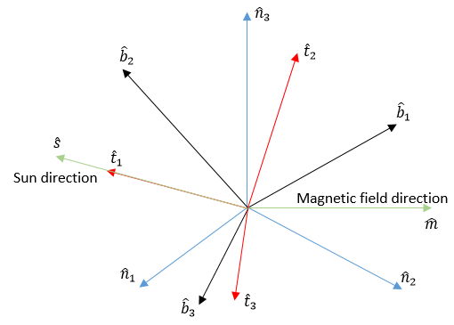

+ Input: 2 direction vectors (Sun, Earth, Magnetic field direction, Stars, Moon, …).

+ Output: DCM $\left[BN\right]$ from Inertial frame to Body fixed frame.

+ Advantage: Easy to operate and calculate.

+ Disadvantage: Exist case that is 2 vectors parallel each other.

* *Wahba’s Problem:*

+ Evaluate the measurements by loss function:

$$J\left(\left[\overline{B}N\right]\right)=\frac{1}{2}\sum_{k=1}^{N}{ω_{k}{\left|{}_{}^{B}{{\hat{v}}_{k}-\left[\overline{B}N\right]{}_{}^{N}{{\hat{v}}_{k}}}\right|}^{2}}$$

* *Devenport’s q-Method:*

+ Input: 2 direction vectors (Sun, Earth, Magnetic field direction, Stars, Moon, …).

+ Output: A quaternions is eigenvector corresponding the largest eigenvalue of ${\left[K\right]}_{4×4}$ matrix.

+ Advantage: Minimize the loss function J.

+ Disadvantage: Hard to find eigenvalues and eigenvector of $R^{4×4}$ matrix.

* *QUEST Method:*

+ Input: 2 direction vectors (Sun, Earth, Magnetic field direction, Stars, Moon, …).

+ Output: A CRP vector $q$ corresponding the optimal eigenvalue of ${\left[K\right]}_{4×4}$ matrix.

+ Advantage:

* It uses a classic Newton-Raphson to find optimal eigenvalue. This allows us to avoid the numerically intensive eigenvalue problem.
* It introduces CRP vector that is easier to calculate a $R^{3×3}$ matrix.

+ Disadvantage: optimal eigenvalue is a approximate value, therefore accuracy of measurements is lower than q-Method.