CIS 21031 – PRACTICAL FOR PLATFORM TECHNOLOGIES DEPARTMENT OF ICT
FACULTY OF TECHNOLOGY
SOUTH EASTERN UNIVERSITY

Continuous Assessment-02
Index No :- SEU/IS/20/ICT/084

Question 1
#!/bin/bash
addition() {
echo "$((num1 + num2))"
}
subtraction() {
echo "$((num1 - num2))"
}
multiplication() {
echo "$((num1 * num2))"
}
division() {
if [ $num2 -ne 0 ]; then
echo "$((num1 / num2))"
else
echo "Error: Division by zero!"
fi
}
modulus() {
if [ $num2 -ne 0 ]; then
echo "$((num1 % num2))"
else
echo "Error: Modulus by zero!"
fi
}
echo "Welcome to Simple Calculator"
read -p "Enter the first number: " num1
read -p "Enter the second number(Your registration number last 02 Digits): " num2
echo "Choose an operation:"
echo "a. Addition"
echo "b. Subtraction"
echo "c. Multiplication"
echo "d. Division"
echo "e. Modulus"
read -p "Enter your choice (a-e): " choice
case $choice in
a) result=$(addition);;
b) result=$(subtraction);;
c) result=$(multiplication);;
d) result=$(division);;
e) result=$(modulus);;
*) echo "Invalid choice"; exit 1;;
esac
echo "Result: $result"

Output:
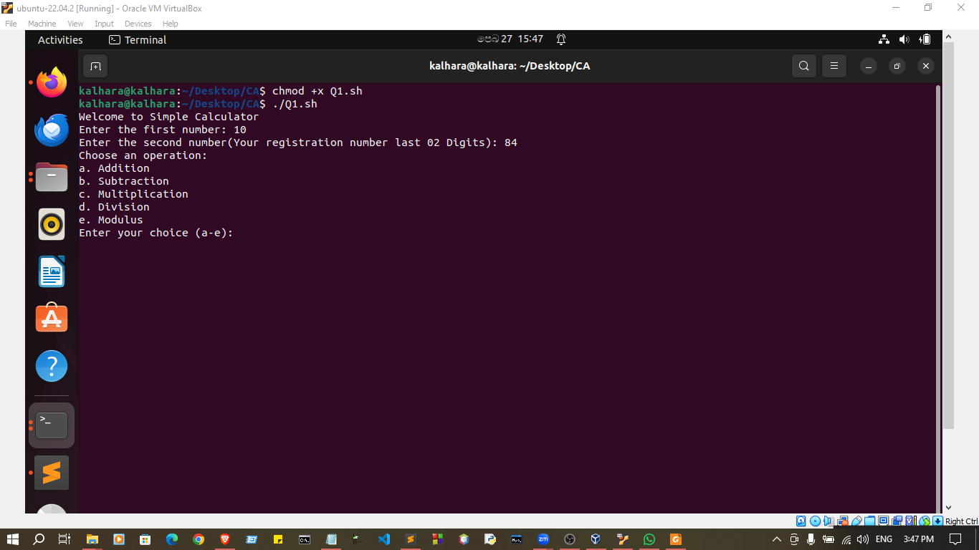

Question 2
#!/bin/bash
function recursiveFunction {
local num=$1
if [ $num -gt 10 ]; then
return
fi
echo $num
num=$((num + 1))
recursiveFunction $num
}
function fibonacci {
local num=$1
if [ $num -le 1 ]; then
echo $num
else
echo $(( $(fibonacci $(($num - 1))) + $(fibonacci $(($num - 2))) ))
fi
}
echo "Counting numbers until 10:"
recursiveFunction 1
echo "Fibonacci Sequence of 10 numbers:"
for ((i=0; i<10; i++)); do
echo -n "$(fibonacci $i) "
done
echo

Output:
