Lab Sheet 07
Title: Aggregation pipeline operators in MongoDB II.
Objective:
• Understanding the Components and Accumulator.
Aggregation Pipeline
The aggregation pipeline consists of stages and each stage transforms the document.
The aggregate () function is used to perform aggregation it can have three operator’s stages, expression and accumulator.
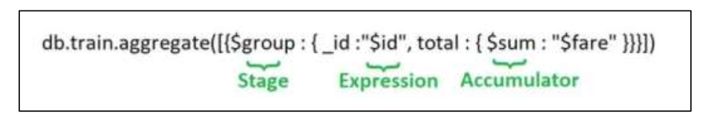
Components of Aggregation Pipeline
- Stages (Operators)

Each stage begins with a MongoDB operator (starts with $) and performs operations like filtering, grouping, sorting, etc.

Stage Operator | Description
$match | Filters documents (like SQL WHERE)
$project | Selects specific fields
$group | Groups documents and can use accumulators
$sort | Sorts documents (ascending or descending)
$skip | Skips n documents
$limit | Limits to n documents
$unwind | Breaks down arrays into individual documents
$out | Writes output to another collection

- Expressions
These refer to field names from documents.
{ $group: { _id: "$section", total: { $sum: 1 } } }

- Accumulators

Used within $group to perform calculations.
 | Accumulator | Description
$sum |  | Adds numeric values
$count |  | Counts documents
$avg |  | Averages values
$min |  | Minimum value
$max |  | Maximum value
$first |  | First value in group
$last |  | Last value in group

Collection: orders

Database: ecommerceDB 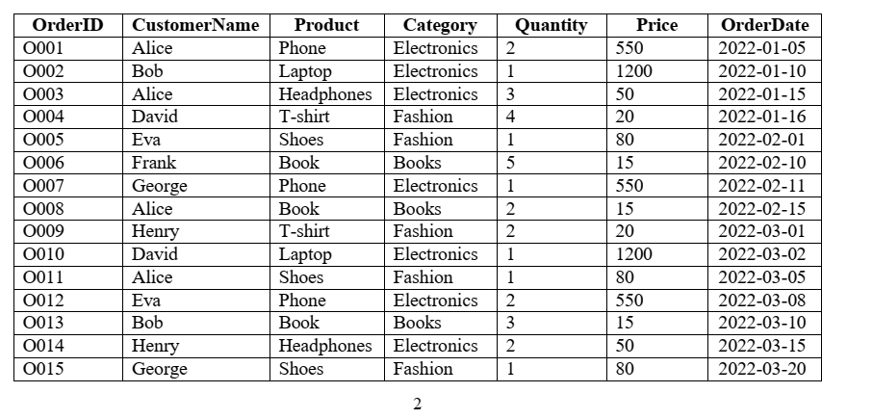
//Create & Use Database
use ecommerceDB

//Create Collection
db.createCollection("orders")

//Insert Data into orders
db.orders.insertMany([
{ OrderID: "O001", CustomerName: "Alice", Product: "Phone", Category: "Electronics", Quantity: 2, Price: 550, OrderDate: ISODate("2022-01-05") },
{ OrderID: "O002", CustomerName: "Bob", Product: "Laptop", Category: "Electronics", Quantity: 1, Price: 1200, OrderDate: ISODate("2022-01-10") },
{ OrderID: "O003", CustomerName: "Alice", Product: "Headphones", Category: "Electronics", Quantity: 3, Price: 50, OrderDate: ISODate("2022-01-15") },
{ OrderID: "O004", CustomerName: "David", Product: "T-shirt", Category: "Fashion", Quantity: 4, Price: 20, OrderDate: ISODate("2022-01-16") },
{ OrderID: "O005", CustomerName: "Eva", Product: "Shoes", Category: "Fashion", Quantity: 1, Price: 80, OrderDate: ISODate("2022-02-01") },
{ OrderID: "O006", CustomerName: "Frank", Product: "Book", Category: "Books", Quantity: 5, Price: 15, OrderDate: ISODate("2022-02-10") },
{ OrderID: "O007", CustomerName: "George", Product: "Phone", Category: "Electronics", Quantity: 1, Price: 550, OrderDate: ISODate("2022-02-11") },
{ OrderID: "O008", CustomerName: "Alice", Product: "Book", Category: "Books", Quantity: 2, Price: 15, OrderDate: ISODate("2022-02-15") },
{ OrderID: "O009", CustomerName: "Henry", Product: "T-shirt", Category: "Fashion", Quantity: 2, Price: 20, OrderDate: ISODate("2022-03-01") },
{ OrderID: "O010", CustomerName: "David", Product: "Laptop", Category: "Electronics", Quantity: 1, Price: 1200, OrderDate: ISODate("2022-03-02") },
{ OrderID: "O011", CustomerName: "Alice", Product: "Shoes", Category: "Fashion", Quantity: 1, Price: 80, OrderDate: ISODate("2022-03-05") },
{ OrderID: "O012", CustomerName: "Eva", Product: "Phone", Category: "Electronics", Quantity: 2, Price: 550, OrderDate: ISODate("2022-03-08") },
{ OrderID: "O013", CustomerName: "Bob", Product: "Book", Category: "Books", Quantity: 3, Price: 15, OrderDate: ISODate("2022-03-10") },
{ OrderID: "O014", CustomerName: "Henry", Product: "Headphones", Category: "Electronics", Quantity: 2, Price: 50, OrderDate: ISODate("2022-03-15") },
{ OrderID: "O015", CustomerName: "George", Product: "Shoes", Category: "Fashion", Quantity: 1, Price: 80, OrderDate: ISODate("2022-03-20") }
])

1: Find all orders in the "Electronics" category
db.orders.aggregate([
{
$match: { Category: "Electronics" }
}
])

2: Calculate total revenue (Quantity × Price) from Electronics category
db.orders.aggregate([
{
$match: { Category: "Electronics" }
},
{
$group: {
_id: null,
totalRevenue: {
$sum: { $multiply: ["$Quantity", "$Price"] }
}
}
}
])

3: Group by Category and calculate total revenue per category
db.orders.aggregate([
{
$group: {
_id: "$Category",
totalRevenue: {
$sum: { $multiply: ["$Quantity", "$Price"] }
}
}
}
])

4: Sort categories by total revenue in descending order
db.orders.aggregate([
{
$group: {
_id: "$Category",
totalRevenue: {
$sum: { $multiply: ["$Quantity", "$Price"] }
}
}
},
{
$sort: { totalRevenue: -1 }
}
])

5: Find the highest quantity ordered for any product
db.orders.aggregate([
{
$group: {
_id: null,
maxQuantity: { $max: "$Quantity" }
}
}
])

6: Display total quantity of each product ordered by each customer
db.orders.aggregate([
{
$group: {
_id: {
customer: "$CustomerName",
product: "$Product"
},
totalQuantity: { $sum: "$Quantity" }
}
},
{
$sort: {
"_id.customer": 1,
"_id.product": 1
}
}
])

7: Find orders placed between 2022-02-01 and 2022-03-01
db.orders.aggregate([
{
$match: {
OrderDate: {
$gte: "2022-02-01",
$lte: "2022-03-01"
}
}
}
])

If stored as ISODate, use this:
db.orders.aggregate([
{
$match: {
OrderDate: {
$gte: ISODate("2022-02-01"),
$lte: ISODate("2022-03-01")
}
}
}
])
8: Unwind Product Categories if stored as array (hypothetical) (Assuming Category: ["Fashion", "Men"])
db.orders.aggregate([
{
$unwind: "$Category"
}
])

9: Write filtered data into a new collection
db.orders.aggregate([
{
$match: { Category: "Electronics" }
},
{
$out: "electronics_orders"
}
])

//Bonus (Optional – Good for Exams)
db.orders.aggregate([
{
$group: {
_id: "$Category",
avgPrice: { $avg: "$Price" }
}
}
])

