CIS41032 - PRACTICAL FOR ADVANCE DATABASE MANAGEMENT SYSTEM
CA 01
Date:2026/06/02
Reg.No:SEU/IS/20/ICT/084 Index.No:ICT461
01.
use HospitalDB

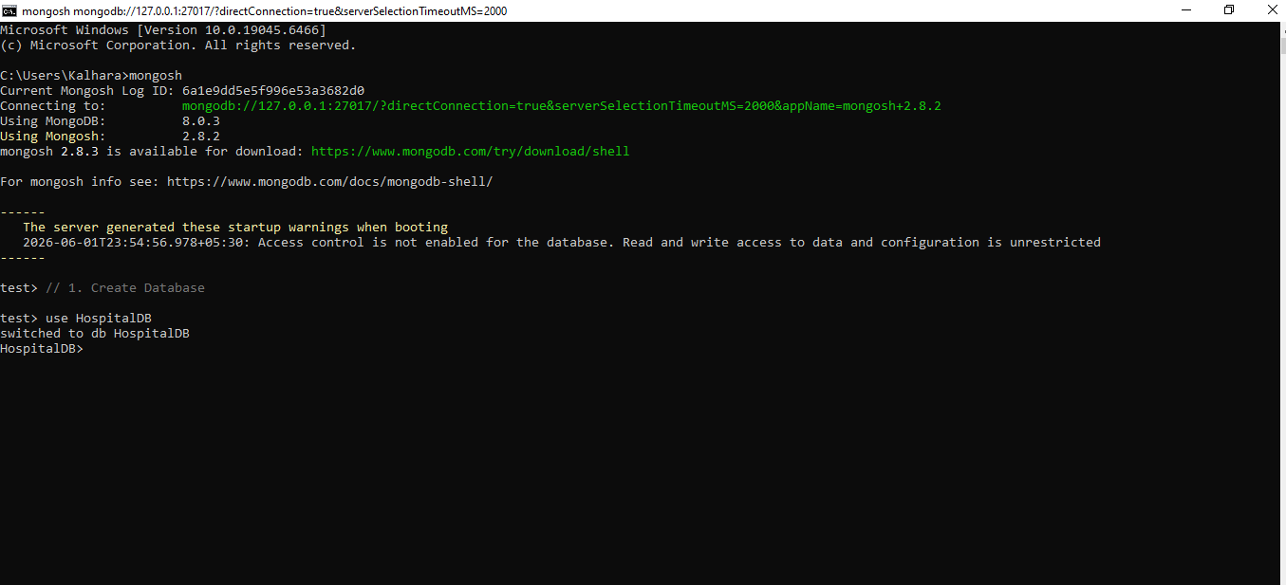

02.
db.patients.insertMany([
{patient_id:"P001",name:"Ravi Kumar",age:45,gender:"Male",disease:"Diabetes",ward:"A1",admission_date:"2023-09-12"},
{patient_id:"P002",name:"Saman Perera",age:30,gender:"Male",disease:"Fever",ward:"B2",admission_date:"2023-10-05"},
{patient_id:"P003",name:"Anjali Deva",age:28,gender:"Female",disease:"Dengue",ward:"A3",admission_date:"2023-11-01"},
{patient_id:"P004",name:"Kumara Silva",age:56,gender:"Male",disease:"Heart Disease",ward:"C1",admission_date:"2023-08-15"},
{patient_id:"P005",name:"Nadeesha Sen",age:35,gender:"Female",disease:"Asthma",ward:"A2",admission_date:"2023-12-18"},
{patient_id:"P006",name:"Ishara Wick",age:60,gender:"Female",disease:"Arthritis",ward:"D1",admission_date:"2024-01-10"},
{patient_id:"P007",name:"Akalanka Jay",age:40,gender:"Male",disease:"Hypertension",ward:"A3",admission_date:"2023-12-01"},
{patient_id:"P008",name:"Ruwani Lak",age:32,gender:"Female",disease:"Diabetes",ward:"B1",admission_date:"2023-07-20"},
{patient_id:"P009",name:"Mahesh Mad",age:25,gender:"Male",disease:"Fracture",ward:"C2",admission_date:"2023-09-08"},
{patient_id:"P010",name:"Dinuli Thar",age:29,gender:"Female",disease:"Migraine",ward:"A1",admission_date:"2023-11-22"},
{patient_id:"P011",name:"Suresh Band",age:38,gender:"Male",disease:"Fever",ward:"B2",admission_date:"2023-09-30"},
{patient_id:"P012",name:"Chathura Ga",age:47,gender:"Male",disease:"Diabetes",ward:"A2",admission_date:"2023-10-18"},
{patient_id:"P013",name:"Nimali Thil",age:34,gender:"Female",disease:"Asthma",ward:"A2",admission_date:"2024-01-01"},
{patient_id:"P014",name:"Thilina Jay",age:31,gender:"Male",disease:"Dengue",ward:"B3",admission_date:"2023-11-15"},
{patient_id:"P015",name:"Malee Perer",age:50,gender:"Female",disease:"Heart Disease",ward:"C1",admission_date:"2023-09-25"}
])

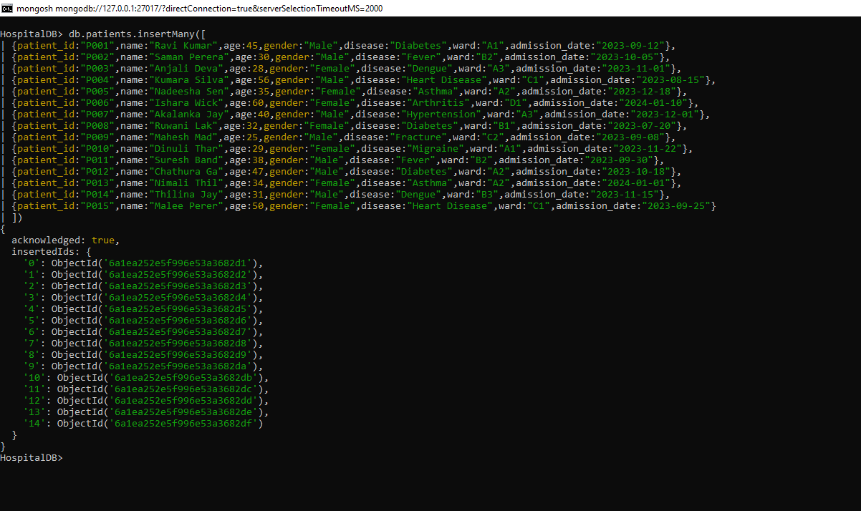

03.
db.patients.insertOne({
patient_id:"P016",
name:"Kavindi Nirosh",
age:37,
gender:"Female",
disease:"Fracture",
ward:"C2",
admission_date:"2024-02-14"
})

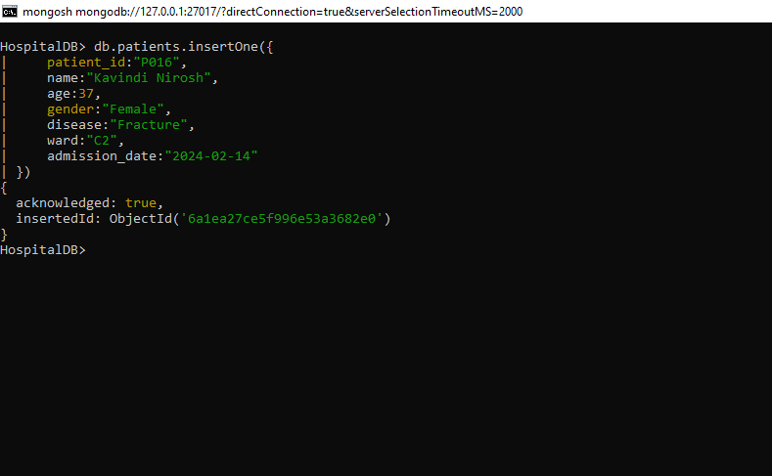

04.
db.patients.find({ward:"A2"})

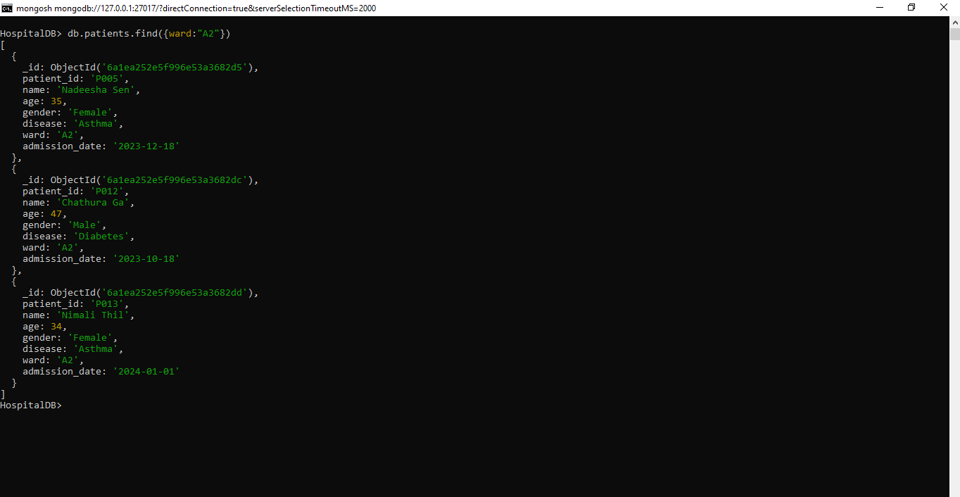
05.
db.patients.find({disease:"Diabetes"})

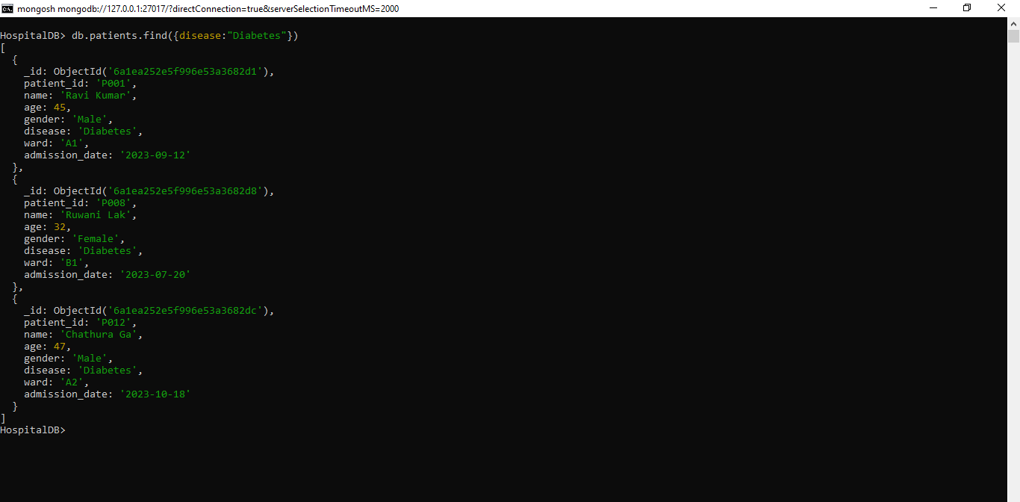

06.
db.patients.find({gender:"Female"},{name:1,disease:1,_id:0})

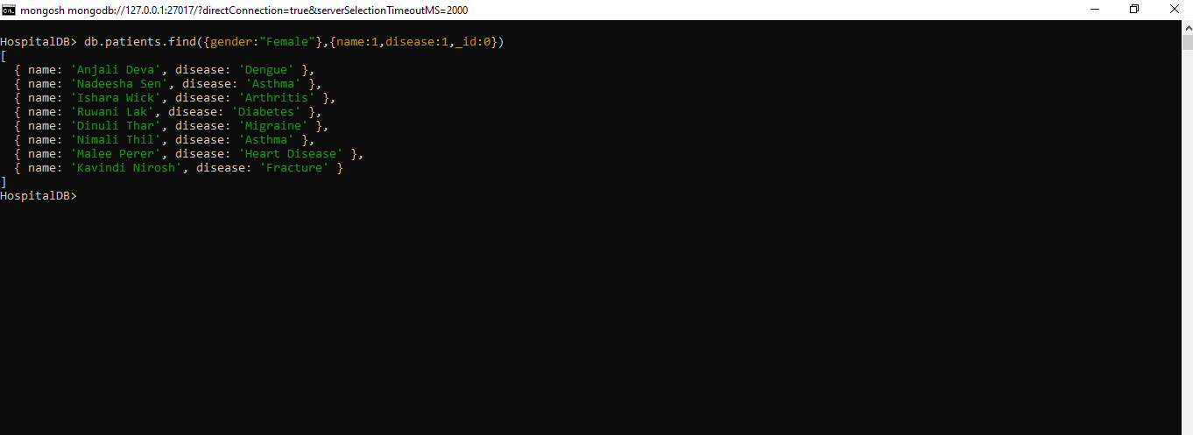
07.
db.patients.find({admission_date:{$gt:"2023-11-01"}})

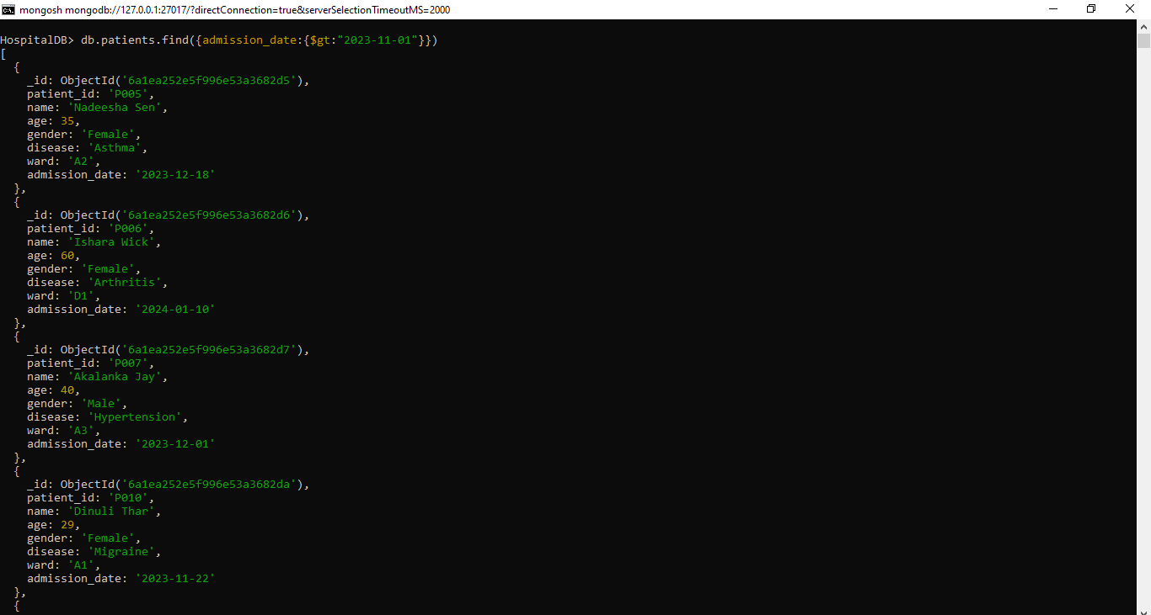

08.
db.patients.find().sort({age:-1})

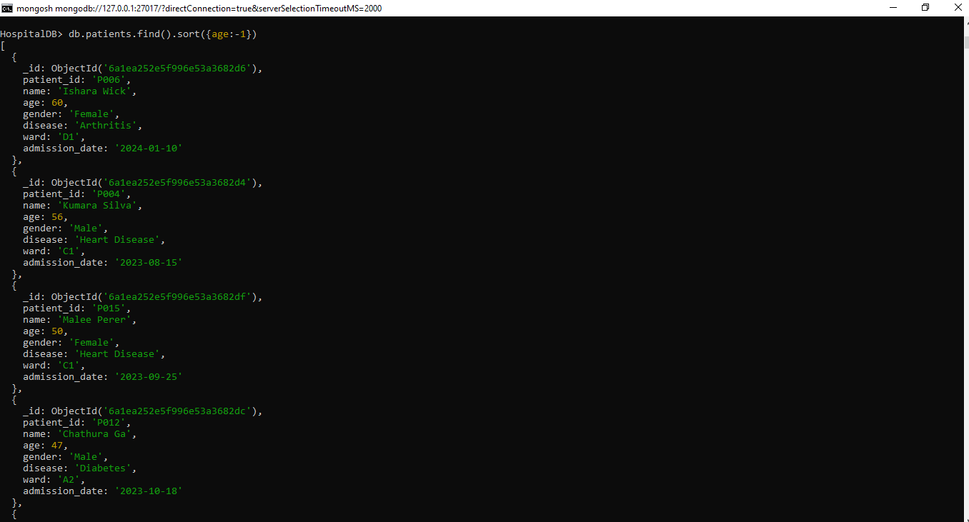
09.
db.patients.find({gender:"Male",age:{$lt:40}})
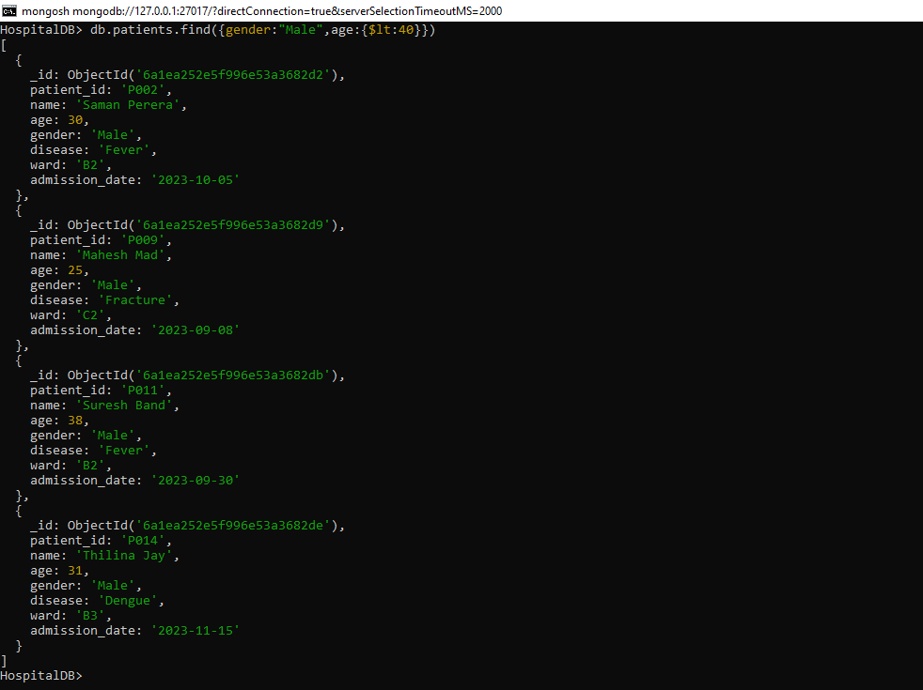

10.
db.patients.updateOne({patient_id:"P003"},{$set:{ward:"B1"}})

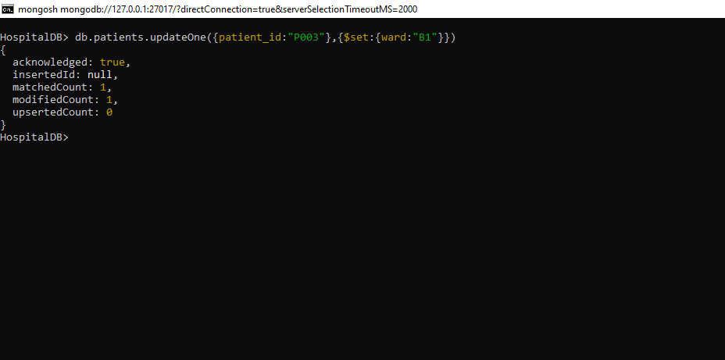
11.
db.patients.updateOne({patient_id:"P002"},{$set:{disease:"Viral Fever"}})

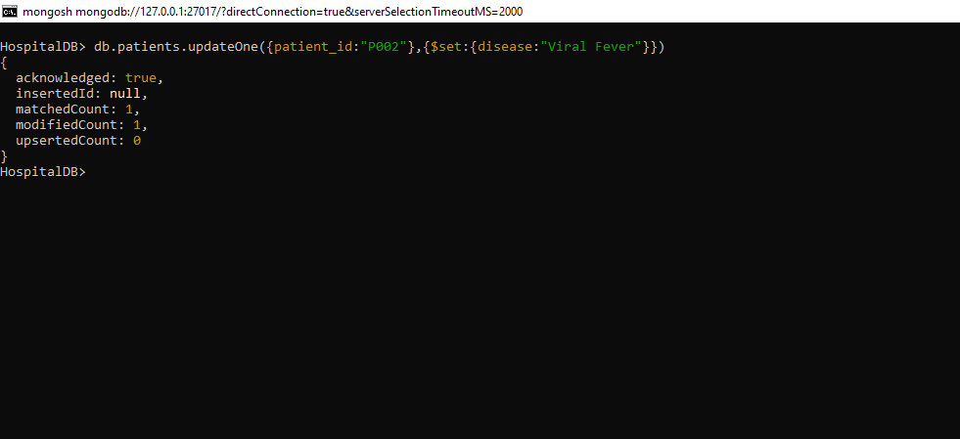

12.
db.patients.updateMany({admission_date:{$lt:"2023-09-01"}},{$set:{status:"Discharged"}})

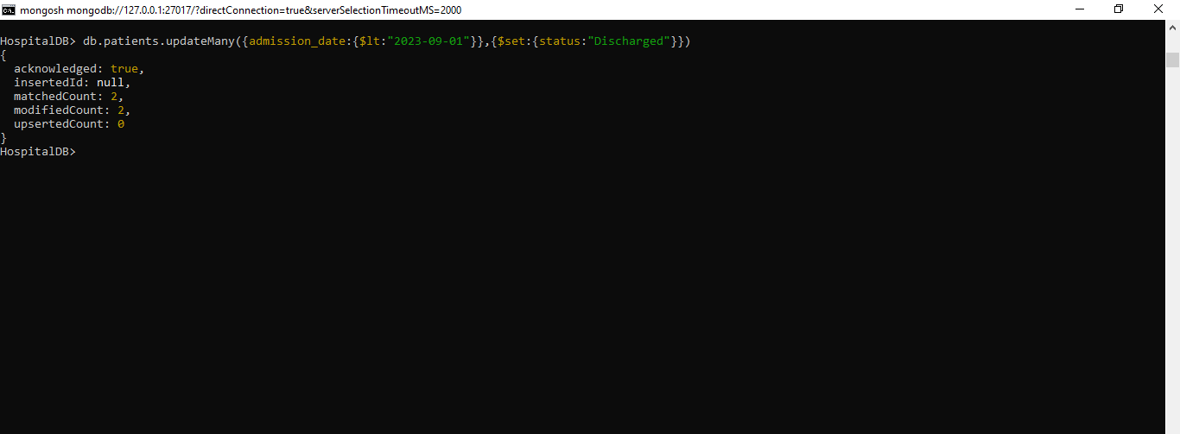

13.
db.patients.updateMany({disease:"Heart Disease"},{$set:{status:"Critical"}})

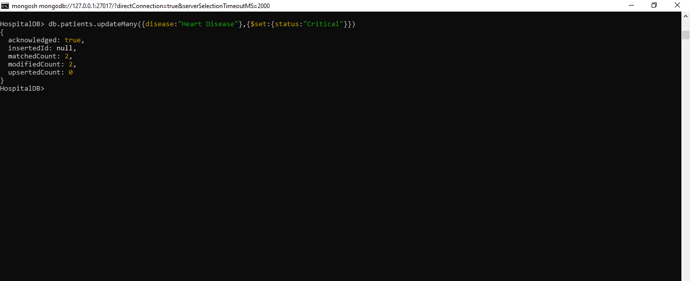

View All Records
db.patients.find().pretty()

