SWT 22022-Practical for Internet Application Development
Department of Information and Communication Technology
Faculty of Technology
Lab sheet
Reg. Number: SEU/IS/20/ICT/084
Academic Year :2020/2021

Title:
- Introduction to PHP ( Hypertext Preprocessor ).

Aims:
- Refresh the knowledge on basic of PHP with HTML.
- Understand the concepts of PHP.

Tasks:
- Configure PC
- Basic Syntax of PHP
- PHP Comments
- PHP variable
- PHP Data Types
- PHP Constant
Activities
1. Configure PC to work with Server-Side Programming (PHP).
I. Install XAMP server
• https://www.apachefriends.org/download.html
• Download an installer according to your operating system → Doubleclick the installer →Next → Next (Select the components)→Next(Select the location) →Next (Select Language ) → Next → Finish
II. Install Visual Studio Code
• https://code.visualstudio.com/download
• Download an installer according to your operating system → Doubleclick the installer → Accept the agreement → Next → Choose the location → Next →Next → Select additional tasks → Next → Install → Finish

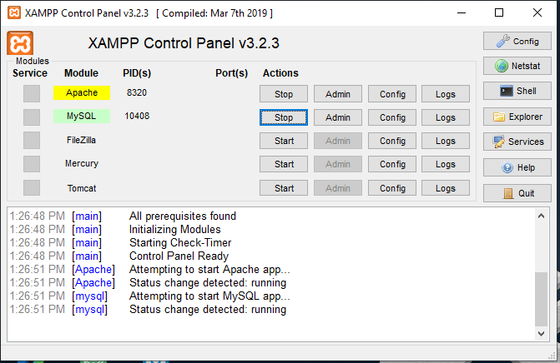

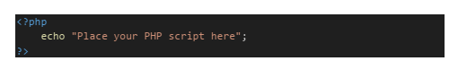
2. Basic Syntax of PHP

I. Create a new file and name it “name.php”.
II. Print your name only using echo function. III. Contain the script within html and run again.

name.php

<?php

echo "My Name is Kalhara";

?>

Output:

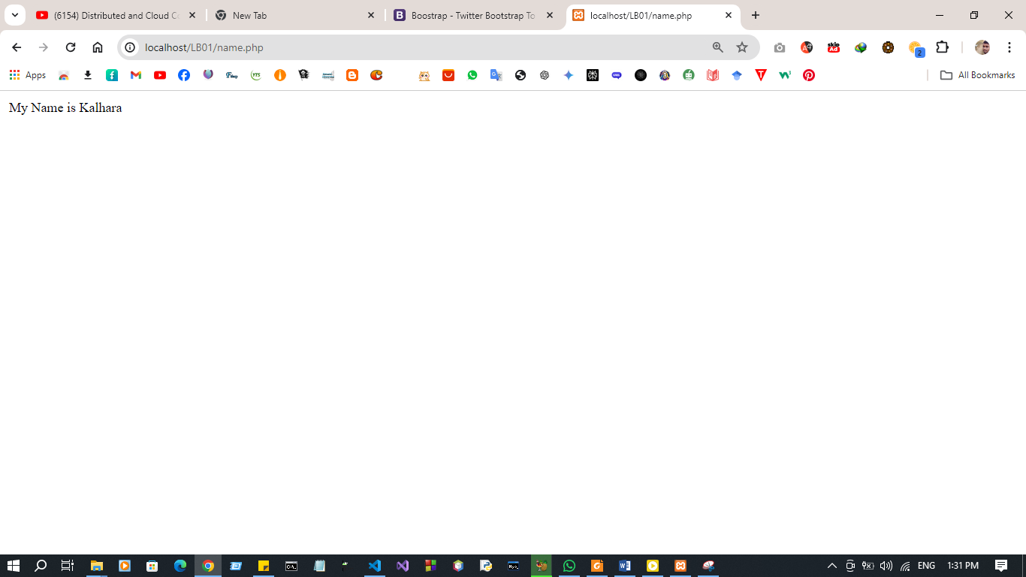
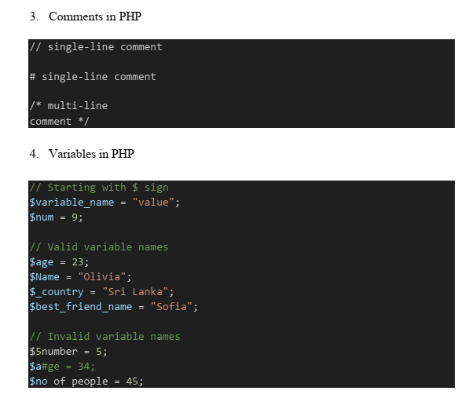

I. Create a new PHP file and name it “greeting.php”.
II. Define three variables to store your friend's name, age, and weight.
III. Display a greeting message to your friend. Ex:- "Hello, Olivia. Have a nice day!".
IV. Display your friend's age and weight on a new line.

greeting.php

<?php
$name="Olivia";
$age=25;
$weight=6.1;

echo "Hello ".$name.". Have a niceday!. <br>";
echo "oliva age is : ".$age."<br>";
echo "oliva weight is :".$weight."<br>";

?>

Output:

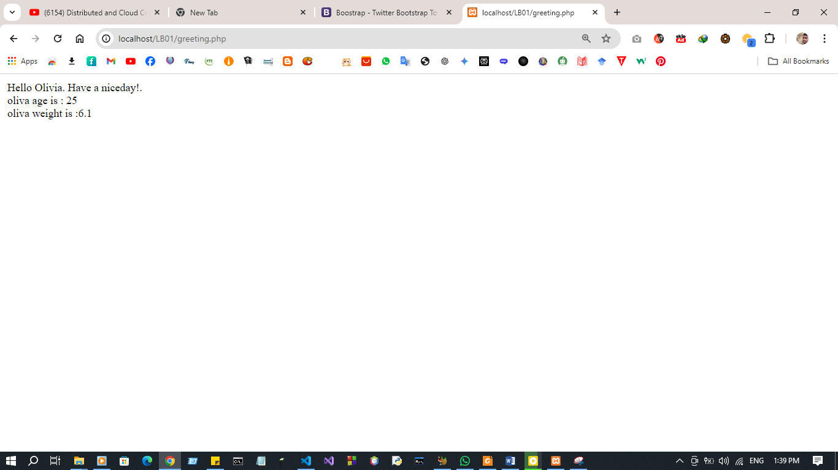

5. Data Types in PHP

// String
$name = "John Doe";
// Integer
$age = 30;
// Float (Double)
$temperature = 20.10;
// Boolean
$isActive = true;
$isValid = false;
// Array
$customers = [];
// NULL
$emptyValue = null;
// Object
//Resource

I. Create a new PHP file and name it “data_types.php”
II. Declare variables for customer name, product id, discount rate, is registered, shopping cart(empty array) , not found.
III. Display the data type of above variables using var_dump() function

data_types.php

<?php
$customer_name = "Pasan Kalhara";
$product_id = 001;
$discount_rate = 0.15;
$is_registered = true;
$shopping_cart = array();
$not_found = null;

var_dump($customer_name);
echo "<br>";
var_dump($product_id);
echo "<br>";
var_dump($discount_rate);
echo "<br>";
var_dump($is_registered);
echo "<br>";
var_dump($shopping_cart);
echo "<br>";
var_dump($not_found);

?>

Output:
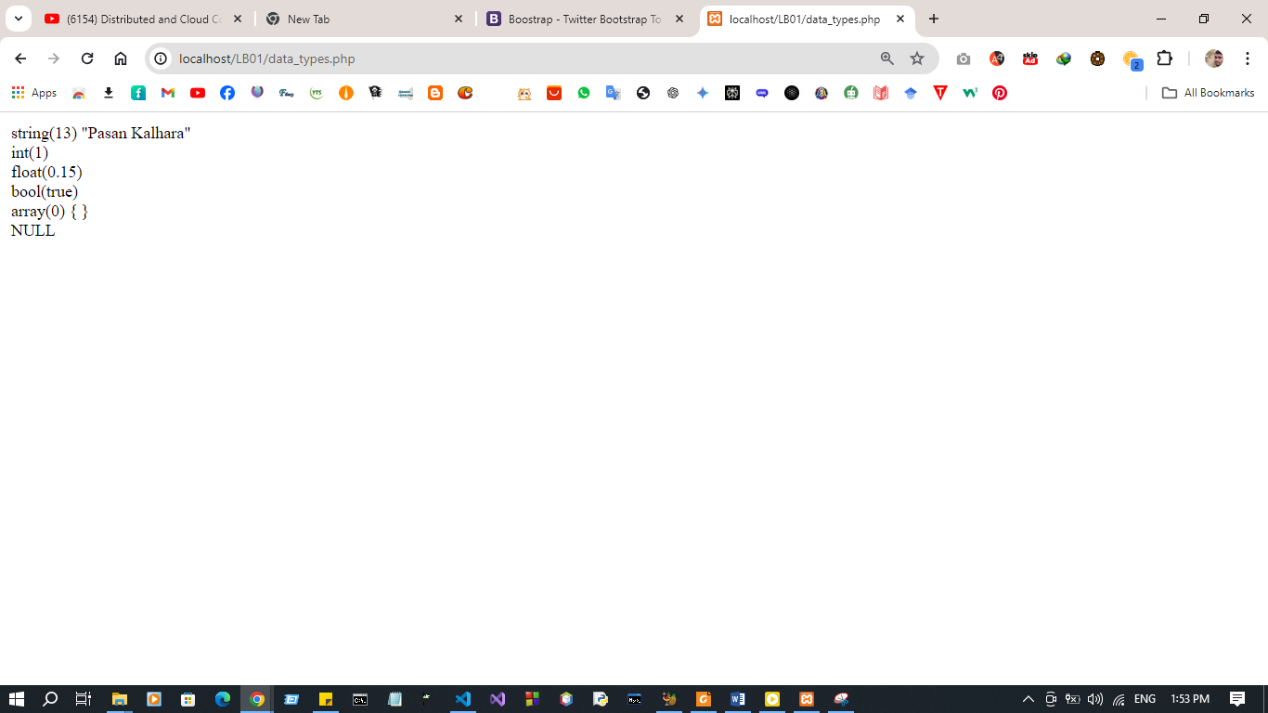

6. Constant in PHP

// define(name_of_the_constant, value_of_the_constant)
define("PI", 3.14159);
echo PI;
// const key word
const MAX_ATTEMPT = 3;
echo "<br>".MAX_ATTEMPT

I. Create a new PHP file and name it “constant.php”.
II. Create a constant variable to store shipping cost.
III. Try to change the shipping cost after assign the value.

constant.php

<?php

define("SHIPPING_COST", 5.99);
echo "Initial Shipping Cost: " . SHIPPING_COST . "<br>";
const Updated_SHIPPING_COST =9.9;
echo "Updated Shipping Cost: " . SHIPPING_COST ;
?>

Outpu:
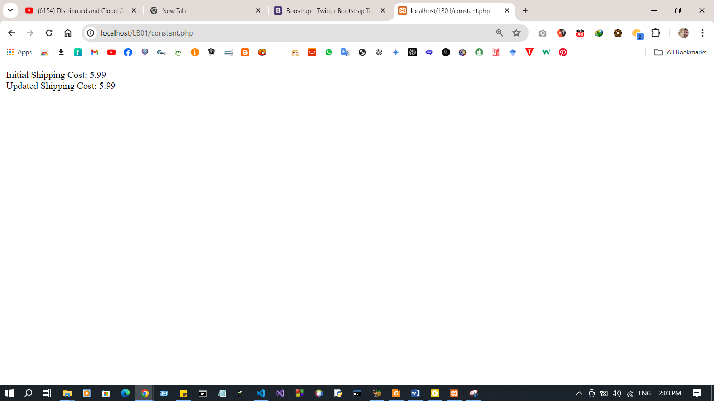

Discussion:

LAB SHEE 02
Title:
- Introduction to PHP - II.
Aims:
• Refresh the knowledge on operators.
• Refresh the knowledge on PHP statements.
• Refresh the knowledge on PHP Loops.
• Introduction to PHP functions and arrays
Tasks:
• Operators in PHP
• PHP Conditional Statements
• PHP Loops
• PHP Functions
• PHP Arrays
Activities
1. Operators in PHP
I. Try each operator and display its outputs
CODE
<?php

echo "------------------------------------------------------------------------- <br>";
echo" Arithmetic Operators + , - , * , / , % , ++ , ";
echo"<br>";
echo "------------------------------------------------------------------------- <br>";
echo"<br>";
$number1 = 45;
$number2 = 67;
$sum = $number1 + $number2;
echo "Sum : " . $sum;
echo"<br>";

echo"<br>";
echo "------------------------------------------------------------------------- <br>";
echo "Comparison Operators == , != , > , < , >= , <= ";
echo"<br>";
echo "------------------------------------------------------------------------- <br>";
echo"<br>";
$number3 = 45;
$number4 = 67;
$is_equal = $number1 == $number2;
echo "Is Equal ( ".$number3.",".$number4." ) : " . $is_equal;
echo"<br>";

echo"<br>";
echo "------------------------------------------------------------------------- <br>";
echo " Logical Operators and , or , && , || , !";
echo"<br>";
echo "------------------------------------------------------------------------- <br>";
$true_val = true;
$false_val = false;
$and_operator = ($true_val and $false_val);
echo "AND ( " . $true_val . "," . $false_val . " ) : " .$and_operator;
echo"<br>";

echo"<br>";
echo "------------------------------------------------------------------------- <br>";
echo " Assignment Operators = , += , -= , *= , /= , %= ";
echo"<br>";
echo "------------------------------------------------------------------------- <br>";
echo"<br>";
$var1 = 23;
$var2 = 34;
$assignment_opr = $var1 + $var2;
echo "Simple Assignment ( " . $var1 . "," . $var2 . " ) : " . $assignment_opr;
echo "<br>";

echo"<br>";
echo "------------------------------------------------------------------------- <br>";
echo "String Operators . , .=";
echo"<br>";
echo "------------------------------------------------------------------------- <br>";
echo"<br>";
$string_var1 = "Olivia";
$String_var2 = "Edith";
$string_var1 .= $String_var2;
echo $string_var1;
echo "<br>";

echo"<br>";
echo "------------------------------------------------------------------------- <br>";
echo "Conditional Operators ?";
echo"<br>";
echo "------------------------------------------------------------------------- <br>";
echo"<br>";
$number5 = 3;
$number6 = 4;
$cond_output = $number5 == $number6 ? "Number_5 and Number_6 areequal." : "Number_5 and Number_6 are not equal.";
echo $cond_output;

?>

Output:
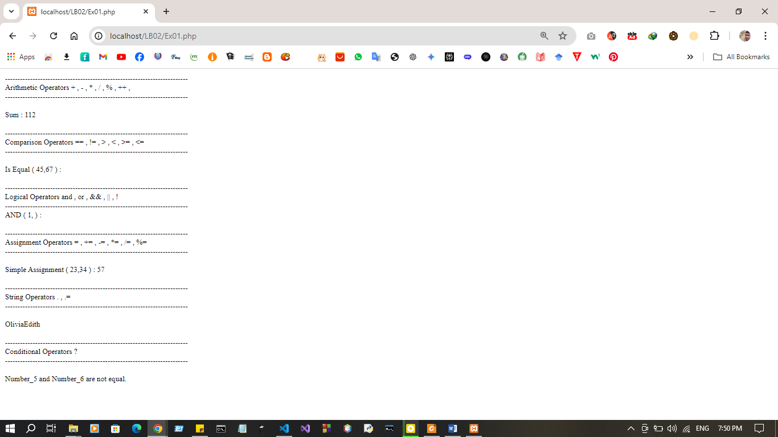
2. Conditional Statements of PHP
<?php
// IF STATEMENT
if (condition) {
// code to be executed if condition is true;
}
// IF-ELSE STATEMENT
if (condition) {
// code to be executed if condition is true;
} else {
// code to be executed if condition is false;
}
// IF-ELSEIF-ELSE STATEMENT
if (condition) {
// code to be executed if this condition is true;
} elseif (condition) {
// code to be executed if first condition is false and this
condition is true;
} else {
// code to be executed if all conditions are false;
}
?>

I. If the room temperature is above 72 degrees Fahrenheit, turn on the air conditioner. If the temperature is below 68 degrees Fahrenheit, turn on the heater. Else, maintain the current temperature.

CODE :
<?php

$room_temperature = 66;

if ($room_temperature >= 72) {
echo "Turning on the air conditioner.\n";;
} elseif ($room_temperature <= 68) {
echo "Turning on the heater.\n";
} else {
echo "Maintaining current temperature.\n";
}
?>
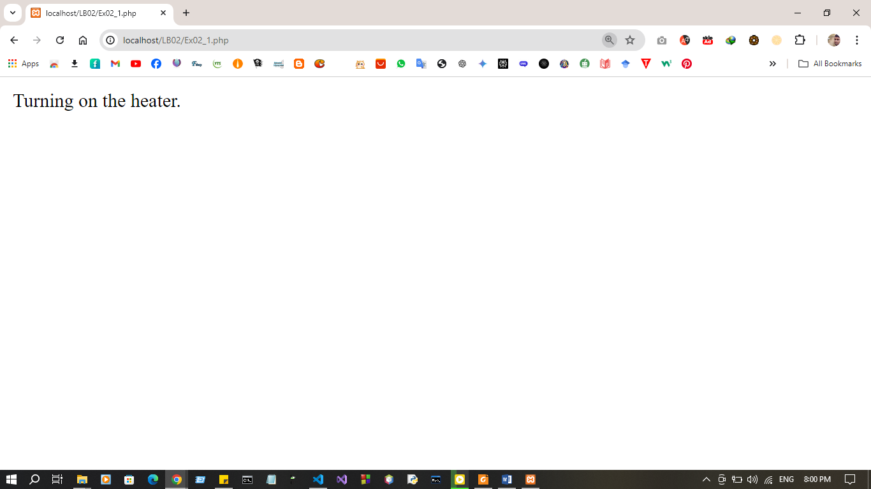
Output:

<?php
// SWITCH STATEMENT
switch (expression) {
case label1:
//code block
break;
case label2:
//code block;
break;
case label3:
//code block
break;
default:
//code block
}
?>

II. Imagine a vending machine that dispenses different snacks based on user selection. The user presses a button corresponding to a specific snack code:
C001 : for Chips
C002 : for Cookies
C003 : for Candy Bar
D : Invalid selection

CODE :
<?php

$user_selection = 'C002';
switch ($user_selection) {
case 'C001':
echo "Dispensing Chips.\n";
break;
case 'C002':
echo "Dispensing Cookies.\n";
break;
case 'C003':
echo "Dispensing Candy Bar.\n";
break;
default:
echo "Invalid selection.\n";
break;
}

?>

Output :
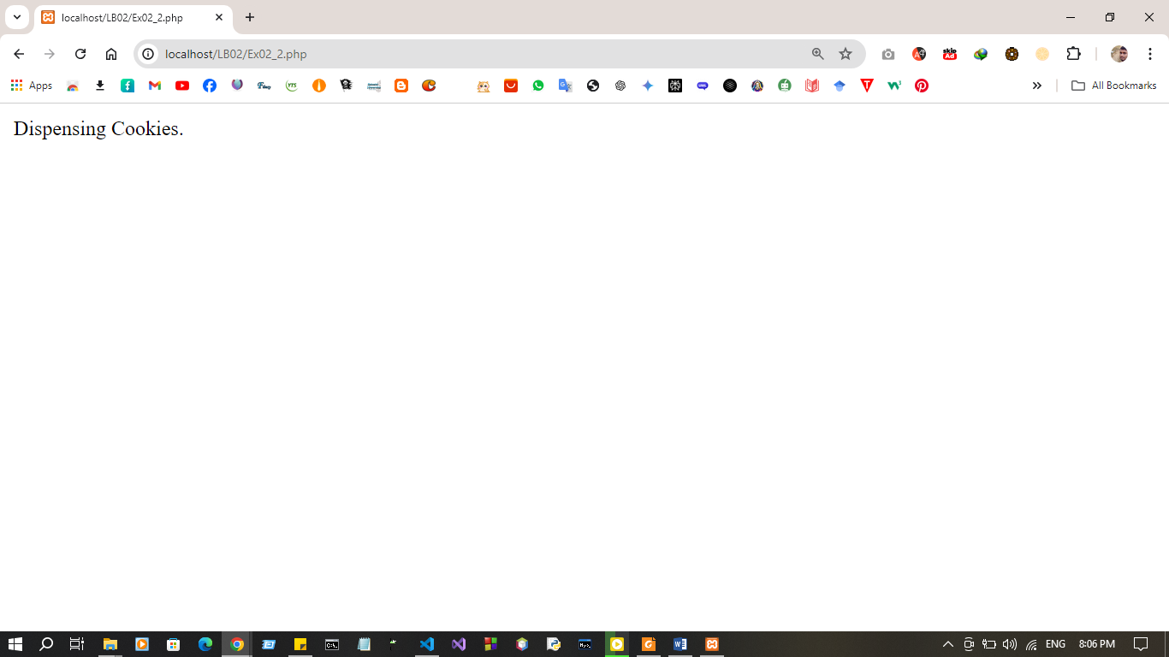
3. Loops of PHP
<?php
//while loop
while (condition) {
# code...
}
//do.. while loop
do {
# code...
} while (condition);
?>

I. Create a script that displays 1-2-3-4-5-6-7-8-9-10 on one line. There will be no hyphen(-) at starting and ending position

CODE:

<?php

$x=0;
while ($x<=10) {
echo "$x"." ";
$x++;

}

?>

Output:

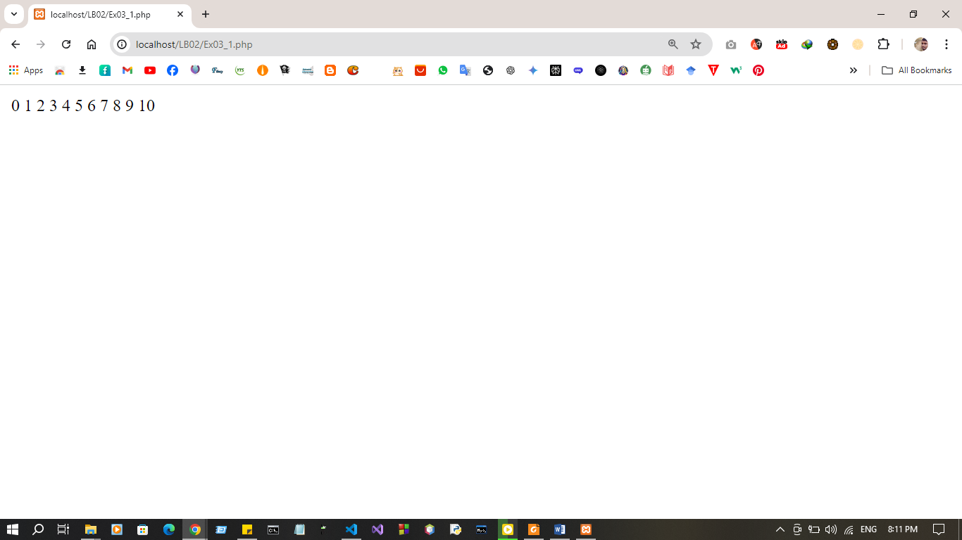

<?php
//for loop
for (expression1, expression2, expression3) {
// code block
}
?>

II. Write a for loop that generates a multiplication table for a number 7. The loop should iterate from 1 to 10 and print each number multiplied by 7.

CODE:

<?php

for ($i = 1; $i <= 10; $i++) {
$result = 7 * $i;
echo "7 x $i = $result <br>";
}
?>

Output:
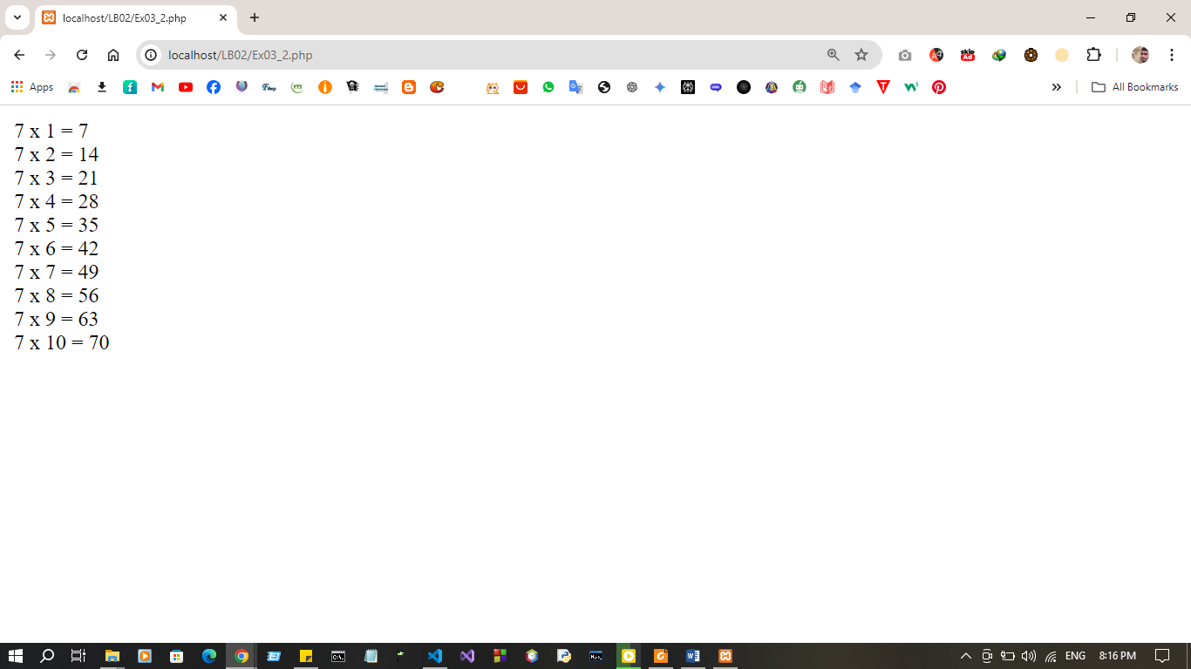

<?php
//foreach loop
foreach ($array_var as $value) {
# code...
}
?>

III. Imagine you have an array containing items in a shopping cart (e.g., ["apples", "bread", "milk"]). Write a foreach loop that iterates through this array and prints the name of each item in the cart.
Code:
<?php
$shopping_cart = ["apples", "bread", "milk"];
foreach ($shopping_cart as $item) {
echo $item . "<br>";
}
?>

Output:
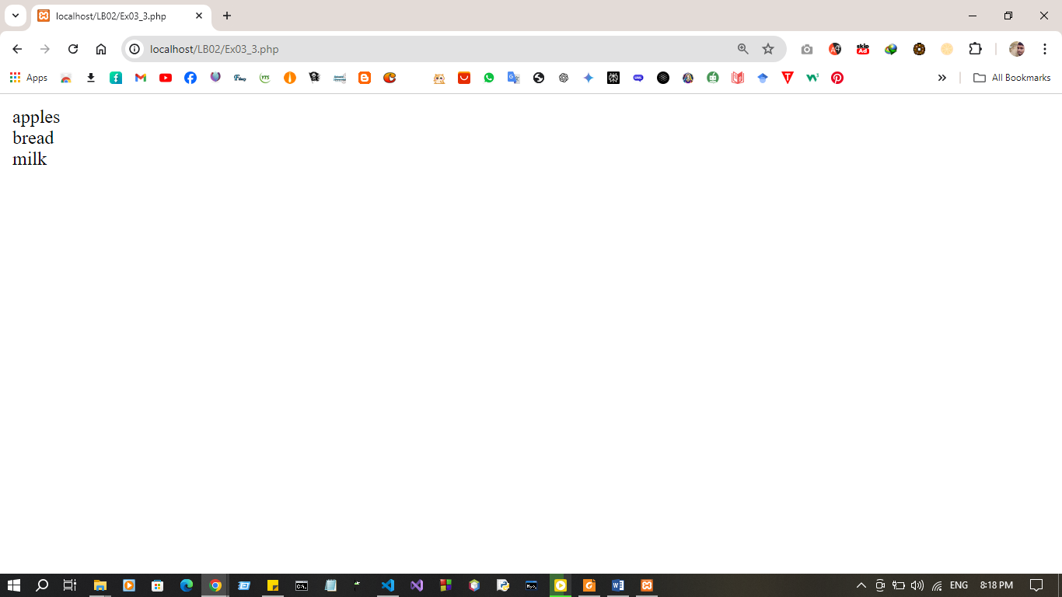

4. Functions of PHP
<?php
function function_name (arguments) {
# code...
}
function_name(value);
?>

I. Imagine you're writing a program to calculate the total bill amount for customer’s purchase. Here's how you can achieve that using functions:
- Function to calculate the tax amount( calculate_tax_amount ): This function takes two parameters: price and tax_rate . It calculates the tax amount by multiplying the price by the tax rate and returns the result.
- Function to calculate the total bill: This function takes two parameters: price and tax_rate. It calls the calculate_tax_amount function (defined earlier) to get the tax amount for the given price and tax rate. Then, it adds the tax amount to the original price to get the total bill amount and returns the final amount.
- Calling the functions and displaying the outputs.

Code:
<?php

function calculate_tax_amount($price, $tax_rate) {
$tax_amount = $price * $tax_rate;
return $tax_amount;
}

function calculate_total_bill($price, $tax_rate) {
$tax_amount = calculate_tax_amount($price, $tax_rate);
$total_amount = $price + $tax_amount;
return $total_amount;
}

$price = 100;
$tax_rate = 0.08;

$tax_amount = calculate_tax_amount($price, $tax_rate);
$total_amount = calculate_total_bill($price, $tax_rate);

echo "Price: $$price <br>";
echo "Tax Amount: $$tax_amount <br>";
echo "Total Bill Amount: $$total_amount <br>";
?>

Output: 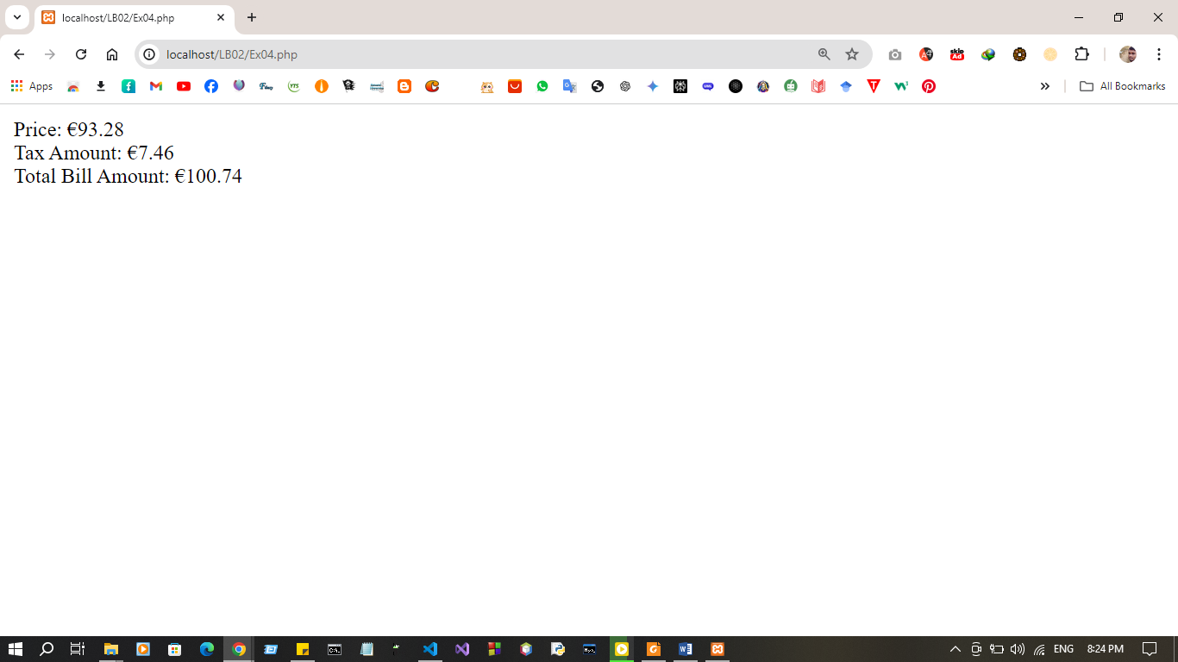

5. Arrays of PHP
<?php
// To define - can use array() construct or [] syntax
$empty_array1 = array();
$empty_array2 = [];
$numbers1 = array(1, 2, 3);
$numbers2 = [1, 2, 3];
?>

I. Imagine you're managing a shopping cart system where items are stored in an array. Each item is represented as an associative array with properties like "name", "price", and "quantity". You want to implement functions to achieve the

following:
- Calculate total per item: This function should take a single item (associative array) as input and calculate the total cost for that specific item by multiplying the "price" by the "quantity". It should return the calculated total cost.
- Calculate total bill: This function should iterate through the entire shopping cart array containing all items. Within the loop, it should call the previously defined function (calculate total per item) for each item in the cart. It should accumulate the individual item totals and return the final total bill amount

Code :
<?php
function calculate_total_per_item($item) {
$total_cost = $item['price'] * $item['quantity'];
return $total_cost;
}
function calculate_total_bill($cart) {
$total_bill = 0;
foreach ($cart as $item) {
$total_cost = calculate_total_per_item($item);
$total_bill += $total_cost;
}
return $total_bill;
}

$shopping_cart = [
["name" => "apples", "price" => 1.2, "quantity" => 10],
["name" => "bread", "price" => 2.5, "quantity" => 2],
["name" => "milk", "price" => 3.0, "quantity" => 1]
];

$total_bill = calculate_total_bill($shopping_cart);
echo "Total Bill Amount: $$total_bill\n";
?>
Output:
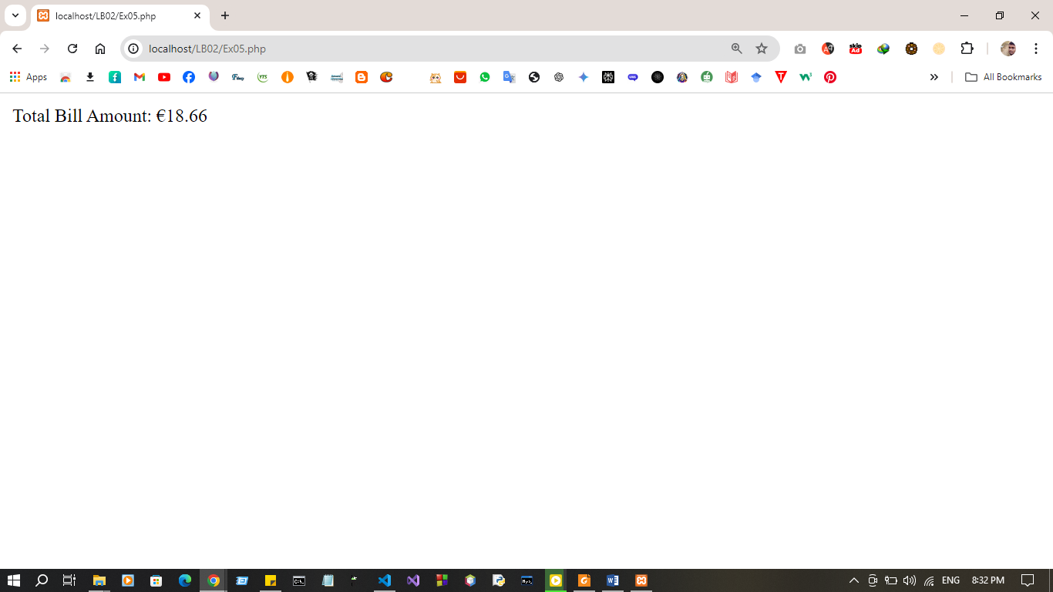

Discussion:

LAB SHEET 03

Title:
- Introduction to Database and MySQL (OOP).

Aims:
- Setting up a MySQL database
- Writing SQL queries for CRUD operations
- Basic Page

Tasks:
- Create database in MySQL
- Build the connection with PHP
- Create / Store data in MySQL database using PHP
- Read data in MySQL database using PHP
- Update in MySQL database using PHP
- Delete in MySQL database using PHP
Activities :
- Create database in MySQL

CREATE DATABASE facility;

USE facility;

CREATE TABLE students (
Name varchar(255) NOT NULL,
Gpa decimal(4,3) NOT NULL,
ID int(10) NOT NULL PRIMARY KEY AUTO_INCREMENT
);

- Implement connection

private function connect(){
$this->connection = mysqli_connect($this->host, $this->username, $this>password, $this->database);

if (!$this->connection) {
die("Connection Failed: " . mysqli_connect_error());
}

- Read Operation

public function getAllStudents(){
$query = "select * from `students`";
$result = mysqli_query($this->connection, $query);
if (!$result) {
die("Failed to retrieve data");
}
$students = [];
while ($row = mysqli_fetch_assoc($result)) {
$students[] = $row;
}
return $students;
}

- Create / Store / Insert Operation

public function create(){
if (empty($this->name) || empty($this->gpa)) {
return header('location:index.php?error=All fields are required');
}
$query = "insert into `students` (`name`,`gpa`) values('$this>name', '$this->gpa')";
$result = mysqli_query($this->connection, $query);
if (!$result) {
return header('location:index.php?error=Failed to add student');
}
return header('location:index.php?success=Successfully added student');
}

- Update Operation
- Read specific student
public function read(){
$query = "select * from `students` where `id` = '$this->id'";
$result = mysqli_query($this->connection, $query);
if (!$result) {
return false;
}
$row = mysqli_fetch_assoc($result);
$this->setId($row['id']);
$this->setName($row['name']);
$this->setGpa($row['gpa']);
return true;
}
- Update the student data

public function update(){
if (empty($this->id) || empty($this->name) || empty($this->gpa)) {
return header('location:index.php?error=All Fields are required');
}
$query = "update `students` set `name` = '$this->name',gpa` = '$this->gpa' where `id` = '$this->id'";
$result = mysqli_query($this->connection, $query);
if (!$result) {
return header('location:index.php?error=Failed updatedstudent data');
}
return header('location:index.php?success=Successfullyupdated student data');
}

- Delete operation
public function delete(){
$query = "delete from `students` where `id` = '$this->id'";
$result = mysqli_query($this->connection, $query);
if (!$result) {
return header('location:index.php?error=Failed to delete student');
}
return header('location:index.php?success=Successfully deleted student');
}
- Add some CSS to the web page using Bootstrap

index.php

<?php
include('DatabasesConnection.php');
require_once('Students.php');

$db = new DatabasesConnection("localhost", "root", "", "faculty");
$connection = $db->getConnection();

$student = new Student($connection);
$students = $student->getAllStudent();

if (isset($_GET['ID']) && isset($_GET['to_delete'])) {
$student->setId($_GET['ID']);
$student->delete();
}
?>

<!DOCTYPE html>
<html lang="en">
<head>
<link href="https://cdn.jsdelivr.net/npm/bootstrap@5.3.3/dist/css/bootstrap.min.css" rel="stylesheet" integrity="sha384-QWTKZyjpPEjISv5WaRU9OFeRpok6YctnYmDr5pNlyT2bRjXh0JMhjY6hW+ALEwIH" crossorigin="anonymous">
<title>Faculty Student Details</title>
</head>
<body>
<div class="container-md">
<div class="col-10 mb-3">

<form class="form-control bg-light p-4" action="index.php" method="post">
<div class="mb-3">
<label for="name" class="form-label">Name</label>
<input class="form-control form-control-lg" type="text" id="name" name="name" placeholder="Enter your Name">
</div>
<div class="mb-3">
<label for="gpa" class="form-label">GPA</label>
<input class="form-control form-control-lg" type="text" id="gpa" name="gpa" placeholder="Enter your GPA">
</div>
<input type="submit" value="Add" name="add_student" class="btn btn-primary">
</form>
<div>

<?php
if (isset($_POST['add_student'])) {
$name = $_POST['name'];
$gpa = $_POST['gpa'];
$student->setName($name);
$student->setGpa($gpa);
$student->create();
}
?>

<?php
if (isset($_GET['error'])) {
echo "<div class='alert alert-danger mt-3'>" . $_GET['error'] . "</div>";
}?>

<div class="col-10 mb-3 mt-4">
<table class="table table-bordered table-striped">
<thead class="table-dark">
<tr>
<th>ID</th>
<th>Name</th>
<th>GPA</th>
<th>Actions</th>
</tr>
</thead>
<tbody>
<?php foreach ($students as $std): ?>
<tr>
<td><?php echo $std['ID']; ?></td>
<td><?php echo $std['Name']; ?></td>
<td><?php echo $std['Gpa']; ?></td>
<td><a href="index.php?ID=<?php echo $std['ID']; ?>&to_delete=1" class="btn btn-danger btn-sm">Delete</a></td>
</tr>
<?php endforeach; ?>
</tbody>
</table>
</div>
</div>

<script src="https://cdn.jsdelivr.net/npm/bootstrap@5.3.3/dist/js/bootstrap.bundle.min.js" integrity="sha384-YvpcrYf0tY3lHB60NNkmXc5s9fDVZLESaAA55NDzOxhy9GkcIdslK1eN7N6jIeHz" crossorigin="anonymous"></script>
</body>
</html>

DatabasesConnection.php

<?php

class DatabasesConnection
{
private $host;
private $username;
private $password;
private $database;
private $connection;

public function __construct($host, $username, $password, $database)
{
$this->host = $host;
$this->username = $username;
$this->password = $password;
$this->database = $database;

$this->connect();
}

private function connect()
{
$this->connection = mysqli_connect($this->host, $this->username, $this->password, $this->database);
if (!$this->connection) {
die("Server error");
}
}

public function getConnection()
{
return $this->connection;
}
}
?>

Students.php

<?php
class Student
{
private $name;
private $gpa;
private $id;
private $connection;

public function __construct($connection)
{
$this->connection = $connection;
}

public function setName($name)
{
$this->name = $name;
}

public function setGpa($gpa)
{
$this->gpa = $gpa;
}

public function setId($id)
{
$this->id = $id;
}

public function getName()
{
return $this->name;
}

public function getGpa()
{
return $this->gpa;
}

public function getId()
{
return $this->id;
}

public function getAllStudent()
{
$query = "SELECT * FROM students";
$result = mysqli_query($this->connection, $query);
if (!$result) {
die("Failed to retrieve data!");
}
$students = [];
while ($row = mysqli_fetch_assoc($result)) {
$students[] = $row;
}
return $students;
}

public function create()
{
if (empty($this->name) || empty($this->gpa)) {
return header('Location: index.php?error=All fields are required');
}
$query = "INSERT INTO students (Name, Gpa) VALUES (?, ?)";
$stmt = mysqli_prepare($this->connection, $query);
mysqli_stmt_bind_param($stmt, 'sd', $this->name, $this->gpa);

if (mysqli_stmt_execute($stmt)) {
return header('Location: index.php?success=Successfully added student');
} else {
return header('Location: index.php?error=Failed to add student');
}
}

public function delete()
{
if (empty($this->id)) {
return header('Location: index.php?error=ID is required');
}
$query = "DELETE FROM students WHERE ID = ?";
$stmt = mysqli_prepare($this->connection, $query);
mysqli_stmt_bind_param($stmt, 'i', $this->id);

if (mysqli_stmt_execute($stmt)) {
return header('Location: index.php?success=Successfully deleted student');
} else {
return header('Location: index.php?error=Failed to delete student');
}
}
}

?>

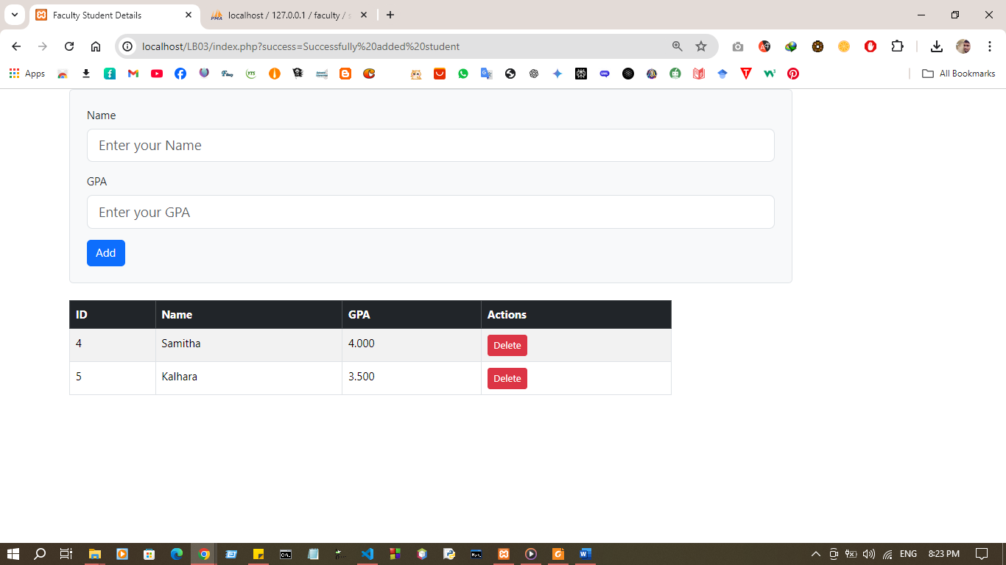
OUTPUT :

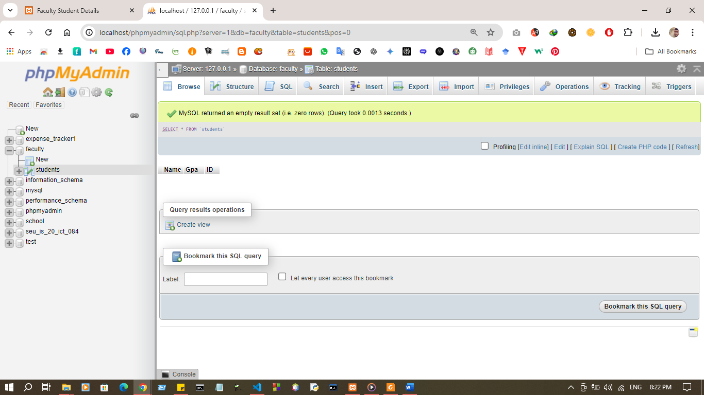

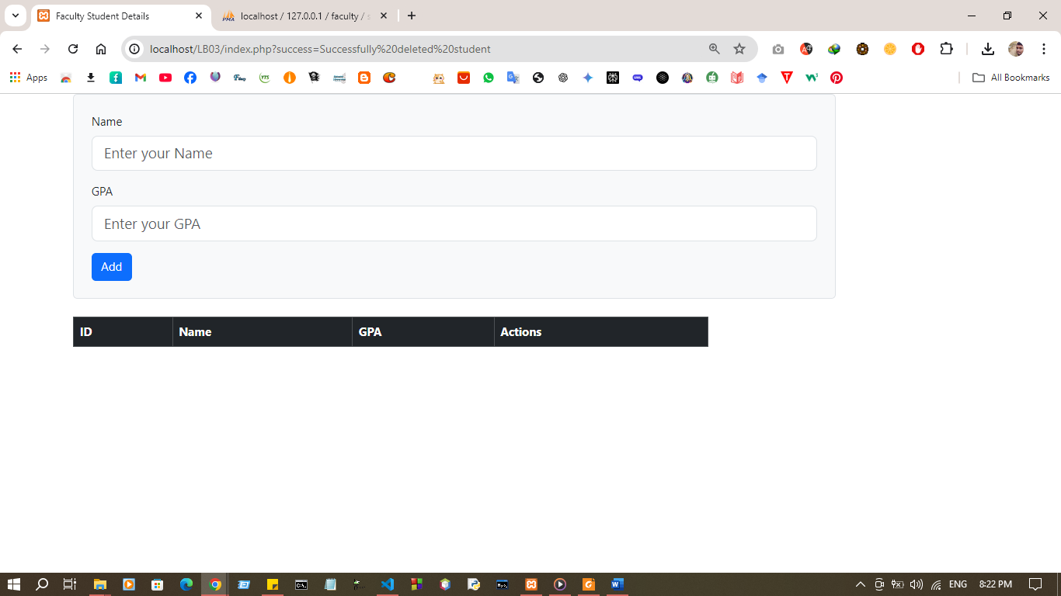

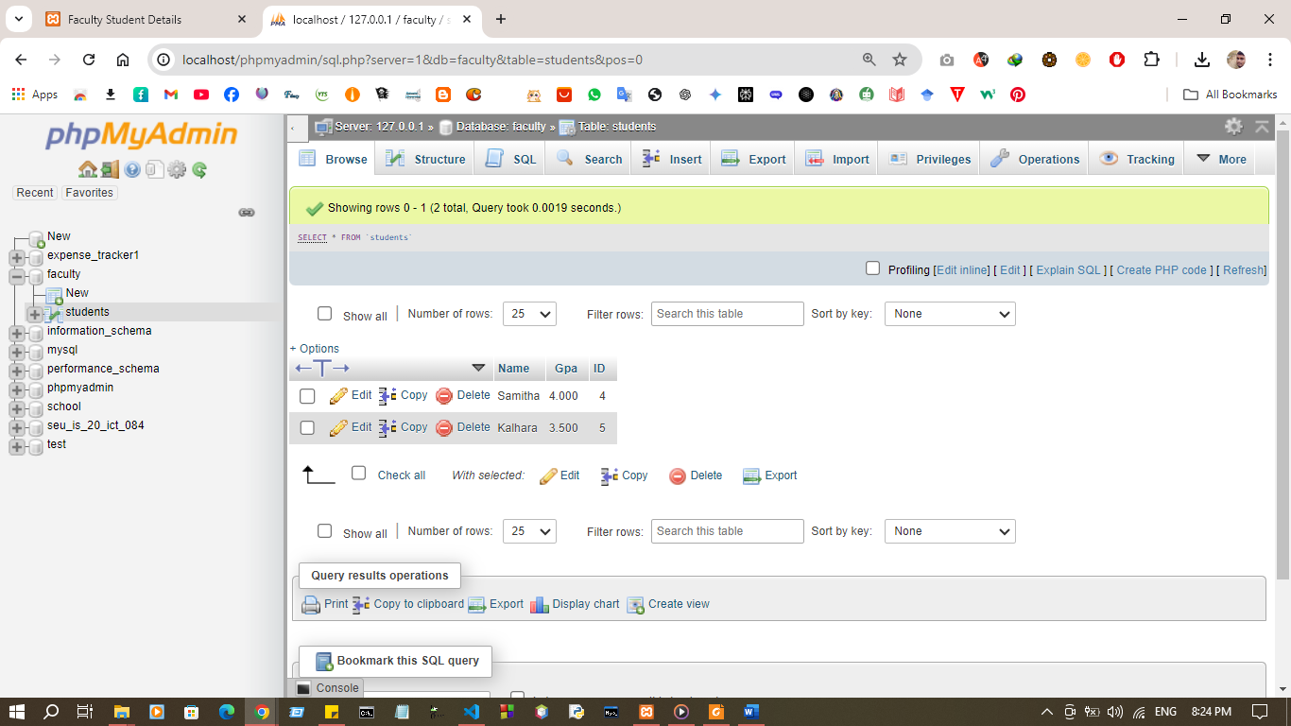
Exercise:
1. Create new database name as “todo”
2. Create new table “task”
3. That table contain id ( primary key ) , title and description.
4. Design a sample web page for this ToDo application using html and bootstrap.
5. Perform CRUD operation.
Code
Index.php

<?php
include('db.php');
require_once('todo.php');

$db = new Db("localhost", "root", "", "todo");
$db->connect();
$connection = $db->getConnection();

$todo = new Todo($connection);
$tasks = $todo->getAllTasks();

if ($_SERVER['REQUEST_METHOD'] === 'POST') {
$title = $_POST['title'];
$description = $_POST['description'];

$todo->setTitle($title);
$todo->setDescription($description);

if ($todo->create()) {
header('Location: index.php?success=Successfully added task');
exit();
} else {
header('Location: index.php?error=Failed to add task');
exit();
}
}

if (isset($_GET['id']) && isset($_GET['action'])) {
if ($_GET['action'] === 'delete') {
$task_id = $_GET['id'];
$todo->setId($task_id);
if ($todo->delete()) {
header('Location: index.php?success=Successfully deleted task');
exit();
} else {
header('Location: index.php?error=Failed to delete task');
exit();
}
} elseif ($_GET['action'] === 'update') {
$task_id = $_GET['id'];
// Redirect to update_task.php with the task ID
header('Location: update_task.php?id=' . $task_id);
exit();
}
}
?>

<!DOCTYPE html>
<html lang="en">
<head>
<meta charset="UTF-8">
<meta name="viewport" content="width=device-width, initial-scale=1.0">
<title>ToDo Application</title>
<link href="https://maxcdn.bootstrapcdn.com/bootstrap/4.5.2/css/bootstrap.min.css" rel="stylesheet">
</head>
<body>
<div class="container">
<h1 class="mt-5">ToDo List</h1>
<div class="card mt-3">
<div class="card-header">Add New Task</div>
<div class="card-body">
<form action="index.php" method="POST">
<div class="form-group">
<label for="title">Title:</label>
<input type="text" class="form-control" id="title" name="title" required>
</div>
<div class="form-group">
<label for="description">Description:</label>
<textarea class="form-control" id="description" name="description" required></textarea>
</div>
<button type="submit" class="btn btn-primary">Add Task</button>
</form>
</div>
</div>

<div class="card mt-3">
<div class="card-header">Tasks</div>
<div class="card-body">
<table class="table table-bordered">
<thead>
<tr>
<th>ID</th>
<th>Title</th>
<th>Description</th>
<th>Actions</th>
</tr>
</thead>
<tbody>
<?php foreach ($tasks as $task): ?>
<tr>
<td><?php echo htmlspecialchars($task['id']); ?></td>
<td><?php echo htmlspecialchars($task['title']); ?></td>
<td><?php echo htmlspecialchars($task['description']); ?></td>
<td>
<a href="index.php?id=<?php echo $task['id']; ?>&action=delete" class="btn btn-danger">Delete</a>
<a href="index.php?id=<?php echo $task['id']; ?>&action=update" class="btn btn-warning">Update</a>
</td>
</tr>
<?php endforeach; ?>
</tbody>
</table>
</div>
</div>
</div>
</body>
</html>
db.php
<?php
class Db {
private $host;
private $username;
private $password;
private $database;
private $connection;

public function __construct($host, $username, $password, $database) {
$this->host = $host;
$this->username = $username;
$this->password = $password;
$this->database = $database;
}

public function connect() {
$this->connection = mysqli_connect($this->host, $this->username, $this->password, $this->database);
if (!$this->connection) {
die("Connection failed: " . mysqli_connect_error());
}
}

public function getConnection() {
return $this->connection;
}
}
?>

todo.php

<?php
class Todo {
private $id;
private $title;
private $description;
private $connection;

public function __construct($connection) {
$this->connection = $connection;
}

public function getId() {
return $this->id;
}

public function getTitle() {
return $this->title;
}

public function getDescription() {
return $this->description;
}

public function setId($id) {
$this->id = $id;
}

public function setTitle($title) {
$this->title = $title;
}

public function setDescription($description) {
$this->description = $description;
}

public function create() {
if (empty($this->title) || empty($this->description)) {
die("Title and Description are required.");
}
$query = "INSERT INTO task (title, description) VALUES (?, ?)";
$stmt = mysqli_prepare($this->connection, $query);
mysqli_stmt_bind_param($stmt, 'ss', $this->title, $this->description);

if (mysqli_stmt_execute($stmt)) {
return true;
} else {
die("Failed to add task: " . mysqli_error($this->connection));
}
}

public function delete() {
if (empty($this->id)) {
die("ID is required.");
}
$query = "DELETE FROM task WHERE id = ?";
$stmt = mysqli_prepare($this->connection, $query);
mysqli_stmt_bind_param($stmt, 'i', $this->id);

if (mysqli_stmt_execute($stmt)) {
return true;
} else {
die("Failed to delete task: " . mysqli_error($this->connection));
}
}

public function update() {
if (empty($this->id) || empty($this->title) || empty($this->description)) {
die("All fields are required.");
}
$query = "UPDATE task SET title = ?, description = ? WHERE id = ?";
$stmt = mysqli_prepare($this->connection, $query);
mysqli_stmt_bind_param($stmt, 'ssi', $this->title, $this->description, $this->id);

if (mysqli_stmt_execute($stmt)) {
return true;
} else {
die("Failed to update task: " . mysqli_error($this->connection));
}
}

public function getAllTasks() {
$query = "SELECT * FROM task";
$result = mysqli_query($this->connection, $query);
if (!$result) {
die("Failed to retrieve data: " . mysqli_error($this->connection));
}
$tasks = [];
while ($row = mysqli_fetch_assoc($result)) {
$tasks[] = $row;
}
return $tasks;
}
}
?>

update_task.php

<?php
include('db.php');
require_once('todo.php');

$db = new Db("localhost", "root", "", "todo");
$db->connect();
$connection = $db->getConnection();

$todo = new Todo($connection);

if (isset($_GET['id'])) {
$task_id = $_GET['id'];
$todo->setId($task_id);
$query = "SELECT * FROM task WHERE id = ?";
$stmt = mysqli_prepare($connection, $query);
mysqli_stmt_bind_param($stmt, 'i', $task_id);
mysqli_stmt_execute($stmt);
$result = mysqli_stmt_get_result($stmt);
$task = mysqli_fetch_assoc($result);

if (!$task) {
die("Task not found!");
}
} else {
die("Invalid request!");
}

if (isset($_POST['id']) && isset($_POST['title']) && isset($_POST['description'])) {
$task_id = $_POST['id'];
$task_title = $_POST['title'];
$task_description = $_POST['description'];

$todo->setId($task_id);
$todo->setTitle($task_title);
$todo->setDescription($task_description);
$todo->update();
}
?>

<!DOCTYPE html>
<html lang="en">
<head>
<meta charset="UTF-8">
<meta name="viewport" content="width=device-width, initial-scale=1.0">
<title>Update Task</title>
<link href="https://maxcdn.bootstrapcdn.com/bootstrap/4.5.2/css/bootstrap.min.css" rel="stylesheet">
</head>
<body>
<div class="container">
<h1 class="mt-5">Update Task</h1>
<div class="card mt-3">
<div class="card-header">Update Task</div>
<div class="card-body">
<form action="update_task.php?id=<?php echo $task['id']; ?>" method="POST">
<input type="hidden" name="id" value="<?php echo htmlspecialchars($task['id']); ?>">
<div class="form-group">
<label for="title">Title:</label>

<input type="text" class="form-control" id="title" name="title" value="<?php echo htmlspecialchars($task['title']); ?>" required>

</div>
<div class="form-group">
<label for="description">Description:</label>

<textarea class="form-control" id="description" name="description" required><?php echo htmlspecialchars($task['description']); ?></textarea>

</div>
<button type="submit" class="btn btn-primary">Update Task</button>
</form>
</div>
</div>
</div>
</body>
</html>
sql.sql
CREATE DATABASE todo;
USE todo;

CREATE TABLE task (
id INT AUTO_INCREMENT PRIMARY KEY,
title VARCHAR(255) NOT NULL,
description TEXT NOT NULL
);

Output:
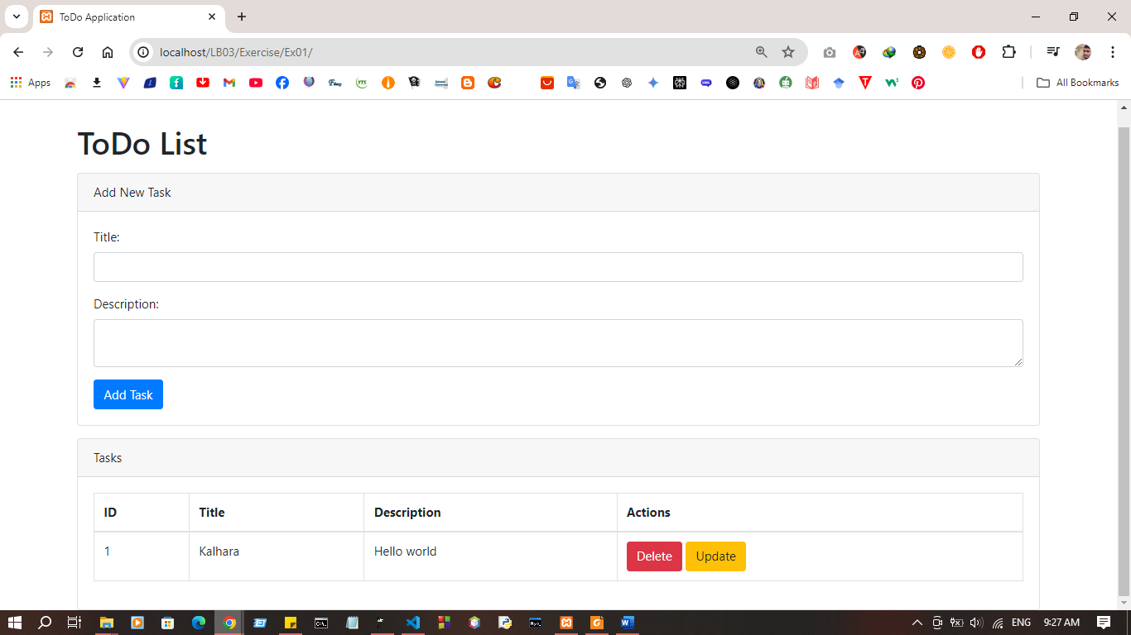

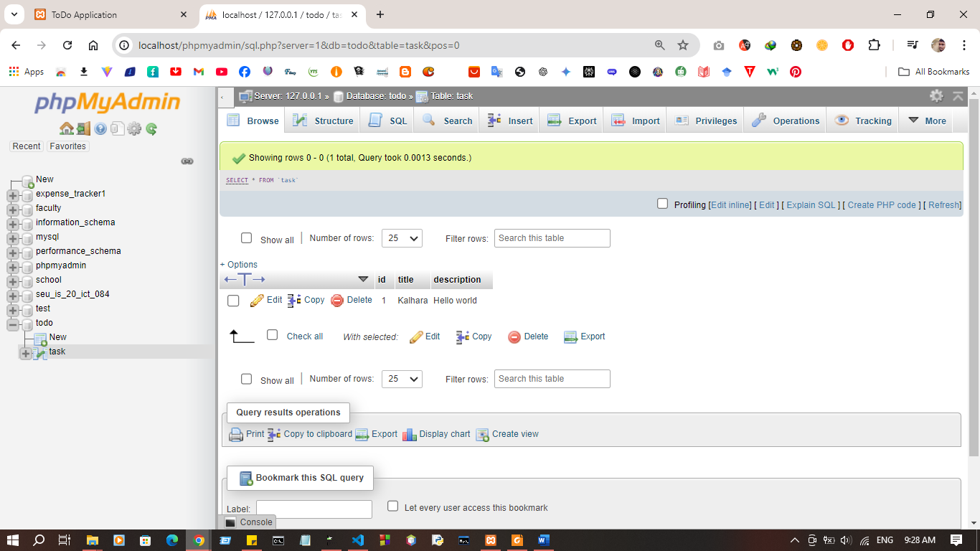
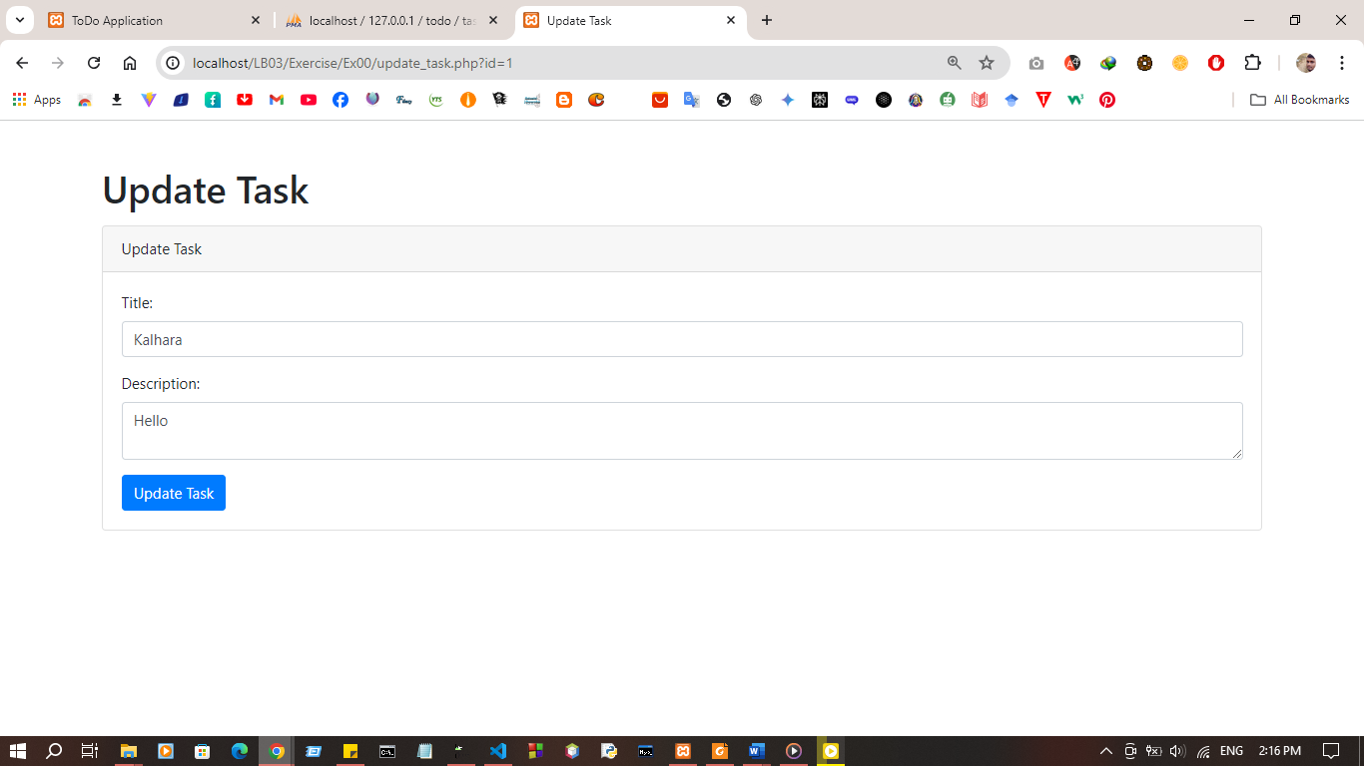

Discussion:

LAB SHEET 04

LAB SHEET 05

LAB SHEET 06

LAB SHEET 07

LAB SHEET 08

LAB SHEET 09

