Lab Sheet 04
Title: Getting started with Windows Form Application using Visual Studio .NET
Aims:
- Getting knowledge on creating Windows Form Application using Visual Studio.
- Getting basic knowledge on adding controls for a Windows Form.
Installing Visual Studio and Configuring .NET
- Download Visual Studio
  - Go to the official download page: https://visualstudio.microsoft.com/downloads/
  - Under Visual Studio for Windows, click Download for the ommunity edition (free for students, open source contributors, and individual developers).
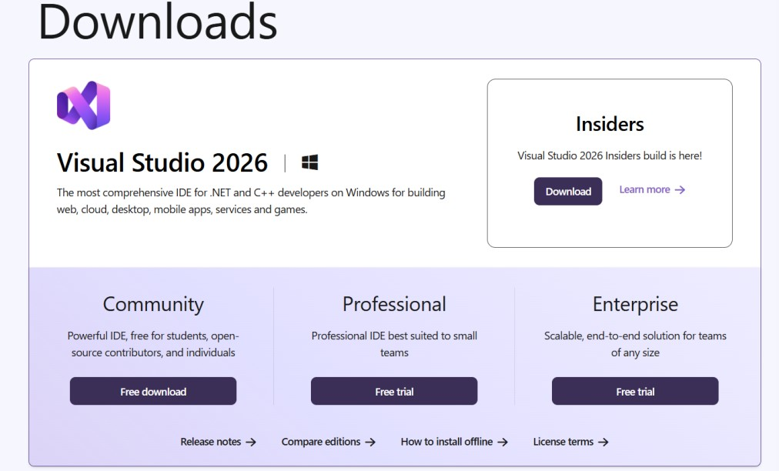

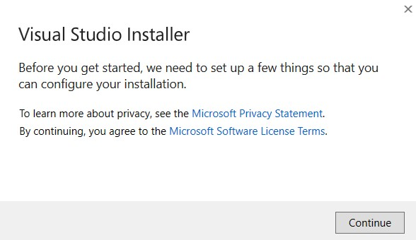
  - Run the downloaded VisualStudioSetup.exe file.

- Install Visual Studio with .NET Desktop Workload
Select the following workload (very important for Windows Forms):
.NET desktop development (this includes tools for Windows Forms, WPF, and Console apps using C# or VB.NET).
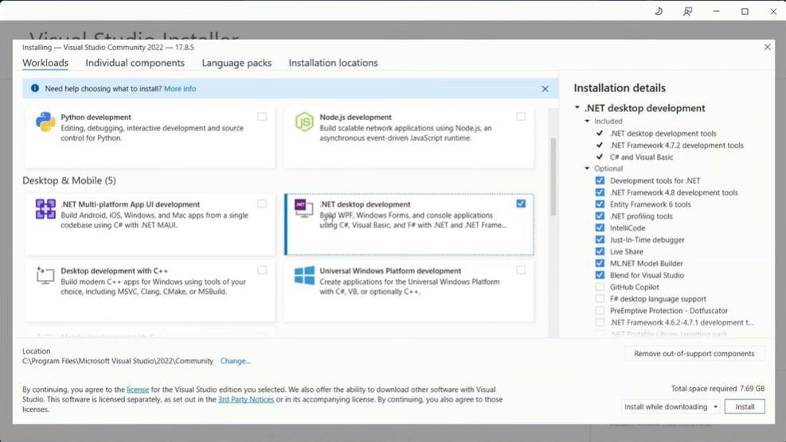


Click Install at the bottom right.

Task 01:
- Create a new C# Windows Form Application project named FootBall.
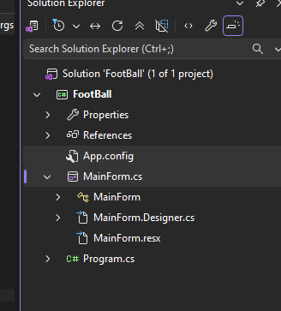
- Rename Form1.cs as MainForm.cs.

- Add a Button control to the form created.
- Set the following Properties to the form and button:

Object | Name Property | Text Property | Text Formatting
Button | BtnCheer | Cheer! | 14pt, Bold, Underlined
form | MainForm | SEUSL Foot Ball | -

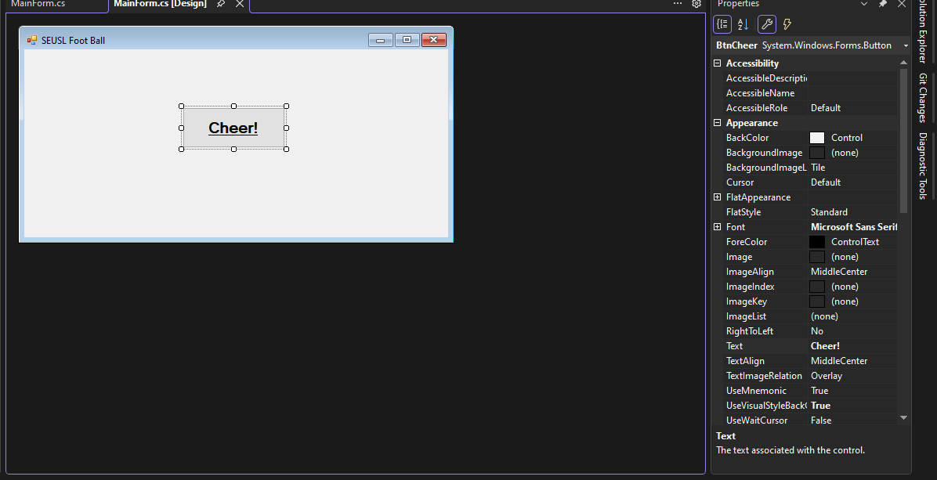
- Write a Program to display the message “GO BOYS” onto a message box when the user clicks on the button. The message should be an information and only with ok button. Message title is Cheering.
MessageBox.Show("Message", " Title", ButtonType, IconType);

using System;
using System.Collections.Generic;
using System.ComponentModel;
using System.Data;
using System.Drawing;
using System.Linq;
using System.Text;
using System.Threading.Tasks;
using System.Windows.Forms;

namespace FootBall
{
public partial class MainForm : Form
{
public MainForm()
{
InitializeComponent();
}

private void BtnCheer_Click(object sender, EventArgs e)
{
MessageBox.Show("GO BOYS", " FootBall", MessageBoxButtons.OK, MessageBoxIcon.Information);
}
}
}

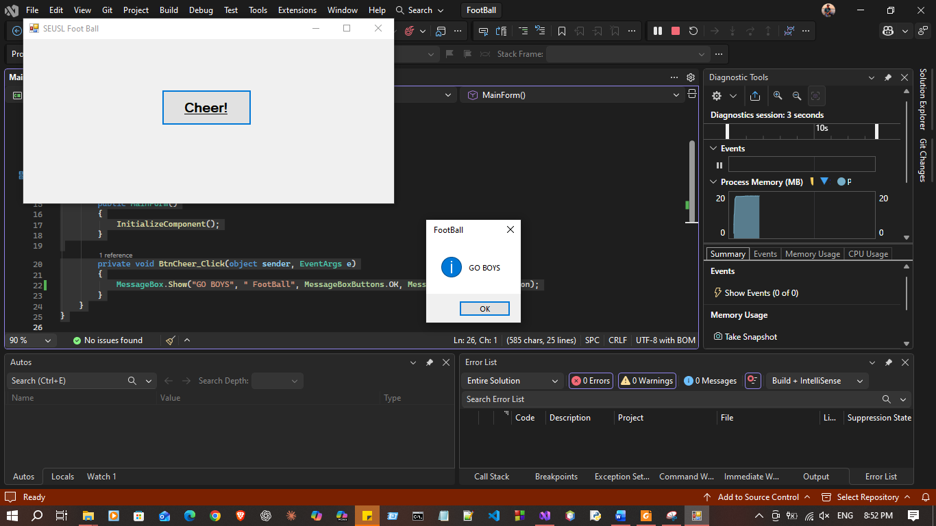
Button Types
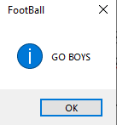
- MessageBoxButtons.OK - OK button.

- MessageBoxButtons.OKCancel - OK and Cancel buttons.
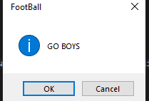

- MessageBoxButtons.AbortRetryIgnore - Abort, Retry, and Ignore buttons.
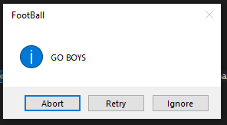
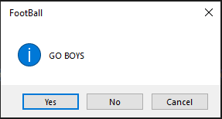
- MessageBoxButtons.YesNoCancel - Yes, No, and Cancel buttons.

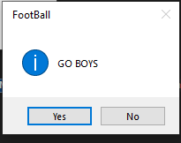
- MessageBoxButtons.YesNo - Yes and No buttons.

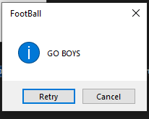
- MessageBoxButtons.RetryCancel - Retry and Cancel buttons.

Icon Types
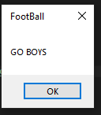
- MessageBoxIcon.None - no symbols.

- MessageBoxIcon.Hand - a symbol consisting of a white X in a circle with a red background.
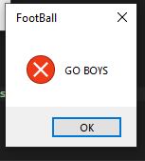

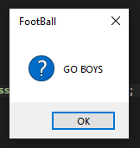
- MessageBoxIcon.Question - a symbol consisting of a question mark in a circle.

- MessageBoxIcon.Exclamation - a symbol consisting of an exclamation point in a triangle with a yellow background.
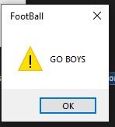

- MessageBoxIcon.Asterisk - a symbol consisting of a lowercase letter i in a circle.
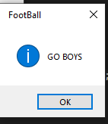
- MessageBoxIcon.Stop - a symbol consisting of white X in a circle with a red background.

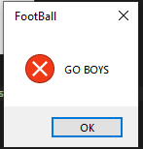
- MessageBoxIcon.Error - a symbol consisting of white X in a circle with a red background.
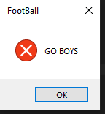
- MessageBoxIcon.Warning - a symbol consisting of an exclamation point in a triangle with a yellow background.
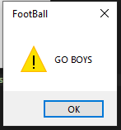

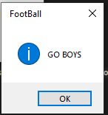
- MessageBoxIcon.Information - a symbol consisting of a lowercase letter i in a circle.

- Compile and run the project.

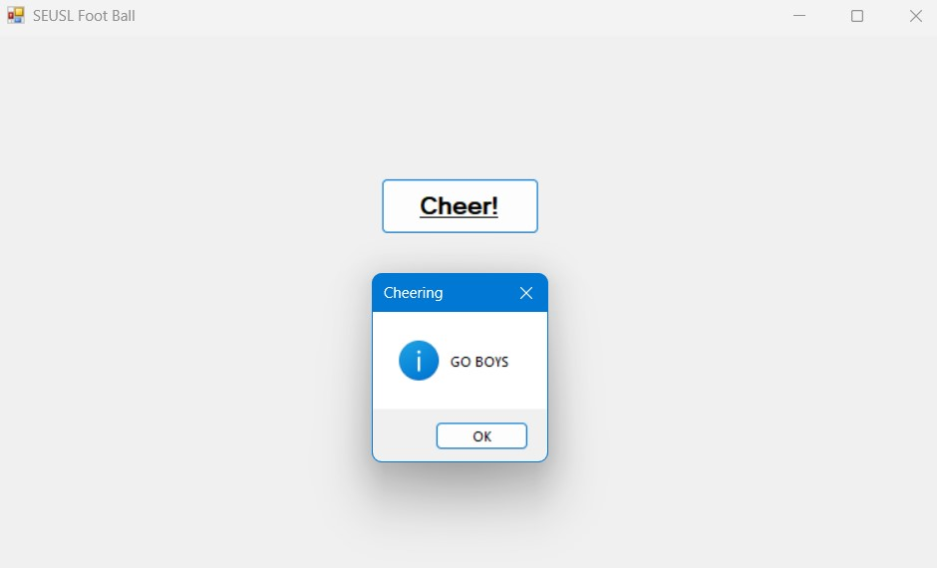

Task 02:
Create a C# application to load image file. Follow the instructions given below to perform the operation.
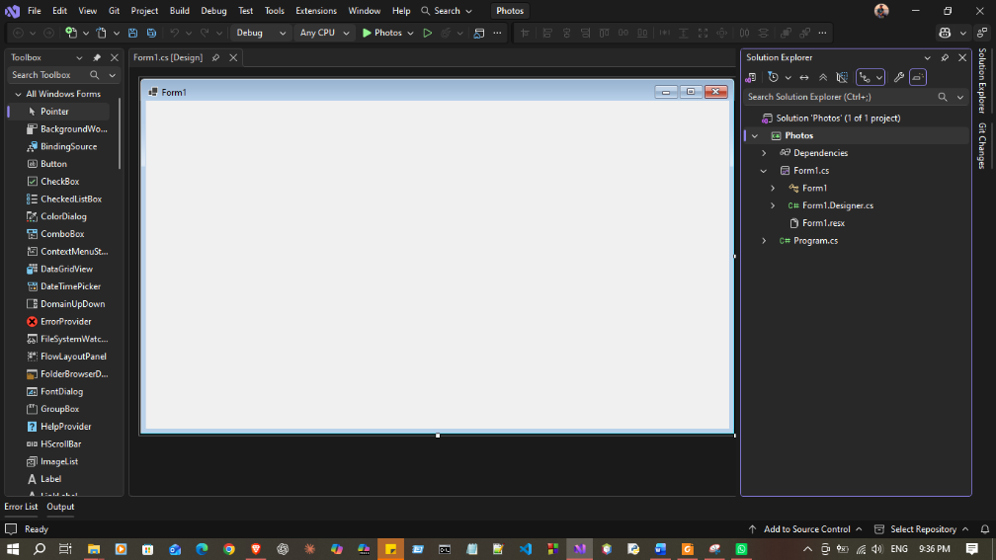
  - Create a new C# Windows Form Application project named Photos.
  - Next, rename the Form1.cs file as LoadPhotos.cs.
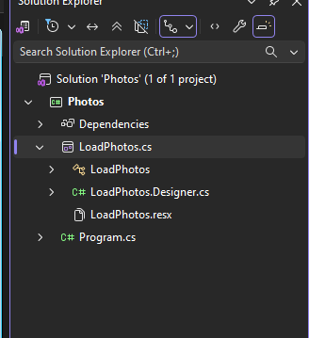
  - Add the following to the design with the given properties:

 | Label | Picture Box | Button | Text Box
Name | Label | PbxPhoto | BtnLoad | TextBox
Text | Select a picture | - | &Load | -
Text Formatting | 12pt, Bold | - | - | -
BackColor | - | ActiveCaption | - | -
Tab Index | - | - | 1 | -
Border Style | - | Fixed3D | - | -

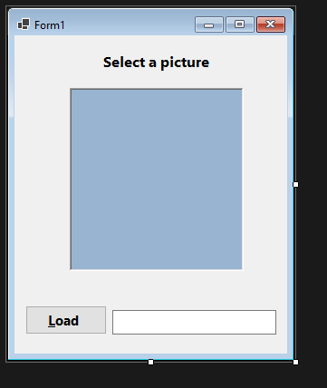
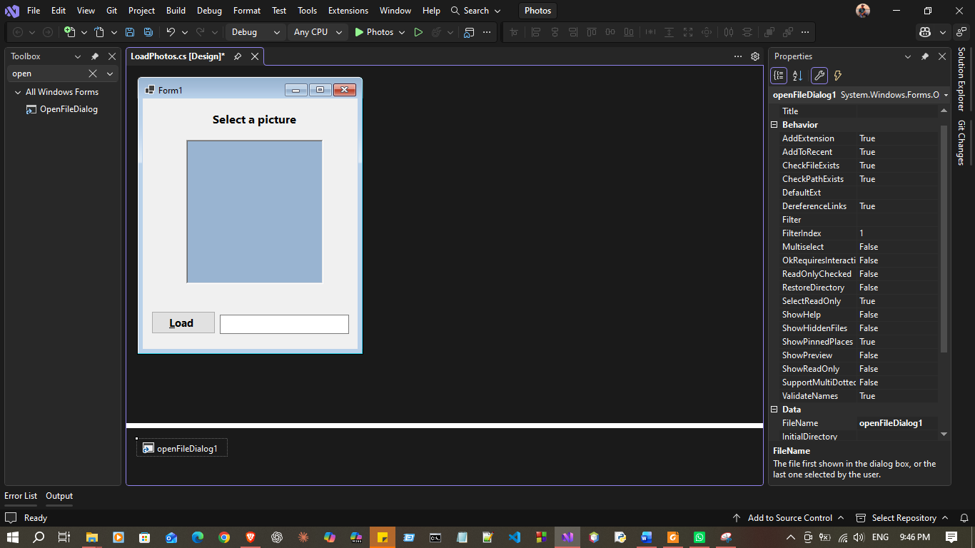
  - Load an image into the picture box using OpenFileDialog class. This functionality will allow to browse for images from any locations in the computer.
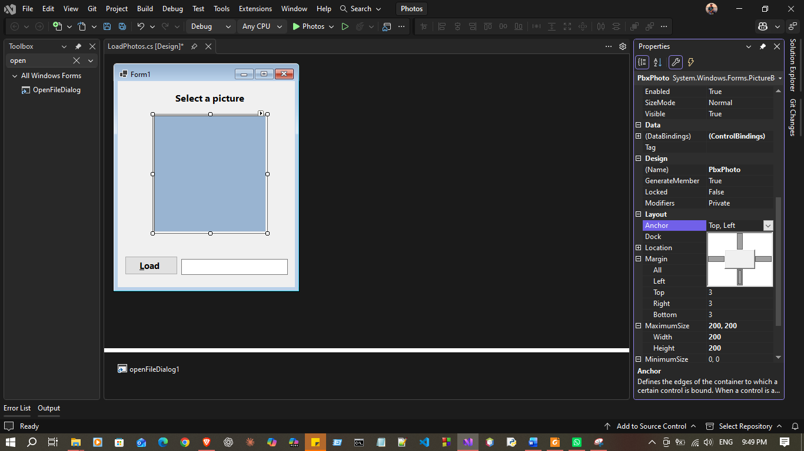
  - Use Anchor Property to resize the form. Set Anchor property to Top, Bottom, Left and Right.

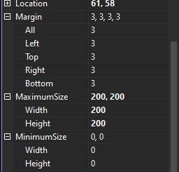
  - Also, assign the values “200, 200” for the minimum size property of the picture box.

PictureBox
Name = PbxPhoto
BackColor = ActiveCaption
BorderStyle = Fixed3D
SizeMode = StretchImage
MinimumSize = 200,200
Anchor = Top, Bottom, Left, Right

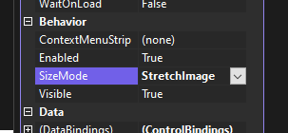
Code:
namespace Photos{
public partial class LoadPhotos : Form{
public LoadPhotos(){
InitializeComponent();
}

private void BtnLoad_Click(object sender, EventArgs e){
OpenFileDialog ofd = new OpenFileDialog();

ofd.Filter = "Image Files|*.jpg;*.jpeg;*.png;*.bmp;*.gif";

if (ofd.ShowDialog() == DialogResult.OK){
TextBox.Text = ofd.FileName;
PbxPhoto.Image = Image.FromFile(ofd.FileName);
}
}

}
}
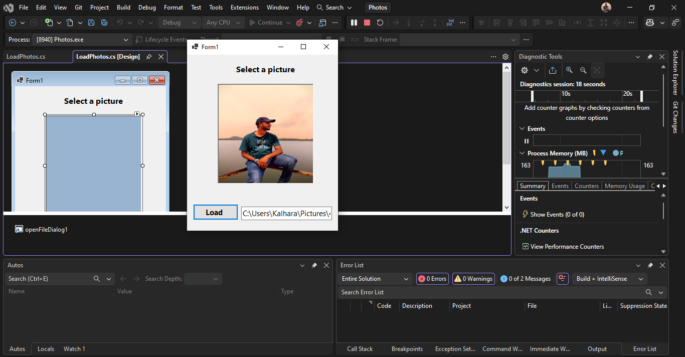
  - Compile and run the project.

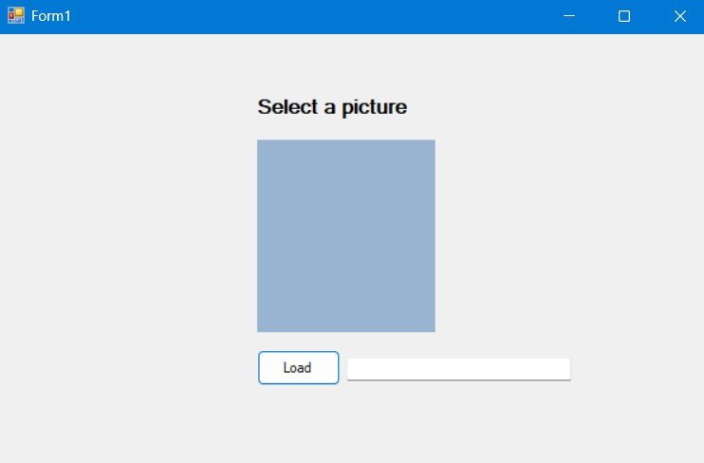

TRY:

Extend the Photos project by adding a second Button and a PictureBox control to the application.
Name the button BtnLoad2 and set the text on the label to “Loa&d2” with a Click event handler that loads a second image and displays it in the second PictureBox named PbxPhoto2. You can use the anchor property for these, or set the Dock property for the first picture box to DockStyle.Top, and for the second picture box to DockStyle.Fill.

Step 1: Add Controls
Drag these controls onto the form:

Button 2
Property | Value
Name | BtnLoad2
Text | Loa&d2
TabIndex | 2

PictureBox 2
Property | Value
Name | PbxPhoto2
BackColor | ActiveCaption
BorderStyle | Fixed3D
SizeMode | StretchImage
MinimumSize | 200,200

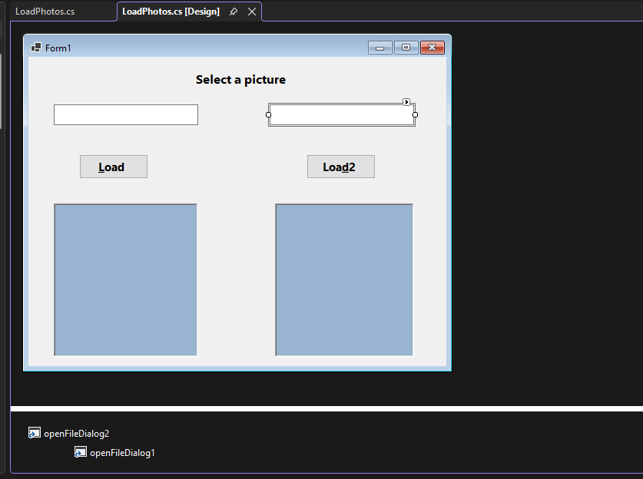
Code:

using System.Security.Cryptography;

namespace Photos{
public partial class LoadPhotos : Form{
public LoadPhotos(){
InitializeComponent();
}

private void BtnLoad_Click(object sender, EventArgs e){
openFileDialog1.Title = "Select First Image";
openFileDialog1.Filter =
"Image Files|*.jpg;*.jpeg;*.png;*.bmp;*.gif";

if (openFileDialog1.ShowDialog() == DialogResult.OK)
{
TextBox.Text = openFileDialog1.FileName;
PbxPhoto.Image =
Image.FromFile(openFileDialog1.FileName);
}
}

private void BtnLoad2_Click(object sender, EventArgs e)
{

openFileDialog2.Title = "Select Second Image";
openFileDialog2.Filter =
"Image Files|*.jpg;*.jpeg;*.png;*.bmp;*.gif";

if (openFileDialog2.ShowDialog() == DialogResult.OK){
PbxPhoto2.Image =
Image.FromFile(openFileDialog2.FileName);
TextBox2.Text = openFileDialog2.FileName;
PbxPhoto2.Image =
Image.FromFile(openFileDialog2.FileName);
}
}

}
}

