Lab Sheet 01
Title: Installation of UML tool
Aims: To install UML tool and design
Task 01: Download setup file
- Tool is BOUML – Open source.
- Official website - https://www.bouml.fr/download.html

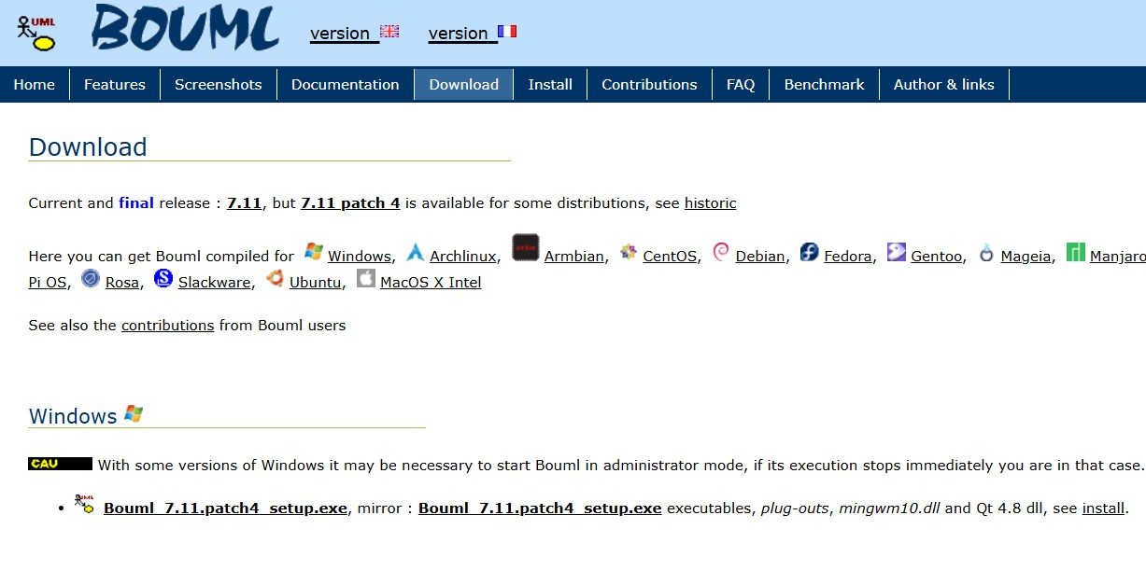

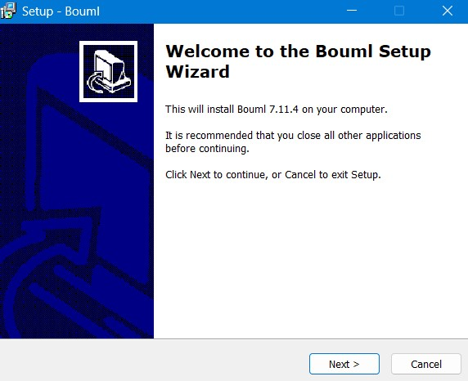
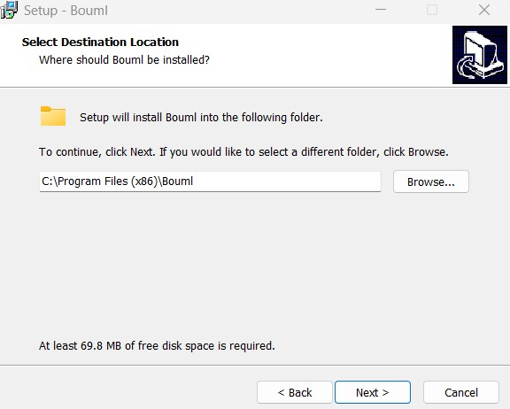

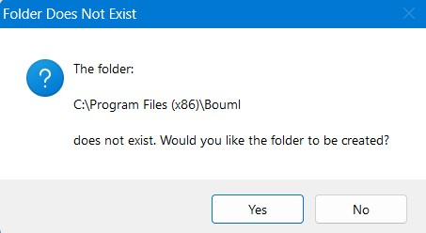
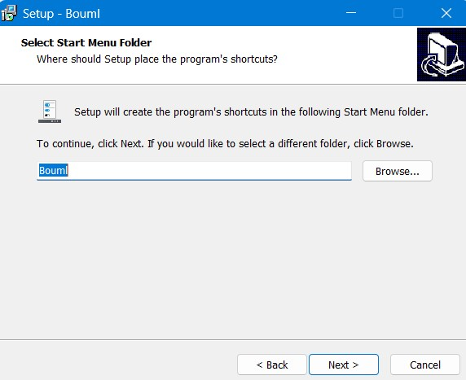
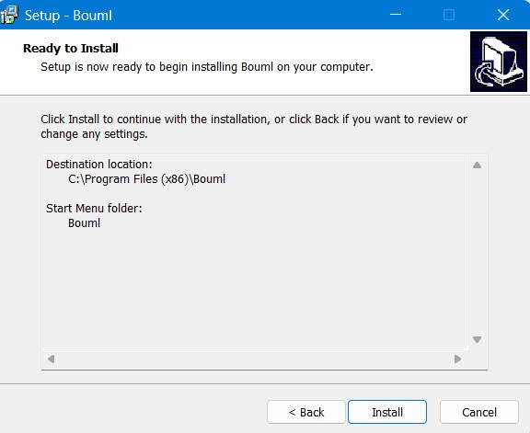

- Download the appropriate file (.pdf or .tar.gz) of the BOUML reference (user) manual in https://www.bouml.fr/documentation.html

Use Case Diagrams • Use Cases
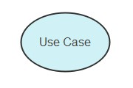
The use cases tell us about how the system will perform in different cases. These use cases are made by keeping in mind what a user wants from the system. Depending on the user's wants and needs, the use cases are made, and then the system is developed and tested according to these cases.

• Actors
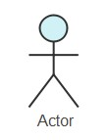
An actor is simply the end-user. That can be anyone, a human, an organization, a machine, or anything. The actors are placed with different cases on the diagram to illustrate how the user will interact with the system.

• Subsystems
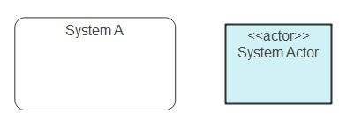

The subsystems in the UML are the different fixed systems that behave independently in a system.
They are used in UML diagrams to represent different units in the system.

• Relationships in the UseCase Diagram
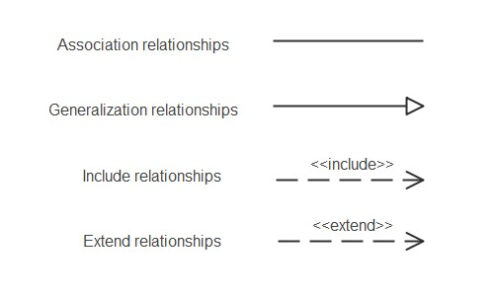
They show the relationship between the model elements. It shows the behavior between model elements.
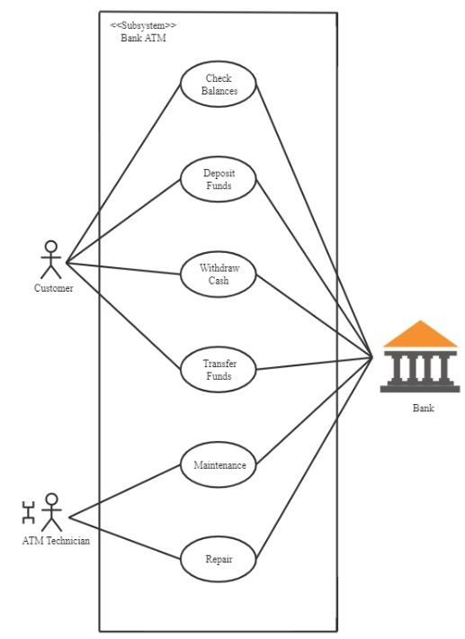

Task 01

Design a Use Case Diagram for an Online Library System that provides book management and borrowing functionalities. The system has two primary actors: Library Users and Administrators. Library users should be able to search for books, borrow books, return books, and reserve books if they are not currently available. Administrators have additional privileges, including adding new books, updating book details, and removing books from the system. Users must log in to access their accounts, while administrators have a separate authentication process.
Your task is to:
- Identify the actors and their roles.
- Define the use cases that represent the system's functionality.
- Draw the Use Case Diagram using BOUML, ensuring proper relationships between actors and use cases.

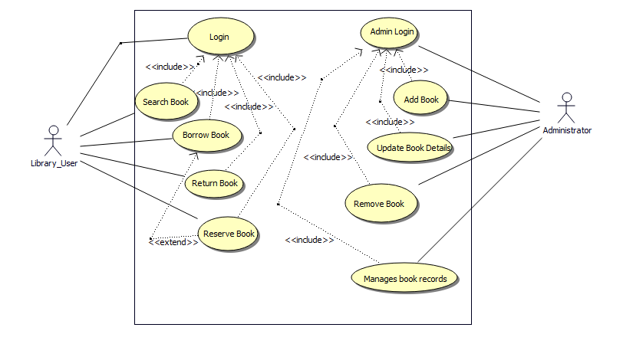

Task 02
Design a Use Case Diagram for an Online Food Ordering System that allows customers to place food orders from a restaurant. The system has two main actors: Customers and Restaurant Staff. Customers should be able to browse the menu, place orders, make payments, track order status, and cancel orders if needed. Restaurant staff can manage orders, update order status, and handle cancellations. Additionally, the system should notify customers when their order is ready for pickup or out for delivery.
Your task is to:
- Identify the actors and their roles in the system.
- Define the use cases that describe the system's key functionalities.
- Draw the Use Case Diagram using BOUML, ensuring proper relationships between actors and use cases.

