Lab Sheet 03
Title: Designing sequence and activity diagrams
Aims:
- To design sequence diagram and activity diagram in BOUML tool Note:
Synchronous Messages
- The sender waits for the receiver to process the message before continuing execution.
- The receiver must complete the requested action and return control before the sender can proceed.
- It is represented by a solid line with a filled arrowhead.
Asynchronous Messages
- The sender does not wait for a response from the receiver.
- The sender continues its execution immediately, without waiting for the receiver to finish processing.
- It is represented by a solid line with an open (stick) arrowhead.
Return Message (Reply Message)
- Shows data or control returning from receiver to sender.
- Only used as a reply to a synchronous call, not for prompts or UI. User prompts are NOT return messages. Prompts are normal synchronous messages.
- It is represented by a dashed line with an open (stick) arrowhead.

Task 01: Design a Sequence Diagram
Consider a scenario where a user is withdrawing cash from an ATM. The sequence starts with the user inserting their ATM card and entering their PIN. The system verifies the PIN, checks the account balance, and prompts the user to select a withdrawal amount. The ATM dispenses the cash and updates the account balance. The sequence involves interactions between the user, the ATM machine, the bank's database system, and the cash dispenser.
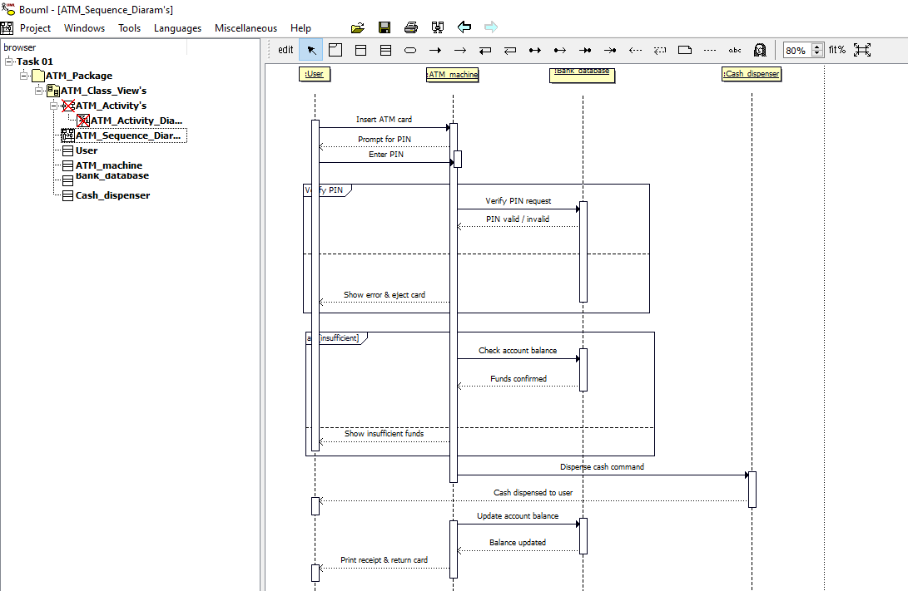

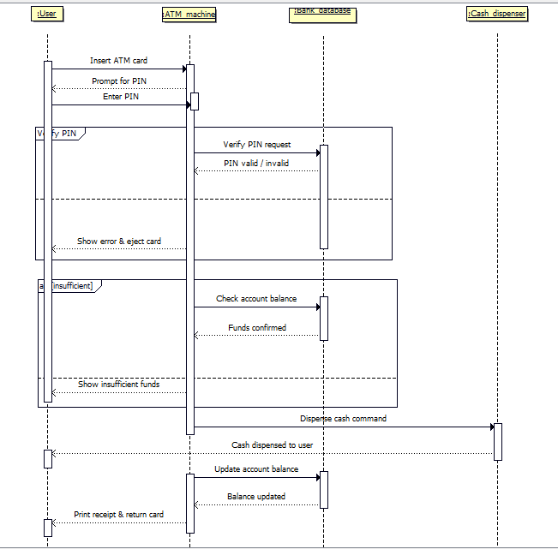

Task 02: Design a Sequence Diagram
Imagine a scenario where a user is checking out items from an online store. The sequence starts with the user selecting items and adding them to the cart. They proceed to the checkout process, where they enter their shipping details and payment information. The system verifies the payment and processes the order. Finally, the user receives a confirmation of the order. This sequence involves interactions between the user interface, shopping cart system, payment gateway, and order processing system.
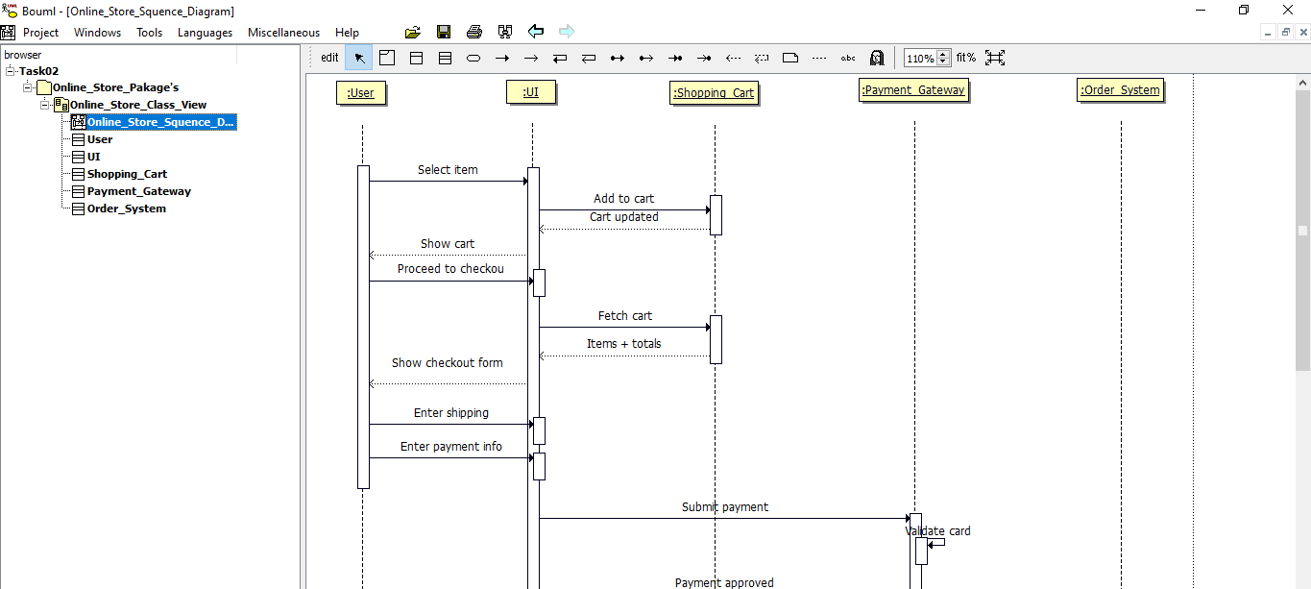

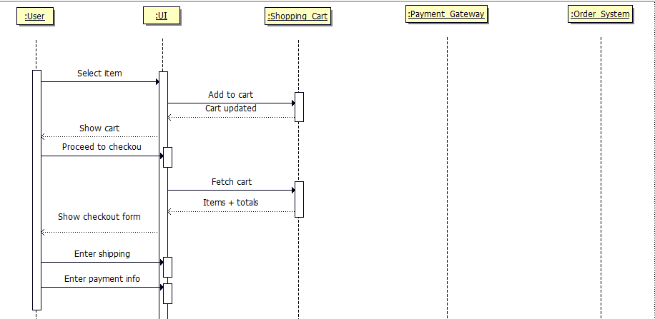

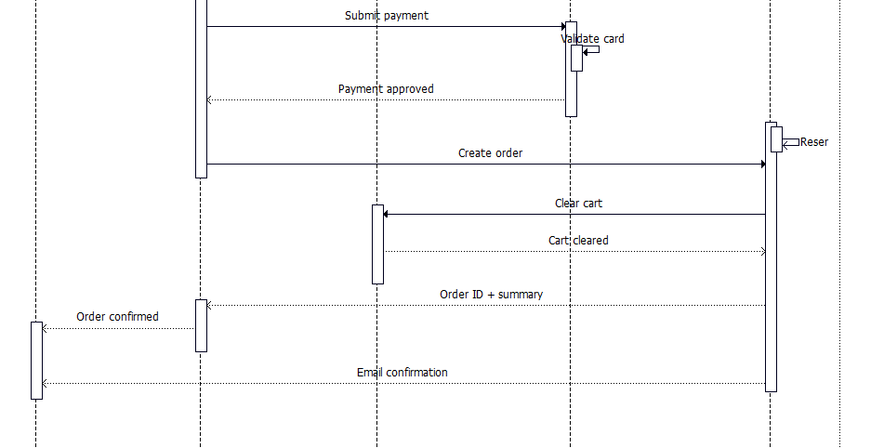

Task 03: Draw an Activity diagram
In the online checkout journey, the user initiates the checkout process after browsing and adding desired items to their cart. An activity diagram would detail the subsequent steps. First, they review the cart contents and confirm quantities. This might involve checking for any applicable discounts or entering coupon codes. Next, they enter their shipping information, specifying the delivery address. The system may offer alternative shipping options with varying costs and estimated delivery times. Following this, the user securely enters their payment details. The system then verifies the payment information with a secure payment gateway, ensuring sufficient funds and authorization. Upon successful verification, the order is processed. The system creates an order record, updates inventory levels for purchased items, and generates a confirmation email sent to the user. This email typically summarizes the order details, including items, shipping information, and estimated delivery timeframe. The activity diagram would visually represent this flow, highlighting decision points like applying coupon codes and showing the seamless transition between activities until the successful order placement.

