UCT41042 - PRACTICAL FOR INTRODUCTION TO SMART SYSTEMS
Continous Assignment
Reg.No:SEU/IS/20/ICT/084 Date:2026/06/04
Q01.
Circuit design in Wokwi:
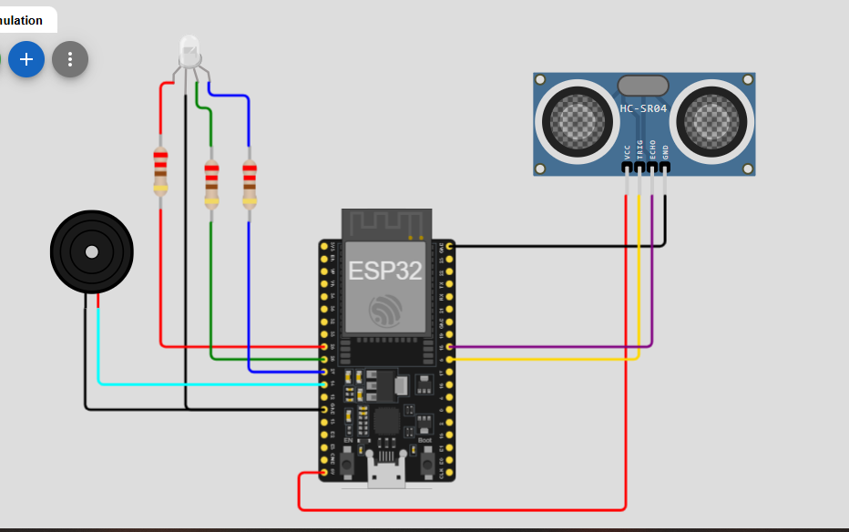
Code:
#define BLYNK_TEMPLATE_ID "TMPL6q3adVhDC"
#define BLYNK_TEMPLATE_NAME "Smart Parking Assistant"
#define BLYNK_AUTH_TOKEN "qewiSQH7C5NzYRaUZ18ZYXtl_wXvXZKv"

#include <WiFi.h>
#include <WiFiClient.h>
#include <BlynkSimpleEsp32.h>

// WiFi details
char ssid[] = "Wokwi-GUEST";
char pass[] = "";

// Sensor pins
#define TRIG_PIN 5
#define ECHO_PIN 18

// RGB LED pins
#define RED_LED 25
#define GREEN_LED 26
#define BLUE_LED 27

// Buzzer pin
#define BUZZER 14

void setup()
{
// Start serial monitor
Serial.begin(115200);

// System start message
Serial.println("SMART PARKING ASSISTANT");
Serial.println("System Testing Started");

// Set sensor pins
pinMode(TRIG_PIN, OUTPUT);
pinMode(ECHO_PIN, INPUT);

// Set LED pins
pinMode(RED_LED, OUTPUT);
pinMode(GREEN_LED, OUTPUT);
pinMode(BLUE_LED, OUTPUT);

// Set buzzer pin
pinMode(BUZZER, OUTPUT);

// Connect to WiFi and Blynk
Serial.println("Connecting...");
Blynk.begin(BLYNK_AUTH_TOKEN, ssid, pass);

// Check Blynk connection
if (Blynk.connected())
{
Serial.println("Blynk Connected");
}
else
{
Serial.println("Blynk Not Connected");
}
}

void loop()
{
// Run Blynk
Blynk.run();

long duration;
float distance;

// Send ultrasonic signal
digitalWrite(TRIG_PIN, LOW);
delayMicroseconds(2);

digitalWrite(TRIG_PIN, HIGH);
delayMicroseconds(10);

digitalWrite(TRIG_PIN, LOW);

// Read echo signal
duration = pulseIn(ECHO_PIN, HIGH);

// Calculate distance
distance = duration * 0.034 / 2;

// Show distance
Serial.print("Distance : ");
Serial.print(distance);
Serial.println(" cm");

// Send distance to Blynk
Blynk.virtualWrite(V0, distance);

// Danger zone
if (distance < 10){
// Red LED ON
digitalWrite(RED_LED, HIGH);
digitalWrite(GREEN_LED, LOW);
digitalWrite(BLUE_LED, LOW);

// Fast buzzer
digitalWrite(BUZZER, HIGH);
delay(100);
digitalWrite(BUZZER, LOW);
delay(100);

// Update Blynk
Blynk.virtualWrite(V1, 255);
Blynk.virtualWrite(V2, 0);
Blynk.virtualWrite(V3, 0);
Blynk.virtualWrite(V4, "DANGER");

Serial.println("Status : DANGER");
}

// Caution zone
else if (distance >= 10 && distance <= 30){
// Yellow LED ON
digitalWrite(RED_LED, HIGH);
digitalWrite(GREEN_LED, HIGH);
digitalWrite(BLUE_LED, LOW);

// Slow buzzer
digitalWrite(BUZZER, HIGH);
delay(500);
digitalWrite(BUZZER, LOW);
delay(500);

// Update Blynk
Blynk.virtualWrite(V1, 0);
Blynk.virtualWrite(V2, 255);
Blynk.virtualWrite(V3, 0);
Blynk.virtualWrite(V4, "CAUTION");

Serial.println("Status : CAUTION");
}

// Safe zone
else{
// Green LED ON
digitalWrite(RED_LED, LOW);
digitalWrite(GREEN_LED, HIGH);
digitalWrite(BLUE_LED, LOW);

// Buzzer OFF
digitalWrite(BUZZER, LOW);

// Update Blynk
Blynk.virtualWrite(V1, 0);
Blynk.virtualWrite(V2, 0);
Blynk.virtualWrite(V3, 255);
Blynk.virtualWrite(V4, "SAFE");

Serial.println("Status : SAFE");

delay(500);
}
}

Serial Monitor output:
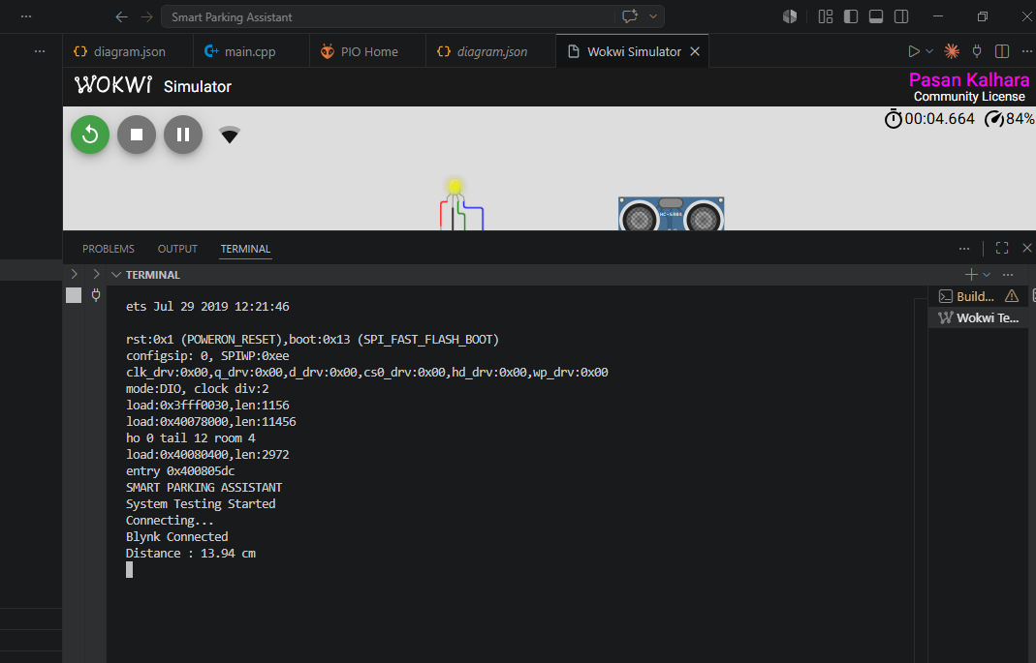

Blynk Web Dashboard:
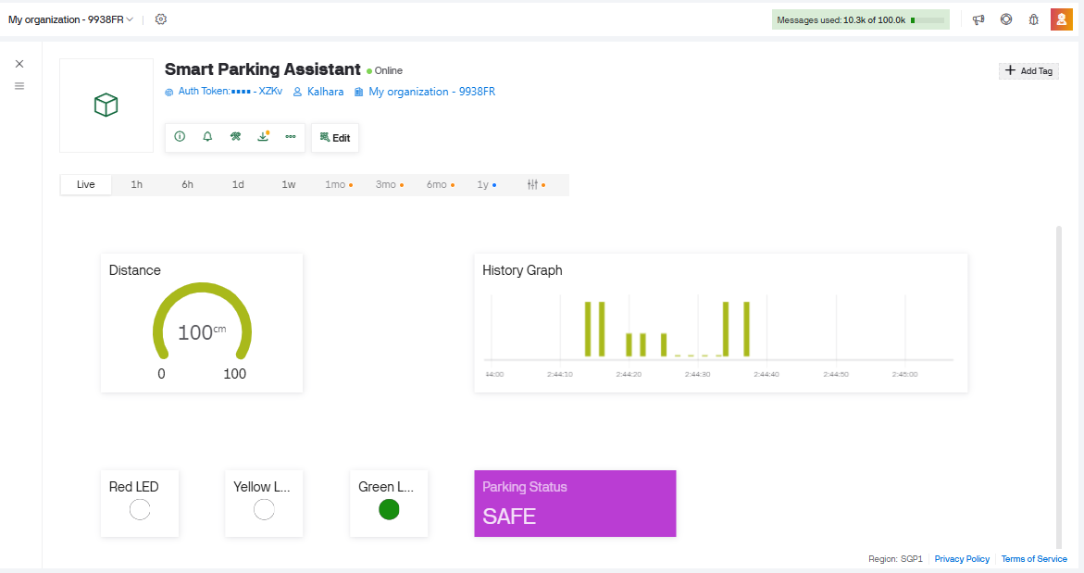
Q02.
Circuit design in Wokwi:
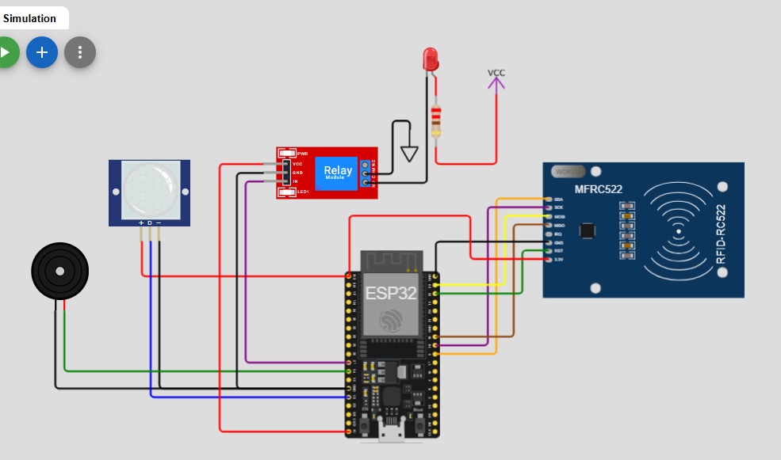

Code:
#define BLYNK_TEMPLATE_ID "TMPL6Sc1JV5Xb"
#define BLYNK_TEMPLATE_NAME "Intrusion Detection System"
#define BLYNK_AUTH_TOKEN "rXIb-8A1eqDXVzU7wYKu-1nfId4IGYfI"

#include <Arduino.h>
#include <WiFi.h>
#include <WiFiClient.h>
#include <BlynkSimpleEsp32.h>
#include <SPI.h>
#include <MFRC522.h>

char ssid[] = "Wokwi-GUEST";
char pass[] = "";

#define PIR_PIN 13
#define BUZZER 14
#define DOOR_RELAY 27

#define SS_PIN 5
#define RST_PIN 22

MFRC522 rfid(SS_PIN, RST_PIN);

bool intrusion = false;
unsigned long intrusionTime = 0;

void setup()
{
Serial.begin(115200);

pinMode(PIR_PIN, INPUT);
pinMode(BUZZER, OUTPUT);
pinMode(DOOR_RELAY, OUTPUT);

SPI.begin();
rfid.PCD_Init();

Blynk.begin(BLYNK_AUTH_TOKEN, ssid, pass);

Serial.println("System Ready");
}

void loop()
{
Blynk.run();

int motion = digitalRead(PIR_PIN);

if (motion == HIGH && intrusion == false)
{
intrusion = true;
intrusionTime = millis();

digitalWrite(BUZZER, HIGH);

Serial.println("Intrusion Alert!");

Blynk.virtualWrite(V0, 255);
}

if (intrusion == true)
{
if (rfid.PICC_IsNewCardPresent() &&
rfid.PICC_ReadCardSerial())
{
String uid = "";

for (byte i = 0; i < rfid.uid.size; i++)
{
uid += String(rfid.uid.uidByte[i], HEX);
}

Serial.print("Card UID: ");
Serial.println(uid);

// Replace with your RFID UID
if (uid == "1234")
{
digitalWrite(DOOR_RELAY, HIGH);

Blynk.virtualWrite(V1, "Access Granted");

Serial.println("Access Granted");

digitalWrite(BUZZER, LOW);

intrusion = false;

delay(5000);

digitalWrite(DOOR_RELAY, LOW);
}
}

if (millis() - intrusionTime > 10000)
{
Blynk.virtualWrite(V1, "Access Denied");

Serial.println("Access Denied");

digitalWrite(BUZZER, LOW);

Blynk.virtualWrite(V0, 0);

intrusion = false;
}
}
}

Serial Monitor output:
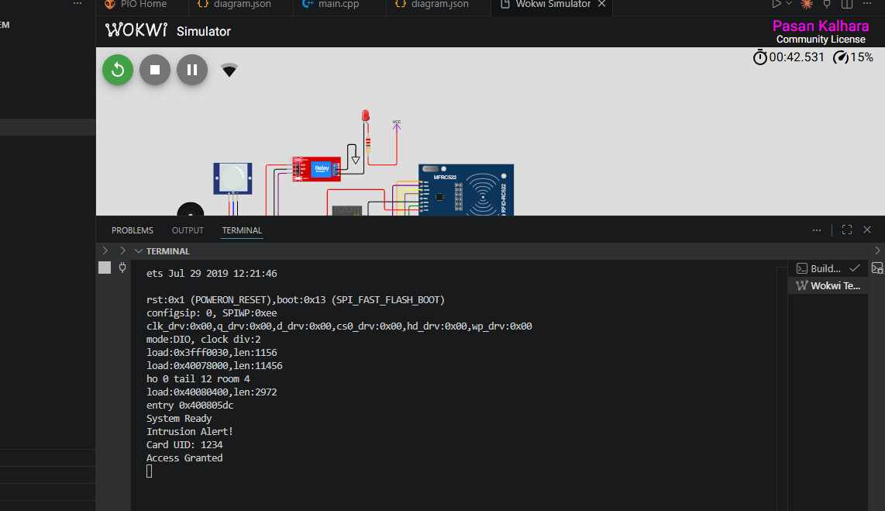

Blynk Web Dashboard:
