UCT41042 - PRACTICAL FOR INTRODUCTION TO SMART SYSTEMS
Assignment 02
Reg.No:SEU/IS/20/ICT/084 Name : P.R.P.S.Kalhara
Q01
Question 1 – Circuit
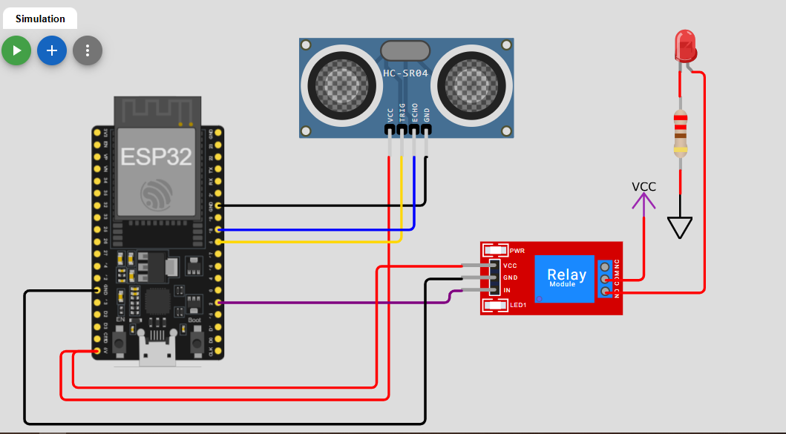
Question 1 – Code
#include <Arduino.h>
#include <WiFi.h>
#include <PubSubClient.h>

#define TRIG_PIN 5
#define ECHO_PIN 18
#define PUMP_PIN 2

#define WIFI_SSID "Wokwi-GUEST"
#define WIFI_PASSWORD ""

#define MQTT_BROKER "192.168.116.178"
#define MQTT_PORT 1883
#define MQTT_CLIENT "esp32-water-tank"

WiFiClient espClient;
PubSubClient mqtt(espClient);

const char *TOPIC_LEVEL = "home/tank/level";
const char *TOPIC_PUMP = "home/tank/pump";
const char *TOPIC_CMD = "home/tank/pump/set";

bool manualMode = false;

void callback(char *topic, byte *payload, unsigned int length){

String msg = "";
for (int i = 0; i < length; i++)
msg += (char)payload[i];
if (String(topic) == TOPIC_CMD){
if (msg == "ON"){
digitalWrite(PUMP_PIN, HIGH);
mqtt.publish(TOPIC_PUMP, "ON", true);
}
if (msg == "OFF"){
digitalWrite(PUMP_PIN, LOW);
mqtt.publish(TOPIC_PUMP, "OFF", true);
}
}
}

void connectWiFi(){
WiFi.begin(WIFI_SSID, WIFI_PASSWORD);
while (WiFi.status() != WL_CONNECTED){
delay(500);
Serial.print(".");
}
Serial.println("\nWiFi Connected");
}

void connectMQTT(){
while (!mqtt.connected()){
Serial.print("Connecting MQTT...");
if (mqtt.connect(MQTT_CLIENT)){
Serial.println("Connected");
mqtt.subscribe(TOPIC_CMD);
}else{

delay(2000);
}
}
}

float getDistance(){
digitalWrite(TRIG_PIN, LOW);
delayMicroseconds(2);
digitalWrite(TRIG_PIN, HIGH);
delayMicroseconds(10);
digitalWrite(TRIG_PIN, LOW);
long duration = pulseIn(ECHO_PIN, HIGH);
float distance = duration * 0.034 / 2;
return distance;
}

void setup(){
Serial.begin(115200);
pinMode(TRIG_PIN, OUTPUT);
pinMode(ECHO_PIN, INPUT);
pinMode(PUMP_PIN, OUTPUT);
connectWiFi();
mqtt.setServer(MQTT_BROKER, MQTT_PORT);
mqtt.setCallback(callback);
}

void loop(){
if (!mqtt.connected())
connectMQTT();
mqtt.loop();
static unsigned long lastPub = 0;
if (millis() - lastPub > 2000){

float distance = getDistance();

float level = ((200 - distance) / 200.0) * 100;

if (level < 0)
level = 0;
if (level > 100)
level = 100;

Serial.print("Distance: ");
Serial.print(distance);
Serial.print(" cm ");

Serial.print("Level: ");
Serial.print(level);
Serial.println("%");

mqtt.publish(TOPIC_LEVEL,String((int)level).c_str(),true);
if (level < 30){
digitalWrite(PUMP_PIN, HIGH);
mqtt.publish(TOPIC_PUMP, "Pump ON - Low Water Level",true);
}else if (level > 80){
digitalWrite(PUMP_PIN, LOW);
mqtt.publish(TOPIC_PUMP,"Tank Full",true);
}else{
digitalWrite(PUMP_PIN, LOW);
mqtt.publish(TOPIC_PUMP,"Normal Level",true);
}
lastPub = millis();
}
}

Question 1– Serial Monitor
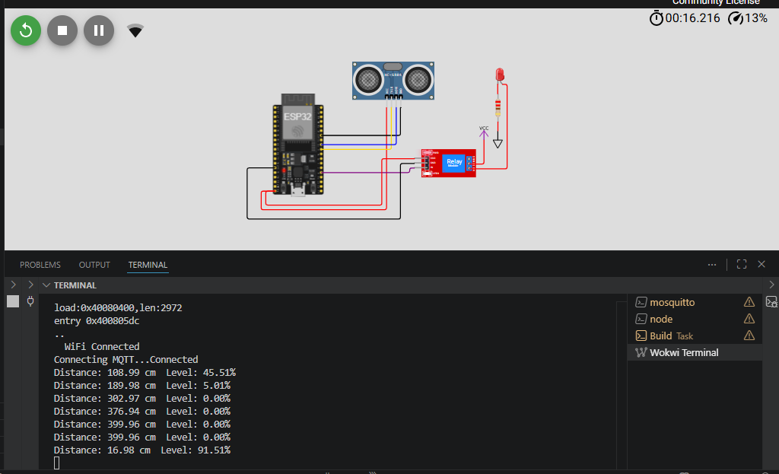

Question 1 – Node-RED Dashboard
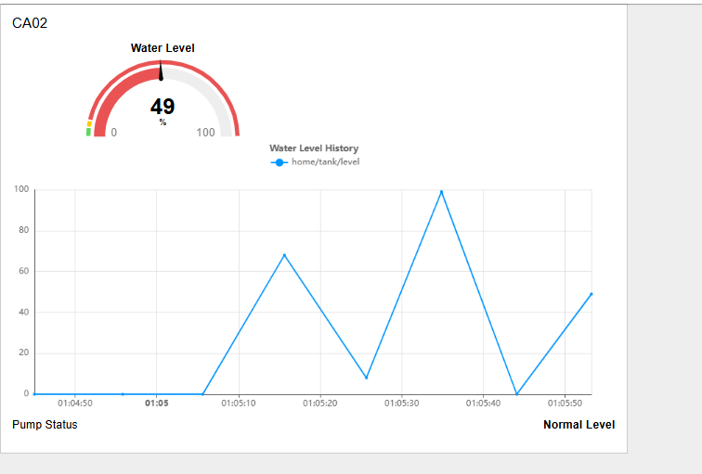
Q02
Question 2 – Circuit
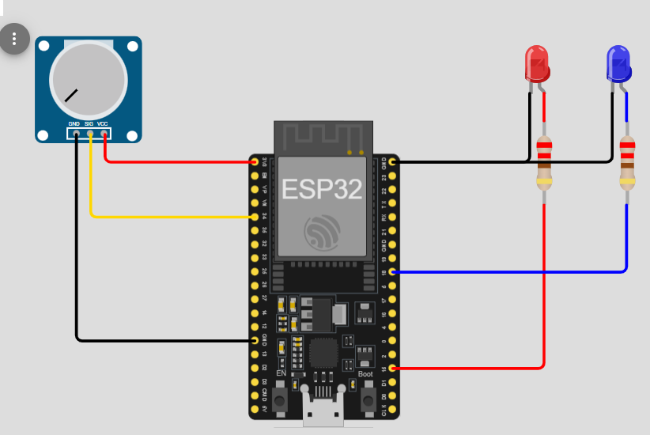

Question 2 – Code
#include <Arduino.h>
#include <WiFi.h>
#include <PubSubClient.h>

#define POT_PIN 34
#define LOAD1_PIN 15
#define LOAD2_PIN 18

#define WIFI_SSID "Wokwi-GUEST"
#define WIFI_PASSWORD ""

#define MQTT_BROKER "192.168.116.178"
#define MQTT_PORT 1883
#define MQTT_CLIENT "esp32-energy-monitor"

WiFiClient espClient;
PubSubClient mqtt(espClient);

const char *TOPIC_POWER = "home/energy/power";
const char *TOPIC_LOAD1 = "home/energy/load1";
const char *TOPIC_LOAD2 = "home/energy/load2";
const char *TOPIC_ALERT = "home/energy/alert";

const char *TOPIC_LOAD1_CMD = "home/energy/load1/set";
const char *TOPIC_LOAD2_CMD = "home/energy/load2/set";

bool autoShutdown = false;

void callback(char* topic, byte* payload, unsigned int length) {
String msg="";
for(int i=0;i<length;i++){
msg += (char)payload[i];
}
if(!autoShutdown){
if(String(topic)==TOPIC_LOAD1_CMD){
if(msg=="ON"){
digitalWrite(LOAD1_PIN,HIGH);
mqtt.publish(TOPIC_LOAD1,"ON",true);
}else{
digitalWrite(LOAD1_PIN,LOW);
mqtt.publish(TOPIC_LOAD1,"OFF",true);
}
}

if(String(topic)==TOPIC_LOAD2_CMD){
if(msg=="ON"){
digitalWrite(LOAD2_PIN,HIGH);
mqtt.publish(TOPIC_LOAD2,"ON",true);
}else{
digitalWrite(LOAD2_PIN,LOW);
mqtt.publish(TOPIC_LOAD2,"OFF",true);
}
}
}
}

void connectWiFi(){
WiFi.begin(WIFI_SSID,WIFI_PASSWORD);
while(WiFi.status()!=WL_CONNECTED){
delay(500);
Serial.print(".");
}
Serial.println("\nWiFi Connected");
}

void connectMQTT(){
while(!mqtt.connected()){
Serial.print("Connecting MQTT...");
if(mqtt.connect(MQTT_CLIENT)){
Serial.println("Connected");
mqtt.subscribe(TOPIC_LOAD1_CMD);
mqtt.subscribe(TOPIC_LOAD2_CMD);
}else{
delay(2000);
}
}
}

void setup(){
Serial.begin(115200);
pinMode(LOAD1_PIN,OUTPUT);
pinMode(LOAD2_PIN,OUTPUT);
connectWiFi();
mqtt.setServer(MQTT_BROKER,MQTT_PORT);
mqtt.setCallback(callback);
}

void loop(){
if(!mqtt.connected()){
connectMQTT();
}

mqtt.loop();
static unsigned long lastPub=0;
if(millis()-lastPub > 1000){
int rawValue = analogRead(POT_PIN);
int powerPercent = map(rawValue,0,4095,0,100);
Serial.print("Raw Value: ");
Serial.print(rawValue);
Serial.print(" Power: ");
Serial.print(powerPercent);
Serial.println("%");
mqtt.publish(TOPIC_POWER,String(powerPercent).c_str(),true);

if(powerPercent > 65){
autoShutdown = true;
digitalWrite(LOAD1_PIN,LOW);
mqtt.publish(TOPIC_LOAD1,"OFF",true);
mqtt.publish(TOPIC_ALERT,"High Power - Load 1 OFF",true);
}else{
autoShutdown = false;
mqtt.publish(TOPIC_ALERT,"Normal Power Usage",true);
}
mqtt.publish(TOPIC_LOAD1,digitalRead(LOAD1_PIN) ? "ON":"OFF",true);
mqtt.publish(TOPIC_LOAD2,digitalRead(LOAD2_PIN) ? "ON":"OFF",true);
lastPub = millis();
}
}

Question 2– Serial Monitor
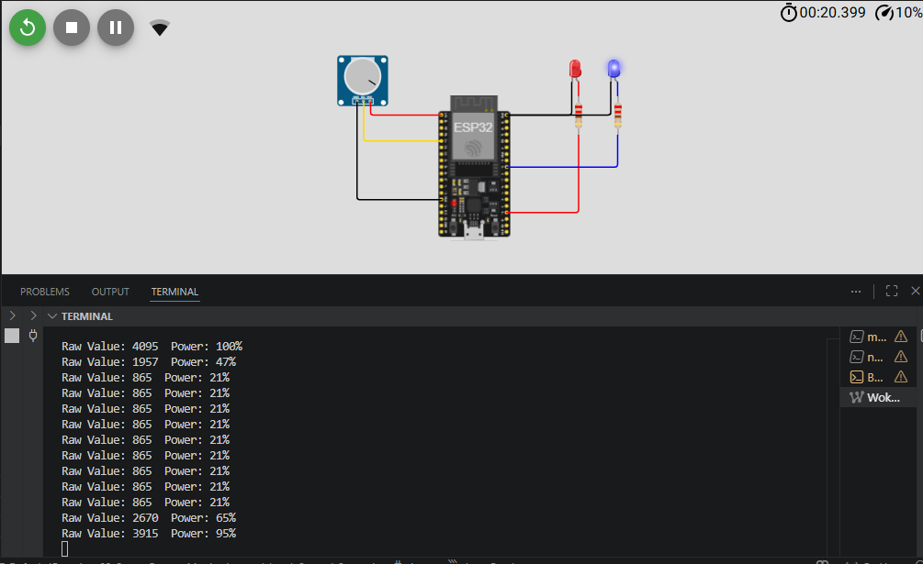
Question 2 – Node-RED Dashboard
