Lab Sheet 10
Title: IoT Sensor Data Logging System using ESP32 and Google Sheets.
Aims:
- To design and implement an IoT-based data logging system using an ESP32 microcontroller and a temperature sensor, where real-time sensor data is transmitted over Wi-Fi and stored in a Google Sheets spreadsheet. This system demonstrates cloud-based data storage, real-time monitoring, and basic IoT integration using HTTP requests and Google Apps Script.
Task 01: IoT Sensor Data Logging System Setup
- Project Setup in Wokwi / VS Code
  - Name the project SensorData_ESP32_GoogleSheet.
- Circuit Design
  - Sensor Connection
    - Connect the DS18B20 (One-Wire Digital Temperature Sensor) to the ESP32.
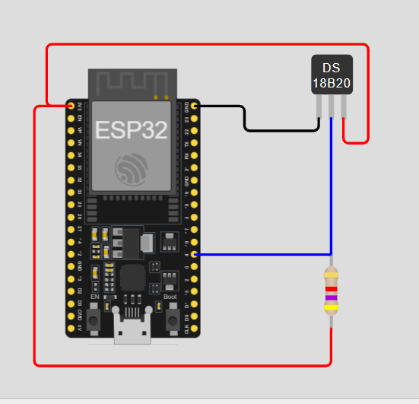
- Library Integration
  - WiFi (Built-in ESP32 library)
  - HTTPClient (Built-in ESP32 library)
  - OneWire (External library)
  - DallasTemperature (External library)

- Google Sheets Configuration
  - Create a new Google Sheet
  - Name the sheet ESP32_Sensor_Data
  - Create the following column headers:
    - Date
    - Time
    - Sensor Value
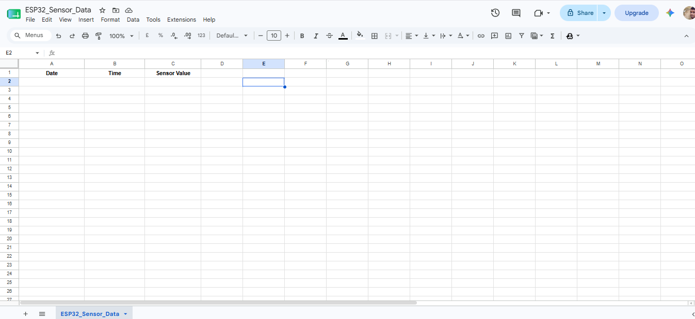

  - Open Google Apps Script from the Extensions menu
  - Write a script to receive HTTP GET/POST requests from ESP32
var sheet = SpreadsheetApp.getActiveSpreadsheet().getActiveSheet();

function doGet(e)
{
var date = new Date();

var sensor = e.parameter.temp;

sheet.appendRow([
Utilities.formatDate(date,"GMT+5:30","yyyy-MM-dd"),
Utilities.formatDate(date,"GMT+5:30","HH:mm:ss"),
sensor
]);

return ContentService.createTextOutput("Success");
}

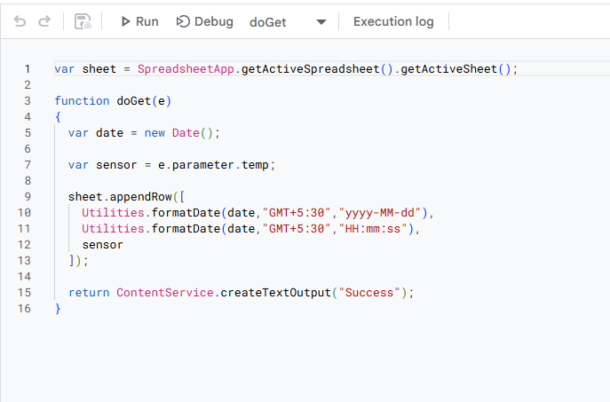

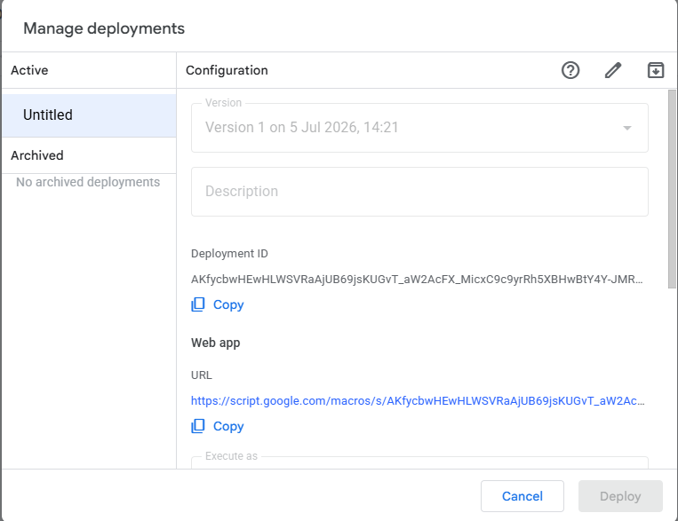
  - Deploy the script as a Web App

  - Set access permission to Anyone
  - Copy the generated Web App URL
https://script.google.com/macros/s/AKfycbwHEwHLWSVRaAjUB69jsKUGvT_aW2AcFX_MicxC9c9yrRh5XBHwBtY4Y-JMR38Uok4r/exec
- Programming Logic Development in Wokwi / VS Code
  - Initialize Serial Monitor
  - Initialize Wi-Fi connection
  - Initialize the DS18B20 sensor
  - Read temperature values at regular intervals
  - Send sensor data to Google Sheets using an HTTP requestData should be sent automatically at a fixed time interval (e.g., every 2 seconds)
    - Each sensor reading should be stored as a new row in Google Sheets
Code:
#include <Arduino.h>
#include <WiFi.h>
#include <WiFiClientSecure.h>
#include <HTTPClient.h>
#include <OneWire.h>
#include <DallasTemperature.h>

const char* ssid = "Wokwi-GUEST";
const char* password = "";

String scriptURL = "https://script.google.com/macros/s/AKfycbwHEwHLWSVRaAjUB69jsKUGvT_aW2AcFX_MicxC9c9yrRh5XBHwBtY4Y-JMR38Uok4r/exec";

// DS18B20 Data Pin
#define ONE_WIRE_BUS 4

OneWire oneWire(ONE_WIRE_BUS);

DallasTemperature sensors(&oneWire);

void setup()
{
Serial.begin(115200);

sensors.begin();

WiFi.begin(ssid, password);

Serial.print("Connecting");

while (WiFi.status() != WL_CONNECTED)
{
delay(500);
Serial.print(".");
}

Serial.println();
Serial.println("WiFi Connected");
}

void loop()
{
sensors.requestTemperatures();

float temp = sensors.getTempCByIndex(0);

Serial.print("Temperature : ");
Serial.print(temp);
Serial.println(" °C");

if (WiFi.status() == WL_CONNECTED)
{
WiFiClientSecure client;
client.setInsecure();

HTTPClient http;

String url = scriptURL + "?temp=" + String(temp);

http.setFollowRedirects(HTTPC_FORCE_FOLLOW_REDIRECTS);
http.begin(client, url);

int httpCode = http.GET();

Serial.print("HTTP Response : ");
Serial.println(httpCode);

http.end();
}

delay(2000);
}
- Simulation & Testing in Wokwi / VS Code
  - Simulate the circuit in Wokwi
  - Verify temperature readings in the Serial Monitor
  - Confirm real-time data entries in Google Sheets

