Lab Sheet 01
Supportive Document for VS code
Title: Create and Run ESP32 Project using Wokwi Simulator and platformIO extension in Visual Studio Code.
Part A: Setup Wokwi in Visual Studio Code

- Install Required Extensions in VS Code
  - Open Visual Studio Code.
  - Go to Extensions.
  - Install the following:
    - Wokwi Simulator
    - PlatformIO
- Activate Wokwi License
  - Press F1 to open Command Palette.
  - Type and select: Wokwi: Request a new License
  - Click Open when prompted.
  - It will open your browser. Log in to your Wokwi account.
  - Click GET YOUR LICENSE.
  - Return to VS Code and confirm the license activation.
Part B: Create a New ESP32 Project in VS Code 1. Open the PlatformIO sidebar (ant icon on the left).
- Click on New Project.
- Fill in the details:
  - Name: ESP32-FirstProject
  - Board: Espressif ESP32 Dev Module
  - Framework: Arduino
  - Choose your desired location → Click Finish.

- Wait until PlatformIO finishes initializing the project.

Part C: Add Wokwi Simulation Support
After the project is created, you need to add two important files for Wokwi:
- In the root of your project, create a new file named wokwi.toml and paste the following: [wokwi] version = 1 firmware = ".pio/build/esp32dev/firmware.bin" elf = ".pio/build/esp32dev/firmware.elf"
- Create a diagram.json file in the root to define hardware.
- Right click diagram.json file and select open with, then select Text Editor.
- Copy and paste here, the code from digram.json file in Wokwi site.
Part D: Add the code for ESP32
- Open the file:
  - src/main.cpp
- Remove default codes except #include <Arduino.h>
- Copy and paste here, the code from sketch.ino file in Wokwi site.
- Save the file.

Part E: Build and Run the Simulation
- Press f1 → Click on PlatformIO:Build → (or press the ✓ icon at the bottom).
- After successful build, press F1 → type and select: Wokwi: Start Simulator
How to Add Libraries for ESP32 in Visual Studio Code using PlatformIO
Method: Using PlatformIO Library Manager
- In the PlatformIO sidebar, click on PIO Home → Open.
- In the PlatformIO Home page, click on the Libraries tab (on the left menu).
- In the search bar, type the name of the library you want to add.
  - Example: Type WiFiManager
- Find the correct library in the results (for WiFiManager, choose tzapu/WiFiManager).
- Click the Add to Project button.
- Select your current project from the list and click Add.
- PlatformIO will automatically add the library to your platformio.ini file.
- After adding the library, you can use it in your code like this:
    - #include <WiFiManager.h>
    - WiFiManager wm;
Lab Sheet No: 01
Title: Getting Started with ESP32 – Digital Input/Output and Wi-Fi Connectivity Basics
Aims: Introducing the fundamentals of ESP32 programming by developing and simulating digital input/output and Wi-Fi connectivity applications, including establishing Wi-Fi connections using both hardcoded credentials and the WiFiManager library, while using the Serial Monitor for debugging and real-time observation.
Tasks:
- Create and simulate ESP32 projects in the Wokwi simulator.
- Use the Serial Monitor for debugging and real-time observation.
- Connect the ESP32 to Wi-Fi using hardcoded SSID and password.
- Implement dynamic Wi-Fi configuration using the WiFiManager library.
- Combine Wi-Fi status with LED behavior for visual feedback and print connection details (IP address) only after successful connection.

ESP32
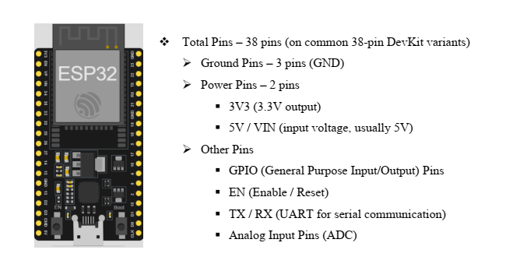

Exercise 1: Connecting ESP32 to Wi-Fi
Part A: Hardcoded Wi-Fi Connection (Simple Method)
- Create a new ESP32 project in Wokwi.
- Write the code for hardcoded Wi-Fi connection using Wokwi-GUEST (open network, no password).
- Run the simulation and observe the Serial Monitor (connection progress dots followed by successful connection and IP address).
- Change the SSID to an incorrect name (e.g., "MyHomeWiFi") and observe the connection failure.
#include <Arduino.h>
#include <WiFi.h>

const char* ssid = "Wokwi-GUEST"; // FIXED
const char* password = "";

void setup() {
Serial.begin(115200);
delay(1000);

Serial.println("\nConnecting to WiFi...");
Serial.println(ssid);

WiFi.mode(WIFI_STA); // optional but good practice
WiFi.begin(ssid, password); // FIXED

int attempts = 0;

while (WiFi.status() != WL_CONNECTED && attempts < 50) {
Serial.print(".");
delay(500); // IMPORTANT FIX
attempts++;
}

if (WiFi.status() == WL_CONNECTED) {
Serial.println("\nConnected Successfully!");
Serial.print("IP Address: ");
Serial.println(WiFi.localIP());
} else {
Serial.println("\nFailed to connect to WiFi");
}
}

void loop() {
}

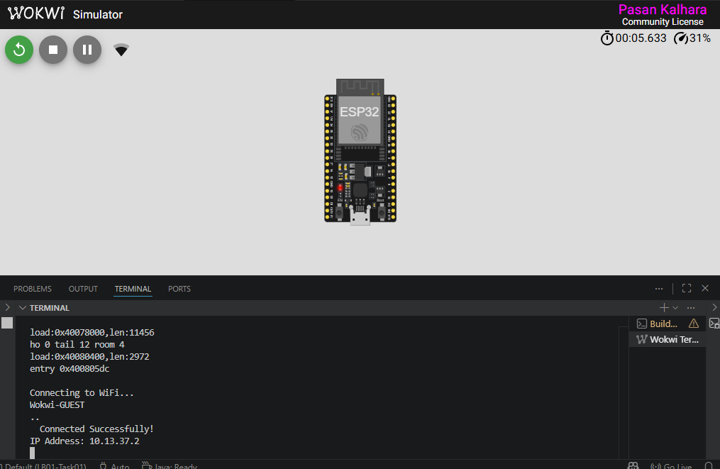
Part B: Using WiFiManager (Recommended for Real Projects)
- Add the WiFiManager library in Wokwi (via Library Manager).
- Write and run the WiFiManager code.
- Observe the Serial Monitor for portal creation and connection status.
- (For real hardware) Connect your phone/laptop to the “ESP32-Config-Portal” Access Point, open a browser at 192.168.4.1, and enter your Wi-Fi SSID and password.

#include <WiFi.h>
#include <WiFiManager.h>
WiFiManager wm;
void setup() {

Serial.begin(115200);
delay(10000);
Serial.println("\n\n ESP32 WiFi Manager Starting...");
WiFi.mode(WIFI_STA);
bool res = wm.autoConnect("ESP32-Config-Portal");
if(res){
Serial.println("Succesfully connected to Wi-Fi");
Serial.print("IP Address: ");
Serial.println(WiFi.localIP());
}else{
Serial.println("\nFailed to connect.");
}
}

void loop() {
delay(1000);
}
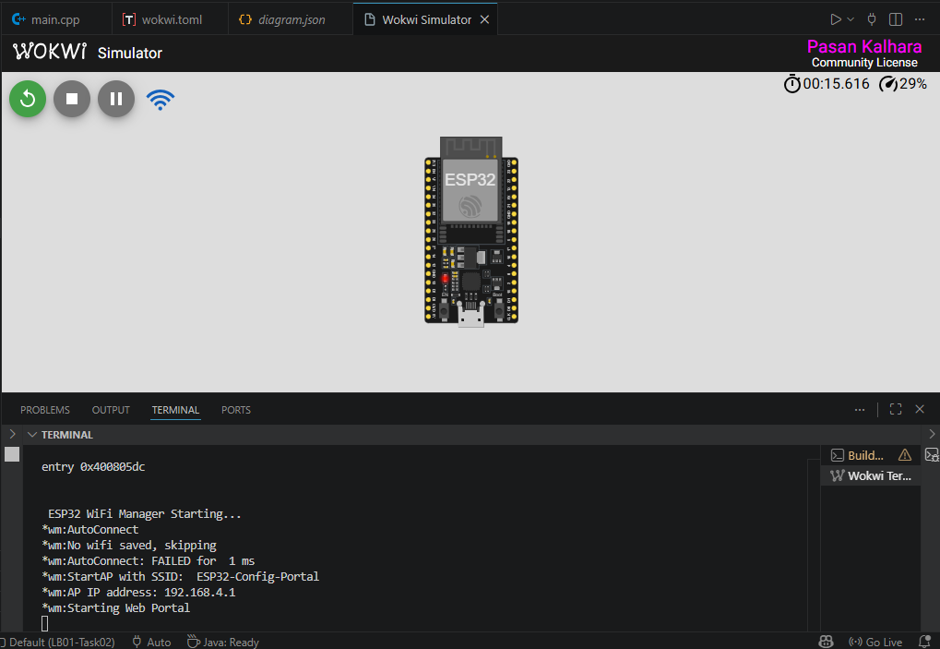
Part C: Combine Wi-Fi status with LED behavior for visual feedback.
- Blink the onboard LED slowly when not connected to Wi-Fi.
- Blink the LED fast or keep it ON when successfully connected.
- Print the IP address only after a successful connection.

#include <WiFi.h>
#include <WiFiManager.h>

WiFiManager wm;
#define LED_PIN 2 // ESP32 onboard LED (usually GPIO 2)
bool wasConnected = false;
bool ledState = false;
unsigned long previousMillis = 0;
const unsigned long DISCONNECTED_BLINK_MS = 1000;
const unsigned long CONNECTED_BLINK_MS = 200;

void blinkLed(unsigned long intervalMs) {
if (millis() - previousMillis >= intervalMs) {
previousMillis = millis();
ledState = !ledState;
digitalWrite(LED_PIN, ledState);
}
}

void setup() {
Serial.begin(115200);
delay(2000);
pinMode(LED_PIN, OUTPUT);
Serial.println("\n\nESP32 WiFi Manager Starting...");
WiFi.mode(WIFI_STA);
// Keep loop running while the portal is active so LED can blink.
wm.setConfigPortalBlocking(false);
// Start WiFi Manager (AP portal will open if no WiFi saved)
wm.autoConnect("ESP32-Config-Portal");
}

void loop() {
wm.process();
const bool isConnected = (WiFi.status() == WL_CONNECTED);

if (!isConnected) {
// Not connected -> slow blink
blinkLed(DISCONNECTED_BLINK_MS);
wasConnected = false;
} else {
// Connected -> fast blink
blinkLed(CONNECTED_BLINK_MS);

// Print IP only when connection is first established
if (!wasConnected) {
Serial.println("\nWi-Fi Connected Successfully!");
Serial.print("IP Address: ");
Serial.println(WiFi.localIP());
wasConnected = true;
}
}
}

