Lab Sheet 02
Title: Over-The-Air (OTA) Firmware Updates with ESP32
Aims: To introduce the concept, importance, and implementation of Over-The-Air (OTA) updates on the ESP32 platform. Students will learn how to enable wireless firmware updates, perform updates remotely and handle OTA events in IoT projects.
Tasks:
- Understand the OTA process and its benefits (remote maintenance, no physical access needed).
- Implement OTA using the ArduinoOTA library.
- Monitor and handle OTA events (start, progress, end, errors).
- Perform version updates and verify success.
- Explore visual feedback.

Key Concepts
- OTA: Firmware update delivered wirelessly (usually over Wi-Fi).
- Partitions: ESP32 uses separate OTA partitions to safely swap between old and new firmware.
- Workflow: Device connects to Wi-Fi → Listens for update → Downloads new binary → Validates → Reboots into new firmware.
- Advantages: Easy field updates, scalability for multiple devices.
- Risks: Interrupted updates, incompatible firmware, security vulnerabilities.
Exercise 1: Basic OTA Setup with ArduinoOTA
- Create a new ESP32 project in Wokwi or open in Arduino IDE.
- Connect a LED with a 220Ω current-limiting resistor to GPIO 2 (Pin 2) of the ESP32.
- Write a sketch that connects to Wi-Fi and enables ArduinoOTA.
- Include proper error handling and event callbacks.
- Upload the initial version (call it Version 1) and observe the Serial Monitor.

Expected Output in Serial Monitor:
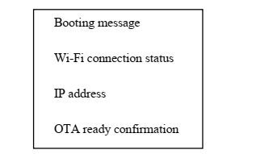
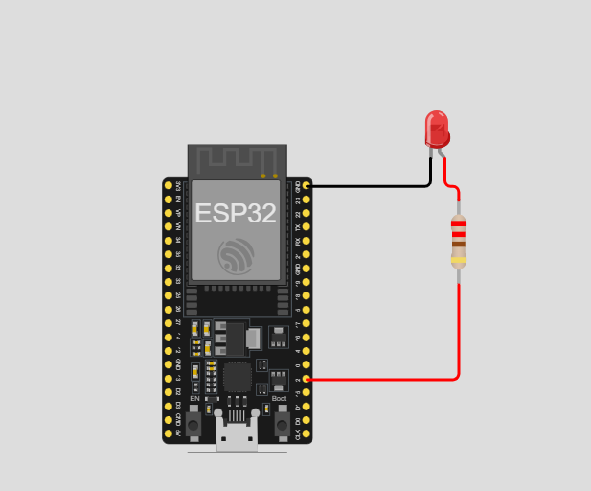

#include <Arduino.h>

#include <WiFi.h>
#include <ArduinoOTA.h>

// ─── Configuration ────────────────────────────────────────────────
const char* WIFI_SSID = "Kalara-WiFi"; // Replace with your Wi-Fi SSID
const char* WIFI_PASSWORD = "Pasa2001#"; // Replace with your Wi-Fi password

const char* FIRMWARE_VERSION = "1.0.0";
const char* HOSTNAME = "ESP32-OTA-v1";

const int LED_PIN = 2; // Built-in LED / GPIO 2 via 220Ω resistor
const int BLINK_DELAY = 1000; // 1 second blink interval (V1 pattern)

void printBanner();
void connectToWiFi();
void setupOTA();
void blinkLED();

// ─── Setup ────────────────────────────────────────────────────────
void setup() {
Serial.begin(115200);
delay(500);
pinMode(LED_PIN, OUTPUT);

printBanner();
connectToWiFi();
setupOTA();

Serial.println("✅ System ready. Waiting for OTA updates...");
Serial.println("─────────────────────────────────────────────");
}

// ─── Loop ─────────────────────────────────────────────────────────
void loop() {
ArduinoOTA.handle(); // Must be called in every loop iteration

blinkLED(); // V1: slow blink (1 second on/off)
}

// ─── Wi-Fi Connection ─────────────────────────────────────────────
void connectToWiFi() {
Serial.printf("\n📡 Connecting to Wi-Fi: %s\n", WIFI_SSID);
WiFi.mode(WIFI_STA);
WiFi.begin(WIFI_SSID, WIFI_PASSWORD);

int attempts = 0;
while (WiFi.status() != WL_CONNECTED) {
delay(500);
Serial.print(".");
attempts++;
if (attempts > 40) {
Serial.println("\n❌ Wi-Fi connection failed! Restarting...");
ESP.restart();
}
}

Serial.println("\n✅ Wi-Fi Connected!");
Serial.printf(" SSID : %s\n", WiFi.SSID().c_str());
Serial.printf(" IP Address: %s\n", WiFi.localIP().toString().c_str());
Serial.printf(" Signal : %d dBm\n", WiFi.RSSI());
}

// ─── OTA Configuration ────────────────────────────────────────────
void setupOTA() {
ArduinoOTA.setHostname(HOSTNAME);
// Optional: set a password for OTA security
// ArduinoOTA.setPassword("admin");

// ── OTA Event: Start ──────────────────────────────────────────
ArduinoOTA.onStart([]() {
String type = (ArduinoOTA.getCommand() == U_FLASH) ? "Sketch" : "Filesystem";
Serial.println("\n🚀 OTA Update Started!");
Serial.printf(" Update type: %s\n", type.c_str());
digitalWrite(LED_PIN, LOW); // LED off during update
});

// ── OTA Event: End ────────────────────────────────────────────
ArduinoOTA.onEnd([]() {
Serial.println("\n✅ OTA Update Complete! Rebooting...");
Serial.println("─────────────────────────────────────────────");
});

// ── OTA Event: Progress ───────────────────────────────────────
ArduinoOTA.onProgress([](unsigned int progress, unsigned int total) {
unsigned int percent = (progress / (total / 100));
Serial.printf("\r⬆️ Uploading: [");
int bars = percent / 5; // 20 bars total
for (int i = 0; i < 20; i++) {
Serial.print(i < bars ? "█" : "░");
}
Serial.printf("] %3u%%", percent);
});

// ── OTA Event: Error ──────────────────────────────────────────
ArduinoOTA.onError([](ota_error_t error) {
Serial.printf("\n❌ OTA Error [%u]: ", error);
switch (error) {
case OTA_AUTH_ERROR: Serial.println("Authentication Failed"); break;
case OTA_BEGIN_ERROR: Serial.println("Begin Failed"); break;
case OTA_CONNECT_ERROR: Serial.println("Connect Failed"); break;
case OTA_RECEIVE_ERROR: Serial.println("Receive Failed"); break;
case OTA_END_ERROR: Serial.println("End Failed"); break;
default: Serial.println("Unknown Error"); break;
}
});

ArduinoOTA.begin();

Serial.println("\n📥 OTA Service Started");
Serial.printf(" Hostname : %s\n", HOSTNAME);
Serial.printf(" OTA Port : 3232 (default)\n");
}

// ─── LED Blink — V1 Pattern (Slow: 1s on / 1s off) ───────────────
void blinkLED() {
static unsigned long lastToggle = 0;
static bool ledState = false;

if (millis() - lastToggle >= BLINK_DELAY) {
lastToggle = millis();
ledState = !ledState;
digitalWrite(LED_PIN, ledState);
}
}

// ─── Banner ───────────────────────────────────────────────────────
void printBanner() {
Serial.println("─────────────────────────────────────────────");
Serial.println(" ESP32 OTA Firmware Update Demo");
Serial.printf(" Firmware Version : %s\n", FIRMWARE_VERSION);
Serial.printf(" Compiled : %s %s\n", __DATE__, __TIME__);
Serial.println("─────────────────────────────────────────────");
}
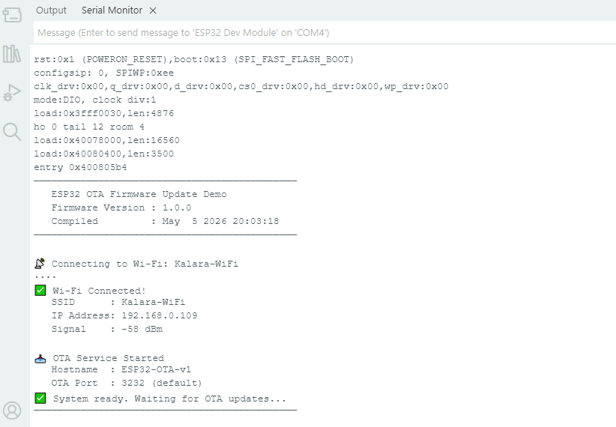
Exercise 2: Performing Your First OTA Update
- Modify the initial sketch to create Version 2:
- Change the version message.
- Modify LED blink pattern (e.g., faster blink or different duty cycle).
- Add a new feature (e.g., print “OTA Update Successful – Now Running v2”).
- In Arduino IDE:
- Select the network port (ESP32’s IP address).
- Upload the new sketch over-the-air.
- Observe the update progress, completion message, and automatic reboot.
- Verify the new behavior (LED pattern + Serial output).

Tools → Port → Select Network Port → [ESP32-OTA-v1 at 192.168.x.x] → Sketch → Upload (or Ctrl+U)
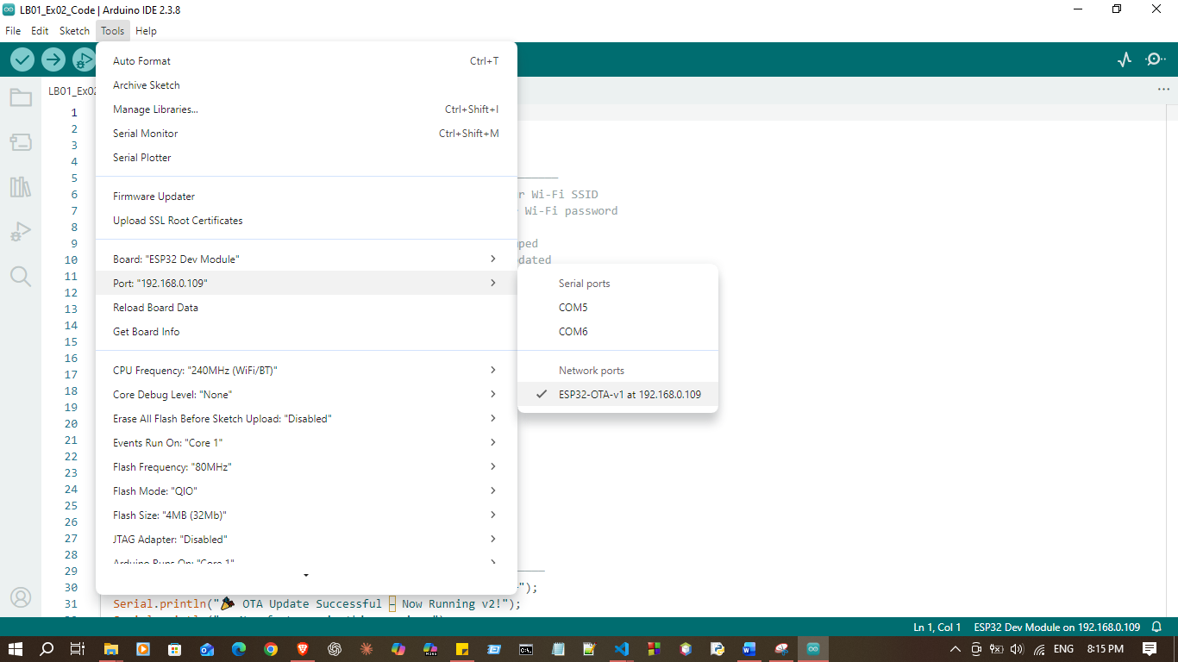

#include <Arduino.h>
#include <WiFi.h>
#include <ArduinoOTA.h>

// ─── Configuration ────────────────────────────────────────────────
const char* WIFI_SSID = "Kalara-WiFi"; // Replace with your Wi-Fi SSID
const char* WIFI_PASSWORD = "Pasa2001#"; // Replace with your Wi-Fi password

const char* FIRMWARE_VERSION = "2.0.0"; // ← Version bumped
const char* HOSTNAME = "ESP32-OTA-v2"; // ← Hostname updated

const int LED_PIN = 2;

// V2 Blink pattern: fast triple-flash then pause
const int FLASH_ON = 100; // 100ms on
const int FLASH_OFF = 100; // 100ms between flashes
const int PAUSE_TIME = 800; // 800ms pause after triple-flash

// ─── Function Prototypes ──────────────────────────────────────────
void printBanner();
void connectToWiFi();
void setupOTA();
void blinkLEDv2();

// ─── Setup ────────────────────────────────────────────────────────
void setup() {
Serial.begin(115200);
delay(500);
pinMode(LED_PIN, OUTPUT);

printBanner();
connectToWiFi();
setupOTA();

// ── V2 Success Message ────────────────────────────────────────
Serial.println("─────────────────────────────────────────────");
Serial.println("🎉 OTA Update Successful – Now Running v2!");
Serial.println(" New features in this version:");
Serial.println(" • Triple-flash LED blink pattern");
Serial.println(" • Improved OTA progress display");
Serial.println(" • Version tracking in Serial output");
Serial.println("─────────────────────────────────────────────");
}

// ─── Loop ─────────────────────────────────────────────────────────
void loop() {
ArduinoOTA.handle(); // Must be called in every loop iteration

blinkLEDv2(); // V2: fast triple-flash pattern
}

// ─── Wi-Fi Connection ─────────────────────────────────────────────
void connectToWiFi() {
Serial.printf("\n📡 Connecting to Wi-Fi: %s\n", WIFI_SSID);
WiFi.mode(WIFI_STA);
WiFi.begin(WIFI_SSID, WIFI_PASSWORD);

int attempts = 0;
while (WiFi.status() != WL_CONNECTED) {
delay(500);
Serial.print(".");
attempts++;
if (attempts > 40) {
Serial.println("\n❌ Wi-Fi connection failed! Restarting...");
ESP.restart();
}
}

Serial.println("\n✅ Wi-Fi Connected!");
Serial.printf(" SSID : %s\n", WiFi.SSID().c_str());
Serial.printf(" IP Address: %s\n", WiFi.localIP().toString().c_str());
Serial.printf(" Signal : %d dBm\n", WiFi.RSSI());
}

// ─── OTA Configuration ────────────────────────────────────────────
void setupOTA() {
ArduinoOTA.setHostname(HOSTNAME);

// ── OTA Event: Start ──────────────────────────────────────────
ArduinoOTA.onStart([]() {
String type = (ArduinoOTA.getCommand() == U_FLASH) ? "Sketch" : "Filesystem";
Serial.println("\n🚀 OTA Update Started!");
Serial.printf(" Update type: %s\n", type.c_str());
Serial.printf(" Current version: %s → New version incoming...\n", FIRMWARE_VERSION);
digitalWrite(LED_PIN, LOW);
});

// ── OTA Event: End ────────────────────────────────────────────
ArduinoOTA.onEnd([]() {
Serial.println("\n✅ OTA Transfer Complete!");
Serial.println(" Validating firmware...");
Serial.println(" Rebooting into new firmware now...");
Serial.println("─────────────────────────────────────────────");
});

// ── OTA Event: Progress ───────────────────────────────────────
ArduinoOTA.onProgress([](unsigned int progress, unsigned int total) {
unsigned int percent = (progress / (total / 100));
unsigned int received = progress / 1024;
unsigned int totalKB = total / 1024;

Serial.printf("\r⬆️ Uploading: [");
int bars = percent / 5;
for (int i = 0; i < 20; i++) {
Serial.print(i < bars ? "█" : "░");
}
Serial.printf("] %3u%% (%u / %u KB)", percent, received, totalKB);
});

// ── OTA Event: Error ──────────────────────────────────────────
ArduinoOTA.onError([](ota_error_t error) {
Serial.printf("\n❌ OTA Error [%u]: ", error);
switch (error) {
case OTA_AUTH_ERROR: Serial.println("Authentication Failed – Check password"); break;
case OTA_BEGIN_ERROR: Serial.println("Begin Failed – Not enough space?"); break;
case OTA_CONNECT_ERROR: Serial.println("Connect Failed – Network issue?"); break;
case OTA_RECEIVE_ERROR: Serial.println("Receive Failed – Upload interrupted"); break;
case OTA_END_ERROR: Serial.println("End Failed – Validation error"); break;
default: Serial.println("Unknown Error"); break;
}
Serial.println(" ⚠️ Device remains on current firmware.");
});

ArduinoOTA.begin();

Serial.println("\n📥 OTA Service Started");
Serial.printf(" Hostname : %s\n", HOSTNAME);
Serial.printf(" OTA Port : 3232 (default)\n");
}

// ─── LED Blink — V2 Pattern (Triple-flash then pause) ─────────────
void blinkLEDv2() {
static unsigned long lastAction = 0;
static int step = 0;

unsigned long now = millis();

// Step sequence: ON, OFF, ON, OFF, ON, PAUSE (repeat)
// 0: flash 1 ON → FLASH_ON
// 1: flash 1 OFF → FLASH_OFF
// 2: flash 2 ON → FLASH_ON
// 3: flash 2 OFF → FLASH_OFF
// 4: flash 3 ON → FLASH_ON
// 5: pause (LED off) → PAUSE_TIME

const int delays[] = {
FLASH_ON, FLASH_OFF,
FLASH_ON, FLASH_OFF,
FLASH_ON, PAUSE_TIME
};
const bool states[] = {
HIGH, LOW,
HIGH, LOW,
HIGH, LOW
};

if (now - lastAction >= (unsigned long)delays[step]) {
lastAction = now;
digitalWrite(LED_PIN, states[step]);
step = (step + 1) % 6;
}
}

// ─── Banner ───────────────────────────────────────────────────────
void printBanner() {
Serial.println("─────────────────────────────────────────────");
Serial.println(" ESP32 OTA Firmware Update Demo");
Serial.printf(" Firmware Version : %s\n", FIRMWARE_VERSION);
Serial.printf(" Compiled : %s %s\n", __DATE__, __TIME__);
Serial.println("─────────────────────────────────────────────");
}

Enter Wi-Fi Password
