Lab Sheet 04
Title: Interfacing Input & Output Devices with ESP32 in Wokwi
Aims: Learn how to correctly connect common Input Devices and Output Devices to the ESP32 Devkit in the Wokwi online simulator. This lab sheet focuses only on hardware connections (wiring) and includes a brief explanation of each device’s purpose.
Tasks:
- Open wokwi and start a new project with ESP32 DevKit.
- Use the + button to search and add each component.
- Use different colored wires (Red = Power, Black = GND, others for signals).
- ESP32 GPIO pins are 3.3V logic. Always connect GND properly..
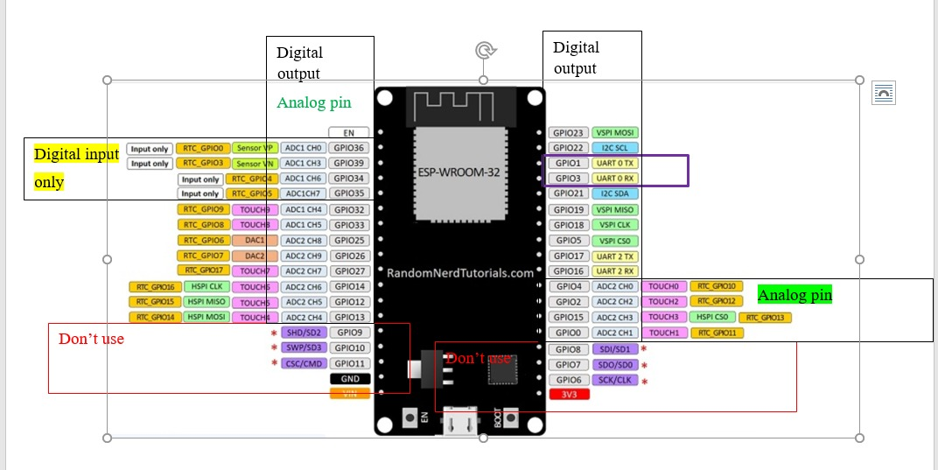

Input Devices

1. Pushbutton (Tactile Switch)
A momentary switch used to detect manual user input (press). Commonly used for triggering actions, resetting systems, or simple user interfaces.

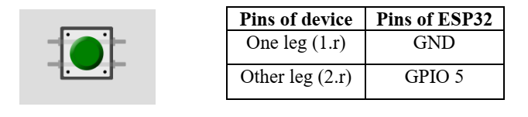
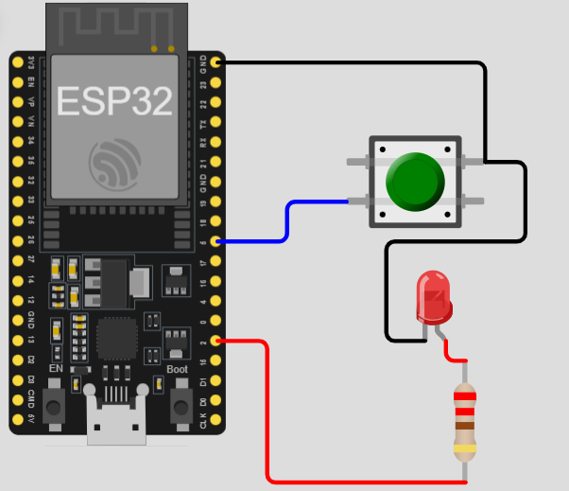
#include <Arduino.h>
// Define the pins
const int BUTTON_PIN = 5; // GIOP5 connected to button
const int LED_PIN = 2; // Onboard LED

// variable for storing the pushbutton status
int buttonState = 0;

void setup() {
Serial.begin(115200);

// Initialize the pushbutton pin as an input with internal pull-up
// This means the pin is HIGH by default and LOW when pressed
pinMode(BUTTON_PIN, INPUT_PULLUP);

// Initialize the LED pin as an output
pinMode(LED_PIN, OUTPUT);
}

void loop() {
// Read the state of the pushbutton value
buttonState = digitalRead(BUTTON_PIN);

// Check if the pushbutton is pressed.
// If it is, the buttonState is LOW (because of INPUT_PULLUP)
if (buttonState == LOW) {
digitalWrite(LED_PIN, HIGH); // Turn LED on
Serial.println("Button Pressed!");
} else {
digitalWrite(LED_PIN, LOW); // Turn LED off
}
}
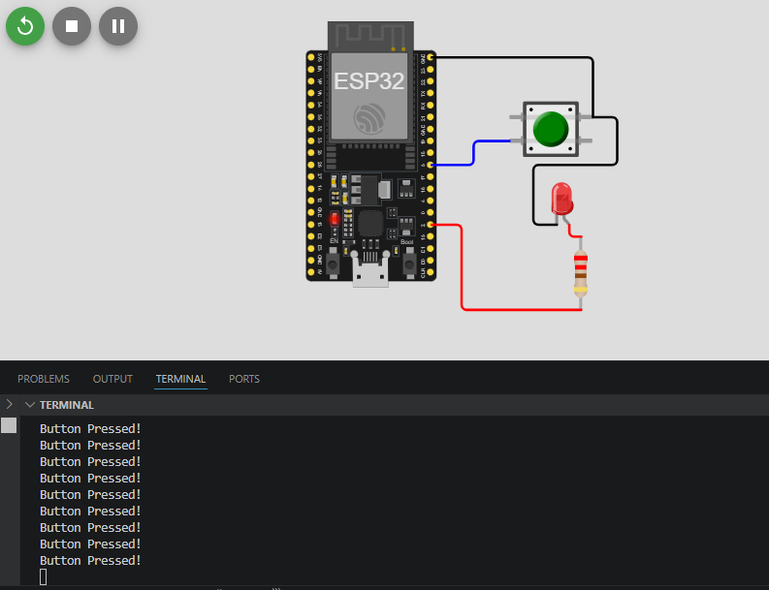

2. Slide Switch / Toggle Switch
Maintains ON/OFF state for mode selection, power control, or configuration settings.
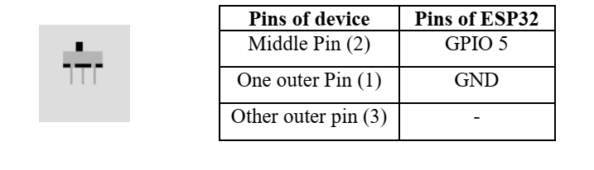
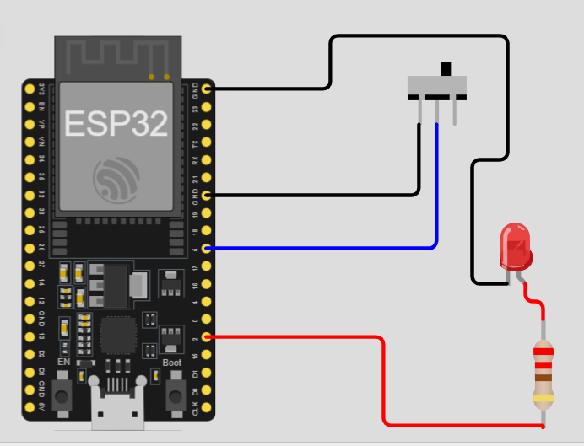
#include <Arduino.h>

// Define the pins
const int SWITCH_PIN = 5;
const int LED_PIN = 2; // Internal LED

void setup() {
Serial.begin(115200);

// Set the switch pin as input with internal pull-up
pinMode(SWITCH_PIN, INPUT_PULLUP);

// Set the onboard LED as output
pinMode(LED_PIN, OUTPUT);

Serial.println("System Initialized. Flip the switch!");
}

void loop() {
// Read the current position of the switch
int switchState = digitalRead(SWITCH_PIN);

if (switchState == LOW) {
// Switch is closed (connected to GND)
digitalWrite(LED_PIN, HIGH);
Serial.println("Status: ON");
} else {
// Switch is open (HIGH due to pull-up)
digitalWrite(LED_PIN, LOW);
Serial.println("Status: OFF");
}

// Small delay to prevent flooding the Serial Monitor
delay(200);
}
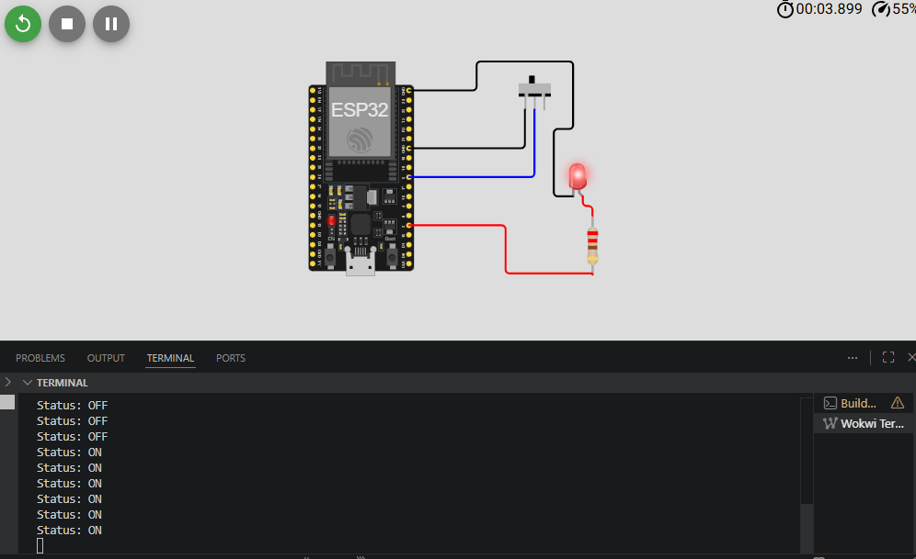

3. Potentiometer (Rotary)
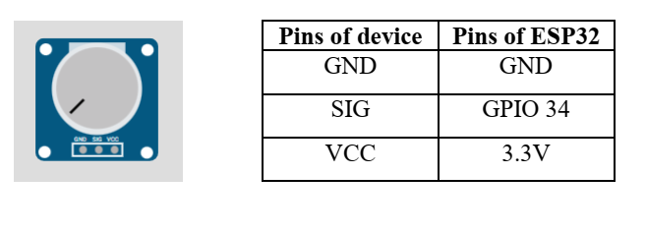
Variable resistor used to adjust analog values (e.g., volume, brightness, speed control).
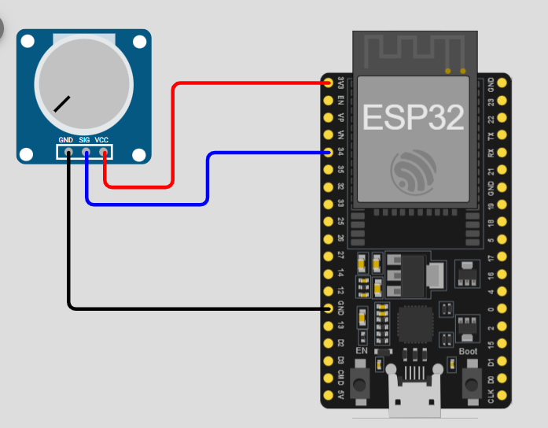
#include <Arduino.h>

// ADC1_CH6 is GPIO 34
const int POT_PIN = 34;

void setup() {
Serial.begin(115200);

// Configure ADC resolution (optional, default is 12-bit)
analogReadResolution(12);

Serial.println("Potentiometer Read Initialized...");
}

void loop() {
// Read the analog value (0 - 4095)
int rawValue = analogRead(POT_PIN);

// Convert the raw value to a voltage (0 - 3.3V)
float voltage = (rawValue * 3.3) / 4095.0;

// Print the results
Serial.print("Raw Value: ");
Serial.print(rawValue);
Serial.print(" | Voltage: ");
Serial.print(voltage);
Serial.println("V");

// Small delay for readability
delay(250);
}
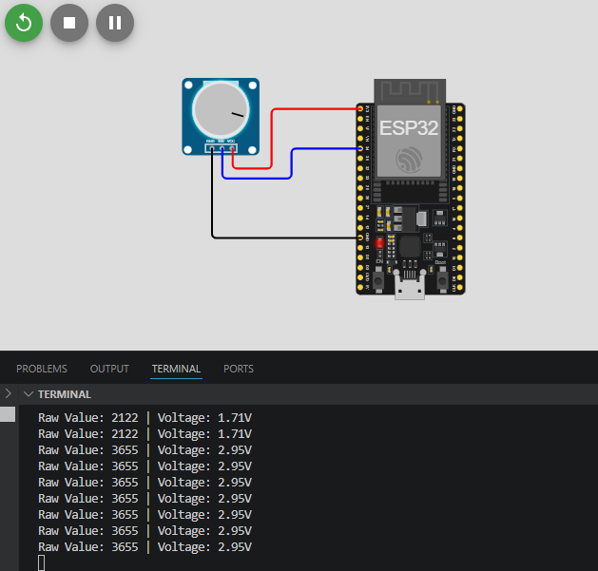

4. Rotary Encoder (KY-040)
Detects rotation direction and steps. Used for menu navigation, volume control, and precise parameter adjustment.
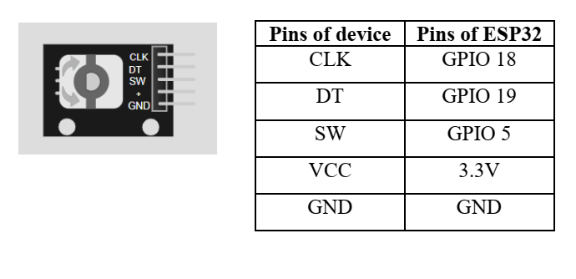

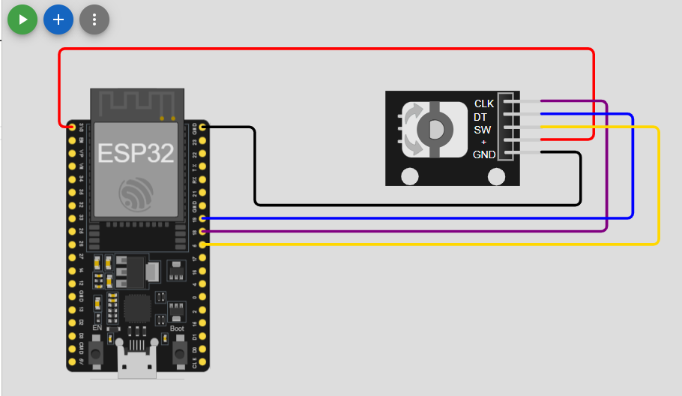
#include <Arduino.h>

// Define pins
#define CLK_PIN 18
#define DT_PIN 19
#define SW_PIN 5

int counter = 0;
int currentStateCLK;
int lastStateCLK;
unsigned long lastButtonPress = 0;

void setup() {
Serial.begin(115200);

// Setup pins
pinMode(CLK_PIN, INPUT);
pinMode(DT_PIN, INPUT);
pinMode(SW_PIN, INPUT_PULLUP);

// Read the initial state of CLK
lastStateCLK = digitalRead(CLK_PIN);
}

void loop() {
// 1. Read Rotation
currentStateCLK = digitalRead(CLK_PIN);

// If CLK has changed, a pulse occurred
if (currentStateCLK != lastStateCLK && currentStateCLK == 1) {
// If the DT state is different from the CLK state,
// the encoder is rotating CCW
if (digitalRead(DT_PIN) != currentStateCLK) {
counter--;
} else {
// Encoder is rotating CW
counter++;
}
Serial.print("Direction: ");
Serial.print(digitalRead(DT_PIN) != currentStateCLK ? "CCW" : "CW");
Serial.print(" | Count: ");
Serial.println(counter);
}
lastStateCLK = currentStateCLK;

// 2. Read Button Press
int btnState = digitalRead(SW_PIN);
if (btnState == LOW) {
// Basic debouncing
if (millis() - lastButtonPress > 50) {
Serial.println("Button Pressed!");
}
lastButtonPress = millis();
}

// No delay here! We need high-speed polling for the encoder.
}
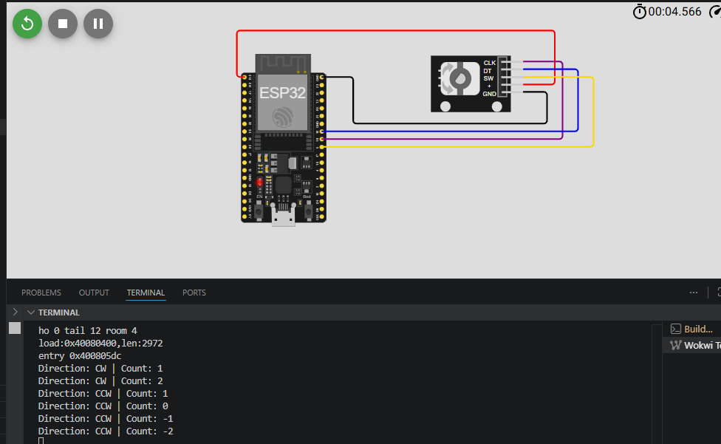

5. Analog Joystick
Provides analog X & Y axis movement and a digital button. Used in gaming, robotics control, and pantilt systems.

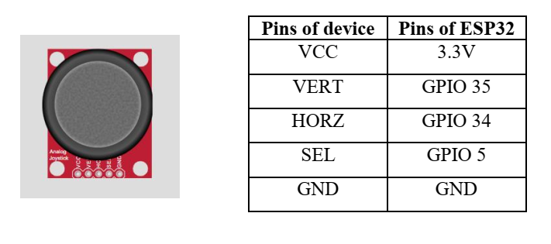
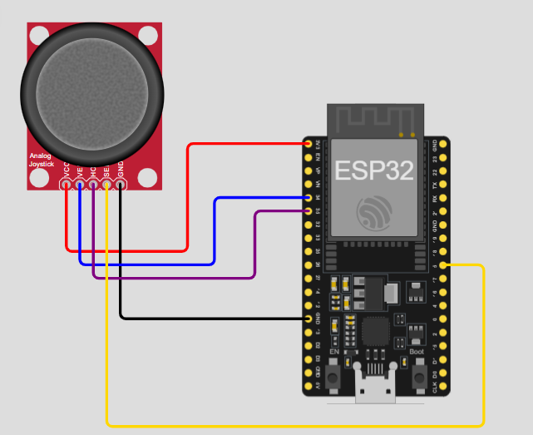

#include <Arduino.h>

// Define pins
const int PIN_X = 34;
const int PIN_Y = 35;
const int PIN_SW = 5;

void setup() {
Serial.begin(115200);

// Joystick button needs a pull-up
pinMode(PIN_SW, INPUT_PULLUP);

// Set ADC resolution to 12-bit (0-4095)
analogReadResolution(12);
}

void loop() {
// Read analog values
int xValue = analogRead(PIN_X);
int yValue = analogRead(PIN_Y);

// Read button (inverted logic because of INPUT_PULLUP)
int swValue = digitalRead(PIN_SW);

// Print raw values
Serial.print("X: ");
Serial.print(xValue);
Serial.print(" | Y: ");
Serial.print(yValue);
Serial.print(" | Button: ");
Serial.println(swValue == LOW ? "PRESSED" : "RELEASED");

// Logic Example: Simple Direction detection
if (xValue < 1500) Serial.println("Moving LEFT");
else if (xValue > 2500) Serial.println("Moving RIGHT");

if (yValue < 1500) Serial.println("Moving UP");
else if (yValue > 2500) Serial.println("Moving DOWN");

delay(200);
}
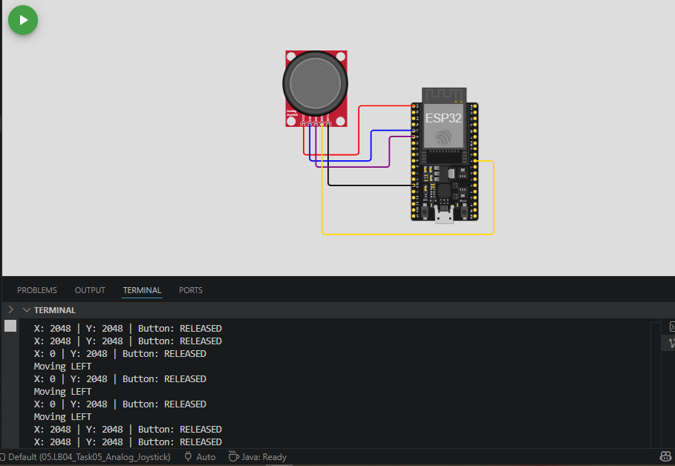

6. Keypad
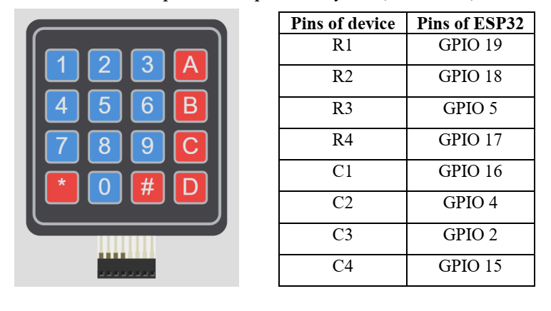
Allows numeric and character input. Used in password systems, calculators, and menu-based projects.

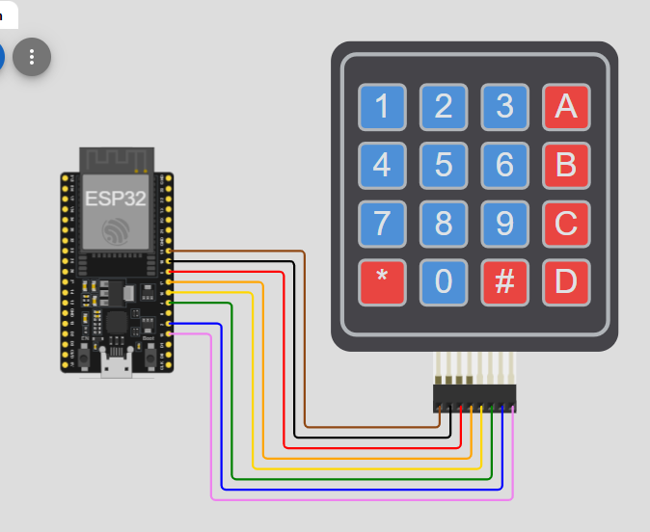

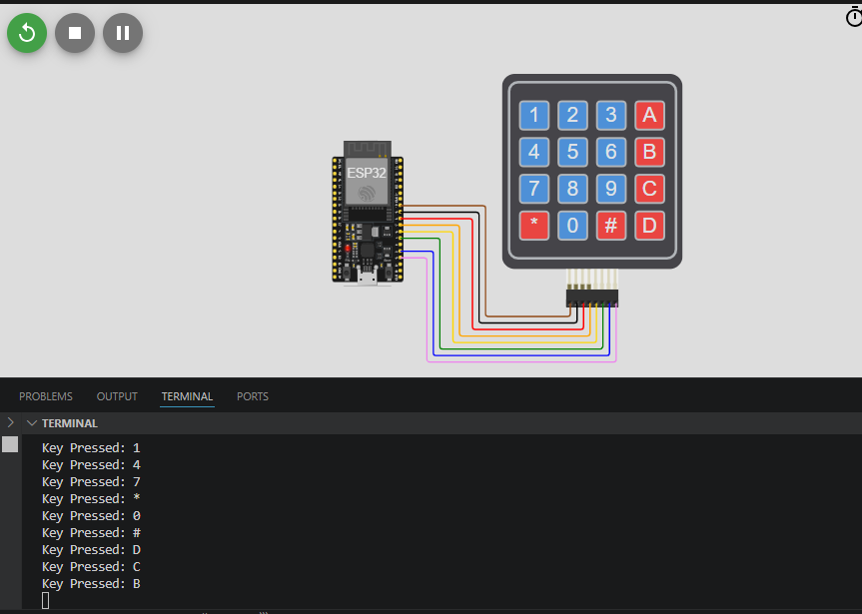

7. IR Receiver
Detects and receives infrared signals from an IR Remote. Used for wireless remote control of devices (TVs, robots, home automation, etc.).

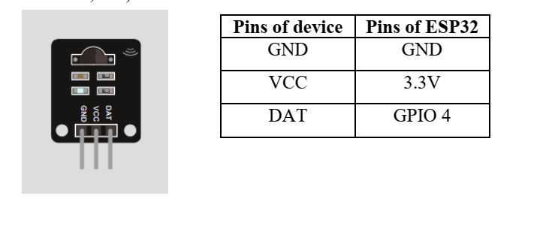
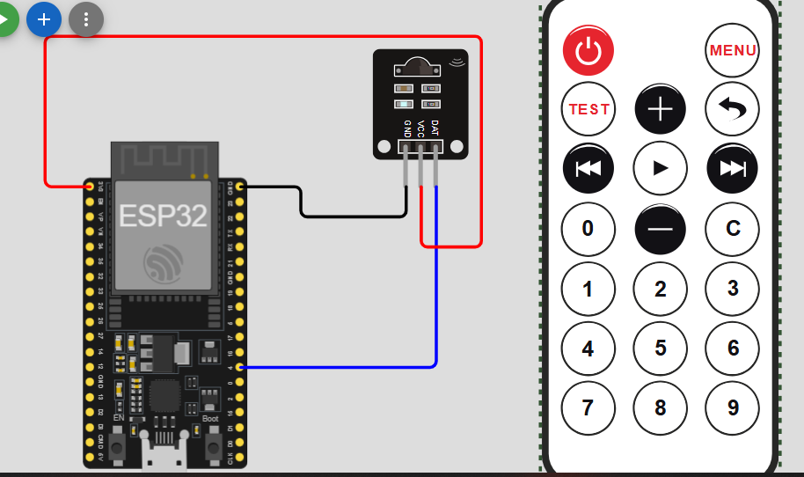
#include <Arduino.h>
#include <IRremoteESP8266.h>
#include <IRrecv.h>
#include <IRutils.h>

// 1. Define the GPIO pin connected to the IR sensor
const uint16_t kRecvPin = 4;

// 2. Establish the IR receiver object
IRrecv irrecv(kRecvPin);
decode_results results;

void setup() {
Serial.begin(115200);

// 3. Start the receiver
irrecv.enableIRIn();
Serial.print("IR Receiver ready on GPIO ");
Serial.println(kRecvPin);
}

void loop() {
// 4. Check if a signal was received
if (irrecv.decode(&results)) {
// Print the protocol (NEC, Sony, etc.) and the Hex code
serialPrintUint64(results.value, HEX);
Serial.println("");

// Resume listening for the next signal
irrecv.resume();
}
delay(100);
}

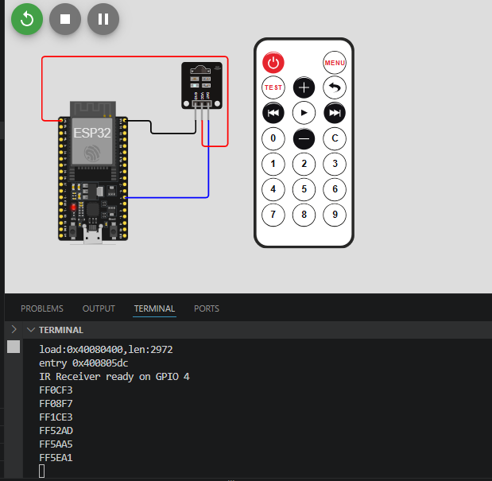

Output Devices

1. IR Remote
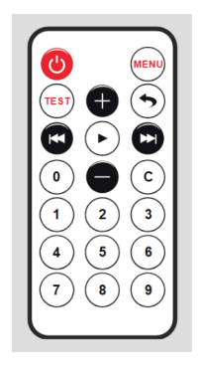
It acts like a TV remote. It transmits (sends) invisible infrared light signals when you press its buttons.

2. LED
Visual indicator for status, alerts, or debugging.

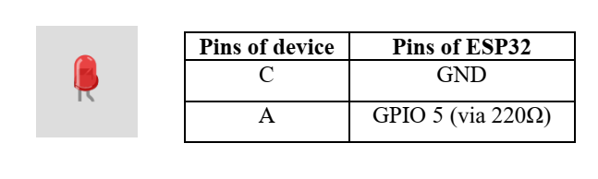
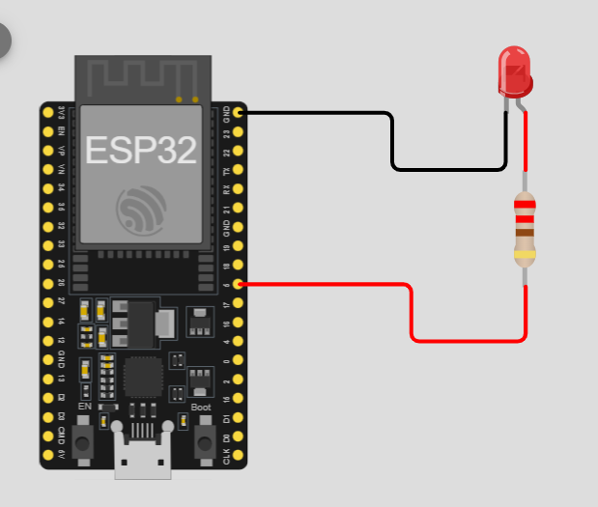
#include <Arduino.h>
// Define the LED pin
const int ledPin = 5;

void setup() {
// Initialize the digital pin as an output
pinMode(ledPin, OUTPUT);
Serial.begin(115200);
Serial.println("LED Blink Test Started");
}

void loop() {
// Turn the LED on (HIGH is the voltage level)
digitalWrite(ledPin, HIGH);
Serial.println("LED ON");
delay(1000); // Wait for a second

// Turn the LED off by making the voltage LOW
digitalWrite(ledPin, LOW);
Serial.println("LED OFF");
delay(1000); // Wait for a second
}

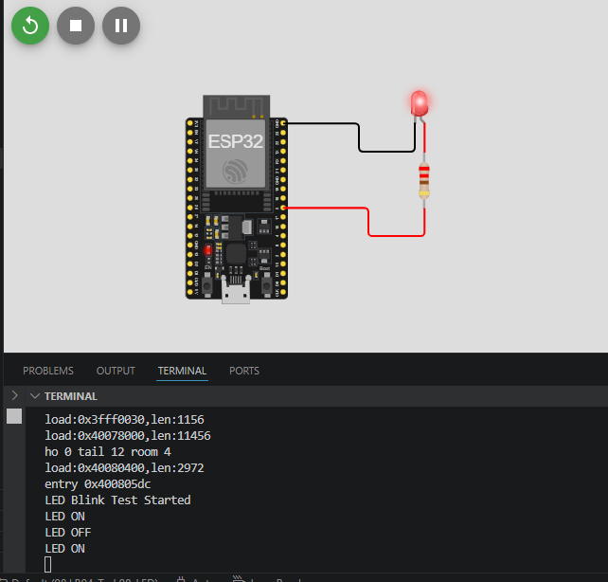

3. RGB LED
Produces multiple colors for status indication or decorative lighting.
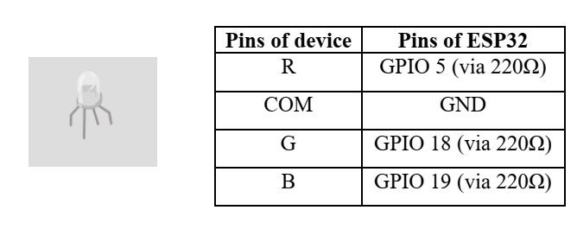

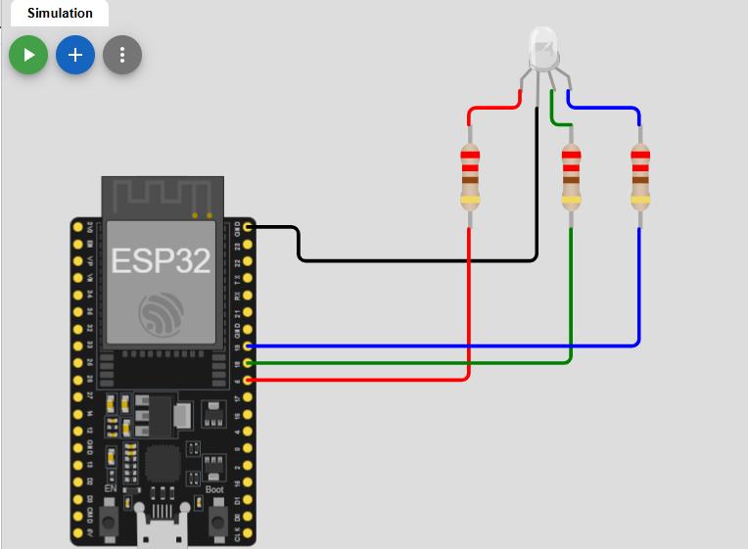
#include <Arduino.h>

// Define Pins
const int redPin = 5;
const int greenPin = 18;
const int bluePin = 19;

// PWM Settings
const int freq = 5000;
const int resolution = 8; // 8-bit resolution (0-255)

// PWM Channels
const int redChannel = 0;
const int greenChannel = 1;
const int blueChannel = 2;
const bool commonAnode = false;

// Forward declaration
void setColor(int redValue, int greenValue, int blueValue);

void setup() {
Serial.begin(115200);

// Set pins as outputs
pinMode(redPin, OUTPUT);
pinMode(greenPin, OUTPUT);
pinMode(bluePin, OUTPUT);

// Configure LED PWM functionalites
ledcSetup(redChannel, freq, resolution);
ledcSetup(greenChannel, freq, resolution);
ledcSetup(blueChannel, freq, resolution);

ledcAttachPin(redPin, redChannel);
ledcAttachPin(greenPin, greenChannel);
ledcAttachPin(bluePin, blueChannel);

// Startup check: LED should turn white briefly.
setColor(255, 255, 255);
delay(1000);
setColor(0, 0, 0);

Serial.println("RGB LED initialized!");
}

void loop() {
// Cycle through some colors
Serial.println("RED");
setColor(255, 0, 0); // Red
delay(1000);

Serial.println("GREEN");
setColor(0, 255, 0); // Green
delay(1000);

Serial.println("BLUE");
setColor(0, 0, 255); // Blue
delay(1000);

Serial.println("YELLOW");
setColor(255, 255, 0); // Yellow
delay(1000);

Serial.println("PURPLE");
setColor(255, 0, 255); // Purple
delay(1000);

Serial.println("CYAN");
setColor(0, 255, 255); // Cyan
delay(1000);

Serial.println("WHITE");
setColor(255, 255, 255); // White
delay(1000);

Serial.println("OFF");
setColor(0, 0, 0); // Off
delay(1000);
}

// Function to set the RGB color
void setColor(int redValue, int greenValue, int blueValue) {
if (commonAnode) {
redValue = 255 - redValue;
greenValue = 255 - greenValue;
blueValue = 255 - blueValue;
}

ledcWrite(redChannel, redValue);
ledcWrite(greenChannel, greenValue);
ledcWrite(blueChannel, blueValue);
}
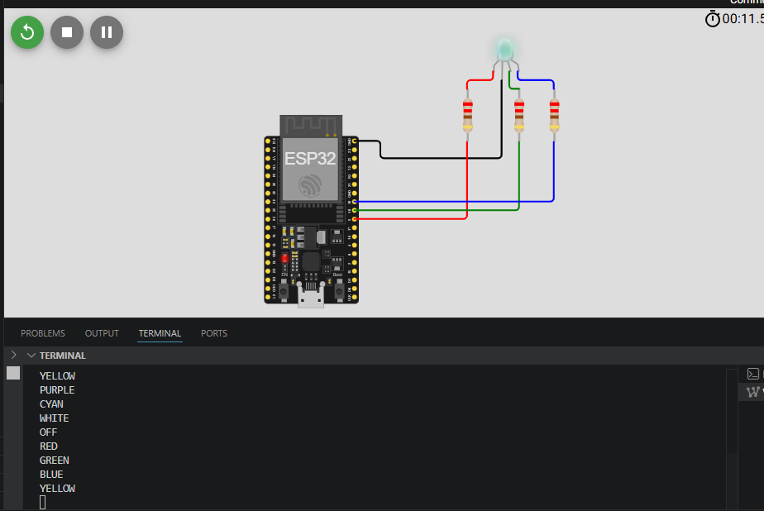

4. Buzzer
Produces simple beeps or tones for alerts, notifications, or feedback.

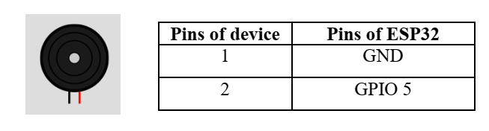
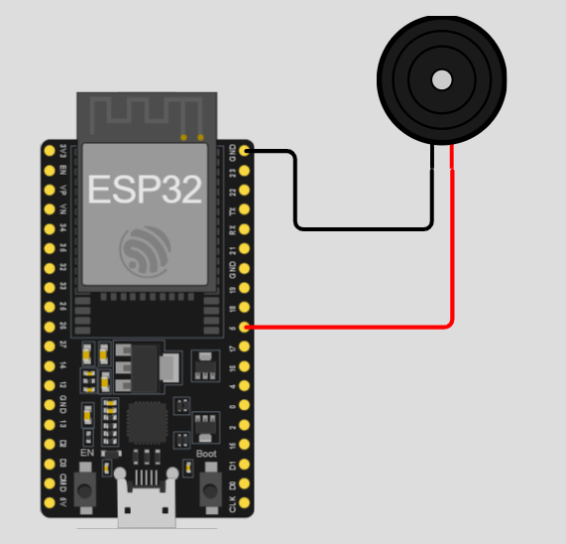
#include <Arduino.h>
// Define the buzzer pin
const int buzzerPin = 5;

void playMelody() {
int notes[] = {262, 294, 330, 349}; // C4, D4, E4, F4
for (int i = 0; i < 4; i++) {
tone(buzzerPin, notes[i]);
delay(200);
noTone(buzzerPin);
delay(50);
}
}

void setup() {
// No special setup needed for tone()
Serial.begin(115200);
}

void loop() {
Serial.println("Buzzer: ON (1000Hz)");

// Play a 1000Hz tone
tone(buzzerPin, 1000);
delay(500);

Serial.println("Buzzer: OFF");

// Stop the tone
noTone(buzzerPin);
delay(1000);

// Simple melody test (Passive Buzzer only)
playMelody();
}

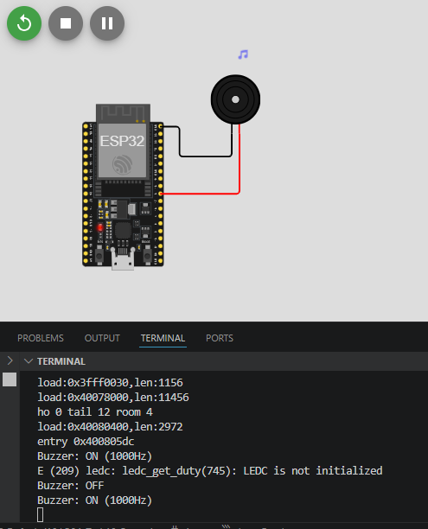

5. Servo Motor
Precise angular control (0–180°). Used in robotics, camera gimbals, and door locks.

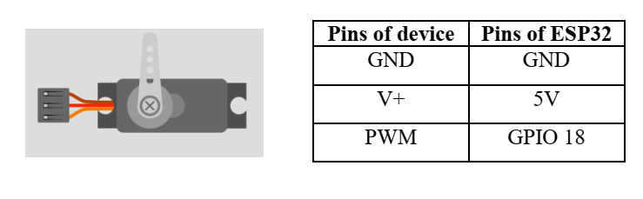
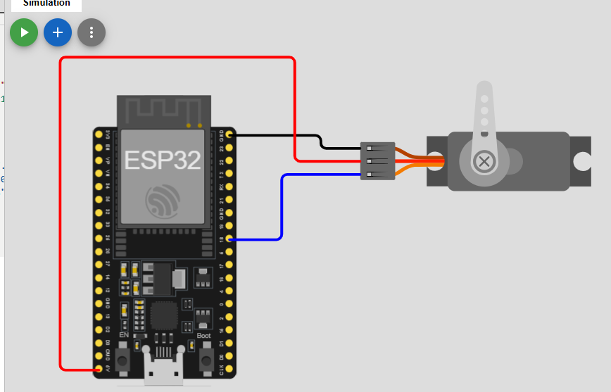
#include <Arduino.h>
#include <ESP32Servo.h>

// 1. Create a servo object
Servo myServo;

// 2. Define the GPIO pin
const int servoPin = 18;

void setup() {
Serial.begin(115200);

// 3. Attach the servo to the pin
// Standard servos use a pulse width of 500us to 2400us
myServo.attach(servoPin, 500, 2400);
}

void loop() {
// Move from 0 to 180 degrees
for (int pos = 0; pos <= 180; pos += 1) {
myServo.write(pos);
delay(15); // Wait for the servo to reach the position
}

delay(1000);

// Move from 180 to 0 degrees
for (int pos = 180; pos >= 0; pos -= 1) {
myServo.write(pos);
delay(15);
}

delay(1000);
}
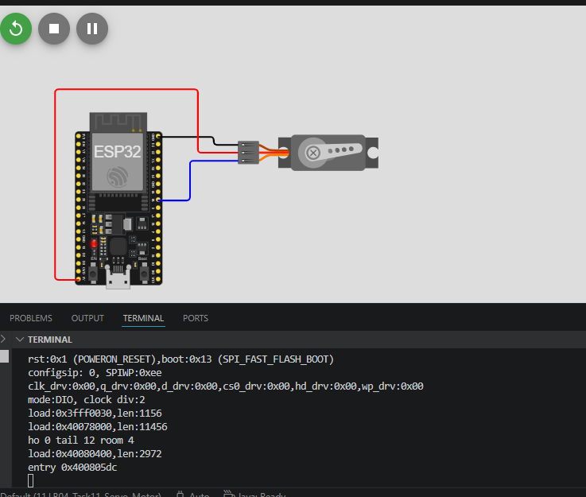

6. Bipolar Stepper Motor + A4988 Driver
Provides precise angular movement and position control. Used in robotics, 3D printers, CNC machines, and automated positioning systems.
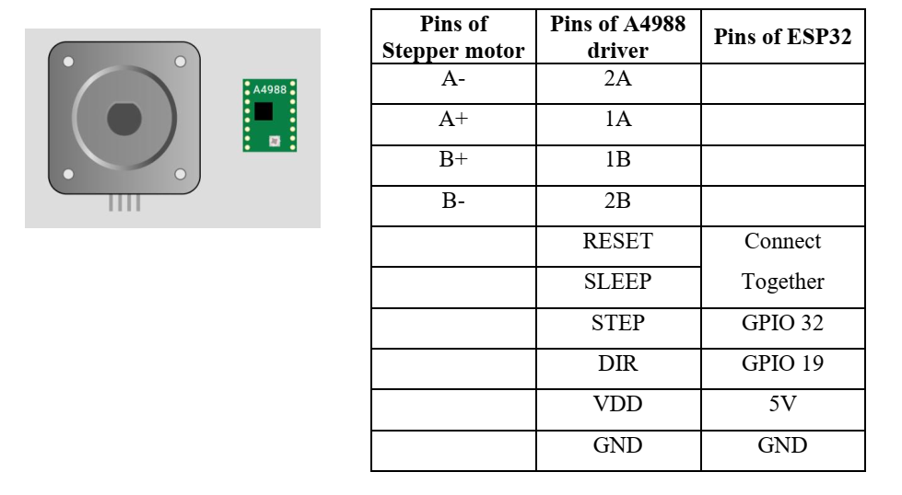
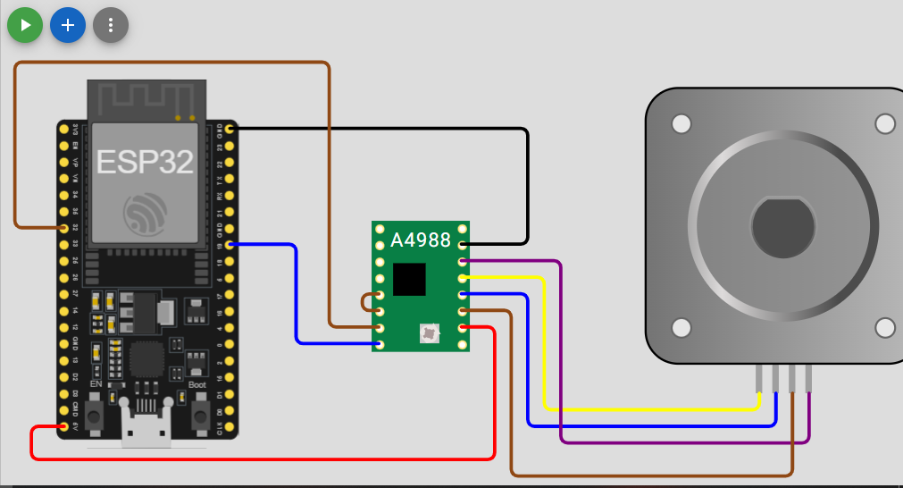
#include <Arduino.h>
#include <AccelStepper.h>

// 1. Define the pins
const int stepPin = 32;
const int dirPin = 19;

// 2. Define the motor interface type (1 means a driver like A4988)
#define motorInterfaceType 1

// 3. Create the stepper object
AccelStepper stepper(motorInterfaceType, stepPin, dirPin);

void setup() {
Serial.begin(115200);

// 4. Set maximum speed and acceleration
stepper.setMaxSpeed(1000); // Steps per second
stepper.setAcceleration(500); // Steps per second squared

Serial.println("Stepper Test Initialized...");
}

void loop() {
// Move to a position (e.g., 200 steps is usually one full rotation)
Serial.println("Moving to 400...");
stepper.moveTo(400);
stepper.runToPosition(); // Blocking call: waits until finished

delay(1000);

// Move back to start
Serial.println("Moving back to 0...");
stepper.moveTo(0);
stepper.runToPosition();

delay(1000);
}
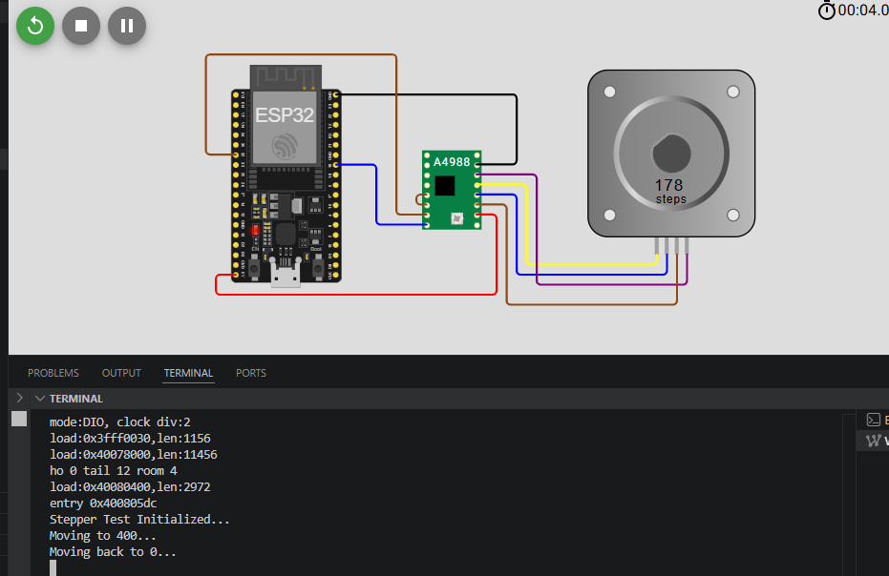

7. Relay Module
Allows low-power ESP32 to control high-power devices (lights, motors, appliances).

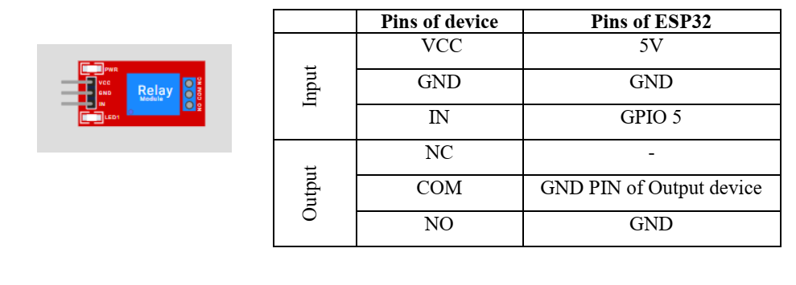
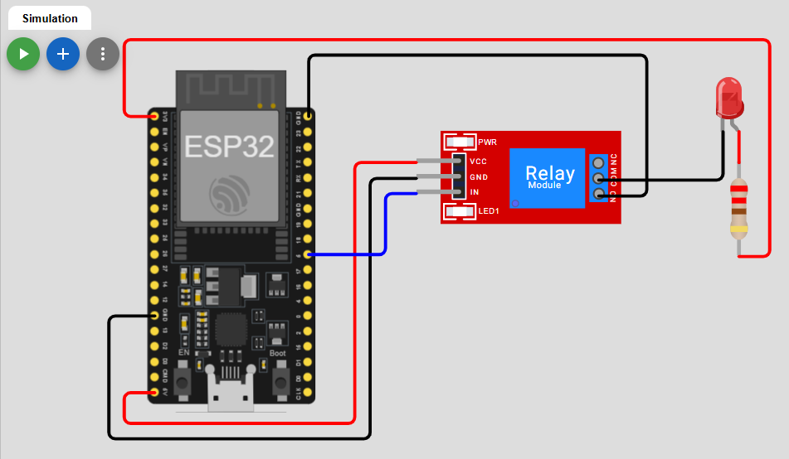
#include <Arduino.h>
// Define the Relay Pin
const int relayPin = 5;

void setup() {
// Initialize the relay pin as an output
pinMode(relayPin, OUTPUT);

// Set initial state to OFF (for Active Low relays)
digitalWrite(relayPin, HIGH);

Serial.begin(115200);
Serial.println("Relay Test Started");
}

void loop() {
// Turn the relay ON
Serial.println("Relay ON - Device Running");
digitalWrite(relayPin, LOW);
delay(3000); // Keep it on for 3 seconds

// Turn the relay OFF
Serial.println("Relay OFF - Device Stopped");
digitalWrite(relayPin, HIGH);
delay(3000); // Keep it off for 3 seconds
}

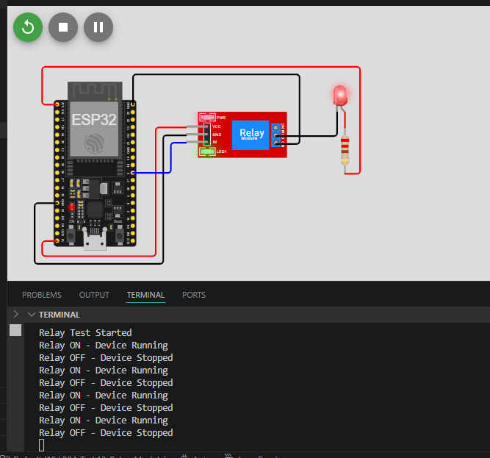

8. LCD 16x2 (Parallel)
Displays text, numbers, and simple messages (2 rows × 16 characters). Classic and very common in beginner projects.
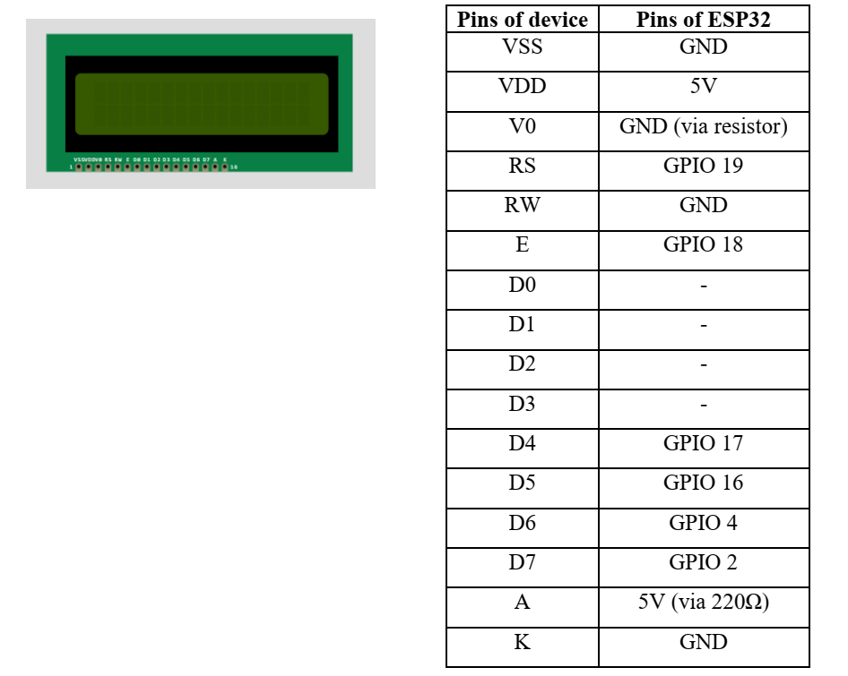
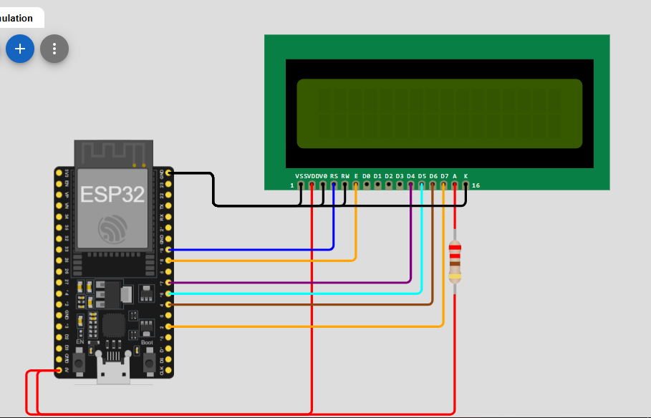
#include <Arduino.h>
#include <LiquidCrystal.h>

// Initialize the library with the numbers of the interface pins
// RS, E, D4, D5, D6, D7
LiquidCrystal lcd(19, 18, 17, 16, 4, 2);

void setup() {
// Set up the LCD's number of columns and rows:
lcd.begin(16, 2);

// Print a message to the LCD.
lcd.print("ESP32 Test...");

delay(2000);
lcd.clear();
}

void loop() {
// Set the cursor to column 0, line 0
lcd.setCursor(0, 0);
lcd.print("System: Online");

// Set the cursor to column 0, line 1
lcd.setCursor(0, 1);
lcd.print("Uptime: ");
lcd.print(millis() / 1000);
lcd.print("s");

delay(1000);
}
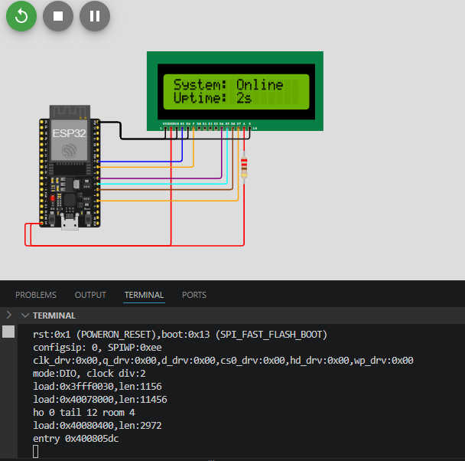

9. LCD 16x2 (I2C)
Same as above but uses only 2 wires (easier wiring).
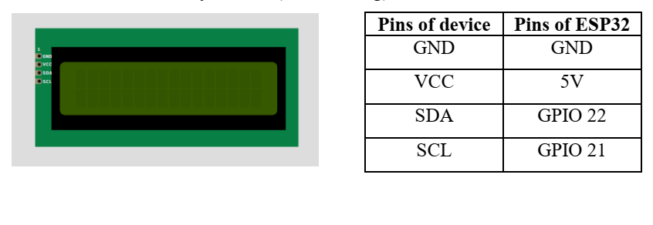

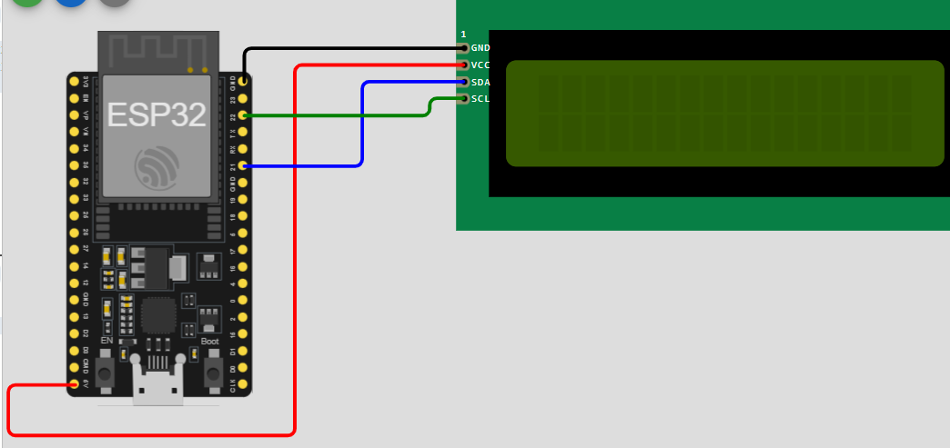
#include <Arduino.h>
#include <Wire.h>
#include <LiquidCrystal_I2C.h>

// 1. Set the LCD address to 0x27 for a 16 chars and 2 line display
// If 0x27 doesn't work, try 0x3F
LiquidCrystal_I2C lcd(0x27, 16, 2);

void setup() {
// 2. Initialize the LCD
lcd.init();

// Turn on the blacklight
lcd.backlight();

// Print a message
lcd.setCursor(0, 0);
lcd.print("I2C LCD Ready!");

lcd.setCursor(0, 1);
lcd.print("ESP32 Booting...");
delay(2000);
lcd.clear();
}

void loop() {
lcd.setCursor(0, 0);
lcd.print("Scanning...");

// Example: Displaying a value
int sensorValue = analogRead(34);
lcd.setCursor(0, 1);
lcd.print("Value: ");
lcd.print(sensorValue);
lcd.print(" "); // Clear trailing digits

delay(500);
}
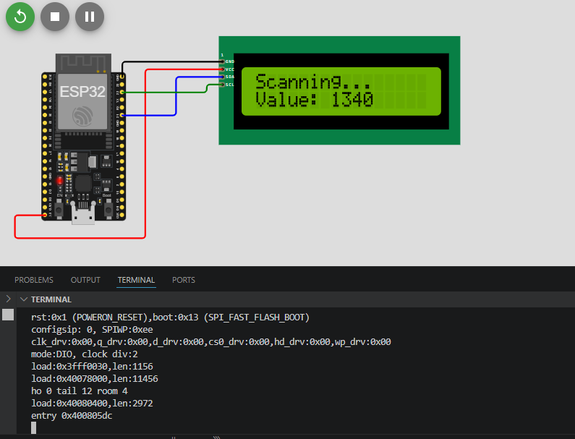

10. MAX7219 LED Dot Matrix
Displays scrolling text, animations, and patterns (8x8 matrix). Can daisy-chain multiple modules.
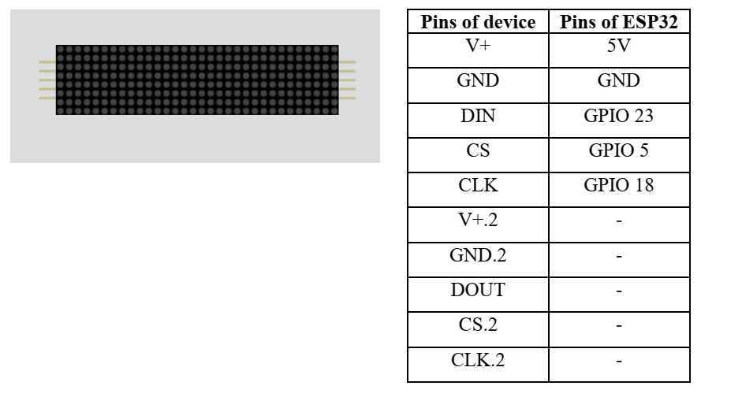
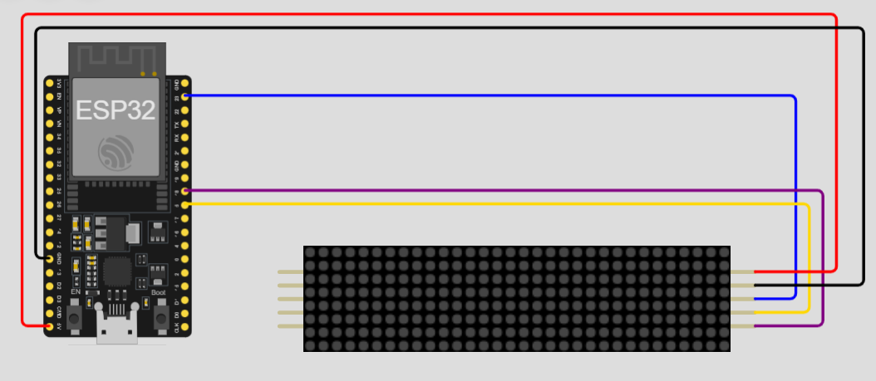
#include <Arduino.h>
#include <MD_Parola.h>
#include <MD_MAX72xx.h>
#include <SPI.h>

// 1. Define Hardware Type and Pins
// Use the Parola hardware preset for the Wokwi MAX7219 matrix part
#define HARDWARE_TYPE MD_MAX72XX::PAROLA_HW
#define MAX_DEVICES 4 // Set this to the number of 8x8 matrices you have
#define CS_PIN 5

// 2. Initialize the Parola object
MD_Parola myDisplay = MD_Parola(HARDWARE_TYPE, CS_PIN, MAX_DEVICES);

void setup() {
// 3. Initialize the display
myDisplay.begin();

// Set intensity (0-15)
myDisplay.setIntensity(5);

// Clear the display
myDisplay.displayClear();

// Configure the scrolling message once in setup
myDisplay.displayText("ESP32 IoT TEST", PA_CENTER, 100, 0, PA_SCROLL_LEFT, PA_SCROLL_LEFT);
myDisplay.displayReset();
}

void loop() {
// 4. Keep the configured animation running
if (myDisplay.displayAnimate()) {
myDisplay.displayReset();
}
}
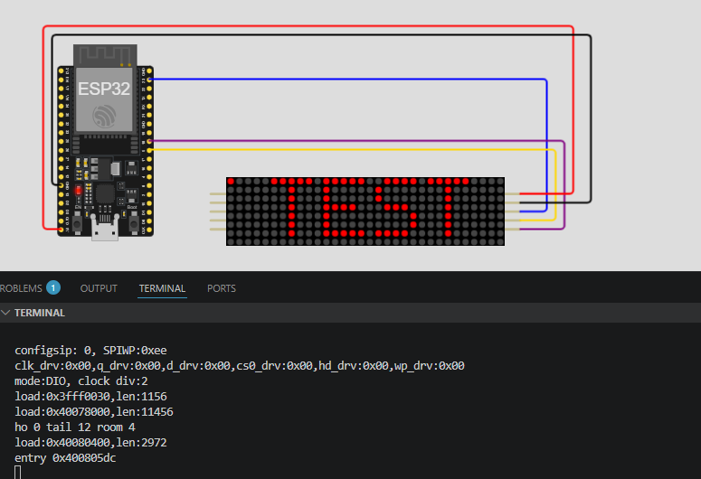

11. Seven Segment Display
Displays numbers and limited characters. Widely used in clocks, counters, and scoreboards.

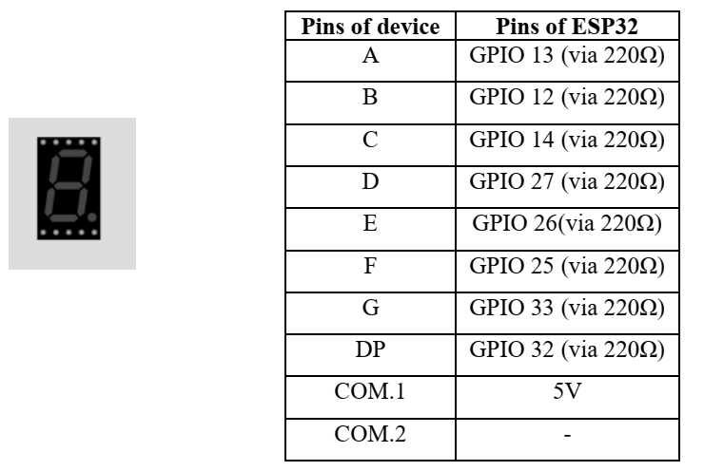
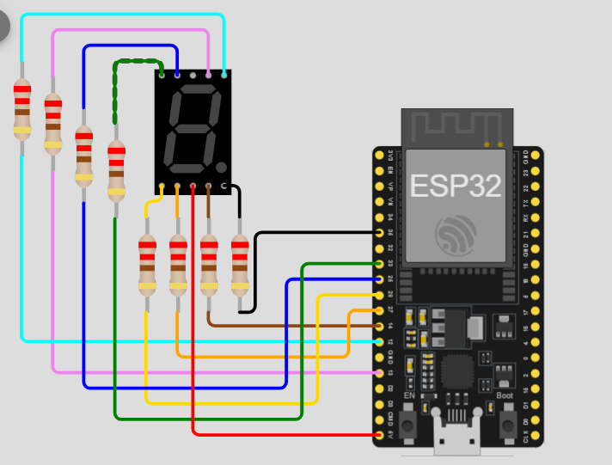
#include <Arduino.h>
// Define pins for segments a, b, c, d, e, f, g
const int segments[7] = {13, 12, 14, 27, 26, 25, 33};

// Binary map for numbers 0-9 (a, b, c, d, e, f, g)
const byte digitMap[10] = {
0b00111111, // 0
0b00000110, // 1
0b01011011, // 2
0b01001111, // 3
0b01100110, // 4
0b01101101, // 5
0b01111101, // 6
0b00000111, // 7
0b01111111, // 8
0b01101111 // 9
};

void displayDigit(int num);

void setup() {
for (int i = 0; i < 7; i++) {
pinMode(segments[i], OUTPUT);
}
}

void loop() {
for (int i = 0; i <= 9; i++) {
displayDigit(i);
delay(1000);
}
}

void displayDigit(int num) {
for (int i = 0; i < 7; i++) {
// Check the bit for each segment
int bit = bitRead(digitMap[num], i);
digitalWrite(segments[i], bit ? LOW : HIGH);
}
}
