Lab Sheet 05
Title: Programming ESP32 with Sensors in Wokwi
Aims: To program the ESP32 to interface with various sensors, understand their libraries and communication protocols, and display real-time sensor data on the Serial Monitor.
Tasks:
- HC-SR04 (Ultrasonic Distance Sensor)
- Write a program to measure distance in centimeters and display it on the Serial Monitor every second.
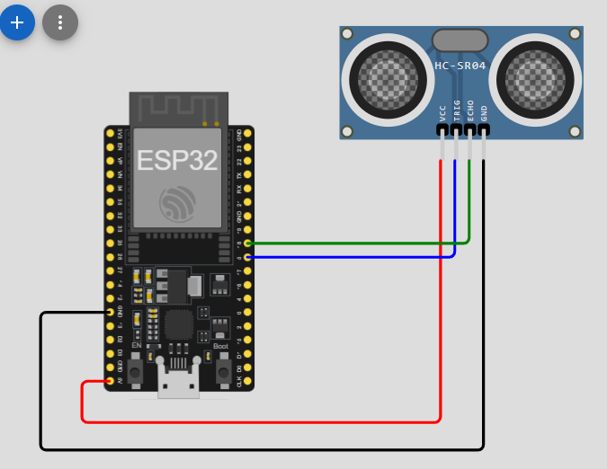

#include <Arduino.h>
const int trigPin = 5;
const int echoPin = 18;

void setup()
{
Serial.begin(9600);
Serial.println("\nHC-SR04 (Ultrasonic Distance Sensor) ");
pinMode(trigPin, OUTPUT);
pinMode(echoPin, INPUT);
}

void loop()
{

// Send pulse
digitalWrite(trigPin, LOW);
delayMicroseconds(2);

digitalWrite(trigPin, HIGH);
delayMicroseconds(10);
digitalWrite(trigPin, LOW);

// Read echo time
long duration = pulseIn(echoPin, HIGH);

// Calculate distance
int distance = duration * 0.034 / 2;

// Print distance
Serial.print("Distance = ");
Serial.print(distance);
Serial.println(" cm");

delay(1000);
}

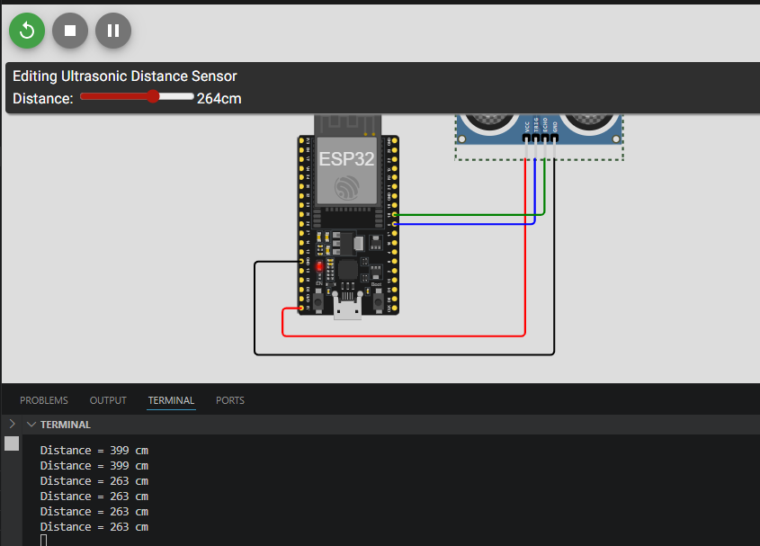
- DHT22 (Digital Humidity & Temperature Sensor)
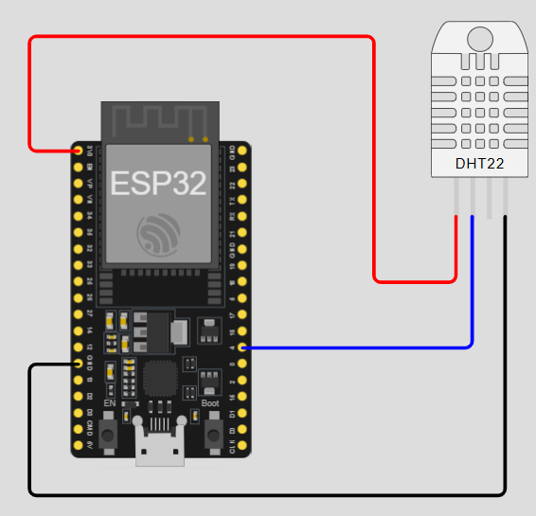
- Write a program to read and display both temperature (°C) and humidity (%) every 2 seconds.

#include <Arduino.h>
#include <DHT.h>

#define DHTPIN 4
#define DHTTYPE DHT22

DHT dht(DHTPIN, DHTTYPE);

void setup()
{
Serial.begin(115200);
Serial.println("\nDHT22 (Digital Humidity & Temperature Sensor) ");
dht.begin();
}

void loop()
{

float temperature = dht.readTemperature();
float humidity = dht.readHumidity();

Serial.print("Temperature: ");
Serial.print(temperature);
Serial.println(" °C");

Serial.print("Humidity: ");
Serial.print(humidity);
Serial.println(" %");

delay(2000);
}
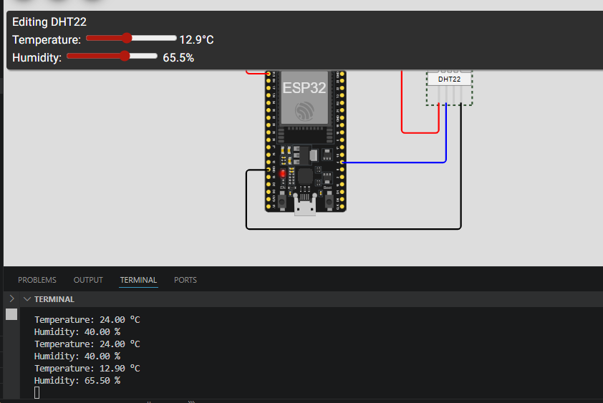

- DS18B20 (One-Wire Digital Temperature Sensor)
- Write a program to read and display the temperature in Celsius.
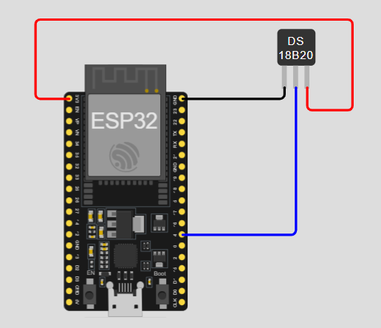
#include <Arduino.h>
#include <OneWire.h>
#include <DallasTemperature.h>

#define ONE_WIRE_BUS 4

OneWire oneWire(ONE_WIRE_BUS);
DallasTemperature sensors(&oneWire);

void setup() {
Serial.begin(9600);
Serial.println("\nDS18B20 (One-Wire Digital Temperature Sensor) ");
sensors.begin();
}

void loop() {

sensors.requestTemperatures();

float temp = sensors.getTempCByIndex(0);

Serial.print("Temperature: ");
Serial.print(temp);
Serial.println(" °C");

delay(1000);
}
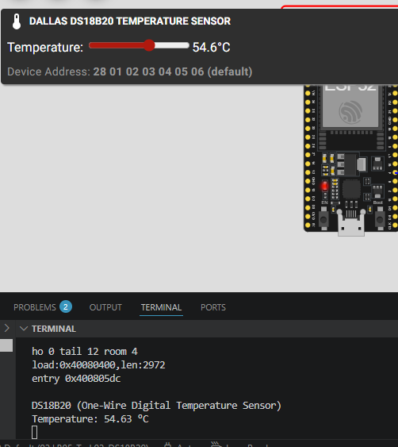
- BMP180 (Barometric Pressure & Temperature Sensor)
- Write a program to display Temperature (°C), Pressure (hPa), and Altitude (meters).
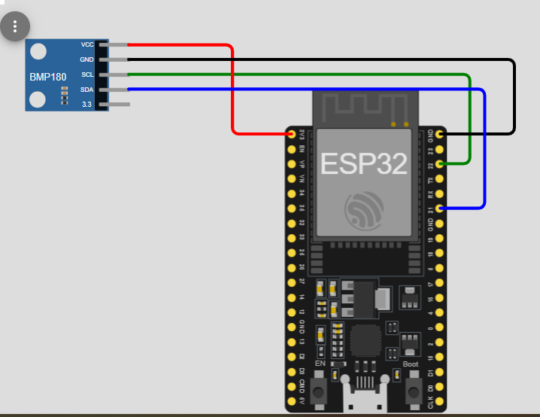
#include <Arduino.h>
#include <Wire.h>
#include <Adafruit_BMP085.h>

Adafruit_BMP085 bmp;

void setup()
{
Serial.begin(115200);
Serial.println("\nBMP180 (Barometric Pressure & Temperature Sensor) ");
bmp.begin();
}

void loop()
{

float temperature = bmp.readTemperature();
float pressure = bmp.readPressure() / 100.0;
float altitude = bmp.readAltitude();

Serial.print("Temperature: ");
Serial.print(temperature);
Serial.println(" °C");

Serial.print("Pressure: ");
Serial.print(pressure);
Serial.println(" hPa");

Serial.print("Altitude: ");
Serial.print(altitude);
Serial.println(" m");

Serial.println();

delay(2000);
}

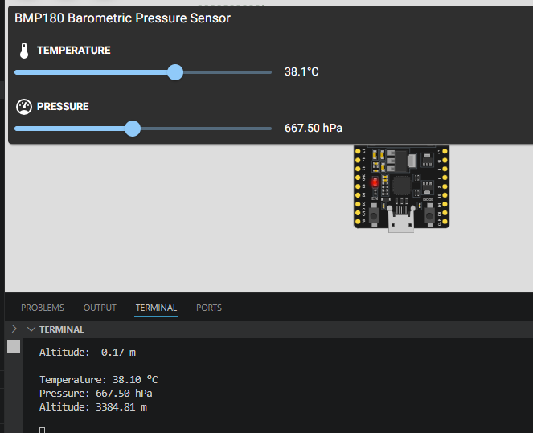
- MPU6050 (3-Axis Accelerometer + Gyroscope + Temperature)
- Write a program to display acceleration (X, Y, Z) and gyroscope (X, Y, Z) values.

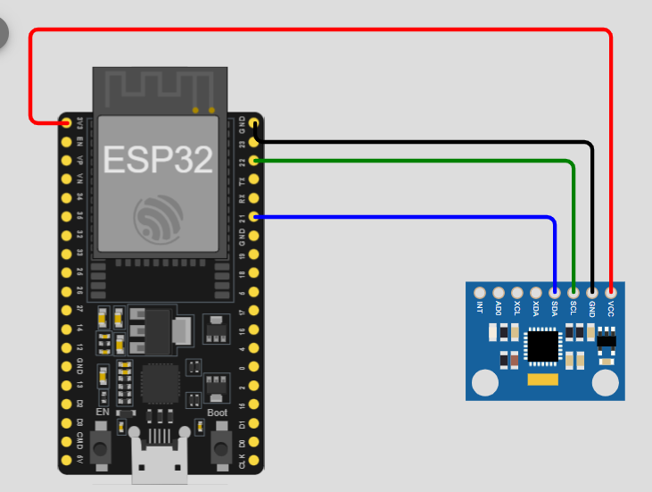
#include <Arduino.h>
#include <Wire.h>
#include <MPU6050.h>

MPU6050 mpu;

void setup() {
Serial.begin(115200);
Serial.println("\nMPU6050 (3-Axis Accelerometer + Gyroscope + Temperature) ");
Wire.begin();
mpu.initialize();
}

void loop() {

int16_t ax, ay, az;
int16_t gx, gy, gz;

// Read Accelerometer and Gyroscope values
mpu.getMotion6(&ax, &ay, &az, &gx, &gy, &gz);

Serial.println("Accelerometer");

Serial.print("X: ");
Serial.print(ax);

Serial.print(" Y: ");
Serial.print(ay);

Serial.print(" Z: ");
Serial.println(az);

Serial.println("Gyroscope");

Serial.print("X: ");
Serial.print(gx);

Serial.print(" Y: ");
Serial.print(gy);

Serial.print(" Z: ");
Serial.println(gz);

Serial.println();

delay(1000);
}
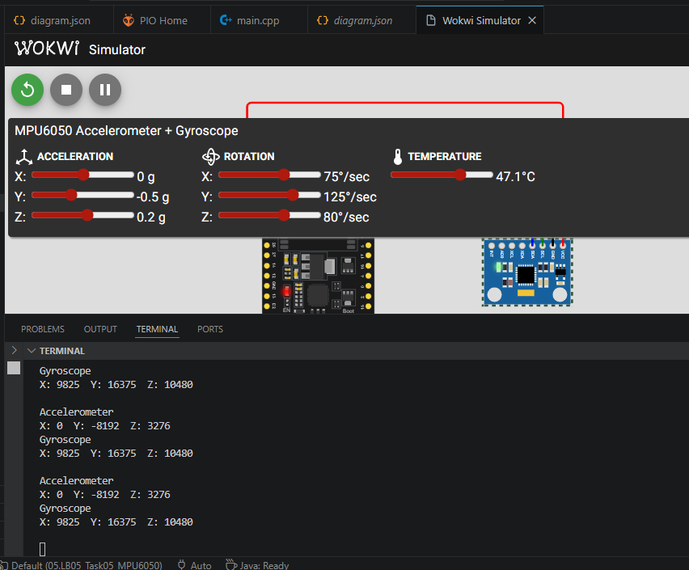

- PIR Motion Sensor (Passive Infrared)
- Write a program to detect motion and print “Motion Detected” or “No Motion” continuously.
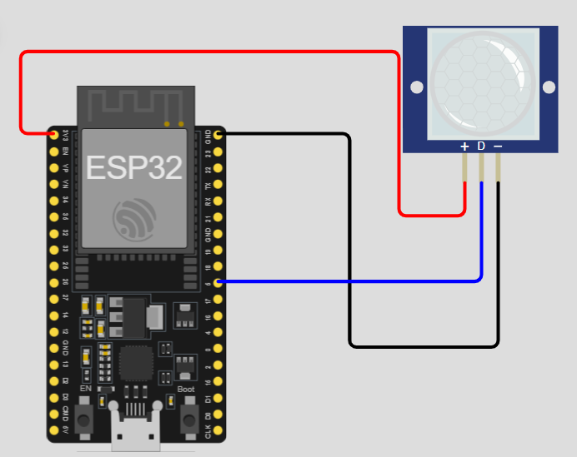
#include <Arduino.h>
const int pirPin = 5;

void setup()
{
Serial.begin(115200);
Serial.println("\nPIR Motion Sensor (Passive Infrared) ");
pinMode(pirPin, INPUT);
}

void loop()
{

int motion = digitalRead(pirPin);

if (motion == HIGH)
{
Serial.println("Motion Detected");
}
else
{
Serial.println("No Motion");
}

delay(1000);
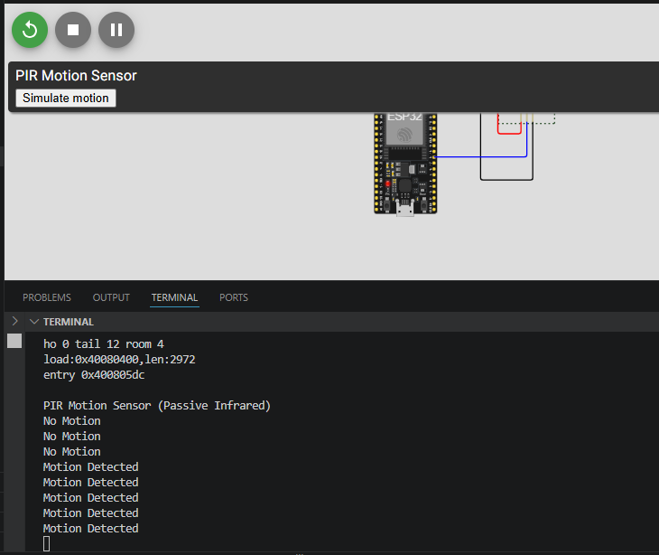
}

- Photoresistor (LDR) Light Sensor
- Write a program to read and display the analog light intensity value.
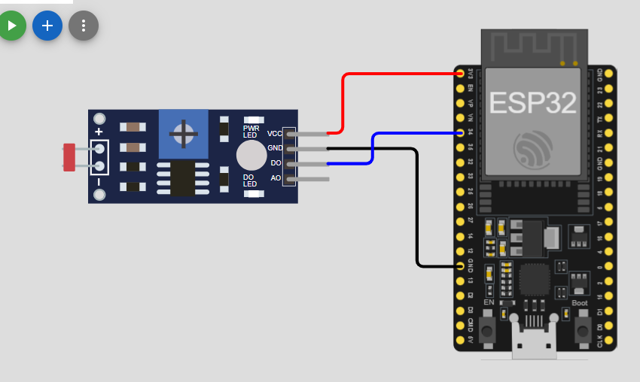
#include <Arduino.h>
const int ldrPin = 34;

void setup() {
Serial.begin(115200);
Serial.println("\nPhotoresistor (LDR) Light Sensor ");
}

void loop() {

int lightValue = analogRead(ldrPin);

Serial.print("Light Intensity: ");
Serial.println(lightValue);

delay(1000);
}
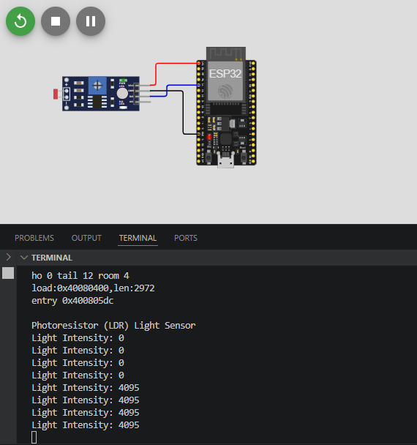
- Analog Temperature Sensor (NTC Thermistor)
- Write a program to calculate and display temperature in °C using the thermistor.
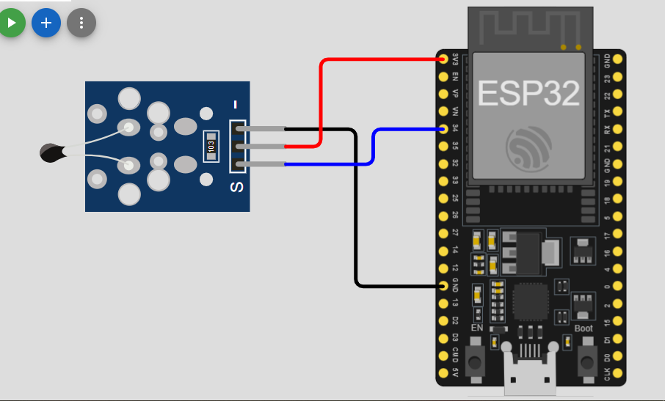
#include <Arduino.h>
const int thermistorPin = 34;

void setup() {
Serial.begin(115200);
Serial.println("\nAnalog Temperature Sensor (NTC Thermistor) ");
}

void loop() {

int value = analogRead(thermistorPin);

// Convert analog value to temperature
float temperature = map(value, 0, 1023, -20, 100);

Serial.print("Temperature: ");
Serial.print(temperature);
Serial.println(" °C");

delay(1000);
}

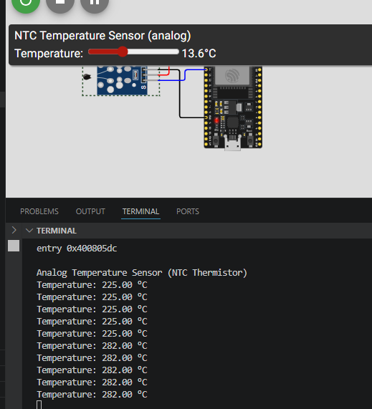
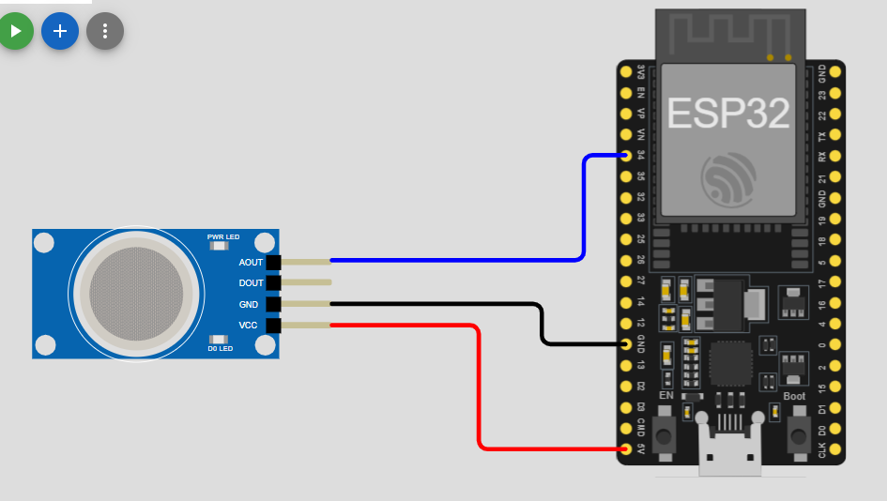
- MQ2 Gas Sensor
- Write a program to read and display the gas/smoke level (analog value) every 500ms.

#include <Arduino.h>
const int mq2Pin = 34;

void setup() {
Serial.begin(115200);
Serial.println("MQ2_Gas_Sensor ");
}

void loop() {

int gasValue = analogRead(mq2Pin);

Serial.print("Gas Level: ");
Serial.println(gasValue);

delay(500);
}
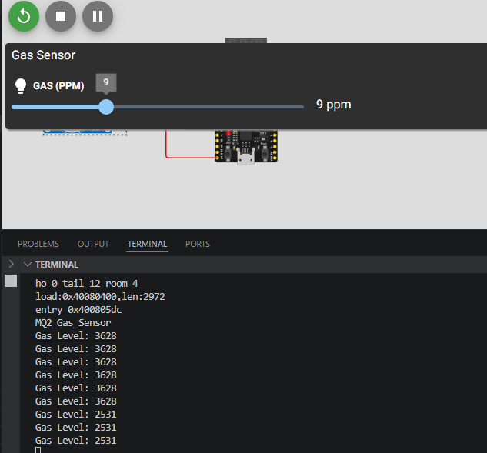
- HX711 Load Cell Amplifier
- Write a program to display weight in grams. Include taring (zeroing) at startup.
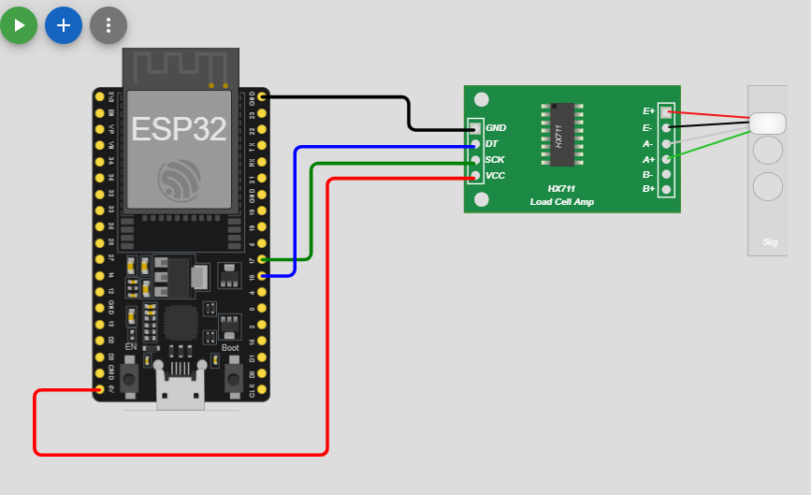
#include <Arduino.h>
#include "HX711.h"

#define DT 16
#define SCK 17

HX711 scale;

void setup()
{
Serial.begin(115200);
Serial.println("\nHX711 Load Cell Amplifier ");
scale.begin(DT, SCK);

// Tare (zero the scale at startup)
Serial.println("Taring... remove any weight");
delay(2000);
scale.tare();

Serial.println("Ready");
}

void loop()
{

// Set calibration factor (you MUST adjust this for your load cell)
float calibration_factor = -7050;

scale.set_scale(calibration_factor);

float weight = scale.get_units(10); // average of 10 readings

Serial.print("Weight: ");
Serial.print(weight);
Serial.println(" g");

delay(500);
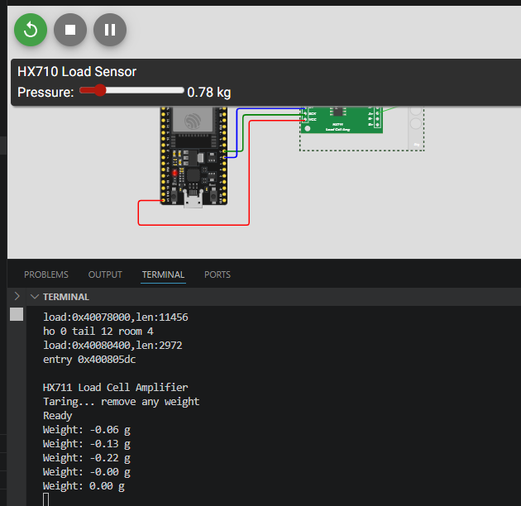
}

- MFRC522 RFID/NFC Reader
- Write a program to read an RFID card and print its UID on the Serial Monitor.
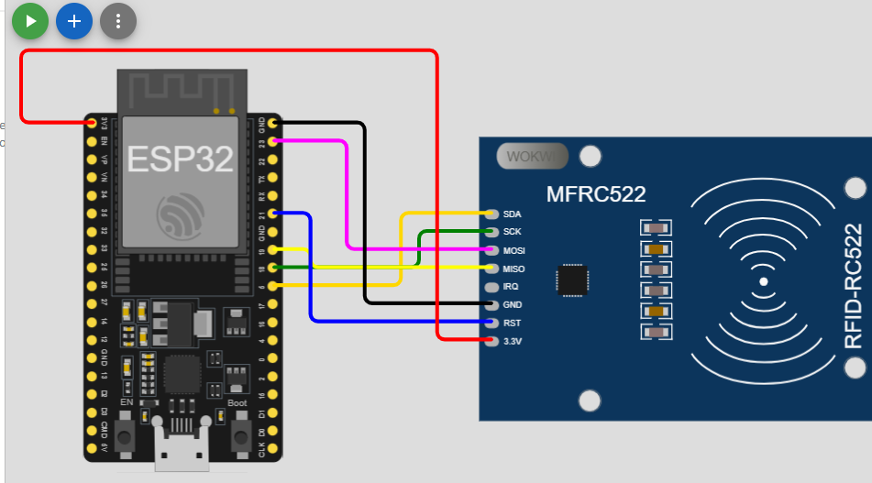
#include <Arduino.h>
#include <SPI.h>
#include <MFRC522.h>

#define SS_PIN 5
#define RST_PIN 22

MFRC522 rfid(SS_PIN, RST_PIN);

void setup() {
Serial.begin(115200);
Serial.println("\nMFRC522 RFID/NFC Reader ");
SPI.begin();
rfid.PCD_Init();

Serial.println("Place RFID card near reader...");
}

void loop() {

if (!rfid.PICC_IsNewCardPresent()) {
return;
}

if (!rfid.PICC_ReadCardSerial()) {
return;
}

Serial.print("UID: ");

for (byte i = 0; i < rfid.uid.size; i++) {
Serial.print(rfid.uid.uidByte[i] < 0x10 ? " 0" : " ");
Serial.print(rfid.uid.uidByte[i], HEX);
}

Serial.println();

rfid.PICC_HaltA();
}
