Lab Sheet 06
Title:
- Programming ESP32 to Interface Input & Output Devices using Wokwi
Aims:
- To learn how to program the ESP32 to correctly read data from input devices and control output devices using the Wokwi online simulator, while understanding the purpose and behavior of each device.
Tasks:
Input Devices
01.Push Button (Tactile Switch)
- Write an ESP32 program to:
  - Detect button press
  - Print “Button Pressed” and “Button Released” on Serial Monitor.
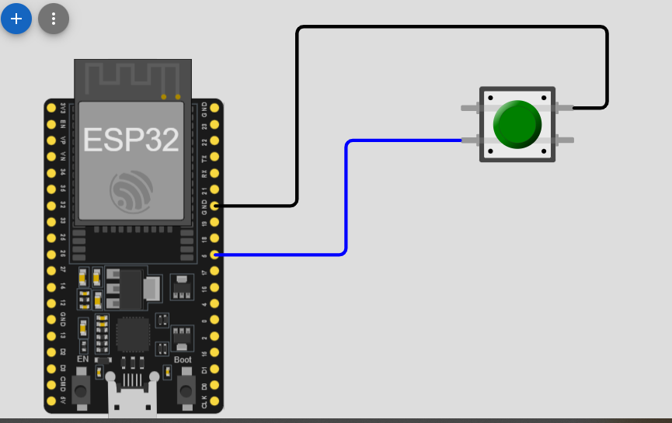
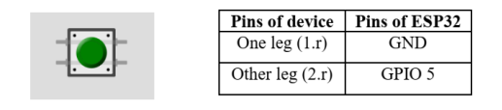

#include <Arduino.h>
const int BUTTON_PIN = 5; // You can use GPIO 4, 5, 18, etc.

// Variable to store the last known state of the button
int lastButtonState = HIGH;

void setup() {
// Initialize serial communication at 115200 baud
Serial.begin(115200);
Serial.println("Push Button Test");

// Configure the button pin as an INPUT with internal pull-up resistor
// This keeps the pin HIGH when the button is NOT pressed.
pinMode(BUTTON_PIN, INPUT_PULLUP);
}

void loop() {
// Read the current state of the button
int currentButtonState = digitalRead(BUTTON_PIN);

// Check if the state has changed
if (currentButtonState != lastButtonState) {

// If the state went from HIGH to LOW, the button was pressed
if (currentButtonState == LOW) {
Serial.println("Button Pressed");
}
// If the state went from LOW to HIGH, the button was released
else {
Serial.println("Button Released");
}

// Save the current state for the next loop iteration
lastButtonState = currentButtonState;

// Small delay to debounce (prevent mechanical flicker)
delay(50);
}
}

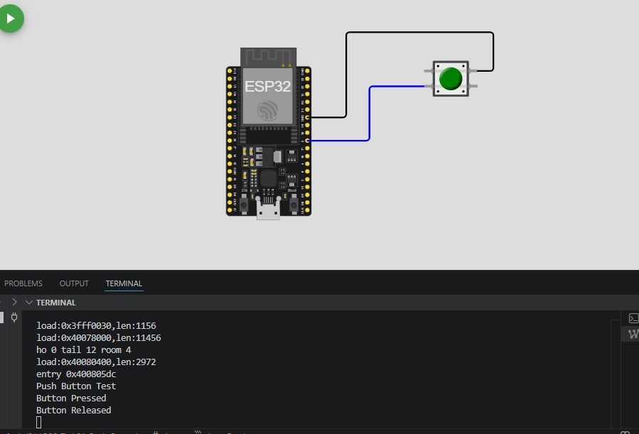

02.Slide Switch / Toggle Switch
- Write a program to:
  - Read the switch state
  - Display ON or OFF in Serial Monitor
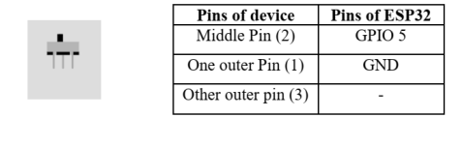
#include <Arduino.h>
const int SWITCH_PIN = 5; // You can use GPIO 4, 5, 18, etc.

// Variable to store the last known state of the switch
int lastSwitchState = -1;

void setup() {
// Initialize serial communication at 115200 baud
Serial.begin(115200);

Serial.println("Slide Switch / Toggle Switch Test");

// Configure the switch pin as an INPUT with internal pull-up resistor
pinMode(SWITCH_PIN, INPUT_PULLUP);
}

void loop() {
// Read the current state of the switch
int currentSwitchState = digitalRead(SWITCH_PIN);

// Check if the switch has been flipped to a new position
if (currentSwitchState != lastSwitchState) {

// If the pin is LOW, the switch closed the circuit to GND (ON)
if (currentSwitchState == LOW) {
Serial.println("Switch: ON");
}
// If the pin is HIGH, the switch opened the circuit (OFF)
else {
Serial.println("Switch: OFF");
}

// Save the current state for the next loop iteration
lastSwitchState = currentSwitchState;

// Small delay to prevent reading contact bounce while flipping
delay(50);
}
}

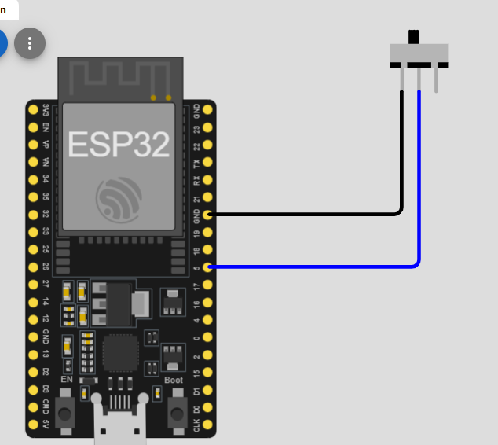
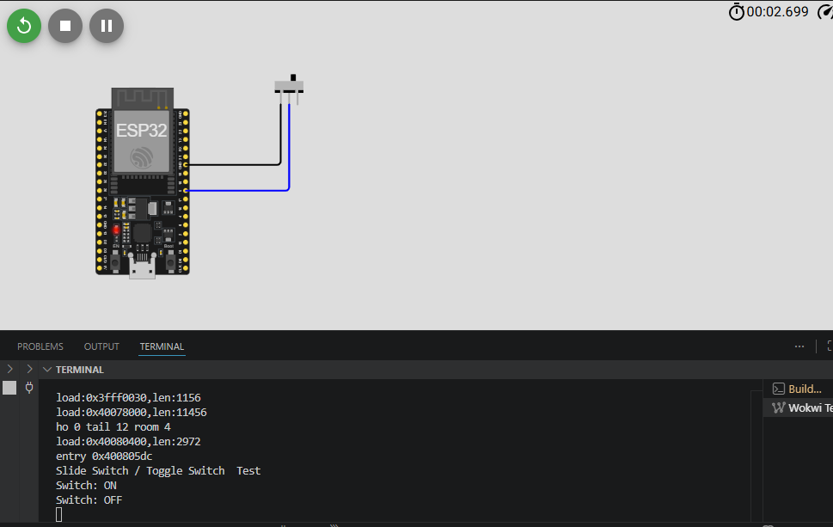

03.Potentiometer (Rotary)
- Write a program to:
  - Read the analog value from GPIO 34
  - Print values (0–4095) on Serial Monitor
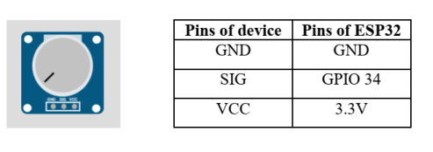
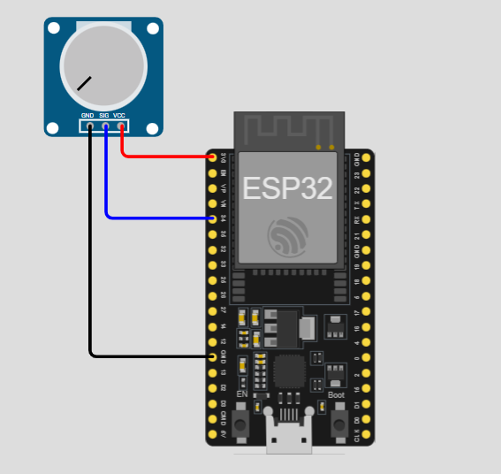
#include <Arduino.h>
// Define the analog pin connected to the potentiometer middle pin
const int POT_PIN = 34; // GPIO 34 is an analog input pin (ADC1_CH6)

void setup() {
// Initialize serial communication at 115200 baud
Serial.begin(115200);
Serial.println("Potentiometer Test");
// Analog pins do not strictly require pinMode(),
// but it's good practice to set it as INPUT.
pinMode(POT_PIN, INPUT);
}

void loop() {
// Read the analog value (0 to 4095)
int potValue = analogRead(POT_PIN);

// Print the value to the Serial Monitor
Serial.print("Potentiometer Value: ");
Serial.println(potValue);

// Wait 100 milliseconds so the monitor doesn't scroll too fast
delay(100);
}

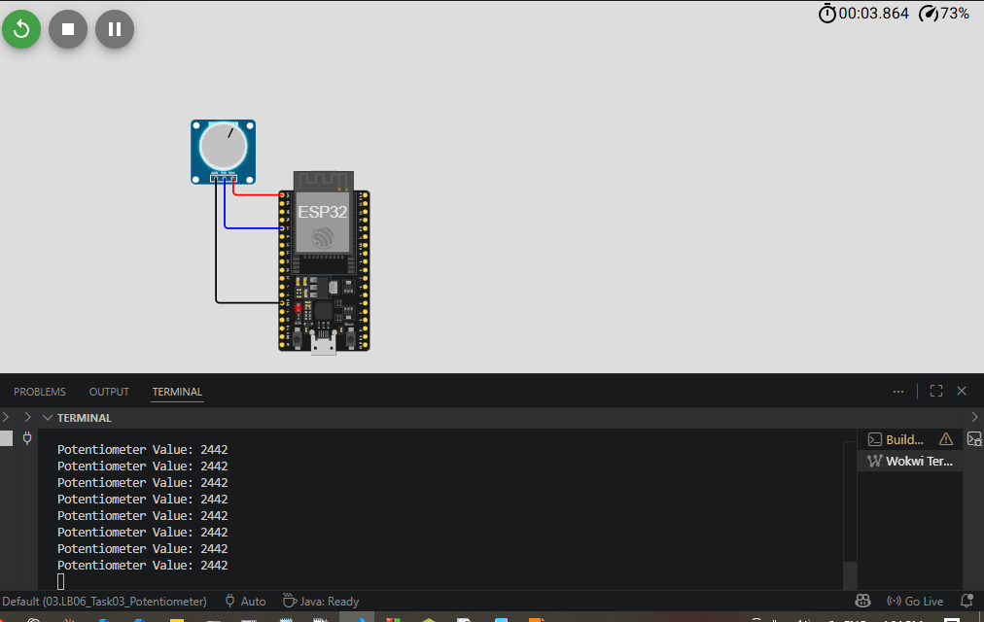
04.Rotary Encoder (KY-040)
- Write a program to:
  - Detect clockwise and anticlockwise rotation
  - Print direction and step count
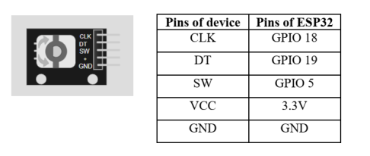
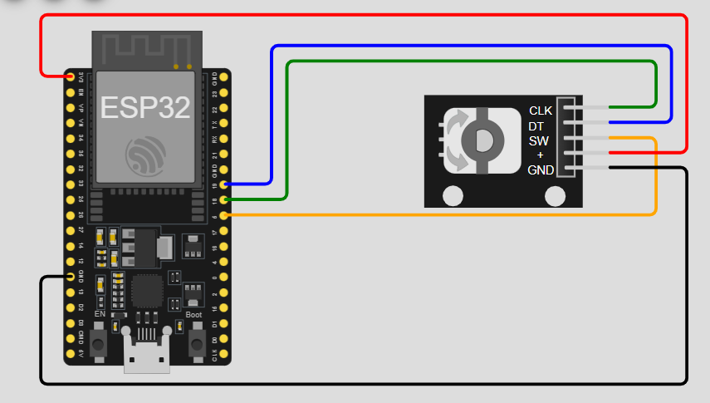
#include <Arduino.h>
// Define the encoder pins
const int CLK_PIN = 18; // Clock pin
const int DT_PIN = 19; // Data pin

int counter = 0; // Stores the step count
int lastClkState; // Stores the previous state of the CLK pin

void setup() {
// Initialize serial communication at 115200 baud
Serial.begin(115200);
Serial.println("Rotary Encoder (KY-040) Test");
// Set encoder pins as inputs
pinMode(CLK_PIN, INPUT);
pinMode(DT_PIN, INPUT);

// Read the initial state of the CLK pin
lastClkState = digitalRead(CLK_PIN);
}

void loop() {
// Read the current state of the CLK pin
int currentClkState = digitalRead(CLK_PIN);

// Check if the knob has been turned (CLK state changed)
if (currentClkState != lastClkState) {

// If the CLK state changed, we check the DT state to find the direction
// If CLK state is different from DT state, it's rotating Clockwise
if (digitalRead(DT_PIN) != currentClkState) {
counter++;
Serial.print("Direction: Clockwise | ");
}
// Otherwise, it's rotating Counter-Clockwise
else {
counter--;
Serial.print("Direction: Counter-Clockwise | ");
}

// Print the current step count
Serial.print("Position: ");
Serial.println(counter);
}

// Save the current CLK state for the next loop
lastClkState = currentClkState;
}

05.Analog Joystick
- Write a program to:
  - Read X-axis, Y-axis, and button press
  - Print values in Serial Monitor
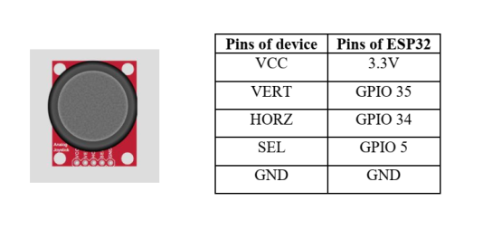
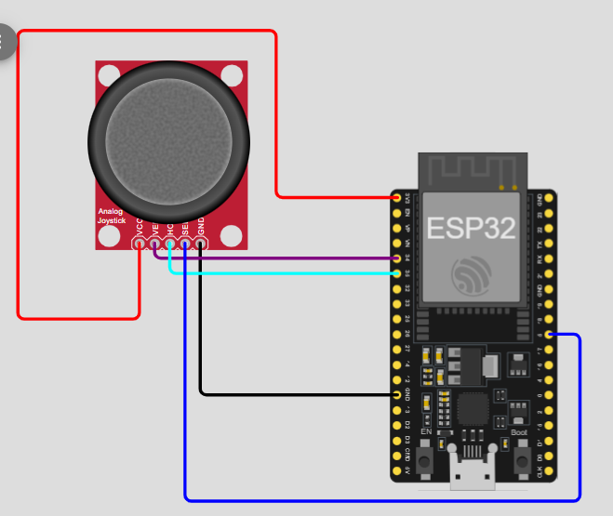
#include <Arduino.h>
// Define the joystick pins
const int X_PIN = 34; // Analog pin for X-axis
const int Y_PIN = 35; // Analog pin for Y-axis
const int SW_PIN = 5; // Digital pin for the push-button

void setup() {
// Initialize serial communication at 115200 baud
Serial.begin(115200);
Serial.println("Analog Joystick Test");
// Configure axis pins as inputs
pinMode(X_PIN, INPUT);
pinMode(Y_PIN, INPUT);

// Configure the switch pin with internal pull-up resistor
pinMode(SW_PIN, INPUT_PULLUP);
}

void loop() {
// Read the analog values (0 to 4095)
int xValue = analogRead(X_PIN);
int yValue = analogRead(Y_PIN);

// Read the digital button state (LOW = Pressed, HIGH = Released)
int buttonState = digitalRead(SW_PIN);

// Print the data to the Serial Monitor
Serial.print("X: ");
Serial.print(xValue);
Serial.print(" | Y: ");
Serial.print(yValue);
Serial.print(" | Button: ");

if (buttonState == LOW) {
Serial.println("PRESSED");
} else {
Serial.println("RELEASED");
}

// Wait 150 milliseconds so the text is readable
delay(150);
}
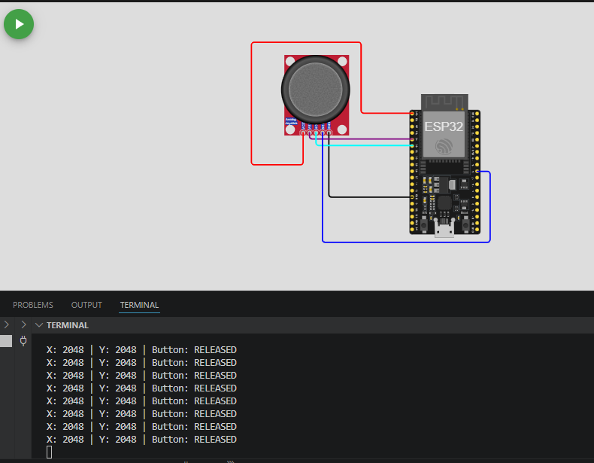
06.Keypad
- Write a program to:
  - Detect key presses
  - Display pressed key on Serial Monitor
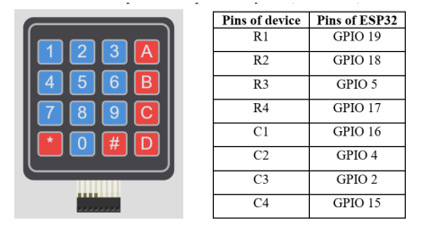
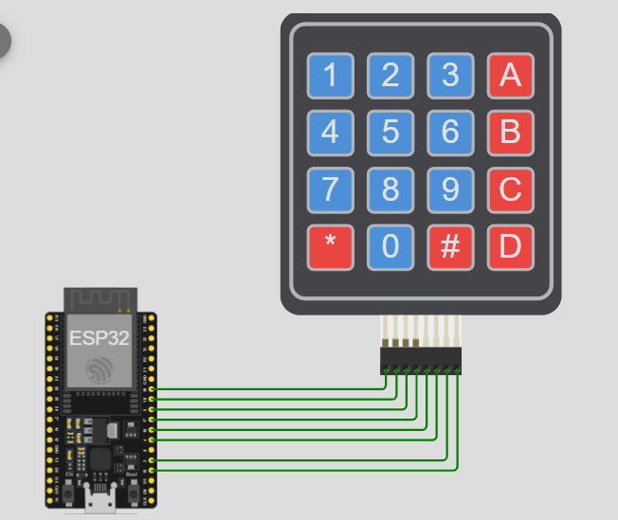
#include <Arduino.h>
#include <Keypad.h>

// Define the number of rows and columns on your keypad
const byte ROWS = 4;
const byte COLS = 4;

// Define the symbols on the buttons of the keypads
char hexaKeys[ROWS][COLS] = {
{'1','2','3','A'},
{'4','5','6','B'},
{'7','8','9','C'},
{'*','0','#','D'}
};

// Connect the ESP32 GPIO pins to the row pins of the keypad
byte rowPins[ROWS] = {19, 18, 5, 17};

// Connect the ESP32 GPIO pins to the column pins of the keypad
byte colPins[COLS] = {16, 4, 2, 15};

// Initialize an instance of class NewKeypad
Keypad customKeypad = Keypad(makeKeymap(hexaKeys), rowPins, colPins, ROWS, COLS);

void setup() {
// Initialize serial communication at 115200 baud
Serial.begin(115200);
Serial.println("Keypad Test");
}

void loop() {
// Check if a key is pressed
char customKey = customKeypad.getKey();

// If a key was pressed, print it to the Serial Monitor
if (customKey) {
Serial.print("Key Pressed: ");
Serial.println(customKey);
}
}

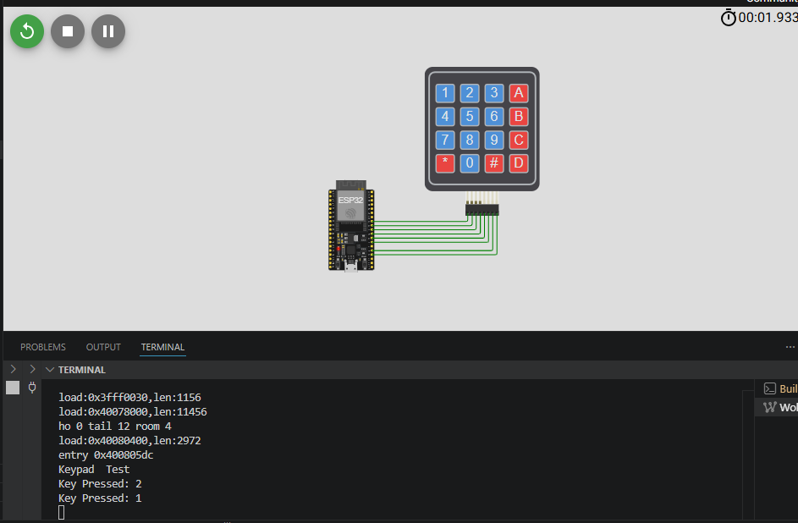
07.IR Receiver
- Write a program to:
  - Receive IR remote signals
  - Print received HEX code
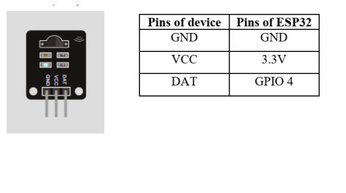
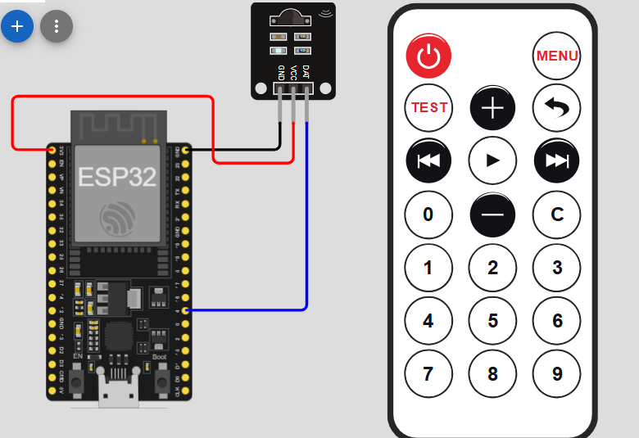
#include <Arduino.h>
#define IR_RECEIVE_PIN 4 // Define the pin connected to the IR receiver output

// The IRremote library requires this macro definition BEFORE including the header
#define DECODE_NEC // Optional: Saves memory by only enabling specific protocols
#include <IRremote.hpp>

void setup() {
// Initialize serial communication at 115200 baud
Serial.begin(115200);
Serial.println("IR Receiver Test");
// Start the receiver and enable visual feedback (blinks onboard LED if applicable)
IrReceiver.begin(IR_RECEIVE_PIN, ENABLE_LED_FEEDBACK);
Serial.println("IR Receiver is ready. Point a remote and press a button!");
}

void loop() {
// Check if a new IR signal has been received and decoded
if (IrReceiver.decode()) {

// Print the command in Hexadecimal format
Serial.print("Protocol: ");
Serial.print(IrReceiver.getProtocolString()); // Prints the protocol name (e.g., NEC, SONY)

Serial.print(" | HEX Code: 0x");
Serial.println(IrReceiver.decodedIRData.command, HEX); // Prints the unique button HEX value

// Resume receiving to prepare for the next button press
IrReceiver.resume();
}
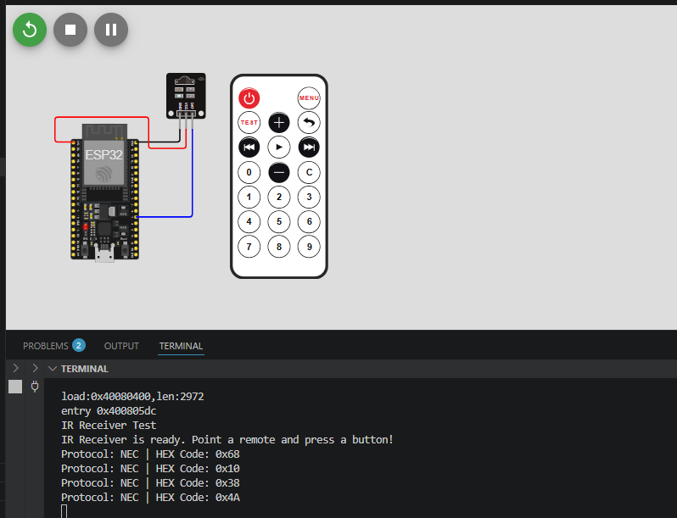
Output Devices
01.IR Remote
- Observe how:
  - Button press sends IR signal
  - Signal is decoded by ESP32
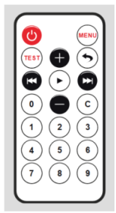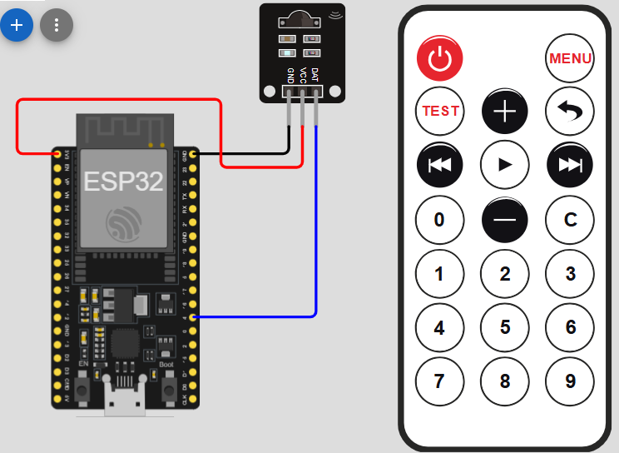
#include <Arduino.h>
#define IR_RECEIVE_PIN 4
#include <IRremote.hpp>

void setup() {
Serial.begin(115200);
Serial.println("IR Remote Test");
IrReceiver.begin(IR_RECEIVE_PIN, ENABLE_LED_FEEDBACK);
}

void loop() {
if (IrReceiver.decode()) {
Serial.print("HEX Code: 0x");
Serial.println(IrReceiver.decodedIRData.command, HEX);
IrReceiver.resume();
}
}
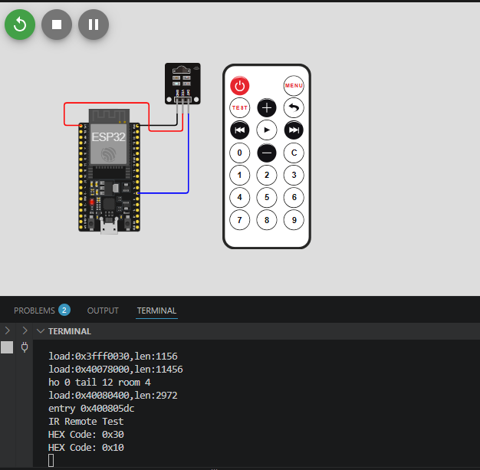
02.LED
- Write a program to:
  - Blink LED with 1-second delay
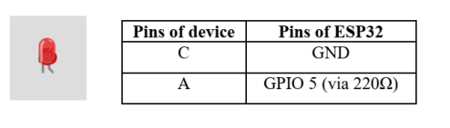
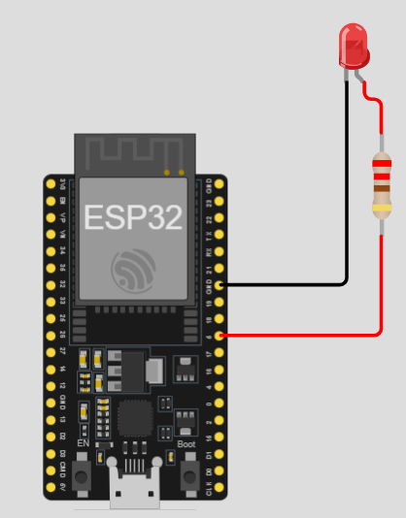
#include <Arduino.h>
const int LED_PIN = 2; // GPIO 5 is also the built-in blue LED on most ESP32 boards

void setup() {
// Configure the LED pin as an OUTPUT
pinMode(LED_PIN, OUTPUT);
}

void loop() {
// Turn the LED ON (HIGH voltage level)
digitalWrite(LED_PIN, HIGH);
delay(1000); // Wait for 1 second (1000 milliseconds)

// Turn the LED OFF (LOW voltage level)
digitalWrite(LED_PIN, LOW);
delay(1000); // Wait for 1 second
}
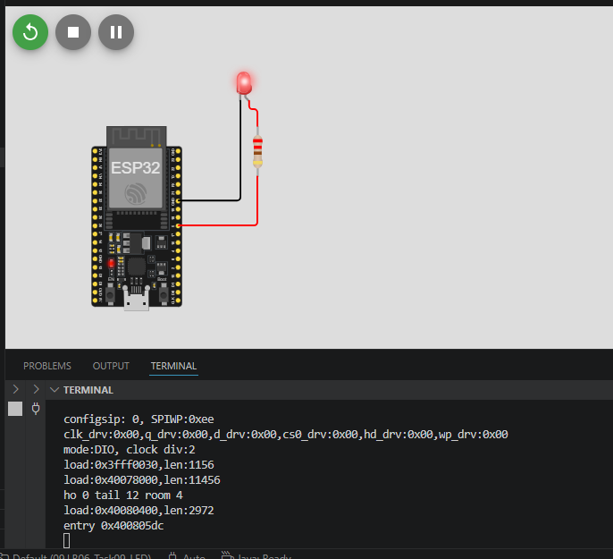

03.RGB LED
- Write a program to:
  - Display Red, Green, Blue, and White colors
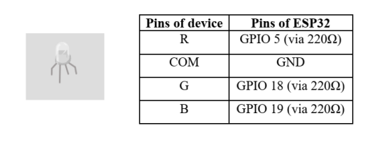
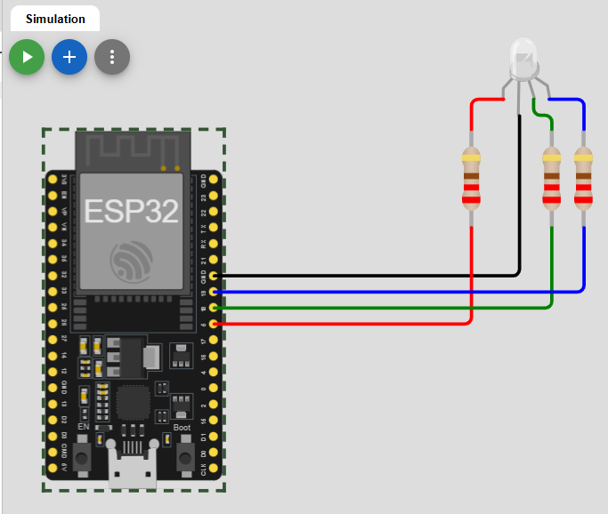
#include <Arduino.h>

// Define the GPIO pins for each color channel
const int RED_PIN = 5;
const int GREEN_PIN = 18;
const int BLUE_PIN = 19;

void setColor(int redState, int greenState, int blueState);

void setup() {
// Set all color pins as OUTPUT
Serial.begin(115200);
Serial.println("RGB LED Test");
pinMode(RED_PIN, OUTPUT);
pinMode(GREEN_PIN, OUTPUT);
pinMode(BLUE_PIN, OUTPUT);
}

void loop() {
// 1. Display RED
setColor(HIGH, LOW, LOW);
delay(1000);

// 2. Display GREEN
setColor(LOW, HIGH, LOW);
delay(1000);

// 3. Display BLUE
setColor(LOW, LOW, HIGH);
delay(1000);

// 4. Display WHITE (Red + Green + Blue mixed together)
setColor(HIGH, HIGH, HIGH);
delay(1000);
}

// Helper function to easily set the pin states
void setColor(int redState, int greenState, int blueState) {
digitalWrite(RED_PIN, redState);
digitalWrite(GREEN_PIN, greenState);
digitalWrite(BLUE_PIN, blueState);
}

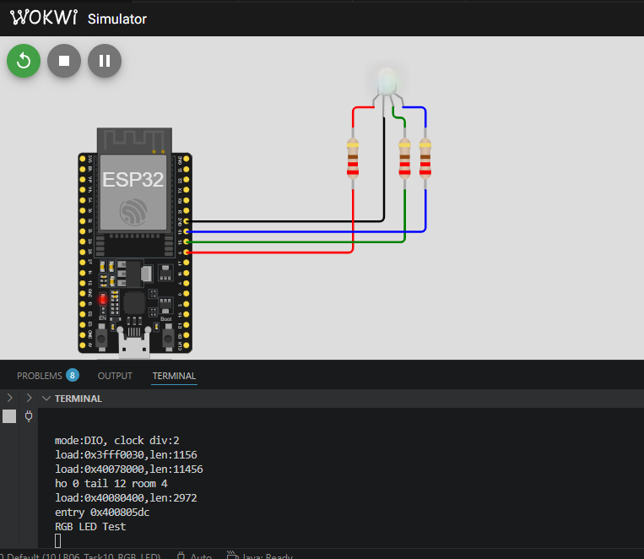

04.Buzzer
- Write a program to:
  - Generate beep sound using GPIO
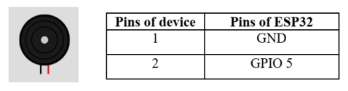
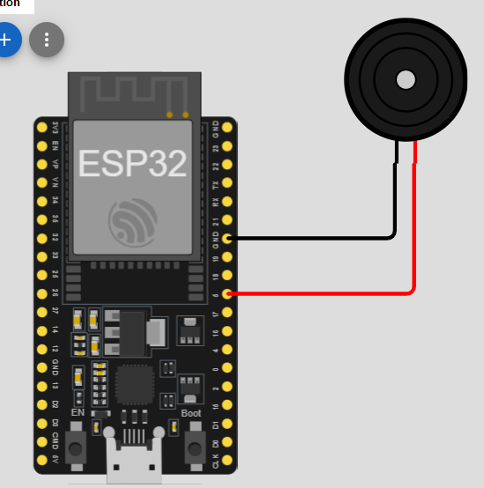
#include <Arduino.h>
// Define the GPIO pin connected to the buzzer
const int BUZZER_PIN = 5; // You can use GPIO 12, 13, 14, etc.

void setup() {
// Configure the buzzer pin as an OUTPUT
Serial.begin(115200);
Serial.println("Buzzer Test");
pinMode(BUZZER_PIN, OUTPUT);
}

void loop() {
// --- Generate the Beep Sound ---
// tone(pin, frequency, duration)
// 2000Hz frequency creates a standard crisp beep
tone(BUZZER_PIN, 2000, 200);

// Wait for 1 second before the next beep
// Note: tone() doesn't pause the code, so we use delay()
delay(1000);
}

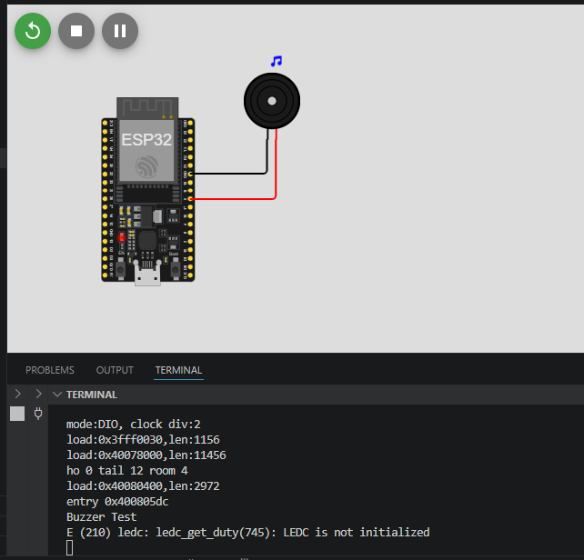
05.Servo Motor
- Write a program to:
  - Rotate servo from 0° → 90° → 180°
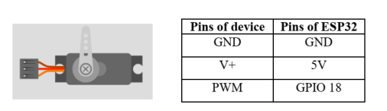
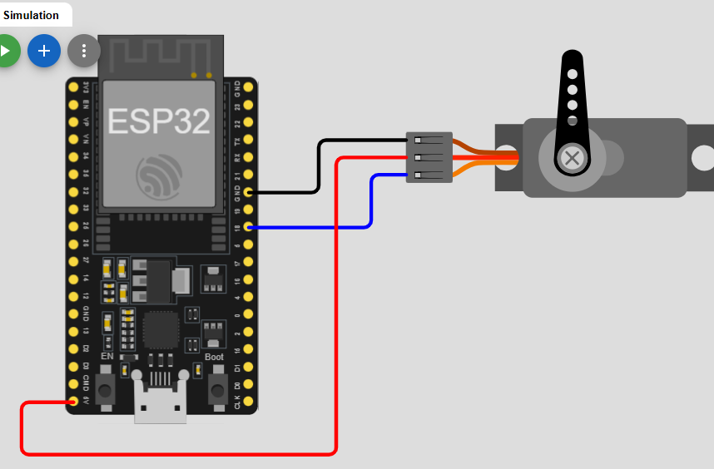
#include <Arduino.h>
#include <ESP32Servo.h>

// Create a servo object
Servo myServo;

// Define the GPIO pin connected to the servo signal wire
const int SERVO_PIN = 18;

void setup() {
// Allow allocation of all timers for servo PWM control
ESP32PWM::allocateTimer(0);
ESP32PWM::allocateTimer(1);
ESP32PWM::allocateTimer(2);
ESP32PWM::allocateTimer(3);
Serial.begin(115200);
Serial.println("Servo Motor");

// Set the PWM frequency for a standard servo (50Hz)
myServo.setPeriodHertz(50);

// Attach the servo object to the pin
myServo.attach(SERVO_PIN, 500, 2400); // Pulse width range in microseconds
}

void loop() {
// Move to 0 degrees
myServo.write(0);
delay(1000); // Wait 1 second for the motor to reach the position

// Move to 90 degrees
myServo.write(90);
delay(1000);

// Move to 180 degrees
myServo.write(180);
delay(1000);
}

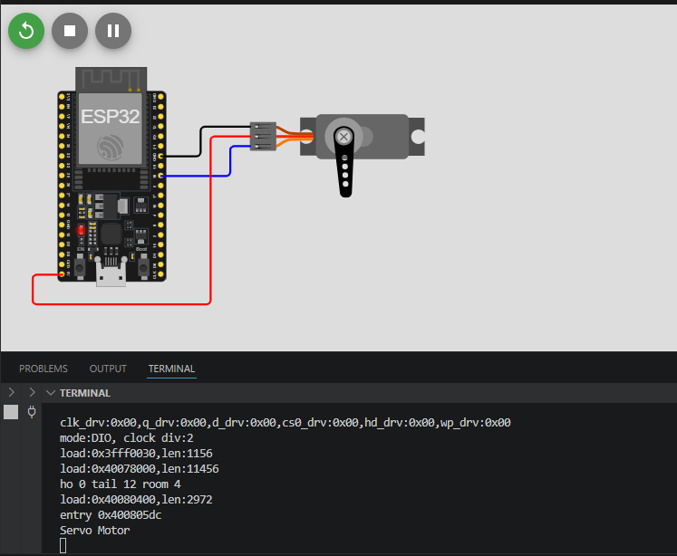
06.Bipolar Stepper Motor + A4988 Driver
- Write a program to:
  - Rotate stepper motor clockwise and anticlockwise
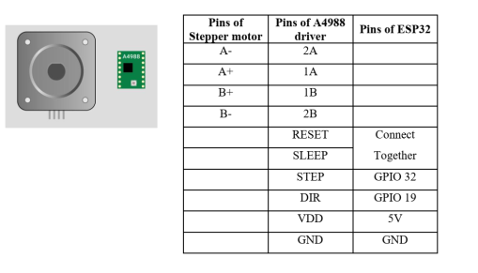
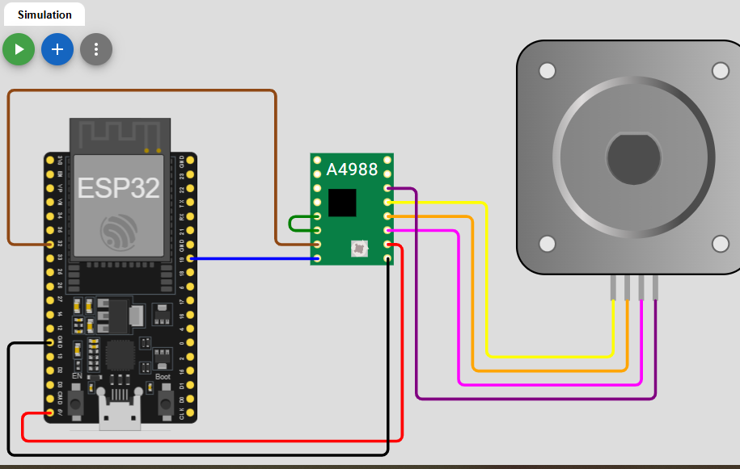
#include <Arduino.h>
const int STEP_PIN = 32; // GPIO 32 sends the step pulses
const int DIR_PIN = 19; // GPIO 19 sets the rotation direction

// Define the steps per revolution for your motor
// (Standard NEMA 17 motors usually have 200 steps per full revolution)
const int STEPS_PER_REV = 200;

void setup() {
// Configure control pins as outputs
pinMode(STEP_PIN, OUTPUT);
pinMode(DIR_PIN, OUTPUT);
Serial.begin(115200);
Serial.println("Bipolar Stepper Motor + A4988 Driver Test");
}

void loop() {
// 1. Rotate Clockwise
digitalWrite(DIR_PIN, HIGH); // Set direction to HIGH (Clockwise)

// Spin one full revolution
for (int i = 0; i < STEPS_PER_REV; i++) {
digitalWrite(STEP_PIN, HIGH);
delayMicroseconds(1000); // Speeds up or slows down the pulse rate
digitalWrite(STEP_PIN, LOW);
delayMicroseconds(1000);
}

delay(1000); // Pause for 1 second

// 2. Rotate Counter-Clockwise
digitalWrite(DIR_PIN, LOW); // Set direction to LOW (Counter-Clockwise)

// Spin one full revolution back
for (int i = 0; i < STEPS_PER_REV; i++) {
digitalWrite(STEP_PIN, HIGH);
delayMicroseconds(1000);
digitalWrite(STEP_PIN, LOW);
delayMicroseconds(1000);
}

delay(1000); // Pause for 1 second
}
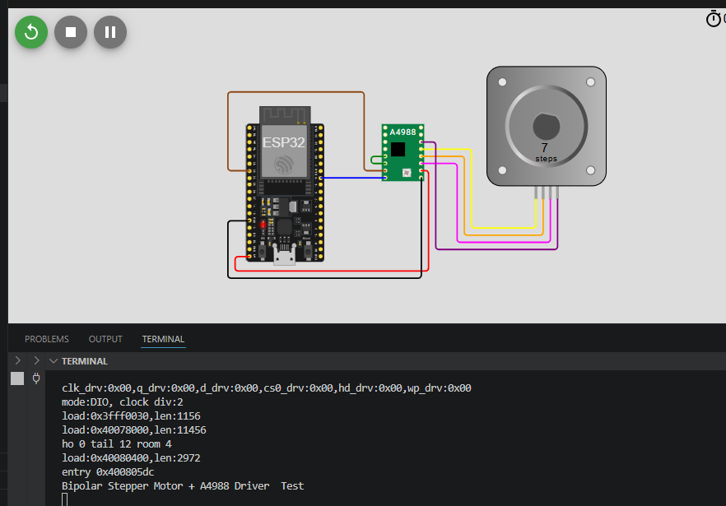

07.Relay Module
- Write a program to:
  - Turn relay ON and OFF using ESP32
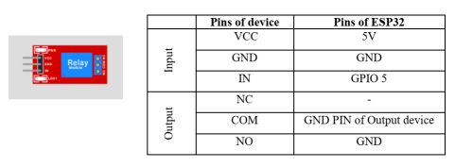
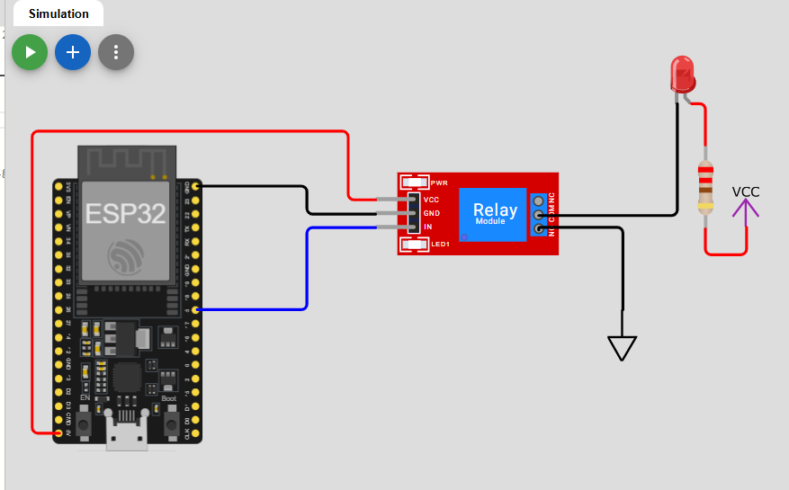
#include <Arduino.h>
const int RELAY_PIN = 5; // You can use GPIO 25, 26, 27, etc.

void setup() {
// Configure the relay pin as an OUTPUT
pinMode(RELAY_PIN, OUTPUT);
Serial.begin(115200);
Serial.println("Relay Module Test");
// Optional: Set initial state to OFF.
// For Active-Low relays, HIGH = OFF. For Active-High relays, LOW = OFF.
digitalWrite(RELAY_PIN, LOW);
}

void loop() {
// Turn the relay ON
digitalWrite(RELAY_PIN, HIGH);
delay(2000); // Wait for 2 seconds

// Turn the relay OFF
digitalWrite(RELAY_PIN, LOW);
delay(2000); // Wait for 2 seconds
}
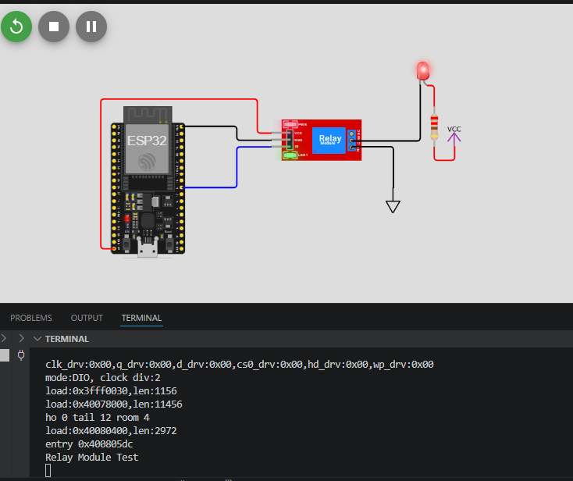
08.LCD 16x2 (Parallel)
- Write a program to:
  - Display your name and roll number
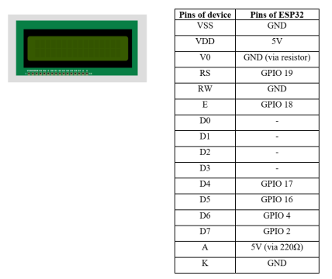
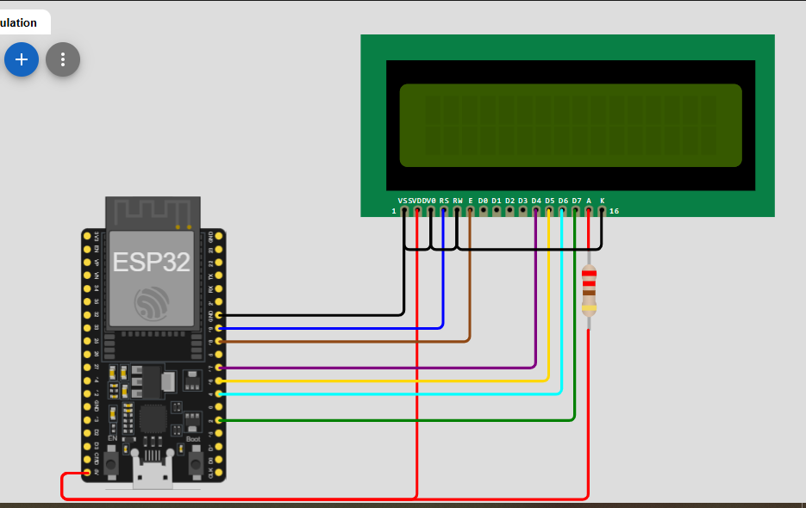
#include <Arduino.h>
#include <LiquidCrystal.h>
// Initialize the library with the numbers of the interface pins
// LiquidCrystal lcd(RS, E, D4, D5, D6, D7)
const int rs = 19, en = 18, d4 = 17, d5 = 16, d6 = 4, d7 = 2;
LiquidCrystal lcd(rs, en, d4, d5, d6, d7);

void setup() {
// Set up the LCD's number of columns and rows:
lcd.begin(16, 2);
Serial.begin(115200);
Serial.println("LCD 16x2 (Parallel) Test");
// Print your name on the first row (Row 0)
lcd.setCursor(0, 0);
lcd.print("Kalhara");

// Move cursor to the second row (Row 1) and print roll number
lcd.setCursor(0, 1);
lcd.print("Roll No: 12345");
}

void loop() {
// Nothing to repeat in the loop since the text is static
}
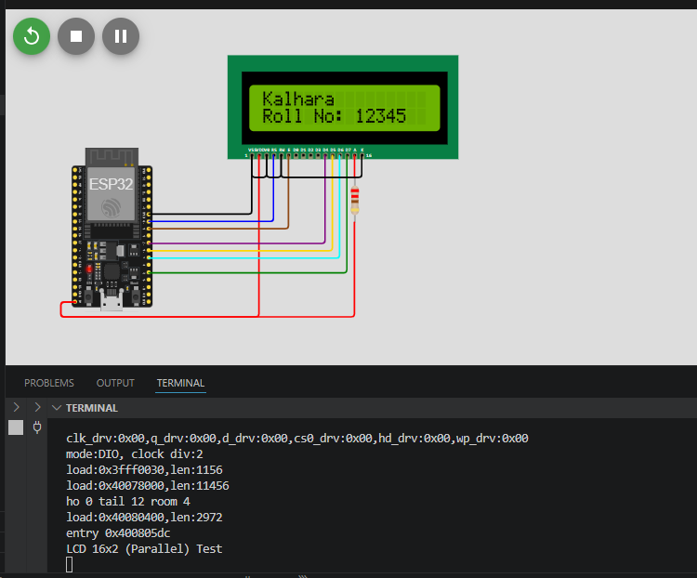

09.LCD 16x2 (I2C)
- Write a program to:
  - Display sensor values on LCD
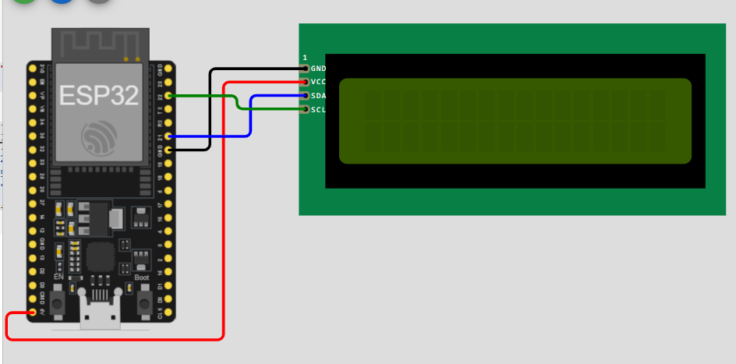
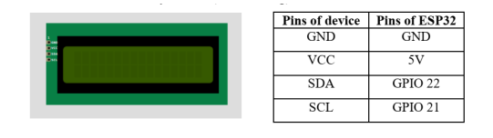

#include <Arduino.h>
#include <Wire.h>
#include <LiquidCrystal_I2C.h>

// Set the LCD address to 0x27 for a 16 chars and 2 line display
// (If 0x27 doesn't work, your module might use 0x3F)
LiquidCrystal_I2C lcd(0x27, 16, 2);

void setup() {
Serial.begin(115200);
Serial.println("LCD 16x2 (I2C) Test");
// Initialize the LCD connected via I2C
lcd.init();
// Turn on the blacklight
lcd.backlight();
// Print a static header on the first row
lcd.setCursor(0, 0);
lcd.print("Sensor Monitor");
}

void loop() {
// Simulate reading a sensor value (e.g., generating a value between 0 and 100)
int mockSensorValue = analogRead(34) / 41; // Scaled down for example display

// Move cursor to the second row (Column 0, Row 1)
lcd.setCursor(0, 1);
lcd.print("Value: ");

// Print the dynamic sensor value
lcd.print(mockSensorValue);

// Clear any leftover trailing digits if the value drops (e.g., from 100 to 9)
lcd.print(" ");

// Update every 500 milliseconds
delay(500);
}
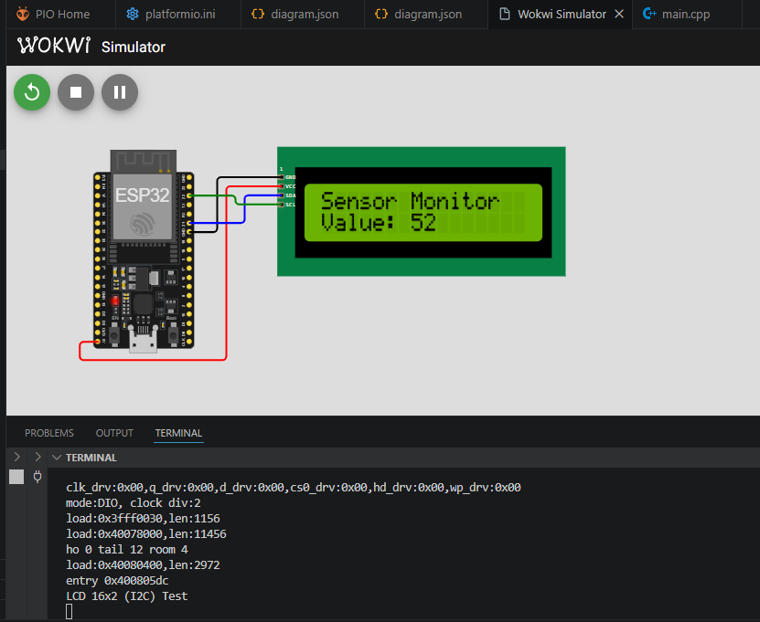
10.MAX7219 LED Dot Matrix
- Write a program to:
  - Display scrolling text
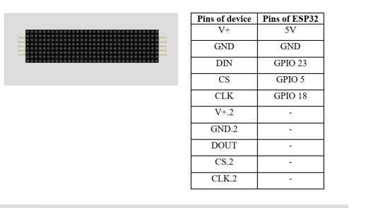

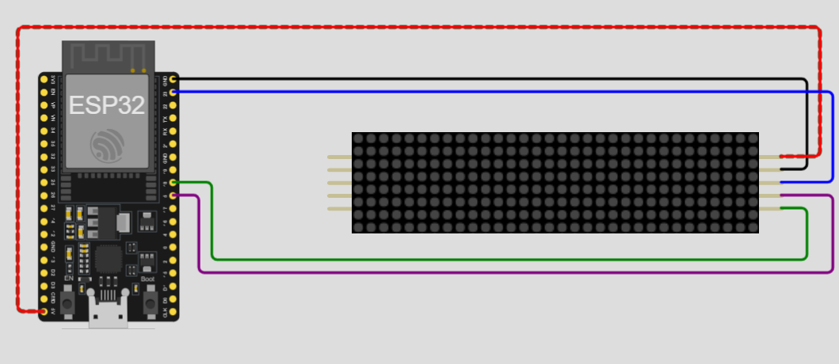
#include <MD_Parola.h>
#include <MD_MAX72xx.h>
#include <SPI.h>

// Try PAROLA_HW instead - often fixes display corruption
#define HARDWARE_TYPE MD_MAX72XX::PAROLA_HW
#define MAX_DEVICES 4

const int DATA_PIN = 23; // DIN
const int CS_PIN = 5; // CS
const int CLK_PIN = 18; // CLK

MD_Parola myDisplay = MD_Parola(HARDWARE_TYPE, DATA_PIN, CLK_PIN, CS_PIN, MAX_DEVICES);

void setup() {
Serial.begin(115200);
delay(1000);
Serial.println("\nMAX7219 LED Matrix - PAROLA_HW Test");

myDisplay.begin();

// Reverse all devices to fix byte order
for (uint8_t i = 0; i < MAX_DEVICES; i++) {
myDisplay.setFont(i, NULL);
}

myDisplay.setIntensity(10);
myDisplay.displayClear();
delay(500);

Serial.println("Display ready!");
myDisplay.displayText("TEST", PA_CENTER, 50, 1000, PA_PRINT, PA_PRINT);
}

void loop() {
if (myDisplay.displayAnimate()) {
myDisplay.displayReset();
}
}

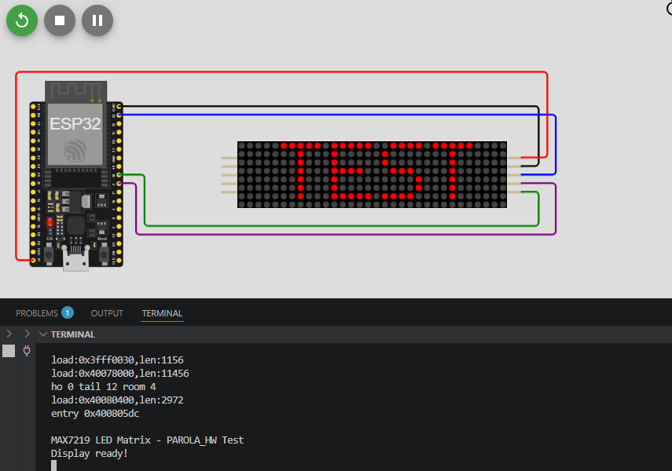
11.Seven Segment Display
- Write a program to:
  - Display digits 0–9 sequentially

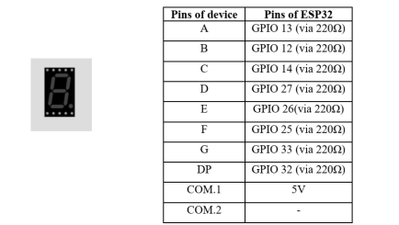
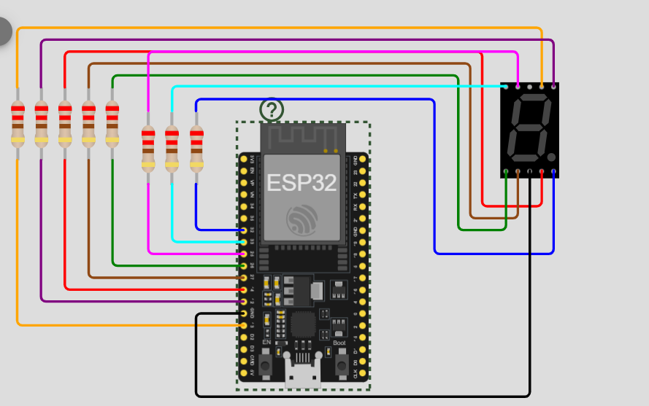

#include <Arduino.h>
// Define segment pins according to your image table
const int segA = 13;
const int segB = 12;
const int segC = 14;
const int segD = 27;
const int segE = 26;
const int segF = 25;
const int segG = 33;
const int segDP = 32; // Decimal Point pin

// Group all segment pins into an array for easy initialization
const int segments[] = {segA, segB, segC, segD, segE, segF, segG, segDP};

// Byte patterns for digits 0-9 (Common Cathode: 1 = ON, 0 = OFF)
// Bits correspond to: {A, B, C, D, E, F, G}
const byte digitPatterns[10][7] = {
{1, 1, 1, 1, 1, 1, 0}, // 0
{0, 1, 1, 0, 0, 0, 0}, // 1
{1, 1, 0, 1, 1, 0, 1}, // 2
{1, 1, 1, 1, 0, 0, 1}, // 3
{0, 1, 1, 0, 0, 1, 1}, // 4
{1, 0, 1, 1, 0, 1, 1}, // 5
{1, 0, 1, 1, 1, 1, 1}, // 6
{1, 1, 1, 0, 0, 0, 0}, // 7
{1, 1, 1, 1, 1, 1, 1}, // 8
{1, 1, 1, 1, 0, 1, 1} // 9
};

// Function prototype
void displayDigit(int num);

void setup() {
Serial.begin(115200);
Serial.println("Seven Segment Display Test");
// Set all segment pins as OUTPUT
for (int i = 0; i < 8; i++) {
pinMode(segments[i], OUTPUT);
digitalWrite(segments[i], LOW); // Turn all segments OFF initially
}
}

void loop() {
// Loop through digits 0 to 9
for (int digit = 0; digit < 10; digit++) {
displayDigit(digit);
delay(1000); // Wait 1 second before displaying the next number
}
}

// Helper function to update the physical pins with a digit pattern
void displayDigit(int num) {
for (int seg = 0; seg < 7; seg++) {
digitalWrite(segments[seg], digitPatterns[num][seg]);
}
// Keep the decimal point (DP) turned off
digitalWrite(segDP, LOW);
}

