Lab Sheet 07
Title: Temperature-Based Servo Motor Control with Manual Override using ESP32 & Blynk.
Aims:
To design and implement a temperature-based servo motor control system using the ESP32 microcontroller, where the servo motor operates automatically according to temperature variations, while also providing a manual override feature through the Blynk mobile application for real-time user control and monitoring.

Blynk IoT Platform
Blynk is a cloud-based IoT platform that enables real-time bi-directional communication between microcontrollers and smartphone apps. It uses virtual pins (V0–V255) as data channels. The Blynk library abstracts WebSocket/HTTP calls, allowing the developer to read/write virtual pins with simple function calls.
https://blynk.io

Task 01:
- Project Setup in Wokwi / VS Code
- Circuit Design
  - Connect the DHT sensor to an ESP32 GPIO pin
  - Connect the servo motor to a PWM-capable GPIO pin
  - Connect the LCD (I2C) to the ESP32.
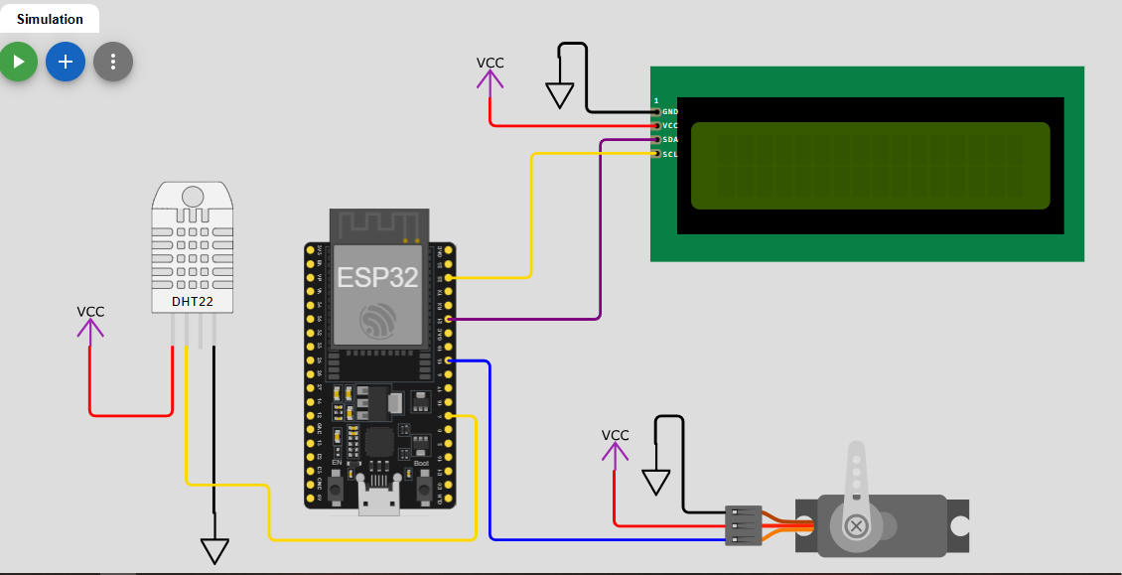

- Library Integration
- Blynk
- DHT sensor library
- Servo
- LiquidCrystal_I2C
[env:esp32dev]
platform = espressif32
board = esp32dev
framework = arduino
lib_deps =
blynkkk/Blynk@^1.3.2
adafruit/DHT sensor library@^1.4.7
madhephaestus/ESP32Servo@^3.2.0
marcoschwartz/LiquidCrystal_I2C@^1.1.4

- Blynk Configuration
a.Create a New Template in Blynk (IoT platform)
Sidebar → Developer Zone → My Templates → Create New Template → Enter Template Name → Select Hardware → Choose Connection Type → Click Create → Add Datastreams → Design Dashboard → Save

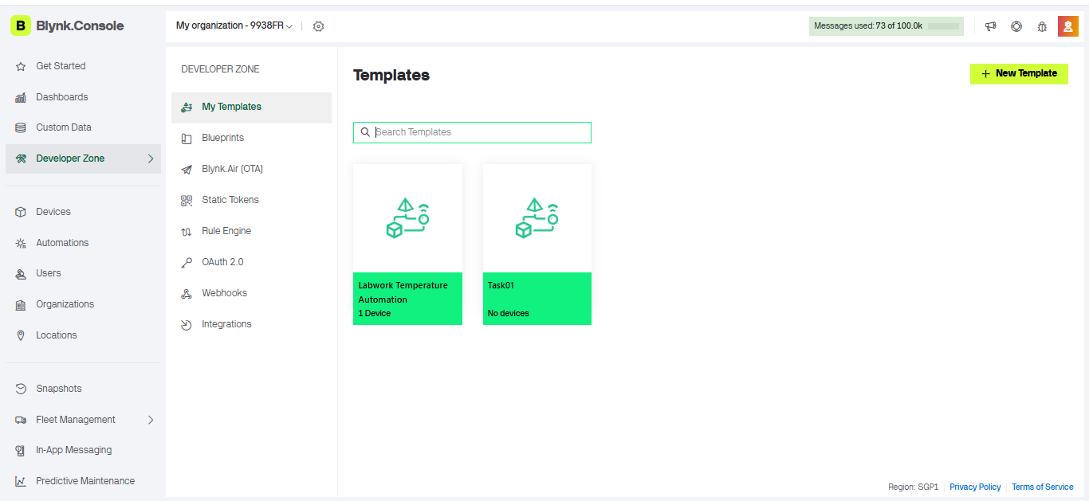
b.Assign virtual pins
- Temperature: Units: Degrees
- iHumidity: Units: Percentage, % | Max: 100
- Servo: Units: Degrees, ° | Max: 180

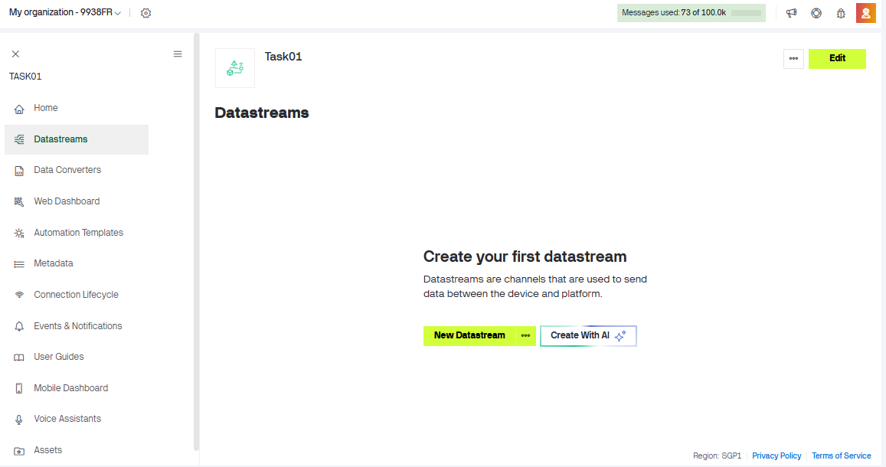
Datastreams → Add New Datastream → Virtual Pin

🌡 Temperature
- Virtual Pin → V0
- Name → Temperature
- Data Type → Double / Float
- Units → °C (Degrees)
- Min → -40 (optional)
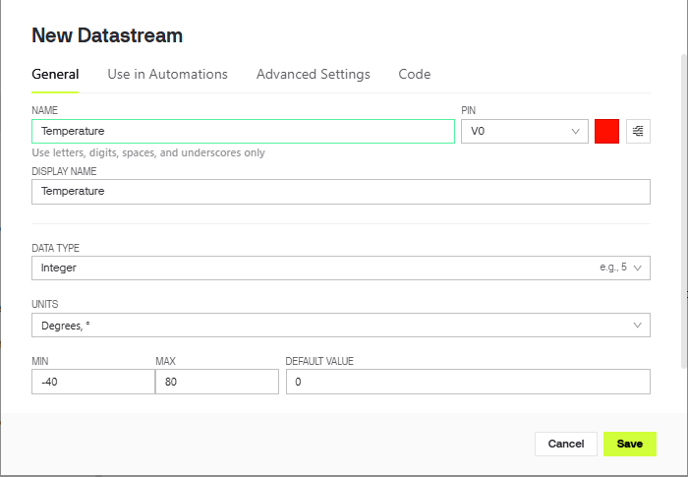
- Max → 80 (optional)

💧 Humidity (iHumidity)
- Virtual Pin → V1
- Name → Humidity
- Data Type → Integer / Double
- Units → % (Percentage)
- Min → 0
- Max → 100
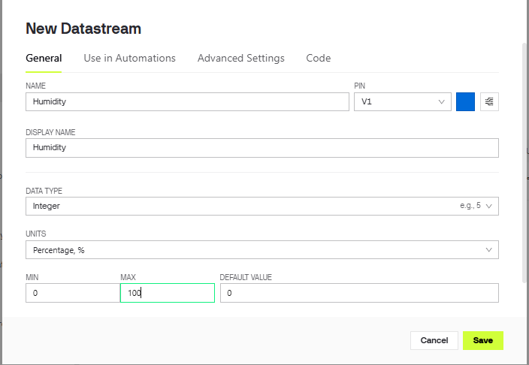

🎛 Servo Motor
- Virtual Pin → V2
- Name → Servo
- Data Type → Integer
- Units → ° (Degrees)
- Min → 0
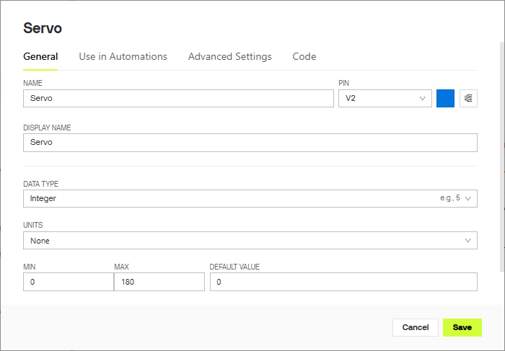
- Max → 180

🔁 Final Summary (Quick View)
Datastreams → Add →
- V0 → Temperature (°C)
- V1 → Humidity (%)
- V2 → Servo (0–180°)
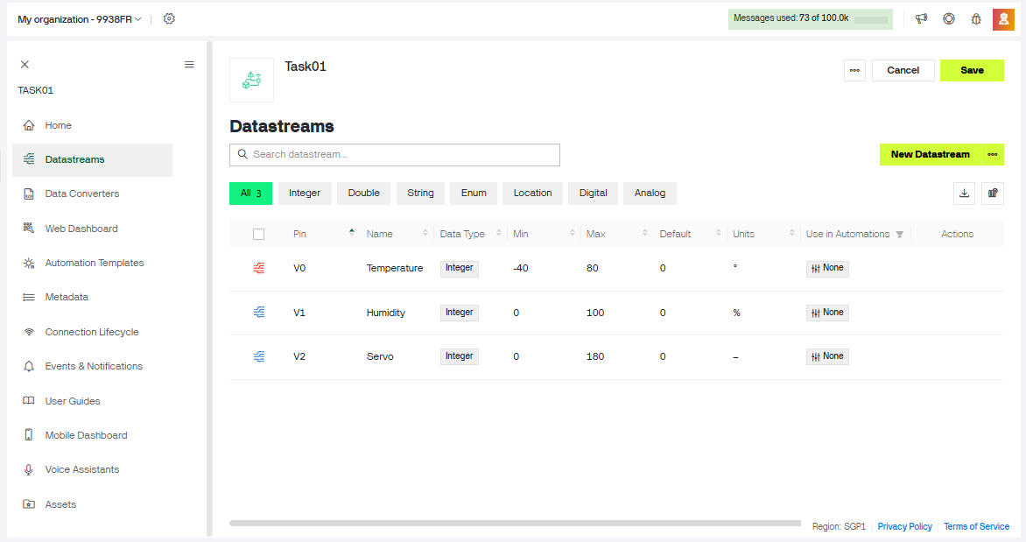

c.Create a New Device
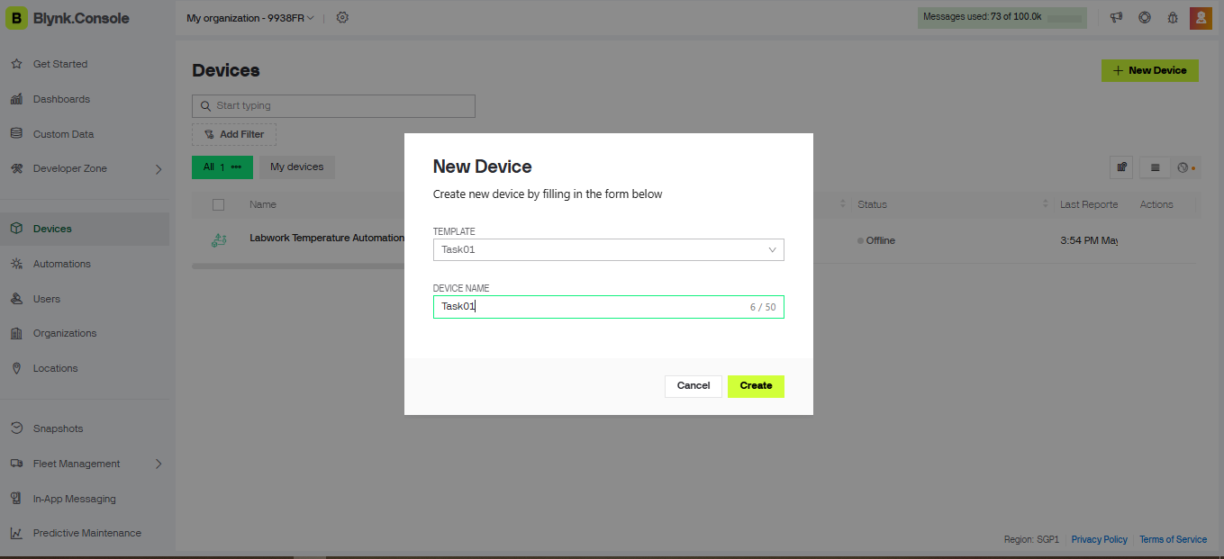
Sidebar → Developer Zone → My Devices → + New Device → From Template → Select Template → Enter Device Name → Create Device → Get Auth Token (or Device Credentials) → Save

d.Add widgets:
- Temperature display (Gauge)
- Humidity display (Gauge)
- Servo (Switch)

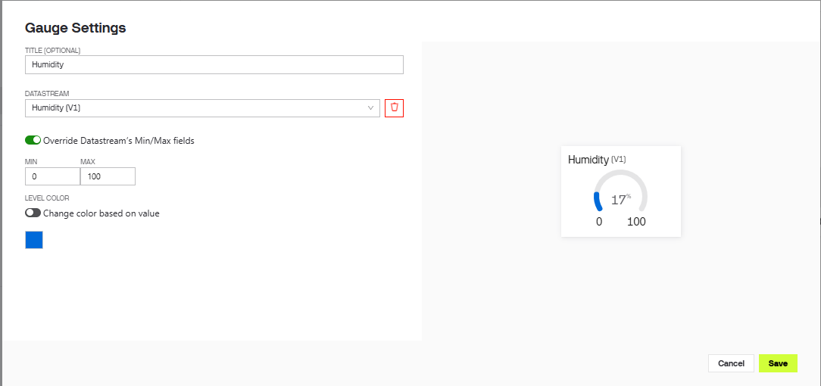
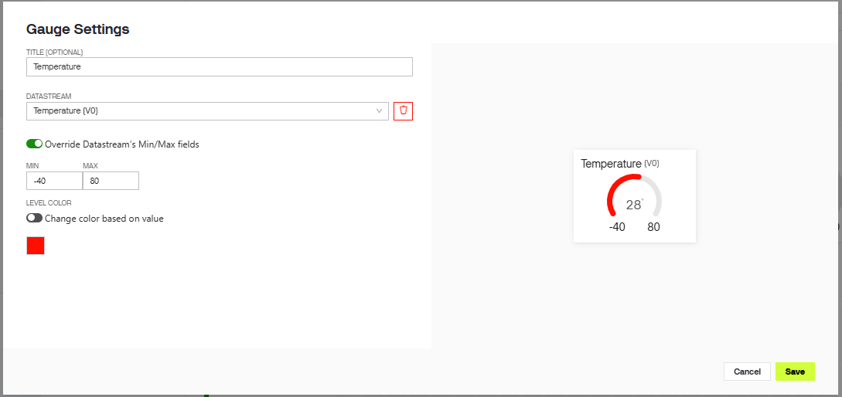
My Device → Open Dashboard → Edit Mode → + Add Widget → Gauge → Select Temperature (V0) → Set Units °C → Save → Add Widget → Gauge → Select Humidity (V1) → Set Units % → Save → Add Widget → Switch (or Slider) → Select Servo (V2) → Set Range 0–180° → Save

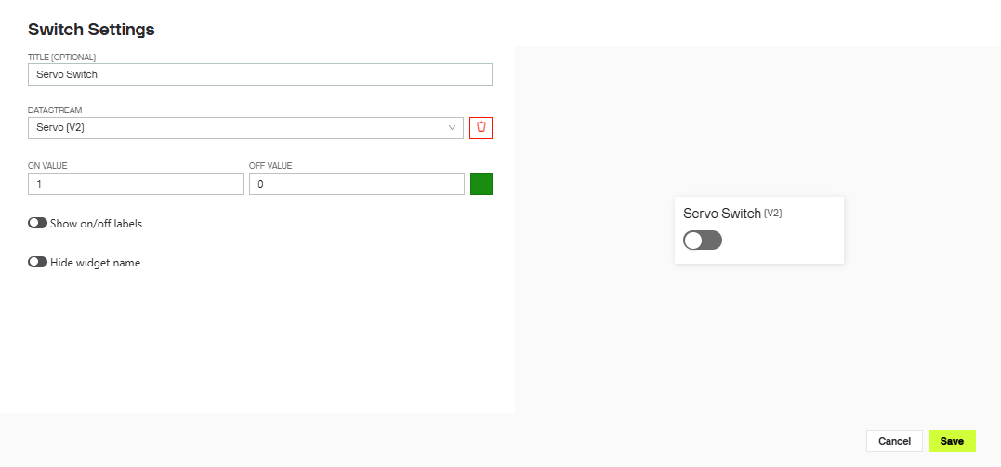
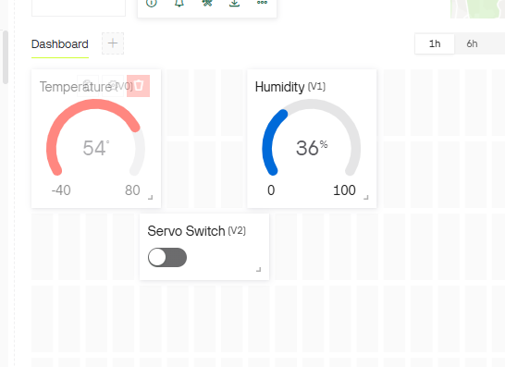

e.Obtain Template ID, Template Name and Auth Token
#define BLYNK_TEMPLATE_ID "TMPL6uxMnzyf7"
#define BLYNK_TEMPLATE_NAME "Task01"
#define BLYNK_AUTH_TOKEN "Jmv5Dwj6JzoPuWPqhYbtjjmdcLusNYy9"

- Programming Logic Development in Wokwi / VS Code
  - Initialize Wi-Fi and Blynk connection
  - Read temperature and humidity from DHT sensor
  - Display the values in LCD

#define BLYNK_TEMPLATE_ID "TMPL6uxMnzyf7"
#define BLYNK_TEMPLATE_NAME "Task01"
#define BLYNK_AUTH_TOKEN "Jmv5Dwj6JzoPuWPqhYbtjjmdcLusNYy9"

#include <Arduino.h>
#include <WiFi.h>
#include <WiFiClient.h>
#include <BlynkSimpleEsp32.h>
#include <DHT.h>
#include <ESP32Servo.h> // Fixed: Standard Servo.h doesn't work on ESP32, changed to ESP32Servo
#include <LiquidCrystal_I2C.h>
#include <Wire.h>

#define DHTPIN 4
#define DHTTYPE DHT22
#define SERVO_PIN 18
#define VPIN_TEMP V0
#define VPIN_HUM V1
#define VPIN_SERVO V2

char ssid[] = "Wokwi-GUEST";
char pass[] = "";

DHT dht(DHTPIN, DHTTYPE);
LiquidCrystal_I2C lcd(0x27, 16, 2);
Servo myservo;

// Added tracker to replace bad delay(2000) in loop
unsigned long lastTime = 0;

BLYNK_WRITE(VPIN_SERVO)
{
int buttonState = param.asInt();

if (buttonState == 1)
{
myservo.write(90);
}
else
{
myservo.write(0);
}
}

void setup()
{
Serial.begin(115200);
Serial.println("Temperature Auotomation Task01");

lcd.init();
lcd.backlight();
lcd.clear();

// Fixed: WiFi.begin must be called BEFORE checking status loop
WiFi.begin(ssid, pass);

lcd.setCursor(0, 0);
lcd.print("Connecting WIFI");
Serial.print("Connecting WIFI");

int attempt = 0;
while (WiFi.status() != WL_CONNECTED && attempt < 20)
{
delay(500);
lcd.print(".");
Serial.print(".");
attempt++;
}

lcd.clear();
if (WiFi.status() == WL_CONNECTED)
{
lcd.setCursor(0, 0);
lcd.println("WiFi Connected");
Serial.println("\nWiFi Connected");
}
else
{
lcd.setCursor(0, 0);
lcd.println("WiFi Conn Failed");
Serial.println("WiFi Connection Failed");
}

delay(1500);
lcd.clear();

Blynk.begin(BLYNK_AUTH_TOKEN, ssid, pass);

dht.begin();

// Fixed: ESP32 PWM timer allocation for servo stability
ESP32PWM::allocateTimer(0);
myservo.setPeriodHertz(50);

myservo.attach(SERVO_PIN, 500, 2400);
myservo.write(0);

lcd.setCursor(0, 0);
lcd.print("System Ready");
Serial.println("System Ready");
delay(1000);
lcd.clear();
}

void loop()
{
Blynk.run();

// Fixed: Using millis() instead of delay(2000) to keep Blynk from disconnecting
if (millis() - lastTime >= 500)
{
lastTime = millis();

float temperature = dht.readTemperature();
float humidity = dht.readHumidity();

if (isnan(temperature) || isnan(humidity))
{
lcd.clear();
lcd.setCursor(0, 0);
lcd.print("Sensor Error");
Serial.println("Temperature Or Humidity Read Error !");
return;
}

lcd.clear();
lcd.setCursor(0, 0);
lcd.print("Temp: ");
lcd.print(temperature, 1);
lcd.print(" C");

lcd.setCursor(0, 1);
lcd.print("Humidity: ");
lcd.print(humidity, 1);
lcd.print("%");

Blynk.virtualWrite(VPIN_TEMP, temperature);
Blynk.virtualWrite(VPIN_HUM, humidity);
}
}

- Simulation & Testing in Wokwi / VS Code
  - Run simulation
  - Adjust temperature values in Wokwi / VS Code
  - Observe servo movement
  - Verify Blynk interaction
