Lab Sheet 08
Title: Smart Garbage Bin Weight Monitoring System using ESP32, HX711 & Blynk.
Aims:
To design and implement a smart garbage bin monitoring system using an ESP32 microcontroller and HX711 load cell amplifier, where the bin weight is continuously measured and displayed on an I2C LCD and the Blynk IoT platform. The system provides visual alerts using an RGB LED to indicate garbage levels (low, medium, full) and detects overweight conditions, thereby optimizing waste collection efficiency.
Task 01: Smart Home Automation System Setup
- Project Setup in Wokwi / VS Code
a. Name the project SmartGarbage_ESP32_Blynk.
- Circuit Design
a. Sensor Connection
i. Connect the HX711 Load Cell Amplifier to the ESP32.
HX711 | ESP32
DT | GPIO 18
SCK | GPIO 19
VCC | 3.3V
GND | GND

b. Output Devices Connection
i. Connect RGB LED and LCD(I2C) display to the ESP32.
LCD | ESP32
SDA | GPIO 21
SCL | GPIO 22
VCC | 5V
GND | GND

RGB LED | ESP32
Red | GPIO 25
Green | GPIO 26
Blue | GPIO 27
Common Cathode | GND

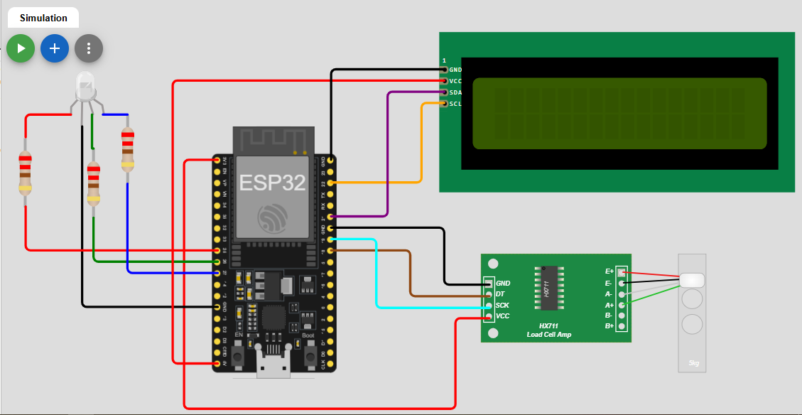

- Library Integration

[env:esp32dev]
platform = espressif32
board = esp32dev
framework = arduino
lib_deps =
blynkkk/Blynk@^1.3.5
bogde/HX711@^0.7.5
marcoschwartz/LiquidCrystal_I2C@^1.1.4

- Blynk Configuration
    - Create a New Template in Blynk (IoT platform)
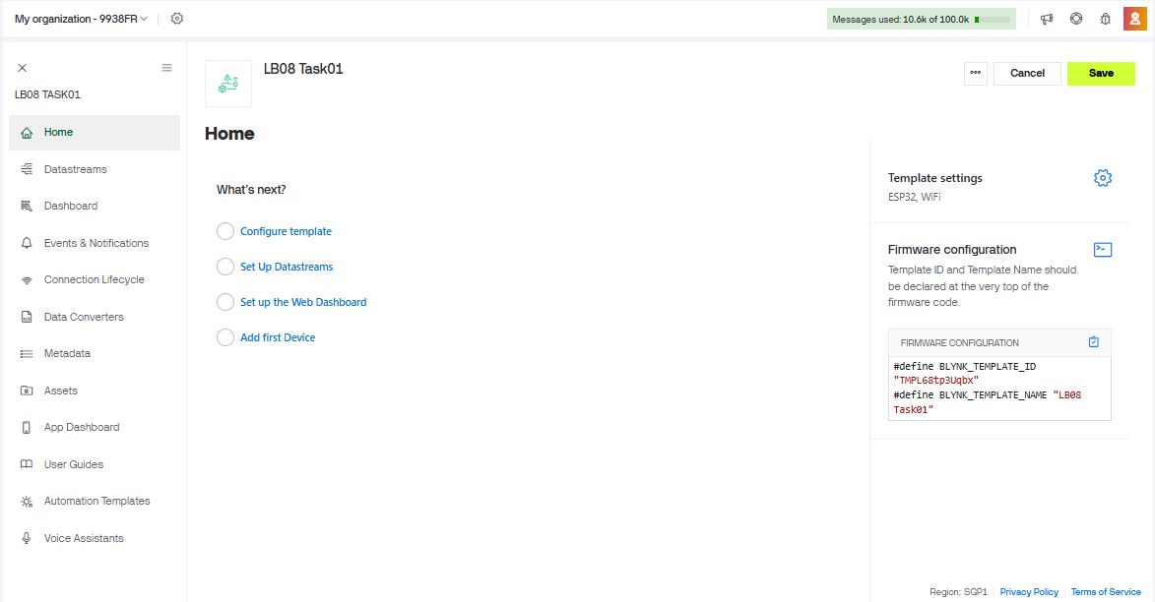
    - Assign virtual pins

Create Datastream
- Name: Weight
- Virtual Pin: V0
- Data Type: Double
- Min: 0
- Max: 10 (or according to your bin capacity)
- Unit: kg

Widget
Add a:
- Gauge Widget or
- Value Display Widget
Connect it to V0.
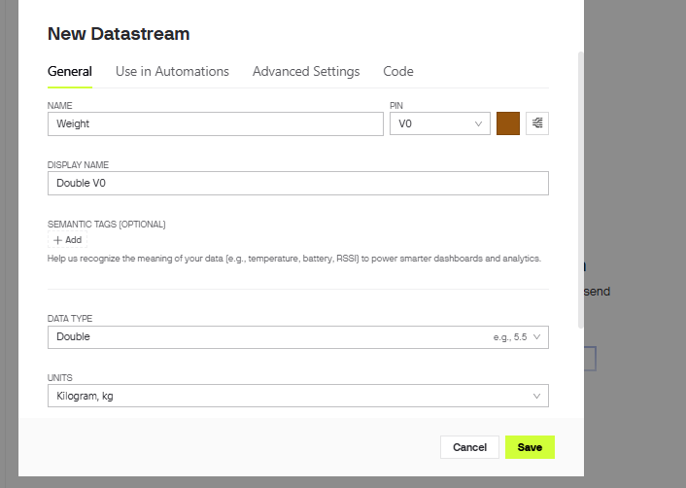

V1 – Bin Status (String)

Create Datastream
- Name: Bin Status
- Virtual Pin: V1
- Data Type: String

Widget
Add a:
- Label Widget
- Labeled Value Widget
Connect it to V1.
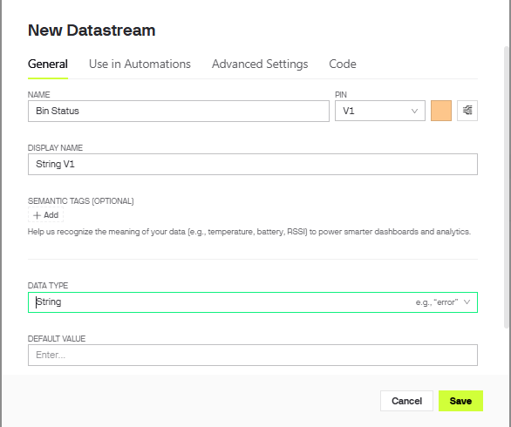

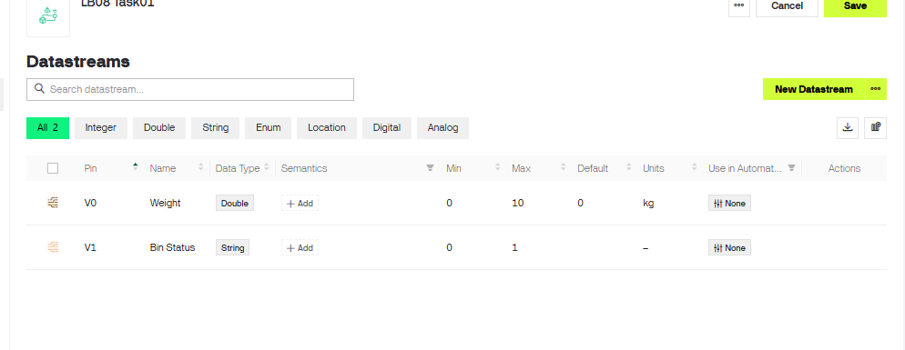

    - Create a New Device
    - Add widgets to display values.

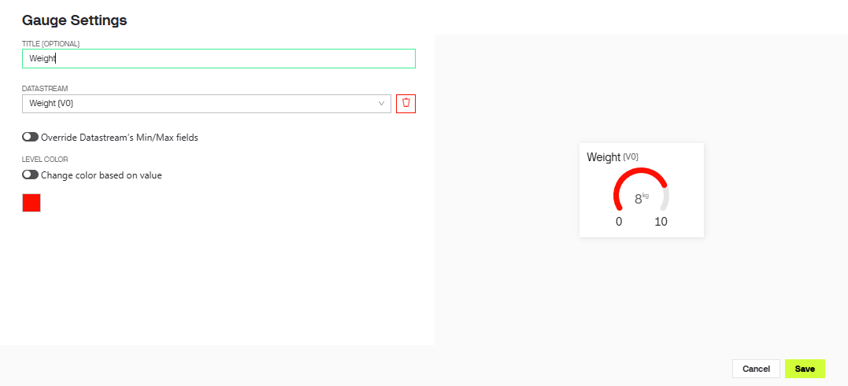
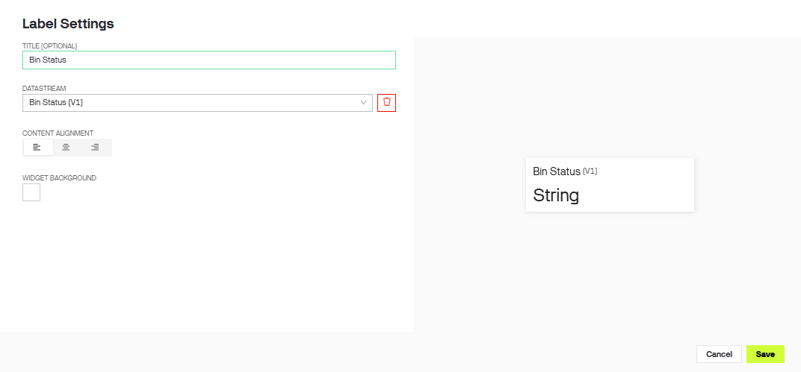

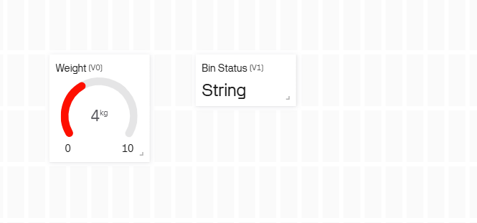

    - Obtain Template ID, Template Name and Auth Token

#define BLYNK_TEMPLATE_ID "TMPL68tp3Uqbx"
#define BLYNK_TEMPLATE_NAME "LB08 Task01"
#define BLYNK_AUTH_TOKEN "b-eGWP8gtiJazDjQcrCp76L1V6DfQGWF"

- Programming Logic Development in Wokwi / VS Code
  - Initialize Wi-Fi and Blynk connection
  - Initialize HX711 and LCD
  - Read weight from load cell using HX711
  - Show weight on LCD
  - RGB LED Logic (Level Indication)
i. Define thresholds:
          - Low Level → Weight < 2 kg
          - Medium Level → 2 kg – 5 kg
          - Full Level → > 5 kg
          - Overweight → > 7 kg ii. LED behavior:
          - Low → Green ON
          - Medium → Blue ON
          - Full → Red ON
          - Overweight → Red BLINKING
#define BLYNK_TEMPLATE_ID "TMPL68tp3Uqbx"
#define BLYNK_TEMPLATE_NAME "LB08 Task01"
#define BLYNK_AUTH_TOKEN "b-eGWP8gtiJazDjQcrCp76L1V6DfQGWF"

#include <Arduino.h>
#include <WiFi.h>
#include <BlynkSimpleEsp32.h>
#include <HX711.h>
#include <LiquidCrystal_I2C.h>

char ssid[] = "Wokwi-GUEST";
char pass[] = "";

#define DT_PIN 18
#define SCK_PIN 19

#define RED_LED 25
#define GREEN_LED 26
#define BLUE_LED 27

HX711 scale;
LiquidCrystal_I2C lcd(0x27, 16, 2);

BlynkTimer timer;

void sendData()
{
// Example weight for simulation
float weight = scale.get_units();

String status = "";

lcd.clear();
lcd.setCursor(0,0);
lcd.print("Weight:");
lcd.print(weight);
lcd.print("kg");

// LOW LEVEL
if(weight < 2)
{
digitalWrite(GREEN_LED, HIGH);
digitalWrite(BLUE_LED, LOW);
digitalWrite(RED_LED, LOW);

status = "LOW";
}

// MEDIUM LEVEL
else if(weight >= 2 && weight <= 5)
{
digitalWrite(GREEN_LED, LOW);
digitalWrite(BLUE_LED, HIGH);
digitalWrite(RED_LED, LOW);

status = "MEDIUM";
}

// FULL LEVEL
else if(weight > 5 && weight <= 7)
{
digitalWrite(GREEN_LED, LOW);
digitalWrite(BLUE_LED, LOW);
digitalWrite(RED_LED, HIGH);

status = "FULL";
}

// OVERWEIGHT
else
{
digitalWrite(GREEN_LED, LOW);
digitalWrite(BLUE_LED, LOW);

digitalWrite(RED_LED, HIGH);
delay(300);
digitalWrite(RED_LED, LOW);
delay(300);

status = "OVERWEIGHT";
}

lcd.setCursor(0,1);
lcd.print(status);

Blynk.virtualWrite(V0, weight);
Blynk.virtualWrite(V1, status);
}

void setup()
{
Serial.begin(115200);

pinMode(RED_LED, OUTPUT);
pinMode(GREEN_LED, OUTPUT);
pinMode(BLUE_LED, OUTPUT);

lcd.init();
lcd.backlight();

scale.begin(DT_PIN, SCK_PIN);

Blynk.begin(BLYNK_AUTH_TOKEN, ssid, pass);

timer.setInterval(2000L, sendData);
}

void loop()
{
Blynk.run();
timer.run();
}

  - Send weight data to Blynk
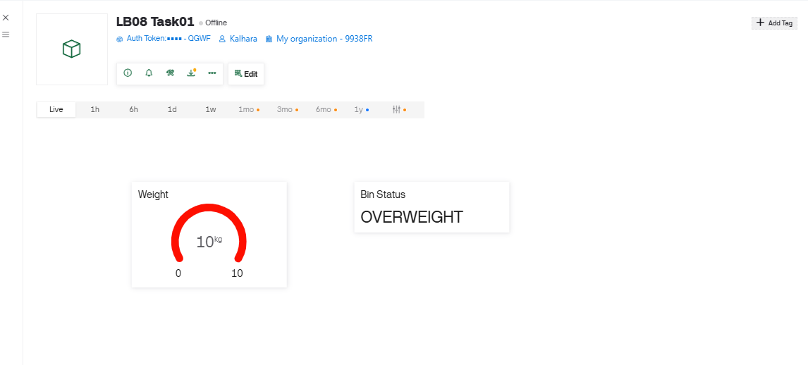
- Simulation & Testing in Wokwi / VS Code
