Lab Sheet 09
Title: ESP32 IoT System with MQTT and Node-RED Integration
Aims:
To design, simulate, and deploy an ESP32-based IoT system that publishes sensor data via MQTT and visualizes it using Node-RED dashboards. Learners will develop firmware, configure an MQTT broker, build Node-RED flows, and create real-time monitoring dashboards for a Smart Room Environmental Monitor.
Tasks: Smart Room Environmental Monitor

Part 1: Environment Setup
- Install extensions in VS Code
  - MQTT Explorer – standalone MQTT client for debugging
  - PlatformIO IDE by PlatformIO – compile ESP32 firmware
  - Node.js (LTS) – required for Node-RED runtime
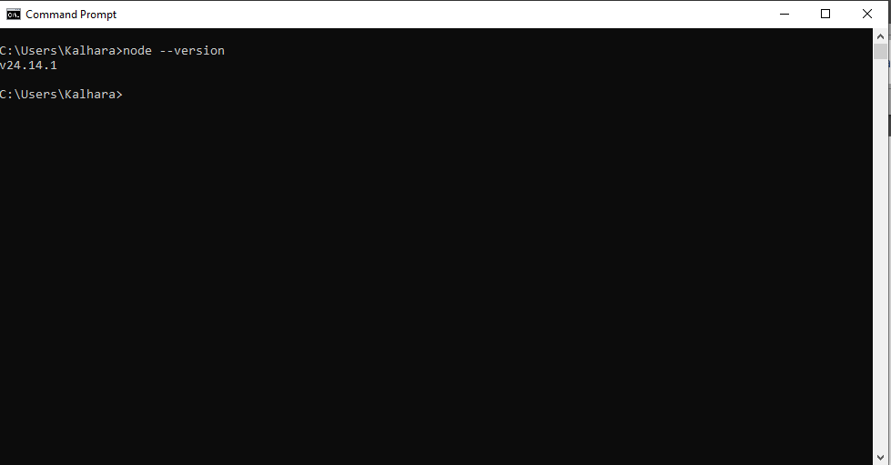
node –version

  - Wokwi by Wokwi – browser-based ESP32 simulator
- Install Node-RED globally via npm:
npm install -g --unsafe-perm node-red
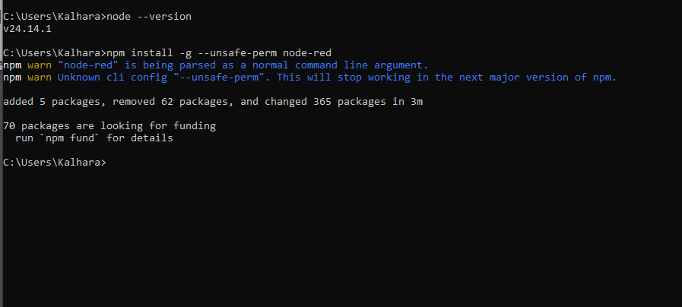
- Install an MQTT Broker (Mosquitto):
  - Download from https://mosquitto.org/download/
  - After install, start the broker:
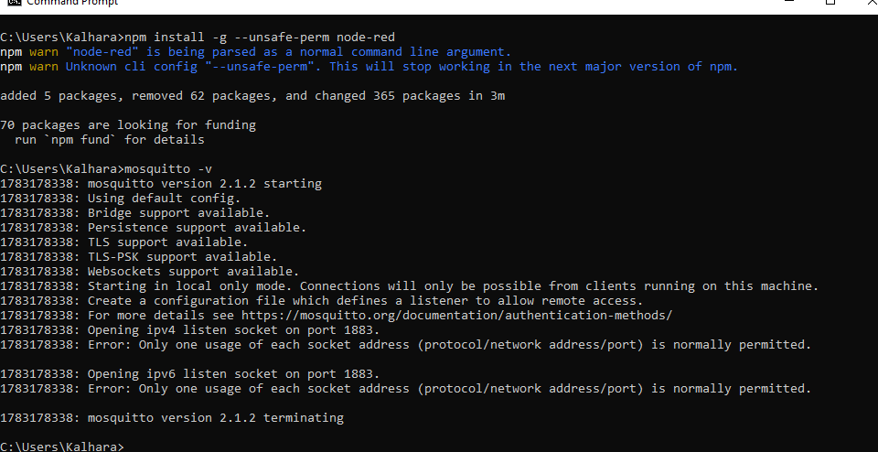
    - mosquitto -v

  - Create file named mosquitto.conf and save on working folder.
    - Type below codes:
listener 1883
allow_anonymous true
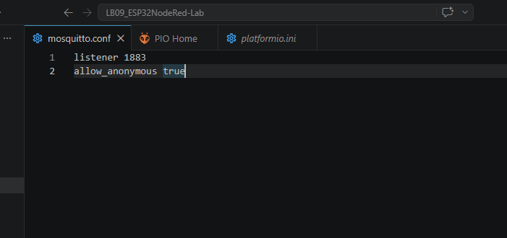
  - Start the broker.
    - In cmd : mosquitto -c mosquitto.conf -v
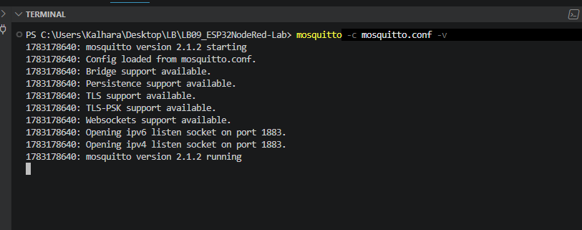

Part 2: Project Setup in Wokwi / VS Code
- Name the project ESP32NodeRed-Lab.
- Circuit Design
- Connect the DHT22 sensor to an ESP32 GPIO pin.
- Connect the PIR sensor to an ESP32 GPIO pin.
- Connect the LED to the ESP32.
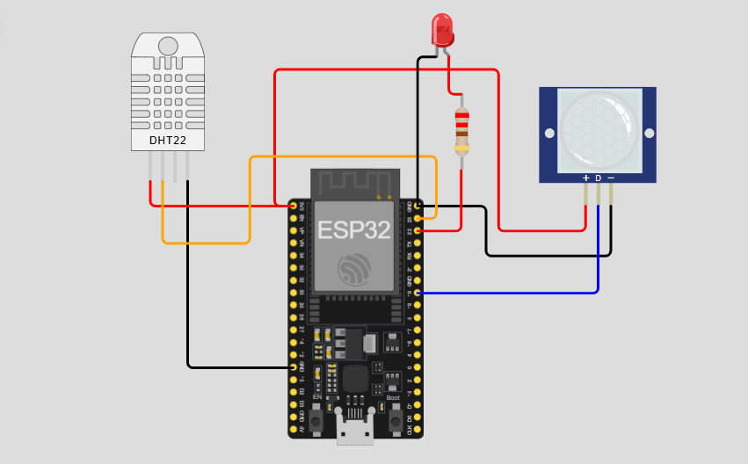
- Library Integration
- PubSubClient
- DHT sensor library
[env:esp32dev]
platform = espressif32
board = esp32dev
framework = arduino
lib_deps =
adafruit/DHT sensor library@^1.4.7
knolleary/PubSubClient@^2.8

- Configure Node-RED
  - Launch Node-RED
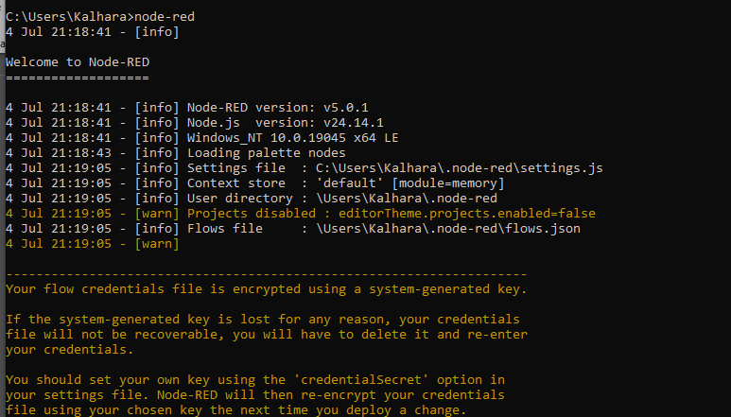

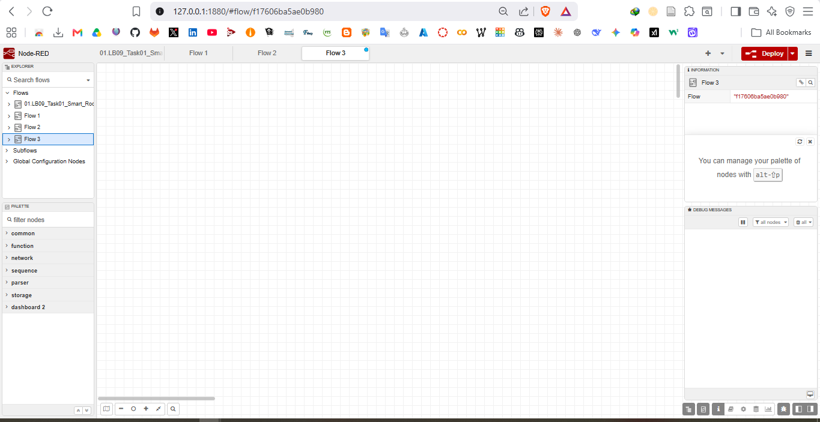

  - Install Required Nodes
i. @flowfuse/node-red-dashboard
- Build the MQTT Subscriber Flow

Node | Type | Configuration
 | Temperature Flow
mqtt in | Input | Topic: home/room/temperature,  Server: ip_address:1883
gauge | Dashboard | Label: Temperature, Min: 0, Max:  80, Unit: °C
chart | Dashboard | Label: Temperature History
 | Humidity Flow
mqtt in | Input | Topic: home/room/humidity  Server: ip_address:1883
gauge | Dashboard | Label: Humidity, Min: 0, Max:  100, Unit: %
 | Motion Detection Flow
mqtt in | Input | Topic: home/room/motion
text | Dashboard | Label: Motion Status
 | LED Control Flow
switch | Dashboard | Label: LED Control,  On Payload: ON,  Off Payload: OFF
mqtt out | Output | Topic: home/room/led/set,  Server: ip_address:1883

- Click Deploy (top-right red button) after wiring all nodes.
- Open the dashboard at http://localhost:1880/dashboard to view live data.
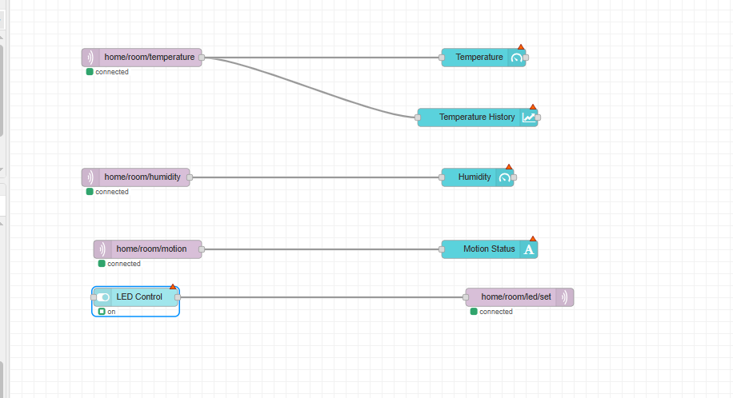

- Programming Logic Development in Wokwi / VS Code
  - Initialize Wi-Fi and MQTT connection to enable network communication between ESP32 and the broker.
  - Read temperature and humidity values from the DHT22 sensor using the appropriate sensor
library.
  - Read and process PIR sensor data for motion detection.
  - Publish all sensor readings to MQTT topics in real time for Node-RED dashboard visualization.
#include <Arduino.h>
#include <WiFi.h>
#include <PubSubClient.h>
#include <DHT.h>

// Wi-Fi සහ MQTT Configurations
const char* ssid = "Wokwi-GUEST";
const char* password = "";
const char* mqtt_server = "192.168.116.232";

// Pin Definitions
#define DHTPIN 23
#define DHTTYPE DHT22
#define PIR_PIN 19
#define LED_PIN 22

// MQTT Topics
#define TOPIC_TEMP "home/room/temperature"
#define TOPIC_HUMID "home/room/humidity"
#define TOPIC_MOTION "home/room/motion"
#define TOPIC_LED_SET "home/room/led/set"

DHT dht(DHTPIN, DHTTYPE);
WiFiClient espClient;
PubSubClient client(espClient);

unsigned long lastMsg = 0;

void setup_wifi() {
delay(10);
Serial.println();
Serial.print("Connecting to ");
Serial.println(ssid);

WiFi.mode(WIFI_STA);
WiFi.begin(ssid, password);

while (WiFi.status() != WL_CONNECTED) {
delay(500);
Serial.print(".");
}

Serial.println("");
Serial.println("WiFi connected");
Serial.print("IP address: ");
Serial.println(WiFi.localIP());
}

// MQTT හරහා පණිවිඩ ලැබෙන විට ක්‍රියාත්මක වන ශ්‍රිතය (Callback)
void callback(char* topic, byte* payload, unsigned int length) {
Serial.print("Message arrived [");
Serial.print(topic);
Serial.print("] ");

String message = "";
for (int i = 0; i < length; i++) {
message += (char)payload[i];
}
Serial.println(message);

// LED එක පාලනය කිරීම
if (String(topic) == TOPIC_LED_SET) {
if (message == "ON") {
digitalWrite(LED_PIN, HIGH);
Serial.println("LED turned ON");
} else if (message == "OFF") {
digitalWrite(LED_PIN, LOW);
Serial.println("LED turned OFF");
}
}
}

void reconnect() {
while (!client.connected()) {
Serial.print("Attempting MQTT connection...");
String clientId = "ESP32Client-";
clientId += String(random(0xffff), HEX);

if (client.connect(clientId.c_str())) {
Serial.println("connected");
// LED Topic එක Subscribe කිරීම
client.subscribe(TOPIC_LED_SET);
} else {
Serial.print("failed, rc=");
Serial.print(client.state());
Serial.println(" try again in 5 seconds");
delay(5000);
}
}
}

void setup() {
Serial.begin(115200);
pinMode(PIR_PIN, INPUT);
pinMode(LED_PIN, OUTPUT);

dht.begin();
setup_wifi();
client.setServer(mqtt_server, 1883);
client.setCallback(callback);
}

void loop() {
if (!client.connected()) {
reconnect();
}
client.loop();

unsigned long now = millis();

if (now - lastMsg > 2000) {
lastMsg = now;

// DHT22 දත්ත කියවීම
float h = dht.readHumidity();
float t = dht.readTemperature();

int motionDetected = digitalRead(PIR_PIN);

if (isnan(h) || isnan(t)) {
Serial.println("Failed to read from DHT sensor!");
return;
}

Serial.print("Temp: "); Serial.print(t);
Serial.print(" | Humid: "); Serial.print(h);
Serial.print(" | Motion: "); Serial.println(motionDetected ? "MOTION!" : "No Motion");

client.publish(TOPIC_TEMP, String(t).c_str());
client.publish(TOPIC_HUMID, String(h).c_str());
client.publish(TOPIC_MOTION, motionDetected ? "Motion Detected" : "Clear");
}
}

- Simulation & Testing in Wokwi / VS Code
  - Run simulation
  - Adjust values in Wokwi / VS Code
  - Verify Node-RED interaction
