Ninad Ramchandra Waskar

Task 1

Elevate Labs

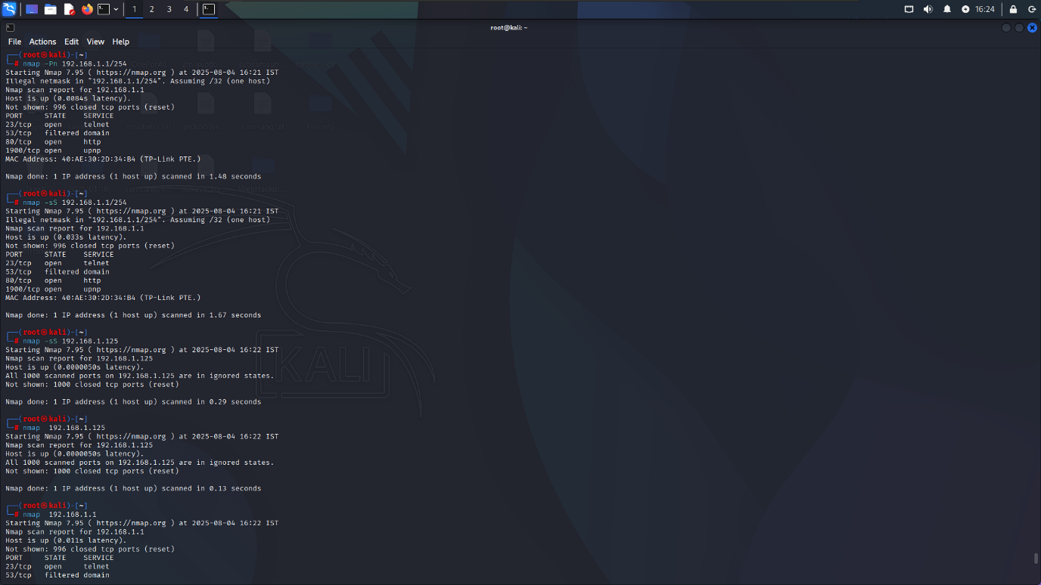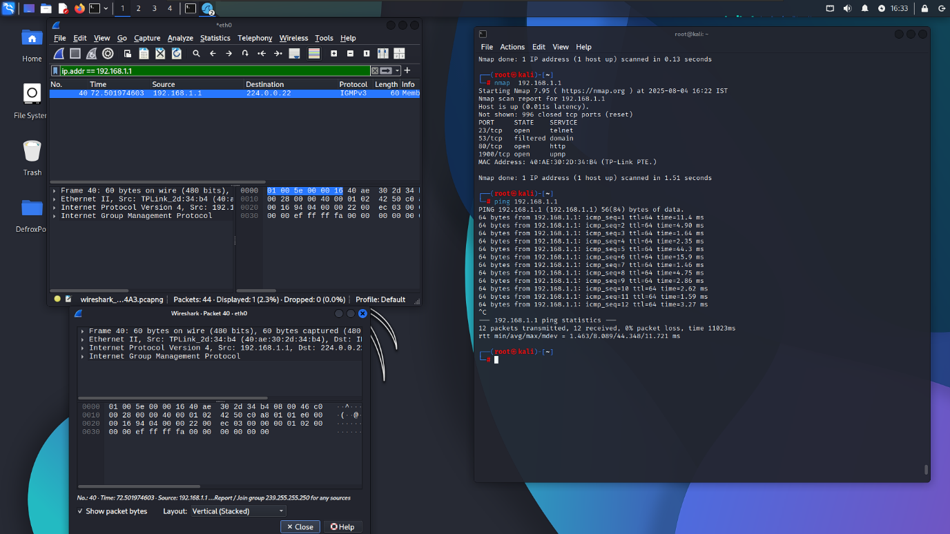

The following are potential risks associated with each of the open/filtered ports:

* **Port 23 (telnet):**
  + Unencrypted communication: Telnet transmits data, including passwords, in plaintext, making it vulnerable to eavesdropping attacks.
  + Weak authentication protocols: Older versions of Telnet may use weak authentication methods, making it prone to brute-force attacks.
  + Potential for remote code execution: If an attacker gains access to the Telnet session, they may be able to execute arbitrary commands on the target system.
* **Port 53 (domain):**
  + DNS cache poisoning: If the DNS server is not properly configured, attackers may be able to inject malicious DNS records into the cache.
  + Zone transfer attacks: Attackers may be able to request zone transfers from the DNS server, potentially exposing sensitive information about the network.
* **Port 80 (HTTP):**
  + Cross-site scripting (XSS) attacks: Malicious scripts injected into web pages served through HTTP can steal user credentials and other sensitive data.
  + SQL injection attacks: Improperly sanitized user input can allow attackers to execute arbitrary SQL queries on the backend database.
  + Denial-of-service (DoS) attacks: High-traffic websites can be brought down by flooding the HTTP server with requests.
* **Port 1900 (UPnP):**
  + Remote control attacks: UPnP devices can be remotely configured and controlled by attackers, potentially allowing them to take control of connected devices.
  + Information disclosure: UPnP devices may expose sensitive information about the connected network, such as device names and IP addresses.

To mitigate these risks, consider implementing the following measures:

* Use secure protocols (e.g., SSH instead of Telnet)
* Enable encryption (e.g., TLS/SSL for HTTPS)
* Implement proper authentication mechanisms
* Regularly update and patch software
* Restrict inbound access to sensitive services
* Monitor network traffic for suspicious activity

**Summary:**

In this exercise, we performed a comprehensive network analysis and vulnerability assessment of a target system. Our findings revealed several open and filtered ports, highlighting potential security risks associated with each service. Through our analysis, we provided recommendations to mitigate these risks and improve overall system security. This exercise demonstrates the importance of regularly monitoring and assessing network infrastructure to identify and address potential vulnerabilities before they can be exploited by malicious actors. Ultimately, our goal is to help organizations maintain robust security postures and protect against evolving threats.

Overall, this task involved the following key activities:

1. Network scanning and enumeration
2. Service identification and classification
3. Risk assessment and prioritization
4. Vulnerability mitigation and remediation strategies
5. Reporting and documentation

This process highlights the critical role of proactive network analysis and vulnerability management in maintaining a secure and resilient IT infrastructure. By staying vigilant and continuously improving security practices, organizations can better defend against emerging threats and reduce the likelihood of compromise.