1. What is Inheritance? Does Java support Multiple Inheritance? Why?

**Inheritance in java** is a mechanism in which one object acquires all the properties and behaviours of parent object. It helps to create new classes that are built upon existing classes. When you inherit from an existing class, you can reuse methods and fields of parent class. Moreover, you can add new methods and fields in your current class also.

Java doesn’t support multiple inheritance in classes because of “Diamond Problem” / Ambiguity. In addition to what you learnt in classes, if incase Java supported multiple inheritance, then it could the issues like below

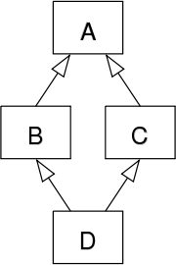The "diamond problem" (sometimes referred to as the "deadly diamond of death") is an ambiguity that arises when two classes B and C inherit from A, and class D inherits from both B and C. If there is a method in A that B and C have [overridden](https://en.wikipedia.org/wiki/Method_overriding_(programming)), and D does not override it, then which version of the method does D inherit: that of B, or that of C?

2. What is overloading? How does it differ from overriding?

Overloading occurs when two or more methods in the same class have the same name but different arguments.

Overriding means having two methods with the same arguments (i.e., method signature), but different implementations. One of them would exist in the parent class, while another will be in the derived, or child class. Overriding allows a child class to provide a specific implementation of a method that is already provided its parent class

**Differences:**

1. Overriding is a run-time concept while overloading is a compile-time concept.
2. overloading is being done in the same class while for overriding base and child classes are required
3. Return type of method does not matter in case of method overloading, it can be same or different. However in case of method overriding the overriding method can have more specific return type.
4. Argument list should be different while doing method overloading. Argument list should be same in method Overriding