Computational Reproduction and Errata Audit
Three CAMS Working Papers
Scale-Recursion Hypothesis · Operator Portability Proposition · The Soil-Bond Index (ηsoil)
Prepared for Neural Nations Research / ComplexityWorkz
Version 2 — 31 July 2026 (supersedes v1, same date)
Computational verification performed by Claude (Anthropic) at the author's request

Revision note
Version 1 of this document was titled “Independent Data-Traceability Audit.” That title promised more than v1 delivered. Version 1 established that each paper's reported statistics are reproducible from its named source file; it did not check whether those source files were complete, whether the reported test statistics corresponded to any standard test, whether the annual observations satisfy the independence assumption those tests require, or whether the metrics under test add information beyond their own components. All four omissions are material, and one of them — data completeness — sits inside the scope v1 claimed for itself, not outside it.
Version 2 was prompted by a second independent review which identified eight further problems. Every one of that review's numerical claims was recomputed here and confirmed. This version adds those items to the errata, adds four checks v1 should have run, restates the assessment in §6, and renames the document to match what it actually establishes.
The two reviews now agree on every recomputed quantity. Where they initially differed — the circular-shift p-values — the discrepancy has been traced and resolved (§5.4).

Purpose and scope
This report documents a computational audit of three working papers in the CAMS research programme. Every statistic below was recomputed independently from the underlying raw ensemble node scores (Coherence, Capacity, Stress, Abstraction) — never from a paper's summary tables or stored derived columns — using each paper's own stated canonical formulas.
What this audit establishes: that the canonical CAMS operators are correctly specified and correctly computed; that the reported figures are, with the exceptions listed in §4, faithfully transcribed from the named files; and that four of the six ηsoil source files supplied are the files the paper was computed on.
What this audit does not establish: that the node scores are accurate readings of institutional history; that ηsoil carries information beyond simpler CAMS quantities (§5.2 indicates it does not); that the crisis discrimination reported is predictive rather than concurrent; or that scale covariance has been tested by these papers (§5.3).

Methodology
Canonical operators, as specified in the source papers:
V_{i} = C_{i} + K_{i} − S_{i} + 0.5A_{i} q_{i} = (0.6C_{i} + 0.4A_{i})/10
W_{ij} = √(q_{i}q_{j}) · 2−(Si+Sj)/10 B̄ = 2/N(N−1) · Σ_{i<j} W_{ij} λ₂ = second-smallest eigenvalue of L = D − W
σ_{V} = population SD of V_{i} across the 8 nodes (ddof = 0)
η_{soil} = [BS_{Lore} × BS_{Archive} × C_{Hands}] / [max(S_{Hands}, 2.0) × σ_{V}]
BSLore and BSArchive are each node's own canonical bond strength, taken as the mean of Wij over the other seven nodes.
Checks performed. (1) Operator reproduction in Python (pandas / numpy / scipy). (2) Data completeness — every source file's year coverage compared against its stated range, added in v2. (3) Test-statistic identification — each reported t recomputed under both Student's and Welch's assumptions, added in v2. (4) Temporal dependence — exact circular-shift permutation test preserving the contiguous block structure of coded crisis periods, added in v2. (5) Incremental value — pooled AUC of ηsoil against its own components and against simpler CAMS quantities, added in v2.

1. Scale-Recursion Hypothesis — Corporate Panel
Source: camcorp5_ensemble_mean.csv (GM, BYD, CATL, Tencent; 2006–2026, n=84 entity-years) and camcorp5_batch2_ensemble_mean.csv (Huawei, Tesla, Bunnings, Woodside, BHP; n=105), the latter used as an out-of-sample extension not tested in the original paper. Both files are complete for their stated ranges.
Claim | Paper | Recomputed
Corporate B̄ range | 0.076–0.446 | 0.0758–0.4464
Corporate λ₂ range | 0.606–3.221 | 0.6063–3.2214
GM 2009 floor | B̄=0.112, λ₂=0.779 | B̄=0.1117, λ₂=0.7786
Tencent B̄ endpoints | 0.431 → 0.232 | 0.4314 (2017) → 0.2315 (2022)
Tencent λ₂, 2018–22 | stays > 1.5 | 1.538–2.944
CATL 2006–10 | B̄ 0.076–0.087 | 0.0758 (flat 2006–09) → 0.0873 (2010)
BYD | no alarm years | B̄ floor 0.288, above every other entity's trough
Raw bottleneck (4 firms) | 100 / 90.5 / 47.6 / 38.1% | identical to 1 d.p.
Standardised bottleneck | 28.6 / 28.6 / 42.9 / 38.1% | identical to 1 d.p.
Table 1 — All figures reproduce to the precision reported. Unchanged from v1.
Out-of-sample extension: 102 of 105 batch-2 entity-years (97%) fall inside the band derived from the 4-firm panel. Mechanism behind the bottleneck artifact: pooled mean node value is lowest for Shield (8.14) versus the next-lowest node (Hands, 9.33) across every entity, and Shield remains the dominant raw bottleneck in 4 of the 5 batch-2 firms.

1.1 Items for correction
- Wording: “Tencent drops from 0.431 to 0.232” reads as monotonic. The path dips to 0.304 (2018), recovers to 0.419 (2020), then falls to 0.232 (2022) — two distinct compressions, not one decline.
- Precision: the stored-bond inflation factor “12×–112×” is not exactly reproducible; the closest bound is 10.81×–111.07× using system B̄ as comparator, or 10.81×–98.10× using mean-over-neighbours.
- Scope: the canonical Wij sums over all 28 node pairs (complete graph K8), not the sparse Mythic/Material partition used in the national-level formalism. B̄ and λ₂ correlate at r=0.981 under this construction, so the two operators are near-redundant here and the partition question is bypassed rather than addressed.
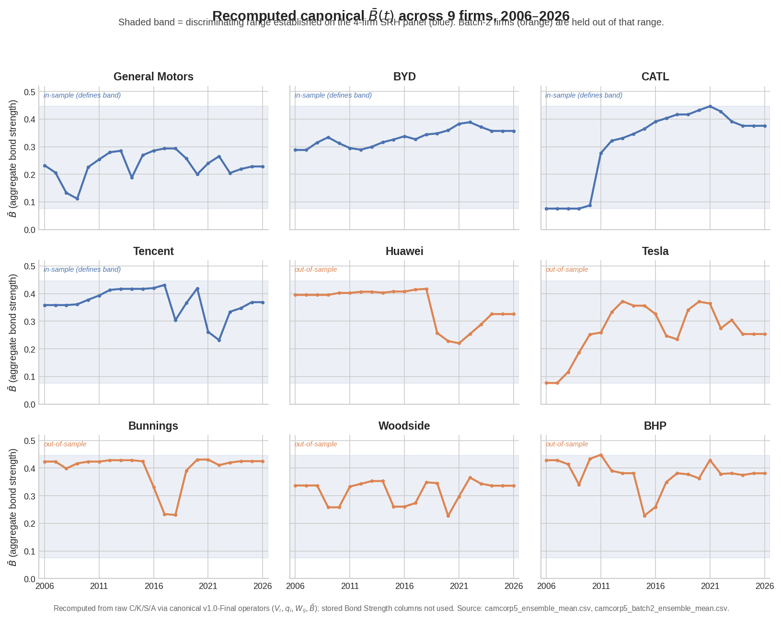
Figure 1 — Recomputed B̄(t) across all 9 firms, 2006–2026. Shaded band is the range established on the 4-firm in-sample panel; batch-2 firms (orange) were held out.

2. Operator Portability Proposition
Source: the corporate panel above, plus Denmark_ENS_Bij_v10.csv (1752–2025, n=114 sampled years) and France_ENS_Bij_v10.csv (1850–2026, n=177). Both national files are complete for their stated ranges, and both carry stored bond-strength columns matching the canonical formula exactly (ratio 1.000), unlike the corporate files.
Statistic | Paper | Recomputed
r(B̄,λ₂) in-sample (n=84) | 0.988 | 0.9875
r(B̄,λ₂) out-of-sample (n=105) | 0.975 | 0.9746
Entity-level r range (9 firms) | 0.933–0.994 | 0.9333–0.9941
Regression slope difference | < 7% | 6.43%
B̄: KS D / MW p / d / shift | 0.214 / 0.011 / 0.380 / +10.4% | identical to 3 d.p.
λ₂: KS D / MW p / d / shift | 0.276 / 0.003 / 0.423 / +12.2% | identical to 3 d.p.
Band containment wide / tight | 98.1% / 27.6% | 98.1% / 27.6%
Bottleneck concordance in / out | 38.1% / 34.3% | 38.1% / 34.3%, p=0.697
Denmark vs Corporate: KS D / d | 0.853 / +2.25 | 0.853 / 2.249
Denmark B̄ range / containment | [0.223, 0.876] / 19.3% | [0.2234, 0.8759] / 19.3%
France vs Corporate: KS D / p / MW p | 0.145 / 0.037 / 0.025 | 0.1451 / 0.0373 / 0.0247
France B̄ range / containment | [0.067, 0.491] / 94.9% | [0.0670, 0.4913] / 94.9%
Denmark vs France: KS D / d | 0.808 / +2.36 | 0.8075 / 2.359
Table 2 — All figures reproduce. Band containment matches only under a joint definition (B̄ and λ₂ simultaneously inside their in-sample IQR); France containment matches only against the 9-firm pooled band, as the paper specifies. Unchanged from v1.

2.1 Item for correction
- Falsification criterion F-P4.3 is stated as “if out-of-sample same-class DKS > 0.20, class-pooling is invalid (triggered).” The paper's own §1.2 reports DKS = 0.214 (B̄) and 0.276 (λ₂), both exceeding 0.20. The status table nonetheless records “NOT TRIGGERED (within-class DKS < 0.28)” — a threshold that is not the criterion's own. P.4.3 (threshold relativity) is supported regardless; the status-table justification is not.
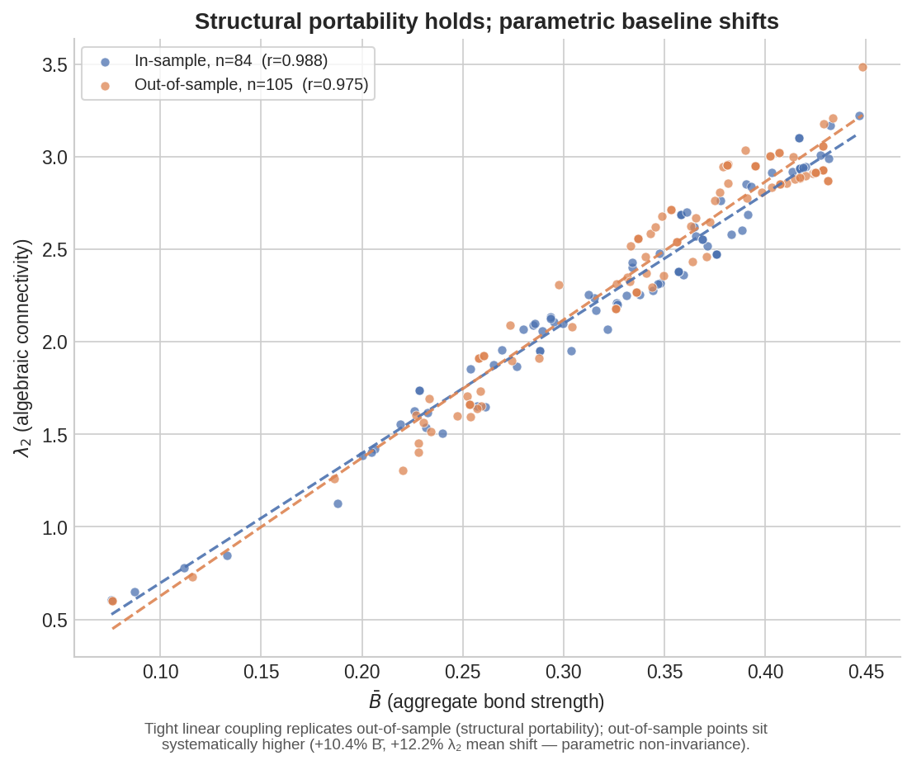
Figure 2 — Structural portability (tight linear coupling) alongside the parametric baseline shift.
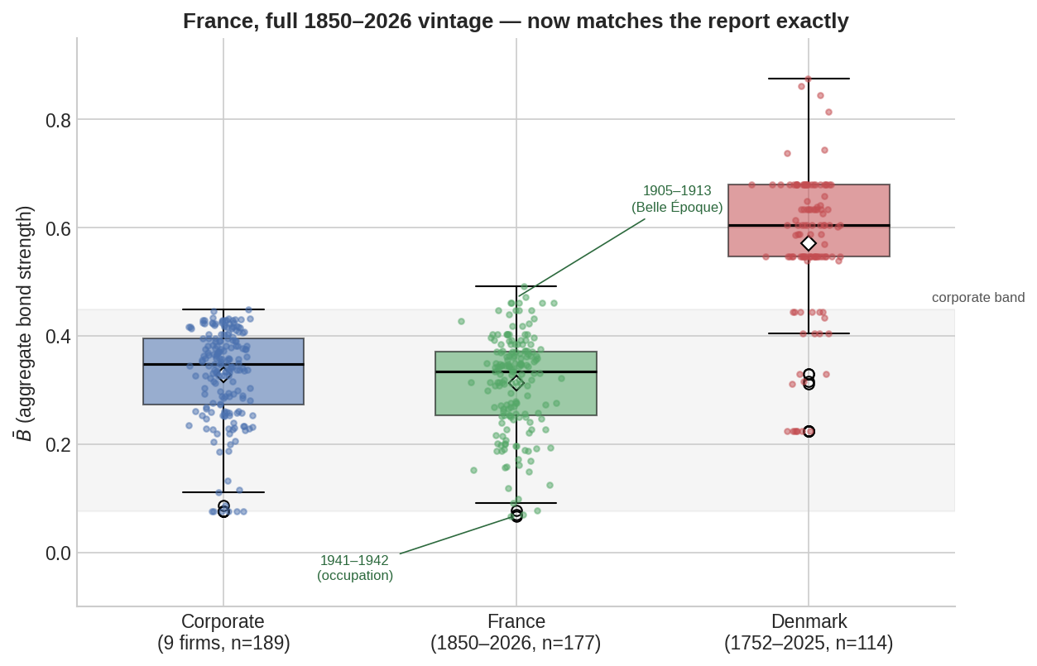
Figure 3 — Denmark separates from the corporate distribution; France, on its correct 1850–2026 vintage, overlaps almost entirely.

3. The Soil-Bond Index (ηsoil)
Sources: Denmark (1752–2025, n=114), Iran (1875–2026, n=152), USA (1996–2026, n=31), China (1900–2026, n=127), Germany (1900–2026, n=86 — see §3.2), Australia (1895–2026, n=131). Node Value and stored bond strength reproduce exactly in all six.

3.1 Validity screening (Denmark)
Precondition | Paper | Recomputed
P1: S_Hands = 0 rate | 105/114 (92.1%) | 105/114 (92.1%)
P2: S_Hands range | “0–8” | 0.0–4.0 (values are 0, 1 or 4 only)
P3: σV range | 0.66–4.12 | 0.66–4.12
Table 3 — P2's stated range does not match the data. Denmark's “Invalid” verdict stands on P1 alone.
On the proposed alternative ηalt = (BSLore × BSArchive × CHands)/σV: the ratio ηalt/ηsoil equals max(SHands, 2) exactly, so the multiplier is exactly 2 for 112 of 114 observations and exactly 4 for the remaining two. ηalt is therefore a two-valued rescaling of ηsoil and cannot generate any within-subgroup ordering the original lacks. It cannot independently validate “soil-bond” and should not be presented as a test.

3.2 Data completeness — not checked in v1
The Germany file supplied for this paper contains 86 of the 127 years in its stated 1900–2026 range. The 41 missing years form a single contiguous block, 1949–1989 — the entire division period, Federal Republic and GDR both, from the founding of the two states to the year before reunification. The omission is undisclosed in the paper.
Version 1 recorded “n=86 now matches exactly” and treated agreement with the paper's stated n as confirmation. It was the opposite: 1900–2026 spans 127 years, so n=86 was itself the signal, and the arithmetic needed to see it is subtraction. The public repository file of the same name is 1017 lines (1016 rows = 127 years × 8 nodes), consistent with complete coverage.
Consequence: Germany's crisis-discrimination result reportedly survives on the complete file and strengthens, but the reported baseline mean ηsoil (0.057), the series peak, and the trajectory description are all computed on a series missing its entire post-war half. Those claims require recomputation, not adjustment. Australia separately omits 1930; the public source has only seven nodes for that year, so exclusion is defensible but must be disclosed.

3.3 Crisis discrimination — test-statistic identification
The reported ηsoil t-statistics correspond to neither Student's nor Welch's test on the named files:
Society | n stable / crisis | Student t | Welch t | Paper t | Match?
Australia | 113 / 18 | 3.64 | 7.25 | 4.12 | neither
China | 95 / 32 | 3.71 | 6.40 | 5.79 | neither
Germany | 54 / 32 | 7.39 | 9.38 | 10.35 | neither
USA | 28 / 3 | 0.87 | 1.75 | 1.06 | neither
Iran | 119 / 33 | 6.93 | 12.29 | 6.72 | neither (nearest Student)
Table 4 — ηsoil. Several reported p-values approximately correspond to one test while the printed t corresponds to neither.
Society | Student t | Welch t | Paper t | Note
Australia | −3.56 | −3.46 | −3.71 | close to neither
China | −2.42 | −2.64 | −2.46 | ≈ Student
Germany | −7.48 | −6.43 | −6.52 | see below
USA | 0.18 | 0.17 | 0.18 | = Student
Iran | −6.52 | −7.67 | −6.52 | = Student
Table 5 — σV. Better behaved than ηsoil, but not uniformly one test.
A specific and diagnosable case: the paper reports σV t = −6.52 with p < 0.0001 for Germany and the identical pair, t = −6.52 and p < 0.0001, for Iran. Iran's Student t computes to exactly −6.52; Germany's computes to −7.48 (Student) or −6.43 (Welch). The duplication is consistent with Germany's cell having been copied from Iran's row. Version 1 described these as reproducing “to the same order of significance and sign,” which was too generous and obscured the pattern.
The group means themselves are sound. Every stable and crisis σV mean reproduces exactly across all five societies, and the baseline ηsoil means match closely to exactly. It is the inferential layer, not the descriptive layer, that requires regeneration.

3.4 Temporal dependence — not checked in v1
Coded crisis years occur in long contiguous blocks: Germany has effectively one episode, China three, Australia five. Independent-samples t-tests on annual observations therefore overstate the effective sample size substantially. An exact circular-shift permutation test, which preserves both the autocorrelation of the η series and the block structure of the crisis mask, gives:
Society | t-test p (Student) | Exact circular-shift p | Survives?
Iran | 1.2×10⁻¹⁰ | 0.0066 | yes
China | 0.00031 | 0.0079 | yes
Australia | 0.00039 | 0.0153 | yes
Germany | 9.7×10⁻¹¹ | 0.0930 | no
USA | 0.392 | 0.2903 | no (already null)
Table 6 — Exact enumeration of all N circular shifts, p = k/N with the observed alignment counted once.
The defensible statement of H1 is therefore narrower than “confirmed for five of six societies”:
Crisis periods have lower mean ηsoil in all five valid panels; the difference is conventionally significant in four, and remains significant under a conservative temporal-shift check in three.

3.5 Incremental value — not checked in v1
Pooled across the five valid societies after within-society standardisation (n=527, 118 crisis years), ηsoil is outperformed by three simpler quantities, including one of its own numerator components:
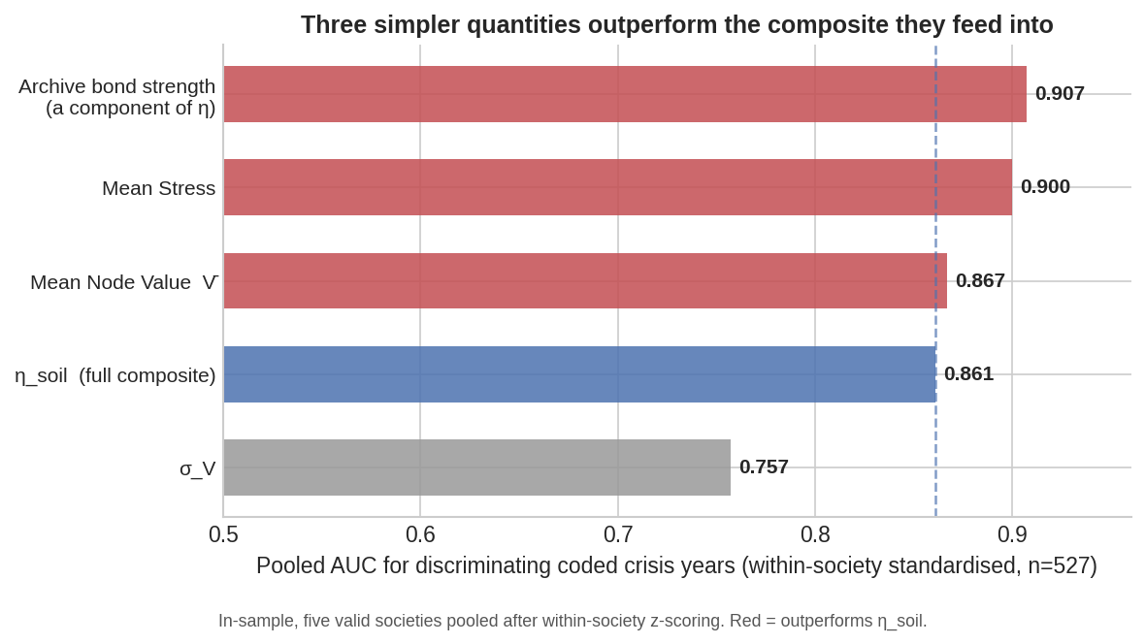
Figure 4 — Pooled in-sample AUC for discriminating coded crisis years.
The diagnosis is sharper than redundancy. Archive bond strength is a factor in ηsoil's own numerator, and it discriminates better (0.907) than the composite built on top of it (0.861). The SHands and σV normalisations are therefore removing signal the numerator already carries, not adding any. This points at a specific repair — ablation and incremental-value testing of the denominator — rather than a general complaint about construct redundancy.
A related construct concern: stress enters ηsoil at three points — through the exponential stress decay inside both bond strengths, directly as SHands in the denominator, and again through σV, which is computed from Node Values that subtract Stress. The crisis labels are historical periods whose stressfulness is known to the scorers, and the project's own methodology page acknowledges that scorers “are trained on historical text that may implicitly contain outcome information.” Coding crises blind to CAMS scores does not remove this dependency, because CAMS scoring was not blind to the identity of the wars and revolutions being scored. H1 is accordingly evidence of concurrent construct alignment, not of prediction.

3.6 Regime attractors (H3)
The three named regimes reproduce as descriptions. Iran 1995 (η=0.212, σV=0.33) matches to four decimal places; USA 2020 (V̄=2.7, σV=1.79, Vmin=0.3) matches exactly; Australia's stable/crisis σV of 3.16/3.93 matches on the corrected file. What is absent is any test that would make them attractors: no clustering criterion, basin estimation, recurrence analysis, transition probability, dwell-time test, or held-out classification is reported, and each class has exactly one exemplar society. They are interpretive typologies, and should be labelled as such.
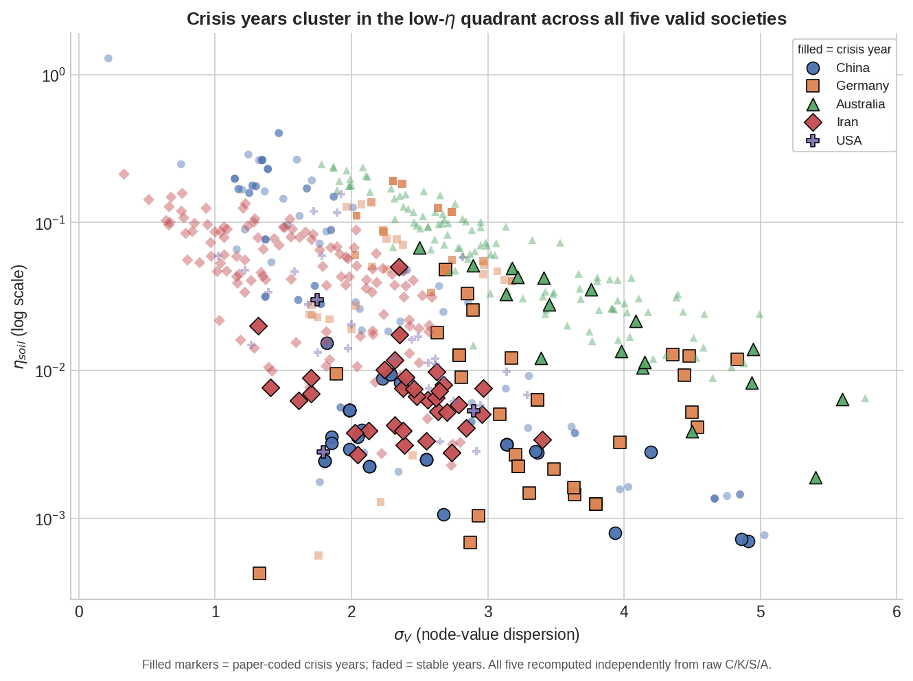
Figure 5 — σV × ηsoil plane, five valid societies. Filled markers are coded crisis years.

4. Consolidated Errata
Items 1–8 were identified in v1. Items 9–17 are new in v2; all were independently recomputed here and confirmed.
# | Paper | Location | Correction | Type
1 | SRH | §3, Tencent | Reword “0.431→0.232” to the two-episode path (2018; 2021–22) | Wording
2 | SRH | §2, inflation factor | “12×–112×” not reproducible; closest is 10.81×–111.07× | Precision
3 | SRH | §2, Wij | Note that complete-graph K8 bypasses the Mythic/Material partition | Scope note
4 | Portability | §3, F-P4.3 | “NOT TRIGGERED (<0.28)” contradicts the criterion's own >0.20 threshold | Logic
5 | ηsoil | Table 1, Denmark P2 | S_Hands range is 0.0–4.0, not “0–8”; ✗ inconsistent with the ≥ 3 rule | Data
6 | ηsoil | §4.3, China 2003 | η=1.285 belongs to 1999; 2003 computes to 0.401 | Year mislabel
7 | ηsoil | §4.3, Australia 1963 | η is 0.234, not 0.263; 1911 (0.248) is the series maximum | Data
8 | ηsoil | §4.5, Iran 1979 | V̄=0.06, σV=2.04, η=0.0027 — not the cited −1.0 / 3.51 / 0.001 | Data
Table 7 — Errata identified in v1.
# | Paper | Location | Correction | Type
9 | ηsoil | Table 2 | Regenerate: reported η t-statistics match neither Student nor Welch. State test type, df and group sizes | Statistical
10 | ηsoil | §4.2 | Remove “all three USA crisis years occupy the bottom decile.” Ranks are 1st, 4th and 22nd of 31 | Data
11 | ηsoil | §5.4 | Australia r(η,V̄) is 0.651, not “above 0.82” (USA is 0.871) | Data
12 | ηsoil | §5.4 | Australia mean S_Hands is 7.252 overall (7.035 stable, 8.611 crisis), not 7.81 | Data
13 | ηsoil | §4.4, Regime A | Replace “V̄ remains above 11.6” with crisis mean V̄ = 11.57; 8 of 18 crisis years fall below, minimum 5.81 | Data
14 | ηsoil | §3.1 / §4 | Disclose Germany's 1949–1989 omission and rerun all baseline, peak and trajectory claims on the 127-year file | Provenance
15 | ηsoil | §3.1 | Disclose Australia's missing 1930 observation and the reason for excluding the incomplete public row | Provenance
16 | ηsoil | §4.3, §4.4 | Restore Figures 1 and 2 or remove their citations — neither appears in the PDF or DOCX | Editorial
17 | ηsoil | Table 2, Germany σV | t = −6.52 duplicates Iran's cell exactly; Germany computes to −7.48 (Student) / −6.43 (Welch) | Transcription
Table 8 — Errata added in v2. Item 17 was identified during this revision and is not in either prior review.
Two provenance items sit outside the errata table because they concern the dataset catalogue rather than the papers. First, the public catalogue lists Denmark 1752–2025 as single-scorer, while the same page's methodology describes triple-AI ensemble scoring; until resolved, Denmark should not be represented as ensemble-scored. Second, the catalogue lists a Germany ensemble series at 1880–2026, a different vintage again from the 1900–2026 file used here — the version actually used should be stated explicitly.

5. Methodological Findings
These are not errata. They concern what the papers can claim, and none is repaired by correcting a number.

5.1 H2 is internally falsified as written
H2 predicts that crisis years “consistently occupy the low-η, high-σ quadrant.” Regime B — Coherent Collapse, the paper's own USA archetype — is defined by crisis producing low σV, and the data confirm it (crisis 2.15 against stable 2.21). The paper states a hypothesis and then, in the same results section, names a regime that contradicts it. This is an internal inconsistency, not an empirical shortfall, and it is repaired by editing rather than by new evidence: H2 should predict low η accompanied by regime-dependent dispersion, which is what the data show and what §5.4 of the paper already argues.

5.2 ηsoil is signal-destructive relative to its own components
Archive bond strength alone achieves AUC 0.907 against the composite's 0.861, and mean Stress achieves 0.900. Because Archive bond strength is a factor in ηsoil's numerator, this is not a rival predictor winning — it is the composite discarding information its own numerator supplies. The SHands and σV normalisations require ablation and incremental-value testing before retention, and any claim to unique metric validity should be withdrawn until they pass.

5.3 Scale covariance is inherited, not tested
Comparing six polities at a single organisational scale demonstrates possible operator portability across societies. It does not test covariance across organisational scales, which is what the title claims. The cross-scale warrant is inherited from P.4 — which rests on a corporate panel and two national comparators, and carries the F-P4.3 inconsistency at item 4. The inherited basis is thinner than either paper's phrasing implies, and this paper adds cross-polity evidence at one scale rather than new cross-scale evidence.

5.4 Reconciliation of the two reviews
The two independent recomputations agree on every quantity, including the four pooled AUCs to three decimal places. They initially differed on the circular-shift p-values. The cause has been identified: both enumerated all N shifts exhaustively, but the second review additionally applied the Monte Carlo correction (k+1)/(N+1) after already counting the observed alignment within k. The resulting inflation equals 1/N in every case — Iran 0.0066 vs 0.0131 against 1/152 = 0.0066, China 0.0079 vs 0.0156 against 1/127 = 0.0079, and so on. With exhaustive enumeration, p = k/N is correct, so the values in Table 6 stand. The substantive conclusion was identical under both conventions.

6. Revised Assessment
The audit confirms that the canonical CAMS calculations are reproducible from the specified C, K, S and A inputs, and that the four original errata remain valid. It does not independently validate the Soil-Bond Index as an incremental, predictive or scale-covariant operator. Crisis-period η is directionally lower in all five valid panels and conventionally significant in four, providing evidence of concurrent construct alignment. However, the reported t-statistics require correction, annual observations are temporally dependent, and simpler quantities — including Archive bond strength and mean Stress — discriminate the nominated crisis periods at least as well as η. H2 is internally inconsistent, because its universal high-dispersion prediction is contradicted by the paper's own Coherent Collapse regime. H3 remains an exploratory typology rather than a demonstrated set of dynamical attractors. Germany's omitted 1949–1989 block is a material provenance failure requiring complete recomputation of its baseline and trajectory claims.
For the other two papers the position is unchanged from v1. The Scale-Recursion Hypothesis reproduces in full and extends cleanly to an untested out-of-sample panel; three refinements are recommended, none altering a result. The Operator Portability Proposition reproduces in full once the correct France vintage is used; one falsification-status entry is internally inconsistent and does not affect the substantive conclusions.

Requirements before “validation” is claimed
- Frozen source files with hashes, analysis code, and crisis masks deposited alongside the paper.
- Explicit disclosure of missing years and per-series scorer provenance.
- Block-bootstrap, episode-level or interrupted-time-series inference in place of annual t-tests.
- Comparison against mean Stress, V̄, bond strength and simpler null indices, with ablation of the ηsoil denominator.
- Leave-one-crisis-episode and leave-one-society-out tests.
- Externally coded outcomes and prospective or genuinely blinded scoring.
- A pre-registered clustering or classification test for the three regimes.
The arithmetic survives. What changes is the epistemic status attached to it, which this version states accurately.

