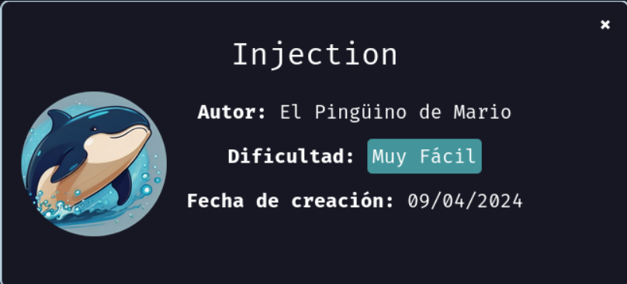
We start deploying the machine:
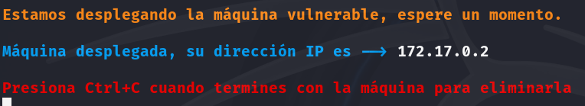
After we deploy the machine, we proceed with a ping to check the connection, and the scan of open ports to check for vulnerabilities.
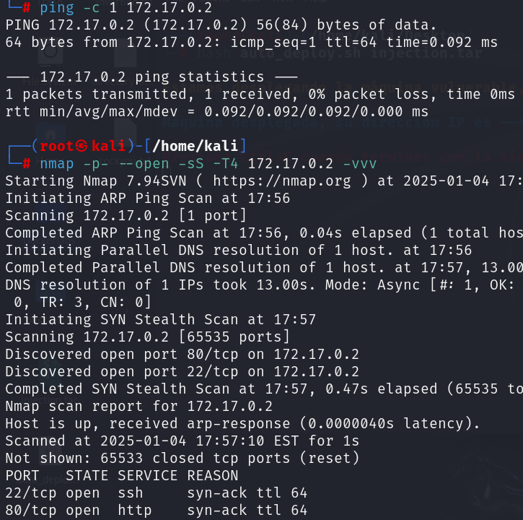
Only open ports are 22, ssh, and 80, http. First let’s see what’s in the port 80.
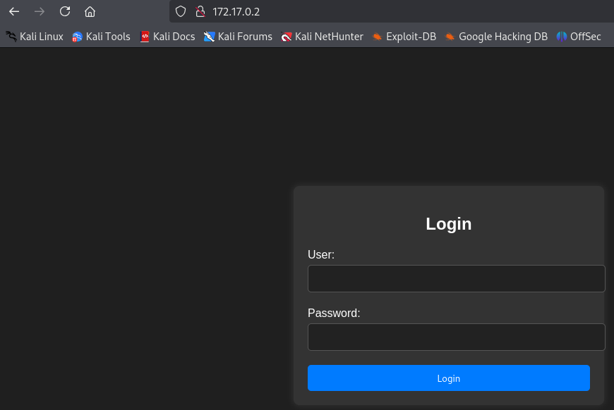
There’s a login page, so the first thing that we can think about is trying an injection SQL. Let’s try ‘OR 1=1 -- -
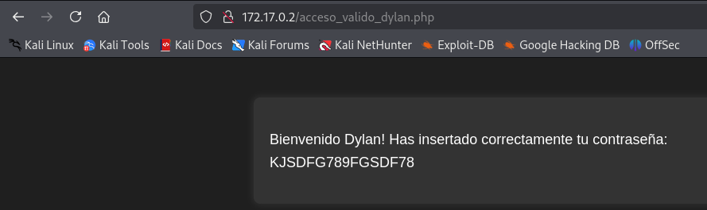
We entered, and now we know that there’s an user called Dylan, with password KJSDFG789FGSDF78.
So let’s enter.
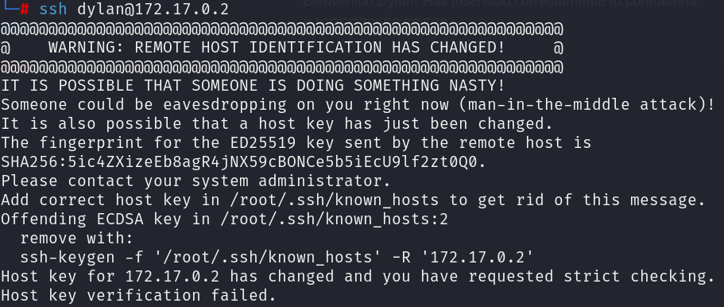
To solve this error just copypaste the line ssh-keygen…
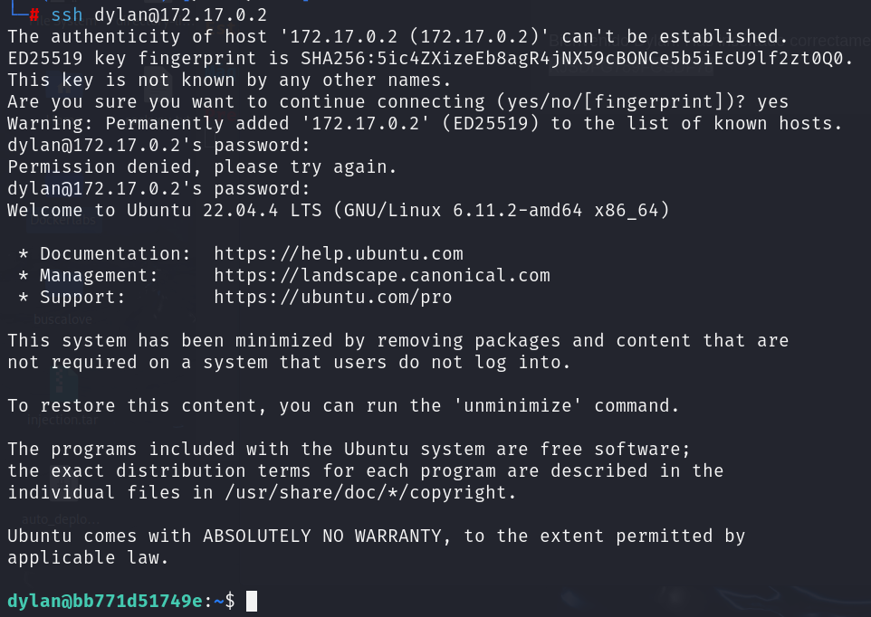
We’re in but as dylan, so let’s try to escalate. (Use GTFO bins)
