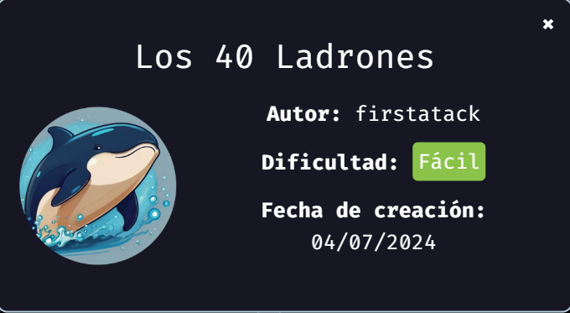
We start deploying the machine:
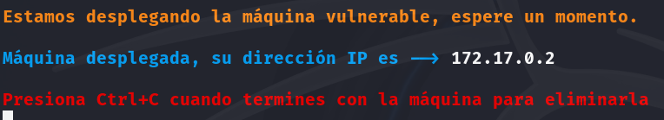
After we deploy the machine, we proceed with a ping to check the connection, and the scan of open ports to check for vulnerabilities.
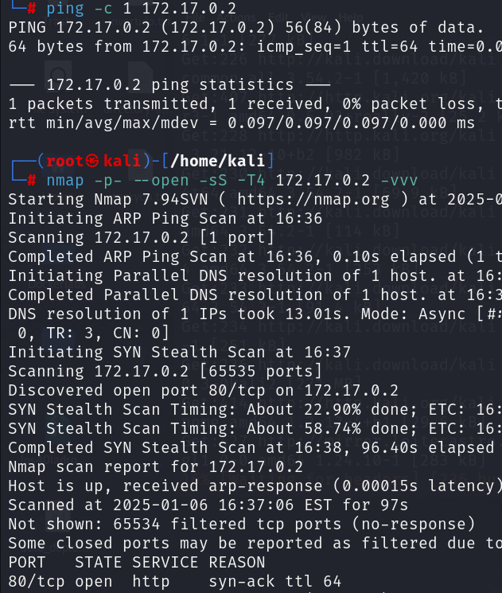
As we can see the only open port is the 80, so let’s check.
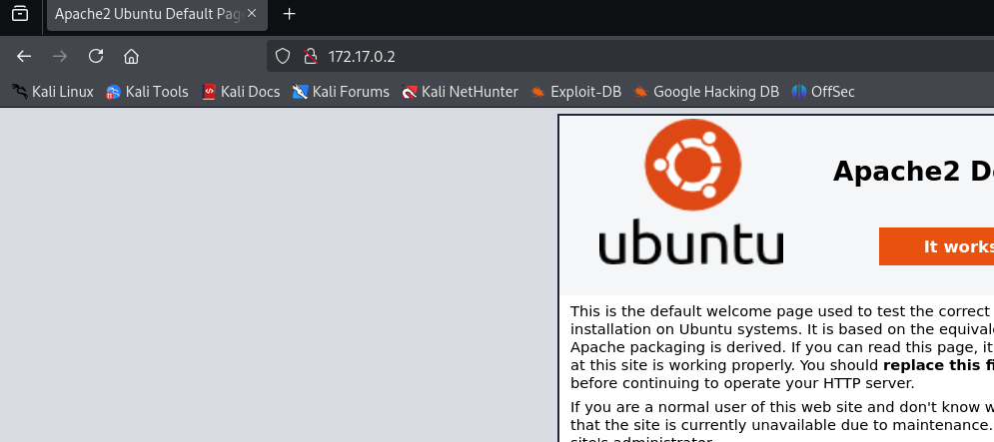
Default apache2 page. Nothing interesting. Let’s scan with gobusters what possible subpages are.
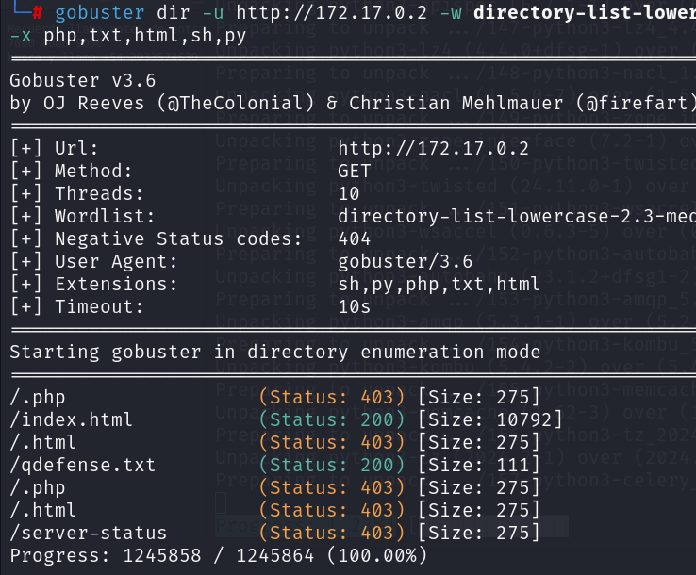
We found qdefense.txt, let’s take a look.

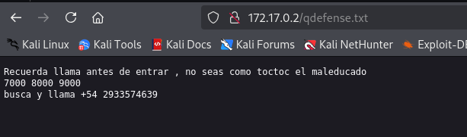
In this domain, we found that there’s someone called toctoc that doesn’t know how to behave. So next step will be to try hydra with that name. But also we have three consecutive numbers 7000 8000 9000, that sounds tricky and a phone number +54 2933574639.
Let’s try hydra first.
I forgot that port 22 was closed, so we cannot try to enter by ssh at first, but those three numbers and the hint of knock before enter, remembered me of port knocking, something that we can try to open the port 22, and then perform hydra. Let’s do it.
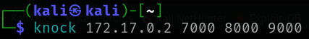
After performing this action, port 22 is open.
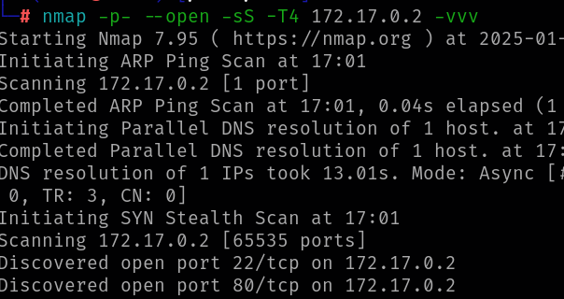
Now, let’s try hydra.
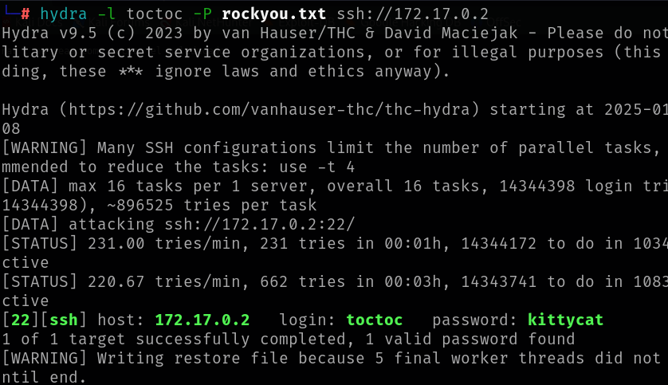
We found the password kittycat, so let’s enter and try to escalate privileges.
