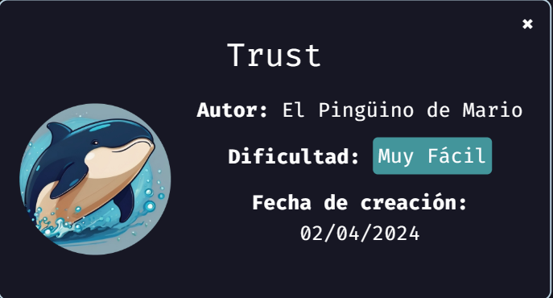
We start deploying the machine:
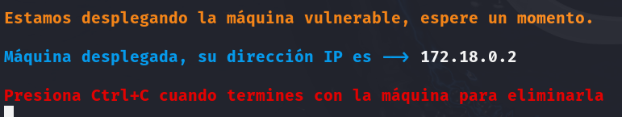
After we deploy the machine, we proceed with a ping to check the connection, and the scan of open ports to check for vulnerabilities.
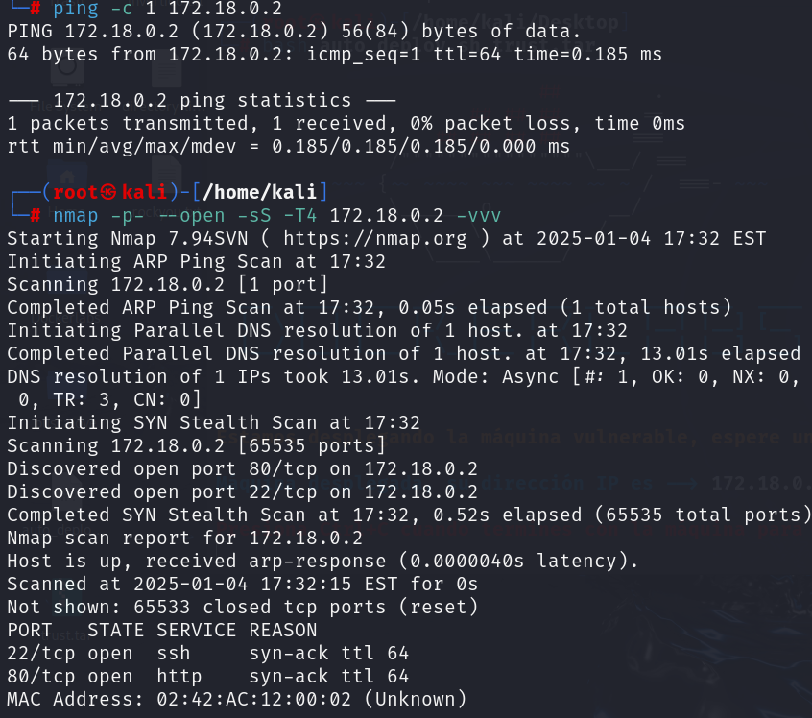
The open ports are 22 and 80, so let’s try in the http.
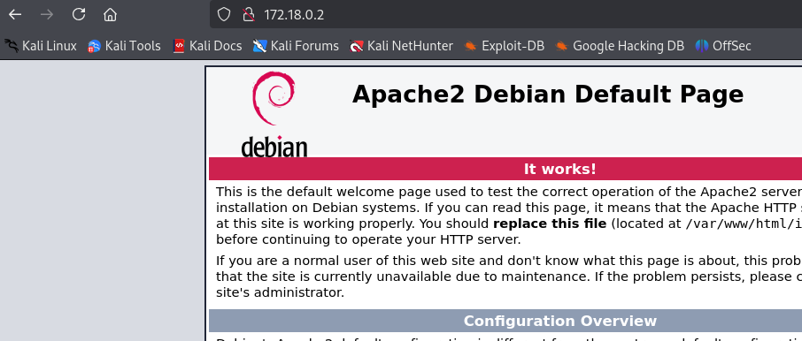
Nothing there, let’s try with gobuster if we’re able to find other pages.
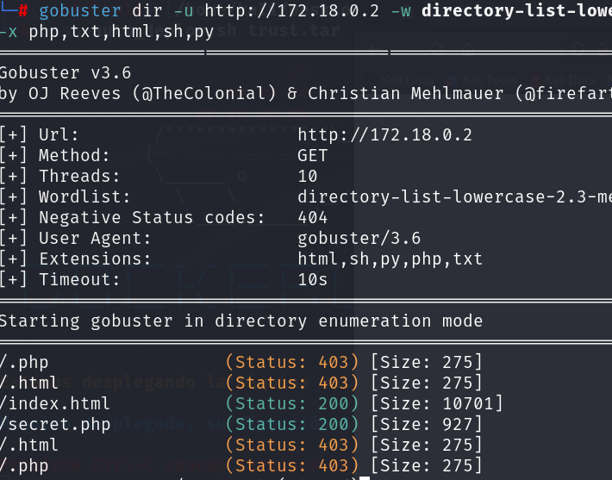
We found secret.php, so we open it.
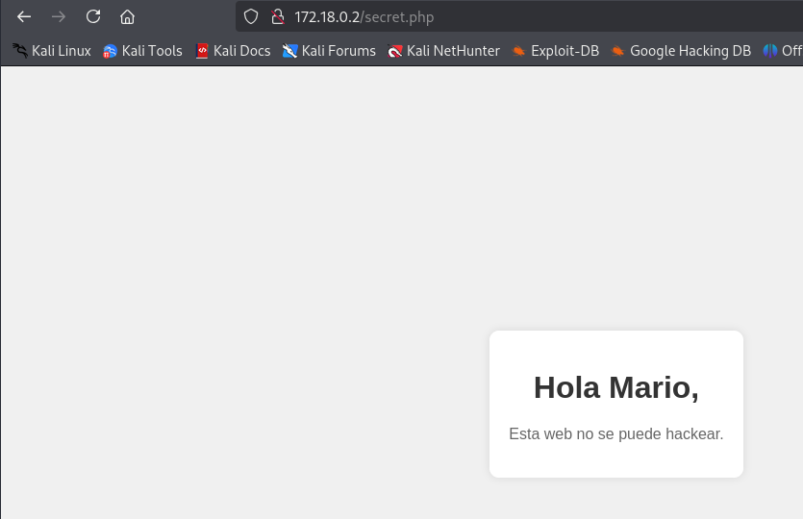
There’s this message, it seems that there’s an user called Mario, so let’s try brute force with hydra.
We found the password chocolate, so let’s enter.
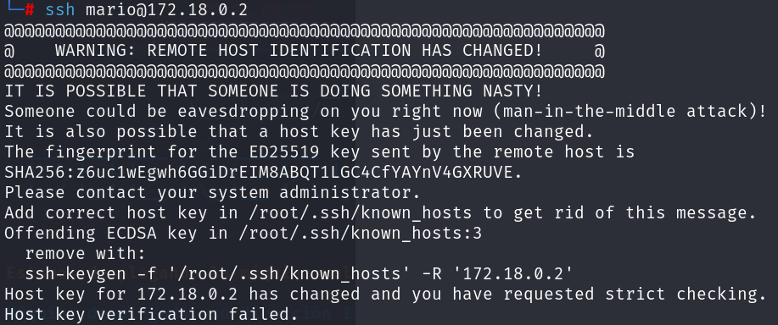
Error, but in the same message how to fix it.
ssh-keygen -f '/root/.ssh/known_hosts' -R '172.18.0.2
And after apply this command, just try again to enter.
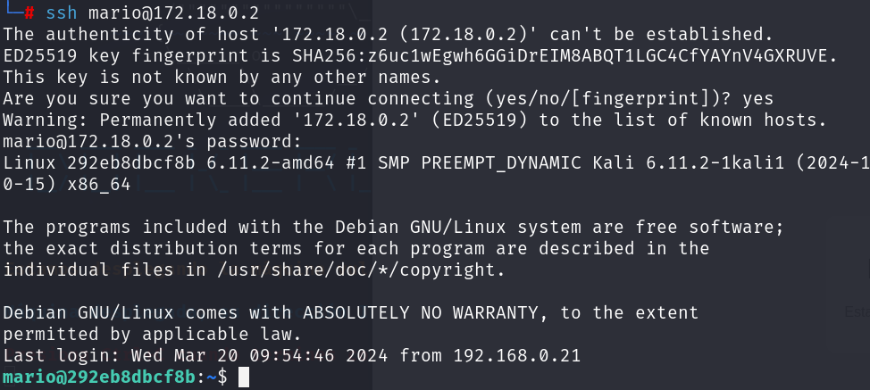
We’re in but as Mario, so let’s escalate privileges to be root.
