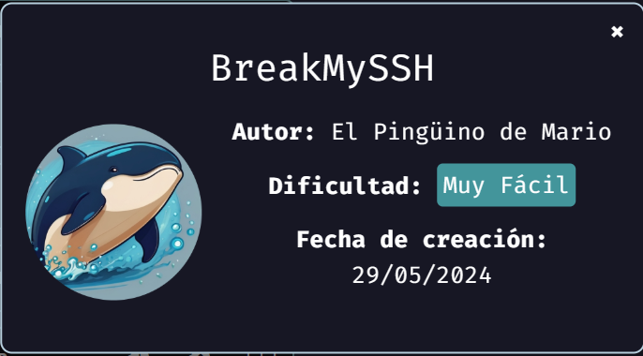
We start deploying the machine:
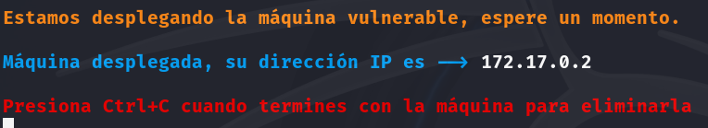
After we deploy the machine, we proceed with a ping to check the connection, and the scan of open ports to check for vulnerabilities.
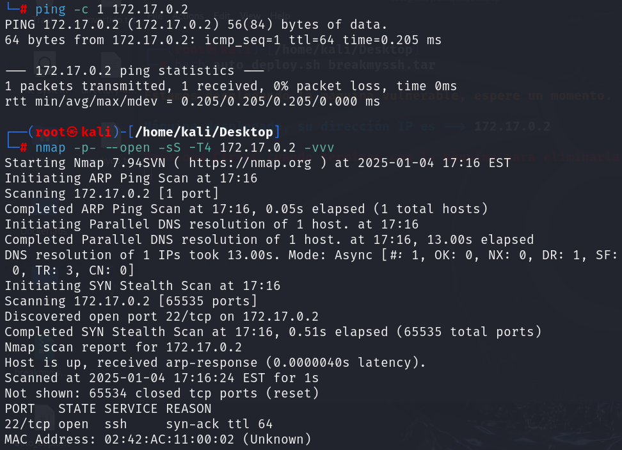
The only open port is 22, so let’s try hydra with root.
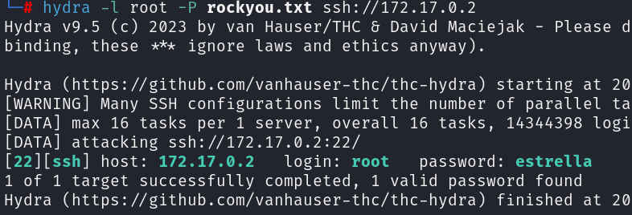
Password found, so let’s try to enter.
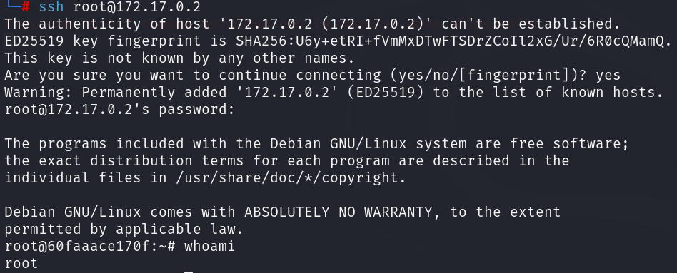
We entered as user root, so there’s no need to do any other move.

