Image Processing And Computer Vision Coursework

1 Viola-Jones Object Detector
Ground Truth and Visualisation

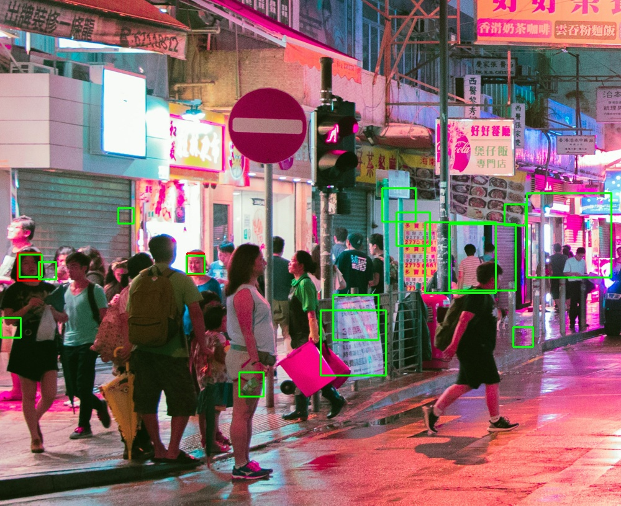

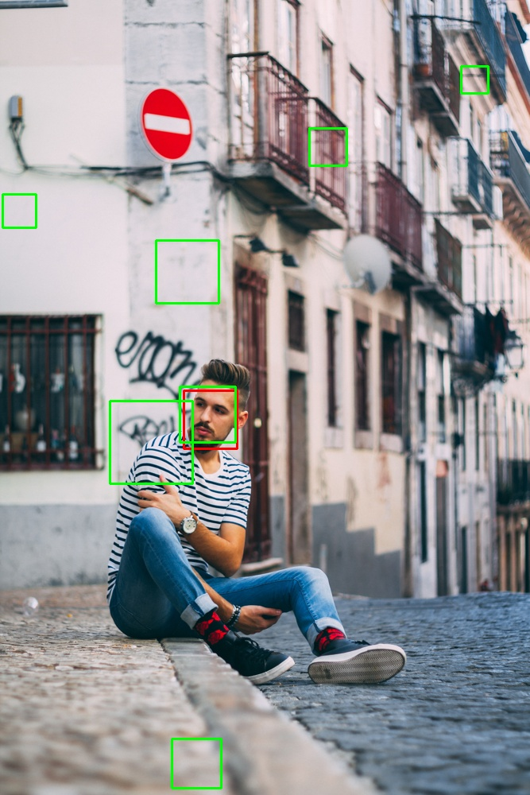

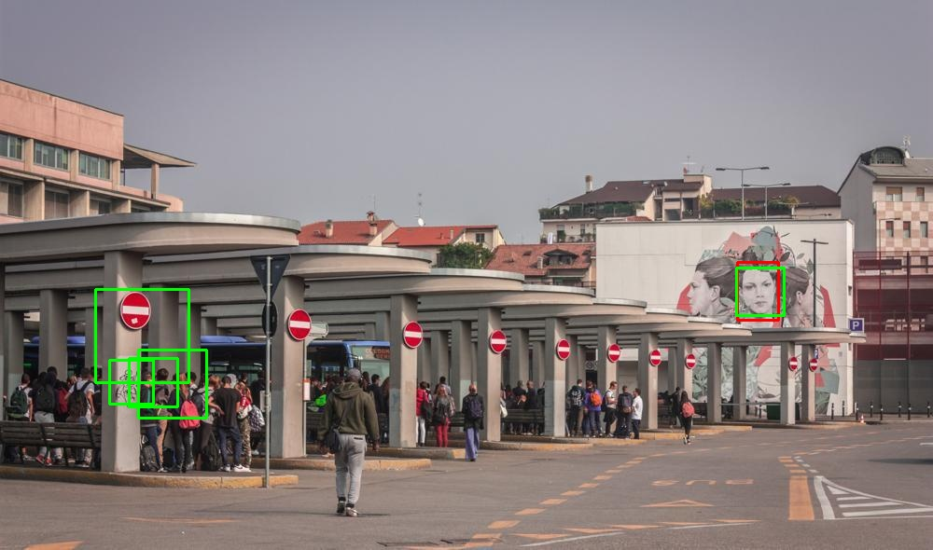

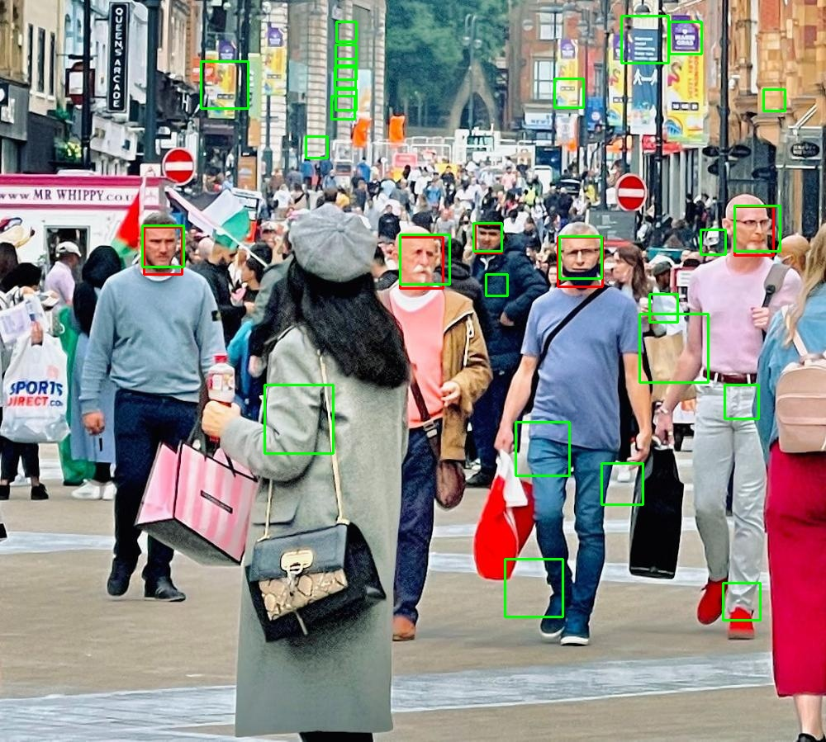
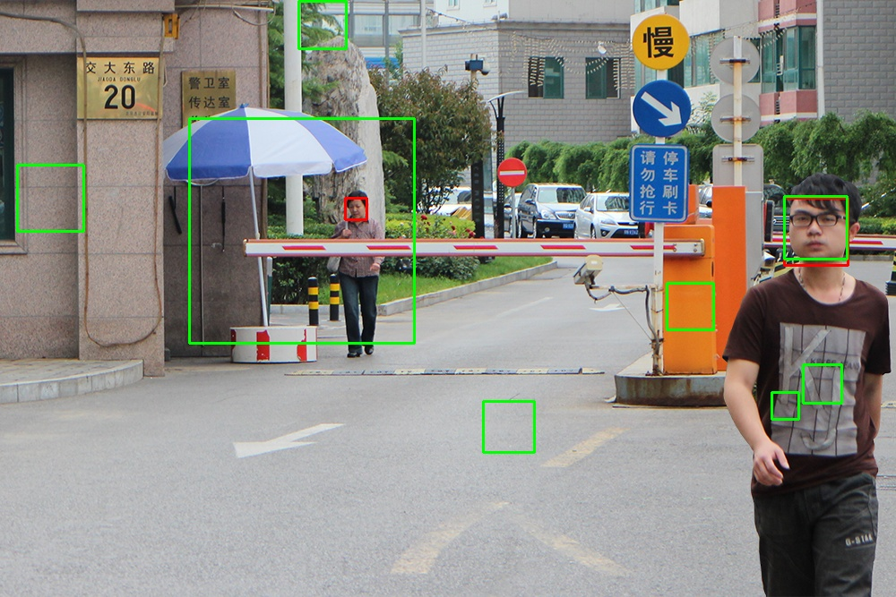

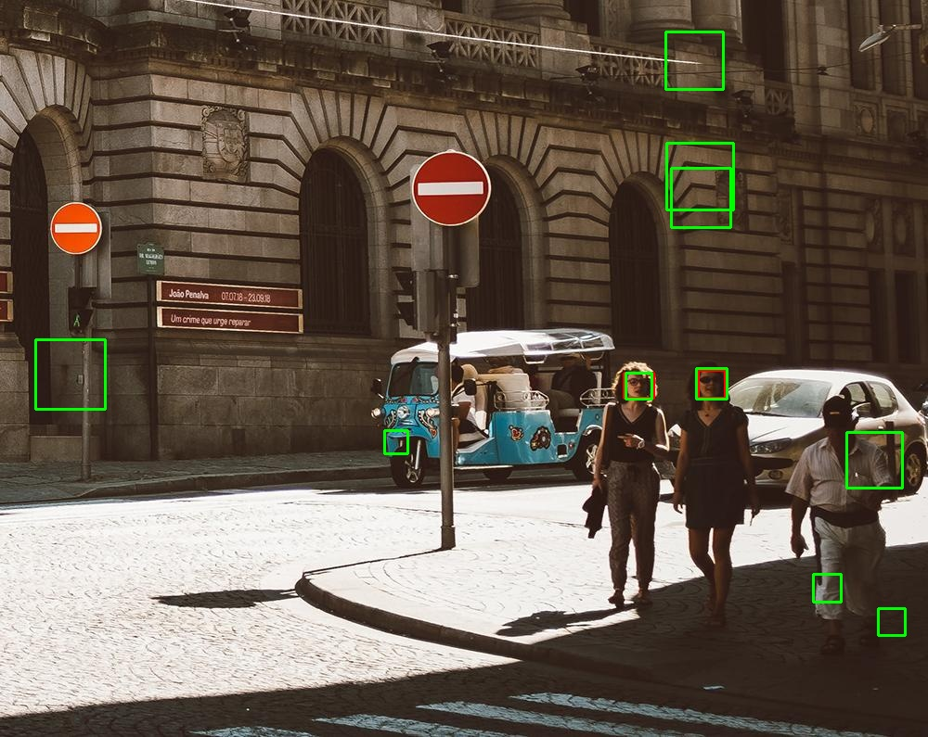

IOU, TPR, F1-Score

2 Building & Testing a Detector
Training Performance

Testing Performance

3 Integration with Shape Detectors
Hough Details

Evaluation

Detection Pipeline

4 Improving the Detector
Idea

Visualise

Evaluate

