**GIMM 440 Personal Project Agreement**

Name: Ben Villanueva

Proposed personal project description:

The Talking Stick part deux – Improving on our networked multiplayer project from last semester.

Portfolio gap this project will fill:

This project fills a gap in my portfolio by showing off my **game design and programming skills** in **AI development for a horror survival game**. I’m buildingan intelligent **enemy AI** that reacts to both sight and sound, adding stealth mechanics and dynamic enemy behavior to make gameplay more immersive. Using **Unreal Engine 5 blueprints and behavior trees.** I am creating an AI that can patrol, search, and chase the player based on what they see and hear. I’m handling **player health, damage and gamemode** to round out the experience. This project is all about making a **polished, game-ready AI system** while sharpening my skills in **gameplay programming and design balance**.

Provide a detailed description (high level) of the work you will complete this semester to create a polished, “complete” project for your portfolio. (If you are a part of an approved group project, list only the parts that you will undertake.) The amount of work listed here should be commensurate with a half-semester long project. Bullet points are fine.

* **Implement Sound Detection**
  + Integrate Unreal Engine’s AI Perception System for sound detection.
  + Set up hearing parameters (range, sensitivity, decay over distance).
  + Implement AI behavior for reacting to different sound types (footsteps, object collisions).
  + Adjust AI priority between sight and sound for realistic detection.
* **AI Behavior and Internal Functionality**
  + Implement health and damage systems for the enemy AI.
  + Ensure the AI can take damage from player attacks and react accordingly.
  + [STRETCH] Variable sight distance based on light
  + [STRETCH] AI that can be distracted by thrown objects
  + [STRETCH] Polished and optimized AI behavior

### **Player Character (MVP)**

* **Health and Damage Functionality**
  + Implement player health and damage system.
  + Ensure enemy attacks apply damage correctly.
  + Add death state for the player when health reaches zero.
* **Footsteps**
  + Implement player footsteps with variable sound intensities (walking vs. running).
  + Ensure footsteps are registered by the AI’s hearing system.

### **Game Systems**

* **Game Mode Controller**
  + Implement a GameMode blueprint to manage game states (start, play, pause, end).
  + Ensure AI and player systems interact properly with the game mode.
  + Handle round resets or level restarts when the player dies.

There I plan to move to other tasks if these get completed ahead of schedule.

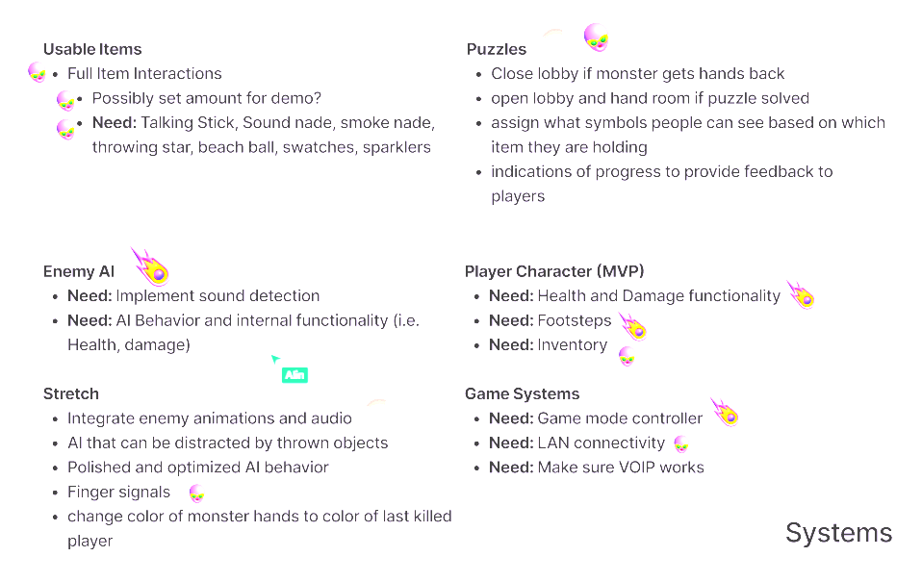

This agreement will be used in the determination of your final grade on the personal project assignments.