INTERNSHIP PROJECT REPORT
Licence Manager Automation System

A full-stack tool that automates monthly licence reporting from a complex multi-header Excel workbook.
Submitted by: Gargi Kalia
Internship Duration: May 18 – 30 June 2026
Technology Stack: Python · FastAPI · Jinja2 · OpenPyXL · JavaScript

1.Summary
This report documents the design, development, and delivery of the Licence Manager Automation System, built during my internship. The project automates a recurring monthly task of extracting and computing multiple licence tables from a complex, multi-header Excel file that was previously processed by hand.
The system accepts an input Excel file containing project-wise, department-wise, and location-wise licence data, and automatically computes five output tables: Licence Summary, Department Lease Distribution, Sub-Location Breakups, ISL (In-Stock Licences), and Keystore. It also provides a web-based frontend where users select software, enter parameters, view computed tables, manage licence keys, and download the complete report.

2. Problem Statement
The team maintained an Excel file, updated every month, containing:
- Two locations (DTA and SEZ) with multiple projects under each
- Department-wise LTC (Lease-To-Contractor) and Valdel licence numbers per project
- Summary columns for Own Licence, Lease Licence, and Total
Each month a team member manually extracted five different licence tables from this file. The process was:
- Time-consuming — typically 2–3 hours per cycle
- Error-prone — manual calculations caused inconsistencies
- Not scalable — adding a project or software meant reworking every table
- Undocumented — the business rules lived only in individual memory

3. System Architecture
The application follows a clean layered architecture that separates parsing, computation, output generation, and routing concerns.

3.1 Architecture Diagram
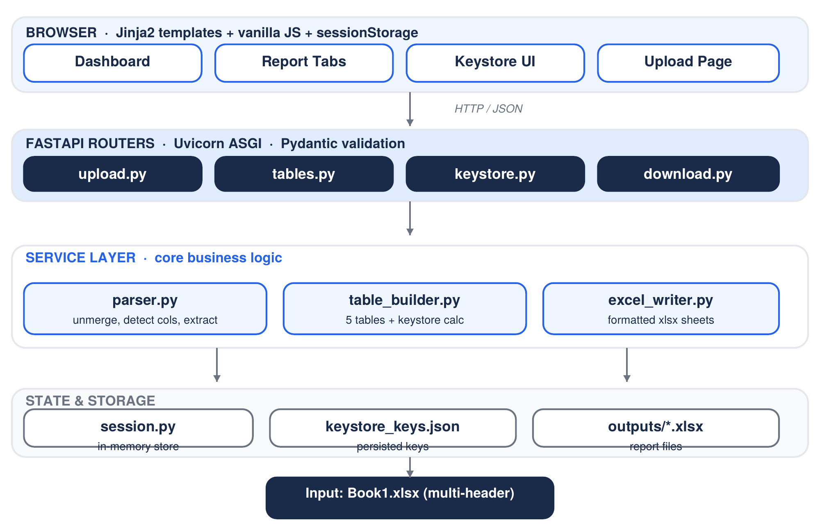
Figure 1 — Layered architecture: the browser talks to FastAPI routers, which call the service layer; state and outputs persist below.
Created using tables.js

3.2 Layer Responsibilities
Layer | Responsibility
Parser | Reads raw Excel, unmerges cells, detects columns dynamically, extracts records
Table Builder | Computes all five table types using the encoded business rules
Excel Writer | Writes computed tables as formatted sheets to the output workbook
Routers | FastAPI endpoints exposing upload, tables, keystore, and download APIs
Session | In-memory session management for parsed data within one usage session
Frontend | Jinja2 templates with vanilla JavaScript for the user interface

3.3 Data Flow
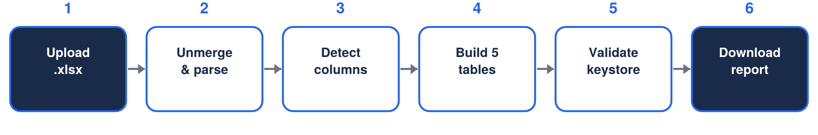
Figure 2 — End-to-end flow from upload to downloadable report.
- User uploads an .xlsx file via the web interface
- Parser unmerges every merged cell and writes a temporary clean file
- Parser detects header rows, project columns (by scanning for LTC headers) and summary columns (Own Lic, Lease Lic, Total) dynamically
- Records are extracted with developer / software / dept metadata using forward-fill
- Parsed data is stored in a server-side session keyed by session ID
- On the Dashboard the user selects developers, software, and inputs (Annual, Advent, Onshore)
- The Report page computes all four tables per software using per-software inputs
- Keystore is computed via a business-rule calculator plus user-entered values
- Download builds every table and writes a formatted Excel report with five sheets

3.4 Folder Structure
File / Folder | Purpose
services/parser.py | Excel parsing, unmerging, column detection, record extraction
services/table_builder.py | All five table computations and the keystore calculator
services/excel_writer.py | Writes five formatted output sheets to the workbook
routers/upload.py | POST /upload — file ingestion and session creation
routers/tables.py | GET endpoints for all tables + developer / software lists
routers/keystore.py | GET keystore table, POST toggle and add-key endpoints
routers/download.py | POST /download — builds all tables, returns Excel
core/session.py | In-memory session store with an 8-hour expiry
core/errors.py | Custom exceptions and global FastAPI error handlers
core/keystore.py | JSON-based keystore persistence (load, save, toggle, add)
data/keystore_keys.json | Persisted key registry, survives server restarts
templates/ + static/ | Jinja2 templates, shared JS utilities, and CSS design system

4. Technology Stack
Technology | Version | Usage
Python | 3.11+ | Core backend language
FastAPI | Latest | REST API framework with auto-generated docs
OpenPyXL | 3.x | Excel read / write / formatting
Jinja2 | 3.x | Server-side HTML templating
Uvicorn | Latest | ASGI server for FastAPI
Pydantic | v2 | Request / response validation
Vanilla JS | ES2020+ | Frontend interactivity, sessionStorage
Custom CSS | — | Navy design system, no framework
JSON | — | Keystore persistence (no database)

5. Key Features Implemented

5.1 Intelligent Excel Parser
- Handles merged cells by unmerging and filling every cell with the top-left value before parsing
- Dynamically detects project columns by scanning for LTC headers — robust to projects being added or removed each month
- Detects summary columns (Own Lic, Lease Lic, Total) by keyword matching
- Uses forward-fill logic for Developer and Software columns that span multiple rows
- Reads own / lease / total from the summary row at the bottom of each software group

5.2 Five Computed Output Tables
Table | Description
Licence Summary | Per-software totals with Annual and Order. Order = Lease − Annual; Advent added for SP3D.
Dept Lease Distribution | Allocates licences across NPP, PP, CV. Advent and Onshore are user-provided additions.
Sub-Location Breakups | Computes Valdel, PP, CEC (sum of Others), VEC (Order − CEC).
ISL | Dept-wise In-Stock Licences split into LTM (integer part) and Share (decimal part).
Keystore | Key-ID registry per software / dept. Values from calculator or user input, validated against order limits.

5.3 Keystore Management
- Keys stored in keystore_keys.json — persist across server restarts
- Active / inactive toggle per key, saved immediately to JSON
- New keys can be added for any software and department combination
- Values validated against the global Order limit (sum of active keys ≤ Order) and per-label limits from Allocated (NPP, PP, CV) and Required (CEC, VEC) tables
- Immediate red highlighting when a typed value pushes the sum over a limit

5.4 Per-Software Input System
- Dashboard supports selecting multiple developers and their respective software
- Each software carries its own Annual and Onshore inputs; Advent appears only for SP3D
- Inputs are saved to browser sessionStorage and applied per-software at compute time
- The Report page shows all four tables in software tabs — one tab per software

6. Challenges & Solutions
A selection of the most instructive bugs encountered during development and how each was resolved.
Challenge | Root Cause | Solution
Merged cells returned None for non-top-left cells | OpenPyXL populates only the first cell of a merged range | Unmerge all ranges, then fill every cell with the top-left value before parsing
Project columns were hardcoded by position (ws['D4']) | Project count changes monthly, breaking fixed references | Scan the header row for LTC headers and derive metadata from rows above
Session expired instantly (diff = −7s) | timedelta() got seconds as a positional arg instead of hours | Use the explicit keyword timedelta(hours=SESSION_EXPIRY_HOURS)
MergedCell AttributeError on .value assignment | iter_rows() returned stale MergedCell objects after unmerge | Address cells via ws.cell(row=x, column=y) after unmerging
grand_ltc accumulated incorrectly | The += sat inside an if total_p_col is not None block | Move grand_ltc += ltc_v outside the conditional so LTC always sums
Developer list came back as one comma-joined string | return [{set comprehension}] wrapped a set inside a list | Return list({...}) without the extra brackets
Own/lease/total repeated across all dept rows | aggregate_by_software used += across departments | Track seen software and set those values once, from the total row
Output filename grew a duplicate _report suffix | get_output_path appended _report to already-suffixed names | Strip an existing _report suffix before appending
CSS variables not resolving in injected markup | var(--accent) inside JS innerHTML is not evaluated | Use hardcoded hex values in the JS template strings
TypeError: unhashable type: dict on render | TemplateResponse called with arguments in the wrong order | Call TemplateResponse(request=request, name='file.html')

7. Validation & Testing

7.1 Parser Validation
- Tested against the actual Book1.xlsx supplied by the team
- Confirmed all five projects detected, with the LTC summary column correctly skipped
- Verified forward-fill propagates Developer and Software across department rows
- Verified own / lease / total are read from the total row, not summed across depts

7.2 API Validation
- Every endpoint exercised through the FastAPI /docs Swagger UI
- Upload returns session ID, project count, software list, and record count
- Table endpoints return computed values matching manual calculations
- Download produces a valid workbook with five correctly formatted sheets
- Keystore toggle and add endpoints persist correctly to JSON

7.3 Frontend Validation
- Developer cards render as separate, clickable elements
- Software cards expose individual inputs; Advent appears only for SP3D
- Report tabs load all four tables independently per software
- Keystore validation highlights exceeded limits in red on input
- Download triggers a file save with per-software inputs correctly applied

8. Limitations & Future Scope

8.1 Current Limitations
- Session data is in-memory only — a server restart requires reuploading the file
- Keystore calculator rules are hardcoded per software name
- No authentication — suited to internal single-user use
- Table edits are saved locally in the browser and not yet reflected in the Excel output

8.2 Future Enhancements
- Persist sessions to disk (JSON or SQLite) so uploads survive restarts
- Make keystore rules configurable through a UI or config file
- Add authentication for multi-user support
- Send edited table values to the download endpoint so Excel reflects edits
- Email notification when the monthly report is generated
- A month-over-month comparison view for licence changes

9. Conclusion
The Licence Manager Automation System successfully automates the monthly manual licence reporting task. It is deliberately generalised — it detects Excel structure at runtime rather than relying on hardcoded cell positions, so it absorbs changes in the number of projects or departments without code changes.
The project spans a full-stack implementation: intelligent data parsing, REST API design with proper error handling, session management, formatted Excel generation, and a professional web frontend. It reduces the monthly reporting effort from several hours to under five minutes.
The internship gave me hands-on experience with production-grade Python backend development, FastAPI architecture patterns, Excel automation with OpenPyXL, and frontend work using vanilla JavaScript and Jinja2 templating.

Gargi Kalia · Internship Project · 2026

