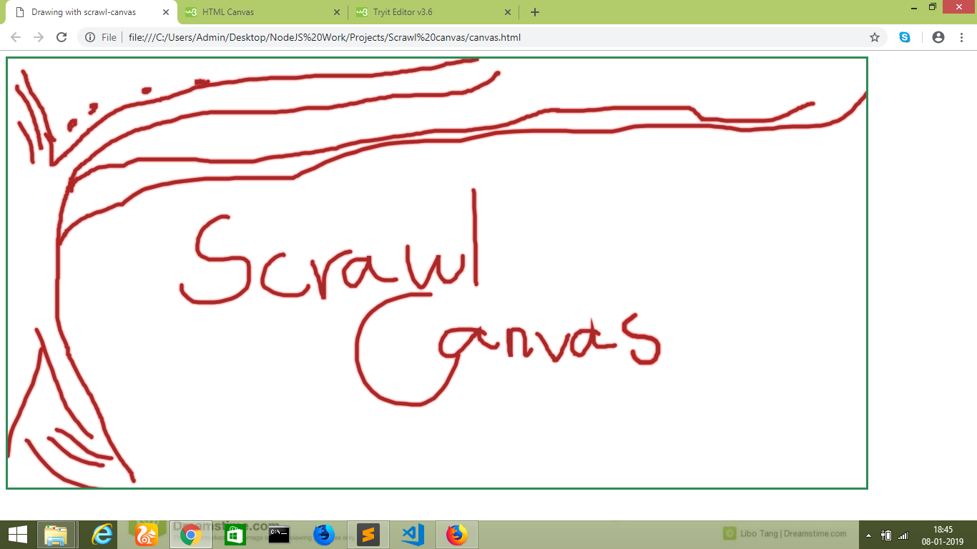

Project Notes

Using Scrawl-canvas: is an open-source JavaScript library for creating and manipulating 2D canvas elements. This project to draw like on a piece of paper using this library. More information in this link:

http://scrawl.rikweb.org.uk/

https://developer.mozilla.org/en-US/docs/Web/API/Canvas_API