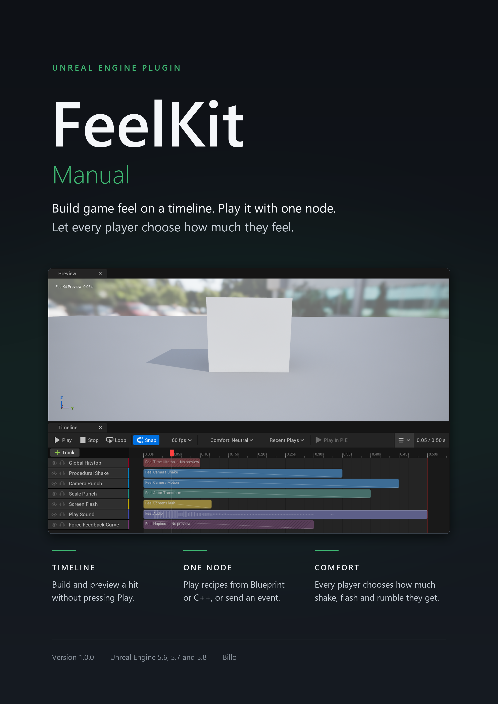
Contents
Update fields (F9) to fill in the contents.
PRO ONLY | In FeelKit Pro only. These sections also carry an orange strip under the heading.
LITE + PRO | In both editions. Guide sections without a tag are in both editions too.

Draft, 25 September 2026

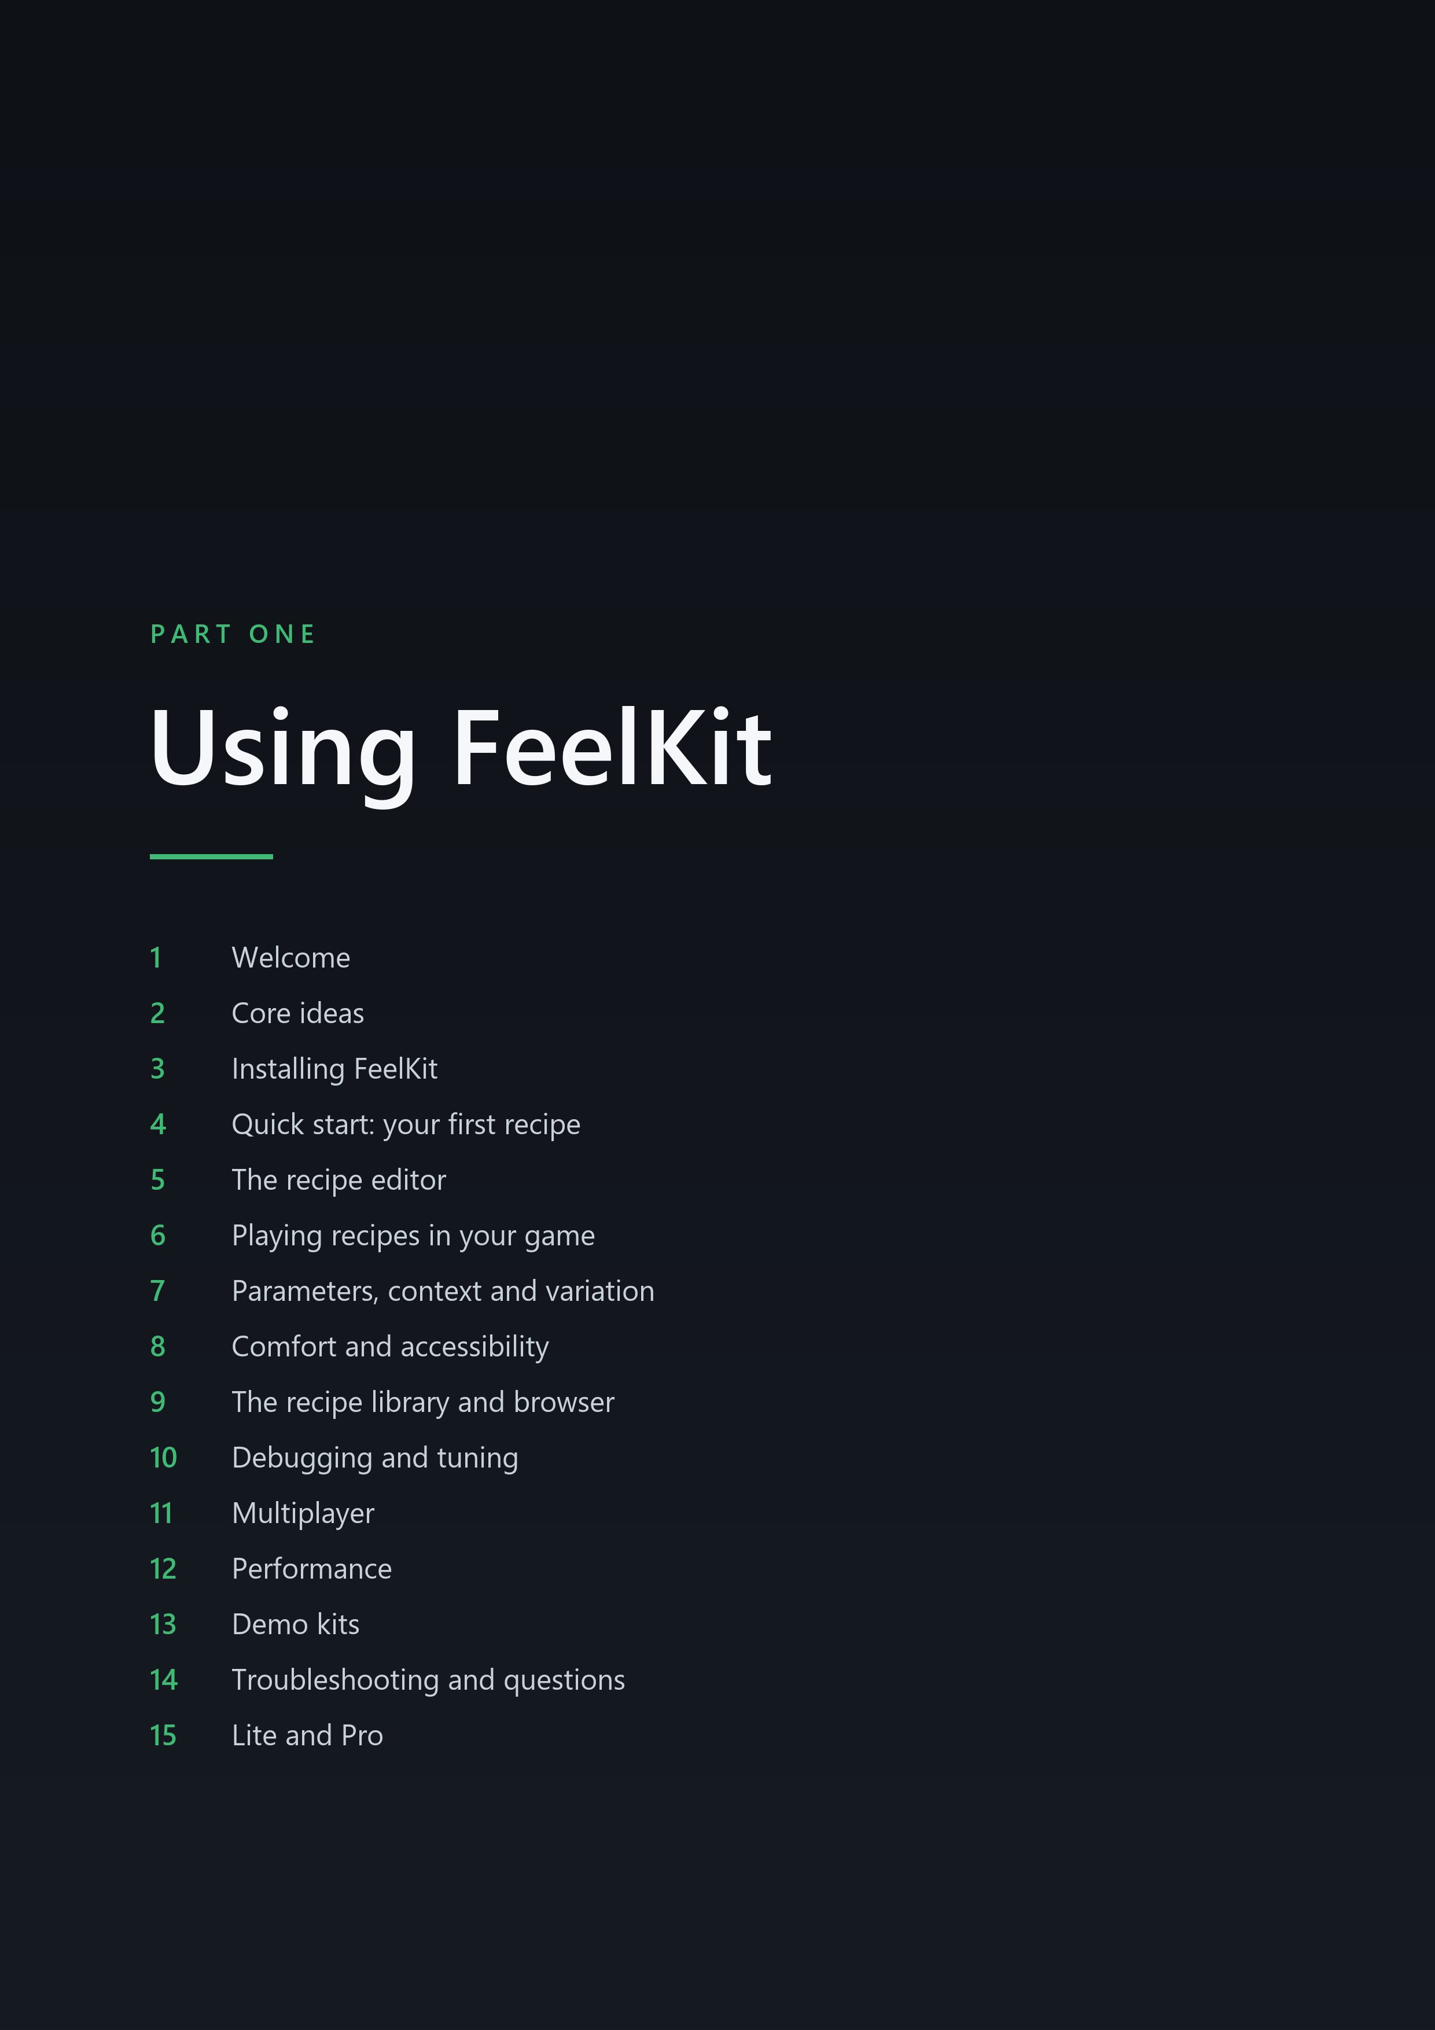



2 Core ideas

IN THIS CHAPTER
2.1 Recipes, tracks and steps
2.2 Channels, and what happens when effects overlap

2.1 Recipes, tracks and steps
A recipe is an asset that defines the feedback for a single moment of play: a hit landing, a heavy landing after a fall, a pickup, a menu button being pressed. A recipe consists of tracks arranged on a timeline, in the same manner that a Level Sequence arranges tracks in Sequencer. Each track plays one step, which is the effect itself: a camera shake, a screen flash, a sound, a controller vibration or a brief freeze of time. FeelKit Pro has 37 steps and FeelKit Lite has 12 of them; chapter 16, Step reference describes each step and names its edition.
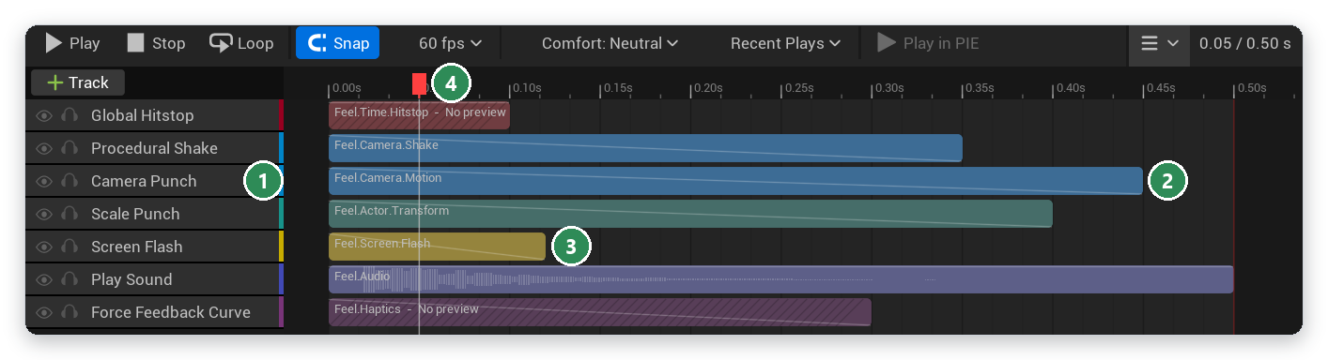
Figure 2.1 The recipe editor on a copy of FR_Impact_HeavyHit. 1 the steps, one per track; 2 a track on the timeline; 3 its channel, by name and colour; 4 the playhead
When a recipe plays, each track begins at its Start Time and runs its step for its Duration, both measured in seconds. A new track lasts 0.5 s. A track with a length of 0 is an instant track: steps that act once, such as Play Sound, Spawn Decal or Blueprint Event, can sit on one. The play ends when its last track ends.
A few settings belong to the recipe as a whole:
- Cooldown (default 0 s): how long the same recipe must wait before it can play again on the same target.
- Max Concurrent (default 0, which means no limit): how many plays of the recipe can run at once on one target. When the limit is reached, a new play does not start and the running ones continue.
- Default Intensity (default 1): a multiplier on every play of the recipe.
The full list of recipe and track fields is in 16.1 Recipe fields and 16.2 Track fields.
A step computes its output for a given moment from three inputs only: the time within its track, its intensity at that time, and a seed. It retains no state from earlier frames. This property allows the recipe editor to scrub the timeline in either direction and show exactly the frame the game would show at that moment, and it guarantees that the same seed always produces the same shake. Steps that act once, such as playing a sound or calling a Blueprint event, do so when their track starts, and some act again when it stops.
Recipes are timed in real time, which Unreal refers to as unscaled time. Consequently, a hitstop that slows the world does not slow the recipe that caused it: a shake continues to move during the freeze, and the recipe ends when its timeline specifies. FeelKit's runtime performs work only while a recipe plays or while a change it made still has to be restored; when nothing is playing, it does not tick at all.

2.2 Channels, and what happens when effects overlap
Every track belongs to a channel, a gameplay tag under Feel. A new track receives its step's default channel, for example Feel.Camera.Motion for Camera Punch, and you can change it on the track. The channel colours the track on the timeline, groups the recipe editor's Intensity tab, and decides which comfort group scales the track (see 2.7 Comfort on one page).
Channel | Used by | Comfort group
Feel.Camera.Shake | Procedural Shake | Camera Shake
Feel.Camera.Motion | Camera Punch, FOV Kick, Camera Roll, Camera Zoom, Look-at Nudge | Camera Motion
Feel.Time.Hitstop | Global Hitstop, Actor Hitstop | Hitstop and Slow-mo
Feel.Time.SlowMo | Slow-mo Ramp | Hitstop and Slow-mo
Feel.Screen.Flash | Screen Flash | Flashes
Feel.Screen.Distortion | Vignette Pulse, Chromatic Aberration, Post Process Material Pulse | Screen Distortion
Feel.Screen.Color | Desaturate, Color Tint | Screen Distortion
Feel.Screen.Fade | Screen Fade | none (Master only)
Feel.Actor.Transform | Scale Punch, Squash and Stretch, Mesh Wobble | none (Master only)
Feel.Actor.Material | Material Parameter Pulse, Hit Flash | none (Master only)
Feel.Actor.Light | Light Flash | Flashes
Feel.Audio | Play Sound | none (Master only)
Feel.Audio.Mix | Sound Class Duck, Pitch Bend, Low-pass Sweep | none (Master only)
Feel.Haptics | Force Feedback Curve, Haptic Pattern | Haptics
Feel.UI | Widget Punch, Widget Shake, Widget Flash, Number Pop | none (Master only)
Feel.Spawn | Spawn Decal, Spawn Particle | none (Master only)
Feel.Meta.Event | Blueprint Event | none (Master only)
Feel.Meta.Recipe | Play Recipe, Random Choice | none (Master only)

The comfort groups in this table are the project defaults. You can change the mapping in the project settings (see 18.5 Comfort).

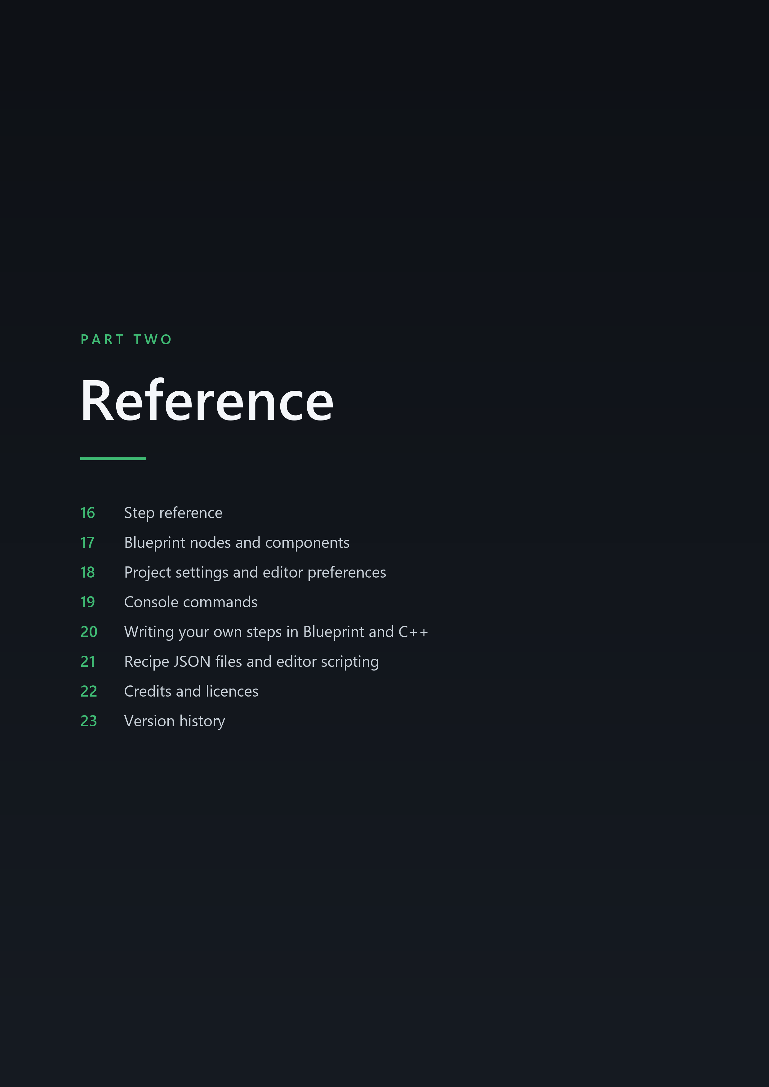



16 Step reference

16.5 Camera steps
Camera steps offset the view of the target's local player, through a camera modifier that FeelKit adds to each local player's camera manager. Tracks of one play add up; separate plays are combined by the Camera Arbitration setting (see 18.2 Camera).

16.5.1 Procedural Shake LITE + PRO
Moves and turns the camera with noise or a sine wave computed from the track time and the seed, so the same seed gives the same shake every time and the preview shows exact frames when scrubbing. Perlin gives smooth random motion on each axis. Sine gives a regular oscillation with a random phase per axis. Directional moves back and forth along Direction only, with the rotation swinging in step. The intensity curve sets the strength over time; the default curve gives a shake that dies away over the track.
Class | UFeelStep_ProceduralShake, module FeelCore.
Default channel | Feel.Camera.Shake.
Comfort group | Camera Shake.
Editor preview | yes.
Track length | needs a length.
New tracks start with | an intensity curve that fades from 1 to 0.

Property | Default | Description
Mode | Perlin | Shape of the shake.
Frequency | 12 Hz | Oscillations per second. At least 0.01.
Location Amplitude | (0, 3, 3) cm | Maximum location offset per camera axis (X forward, Y right, Z up). Shown only when Mode is not Directional.
Direction | (0, 0, 1) | Camera-space direction of a directional shake. Shown only when Mode is Directional.
Directional Amplitude | 8 cm | Maximum offset along Direction. Shown only when Mode is Directional.
Rotation Amplitude | Pitch 1, Yaw 1, Roll 0.5 (degrees) | Maximum rotation offset in degrees per axis.
Field Of View Amplitude | 0° | Maximum field of view change.

16.5.2 Camera Punch LITE + PRO
Pushes and turns the camera to a peak and back along the motion shape; with the default Spring it overshoots and settles like a physical hit. Location Punch and Rotation Punch are the offsets at the peak. Direction Source can point the punch along the play's Direction, or away from or toward the play's Location, as seen from the camera when the play started. The strength stays that of the step settings, and the step settings are used when the play passed no direction or location. Direction Jitter turns the direction by a random angle for each play, which stays fixed for the whole play.
Class | UFeelStep_CameraPunch, module FeelCore.
Default channel | Feel.Camera.Motion.
Comfort group | Camera Motion.
Editor preview | yes.
Track length | needs a length.
New tracks start with | a flat intensity curve at 1.
Motion shape | Spring by default; the shape settings are described in 16.4 Shared motion settings.

Property | Default | Description
Location Punch | (-10, 0, -4) cm | Camera-space location offset at the peak (X forward, Y right, Z up).
Rotation Punch | Pitch -2.5, Yaw 0, Roll 0 (degrees) | Rotation offset at the peak, in degrees.
Direction Source | Step Settings | Where the punch direction comes from. With a play direction or location, the punch keeps the strength of Location Punch and Rotation Punch but points along that direction, as seen from the camera when the play started.
Direction Jitter | 0° | Varies the punch direction per play by up to this angle, so repeated plays never look identical. Range 0 to 90.

16.5.3 FOV Kick LITE + PRO
Changes the field of view by Field Of View Kick at the peak and back. Positive values widen the view, which reads as speed; negative values narrow it, which reads as an impact zoom. The default Kick shape rises fast and eases back.
Class | UFeelStep_FOVKick, module FeelCore.
Default channel | Feel.Camera.Motion.
Comfort group | Camera Motion.
Editor preview | yes.
Track length | needs a length.
New tracks start with | a flat intensity curve at 1.
Motion shape | Kick by default; the shape settings are described in 16.4 Shared motion settings.

Property | Default | Description
Field Of View Kick | 8° | Field of view change at the peak. Positive widens (speed), negative narrows (impact zoom). Range -60 to 60.

16.5.4 Camera Roll PRO ONLY
FeelKit Pro only. FeelKit Lite does not include this.
Rolls the camera around its view axis to Roll Degrees at the peak and back. With Random Direction on, each play picks clockwise or counterclockwise from its seed. Players who turn Allow Camera Roll off in their comfort settings see no camera roll from any recipe.
Class | UFeelStep_CameraRoll, module FeelCore.
Default channel | Feel.Camera.Motion.
Comfort group | Camera Motion; the roll is also removed completely when a player turns Allow Camera Roll off.
Editor preview | yes.
Track length | needs a length.
New tracks start with | a flat intensity curve at 1.
Motion shape | Spring by default; the shape settings are described in 16.4 Shared motion settings.

Property | Default | Description
Roll Degrees | 4° | Roll angle at the peak. Positive rolls clockwise. Range -45 to 45.
Random Direction | On | Pick clockwise or counterclockwise at random for each play.

