Project Development Phase
Performance Test

Date | 19 February 2026
Team ID | LTVIP2026TMIDS66321
Project Name | Cafeteria menu display
Maximum Marks

Model Performance Testing:
Project team shall fill the following information in model performance testing template.
S.No. | Parameter | Screenshot / Values
 | Data Rendered | 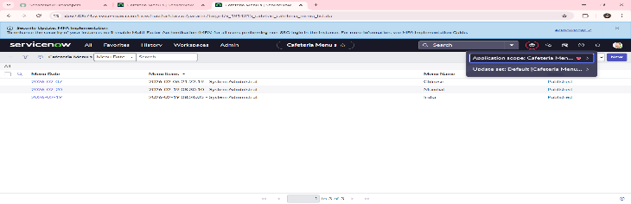
 | Data Preprocessing | 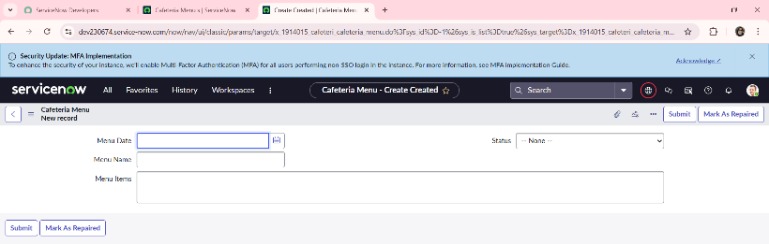
3. | Utilization of Filters | No Filters Used
4. | Calculation fields Used | No Calculations Used
5. | Dashboard design | No of Visualizations / Graphs - 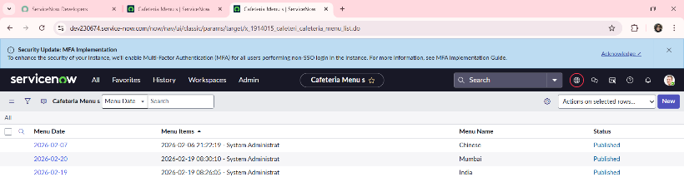
6 | Story Design | No of Visualizations / Graphs –  