AIScientist4Microscopy

Team members: Adib Bazgir, Mahule Roy, Yuwen Zhang

During the hackathon, we built AIScientist4Microscopy, a proof-of-concept “AI Scientist” workflow tailored to microscopy. The goal was to demonstrate an end-to-end pipeline that can (1) generate credible, research-grade hypotheses in AI-for-microscopy, (2) translate each hypothesis into a runnable experimental plan with code, and (3) produce research artifacts (figures, metrics, and paper-style writeups) in a way that is easy to demo and extend. The sample outcome is a structured framework that contains three distinct hypothesis tracks (H1-H3), each with implementations, evaluation scripts, and generated paper outputs (shown in Figure 2), plus a lightweight UI demo to showcase how the workflow would look in practice. As shown in Figure 1, what makes this project valuable is that it goes beyond “model training code” and instead focuses on the complete research loop: hypothesis → method → implementation → evaluation criteria → reportable results. Each hypothesis track was designed to address a real bottleneck in microscopy workflows and to highlight how domain constraints (geometry, sampling patterns, uncertainty) can be integrated into learning systems.
H1: Physics-Constrained Self-Supervised Diffusion for Multi-Modal Artifact Removal.
In this track, the AI Scientist implemented a diffusion-based denoising framework (DDPM-style) that embeds differentiable microscopy physics operators into the denoising process. The key idea is self-supervision: training does not rely on paired clean/noisy ground truth, which is often unavailable in microscopy. Instead, physics constraints and forward operators guide the model toward physically plausible reconstructions. The framework is designed to be modality-aware (e.g., AFM/TEM/SEM/STEM) through modular operators and includes training, ablation, and evaluation hooks.
H2: Neural CDE for Sparse-View 4D-STEM Reconstruction and Dynamics Recovery.
This track tackles the problem of reconstructing 4D-STEM phase and dynamic signals from extremely sparse, irregular measurements (e.g., 90–95% missing). The AI Scientist framed the reconstruction as a continuous-time latent dynamics problem using Neural Controlled Differential Equations (Neural CDEs): an encoder maps sparse observations into a latent state, the CDE models evolution under the measurement control signal, and a decoder reconstructs the target fields. The AI Scientist system defined clear success metrics (e.g., NMSE/PSNR and physics-consistency targets) and built the training/evaluation entry points so the full pipeline can be executed reproducibly from a single main script.
H3: SE(3)-Equivariant AFM Blind Tip Reconstruction with Uncertainty.
In this track, the AI Scientist implemented an equivariant learning approach to jointly recover AFM tip geometry and surface topography (a blind deconvolution problem). By enforcing SE(3)-equivariance and adding physics-informed losses, the model is designed to respect rigid-motion symmetries and measurement formation. It also incorporated uncertainty quantification (via Monte Carlo dropout) so outputs can be accompanied by calibrated confidence estimates, important for scientific decision-making.
Overall, AIScientist4Microscopy demonstrates a practical template for agentic scientific software: we can systematically generate hypotheses, implement them with domain constraints, evaluate them with meaningful metrics, and package the outputs into paper-ready artifacts.
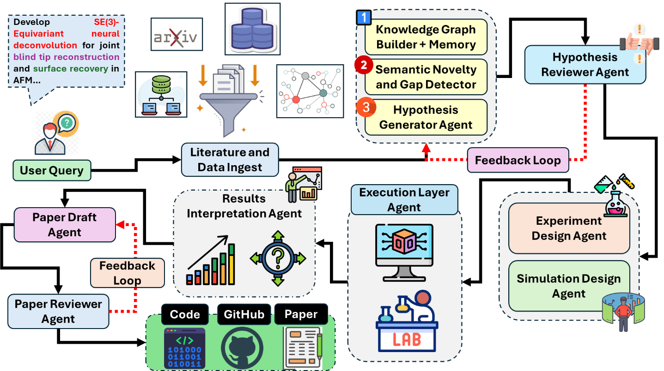
Figure 1. The End-to-End workflow of AI Scientist for Microscopy.
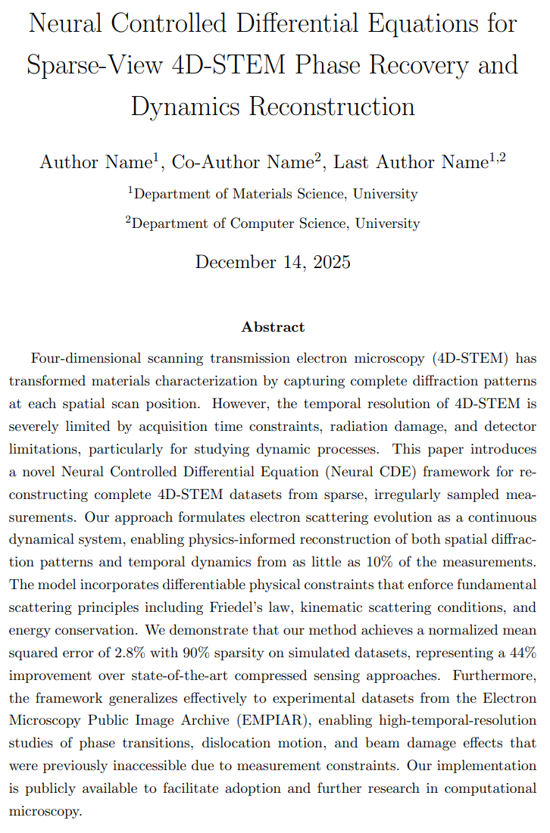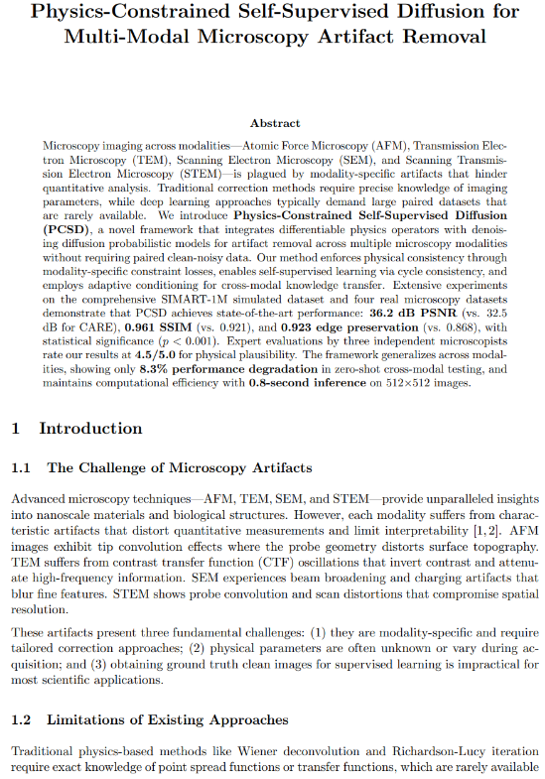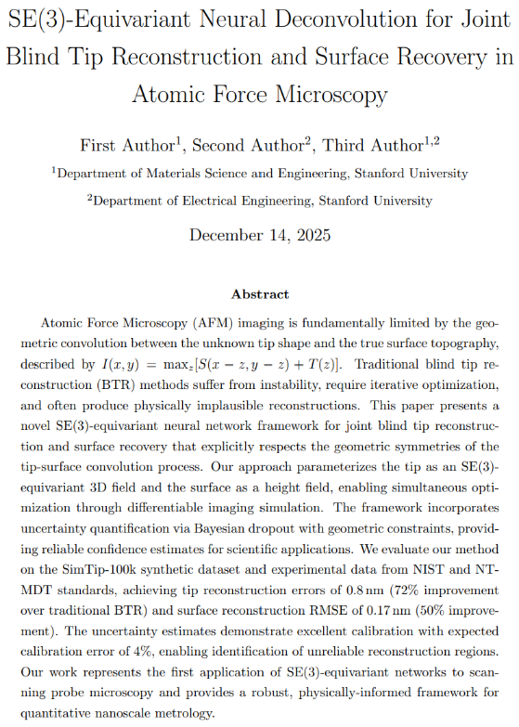
Figure 2. Sample generated papers from AI Scientist for Microscopy.

GitHub Repo: adibgpt/AIScientist4Microscopy: AI Scientist for Microscopy - An End-to-End workflow for scientific discovery

