REPORT ANALYSIS

The objective of this project is to design a database-driven system for collecting and analyzing housing data.

The AMFEX Housing Census aims to gather basic information about housing conditions within the community.

From the information gathered, it has been observed that the average household size in the community is 56129.

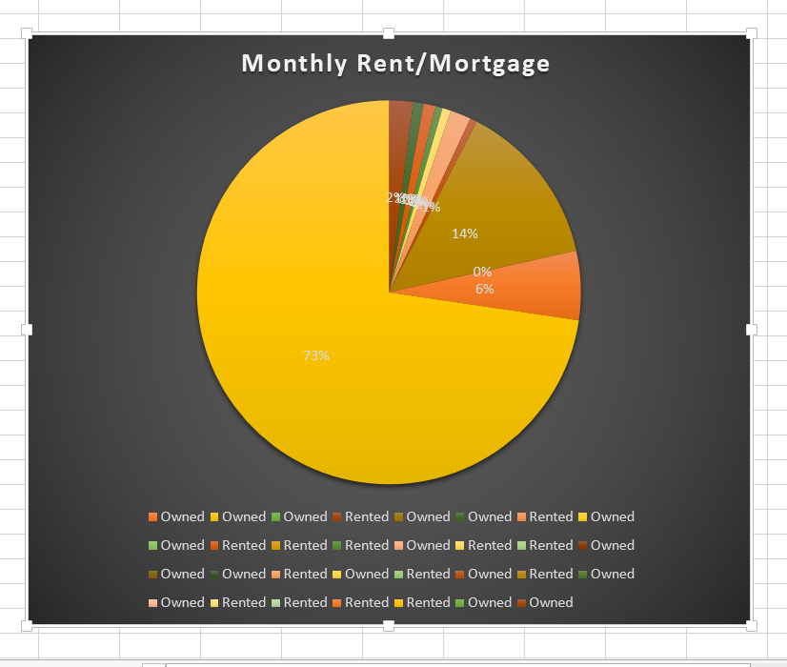

The image above gives a summary of the household information gathered.