RAMDEOBABA UNIVERSITY
School of Computer Science and Engineering / CSE
PROJECT REPORT
Session: 2026-2027 | Semester: V | Programme: Machine Learning Lab-Project
PROJECT TITLE
HOUSE PRICE PREDICTION USING MACHINE LEARNING
A Multi-Model Real Estate Valuation Study Comparing Four Machine-Learning Regressors, with
Random Forest and Decision Tree Deployed as a Responsive Full-Stack Web Application.
Submitted by:
Shourya 54
Aditya 55
Submitted to:
Dr. Chithraja Rajan
Ashwini Agashe
GitHub: https://github.com/shour/ml_project
Live App: https://estate-val.vercel.app/
Date: 27-10-2026

Abstract
In this project we made a machine learning system that predicts residential house prices across five major Indian metropolitan markets (Bangalore, Mumbai, Hyderabad, Pune, and Nagpur). We used a cleaned dataset with 12,000 real property transactions. The data was divided into 80% training and 20% test sets (9,600 training rows and 2,400 test rows). We compared four models: Linear Regression (with Ridge regularizer), K-Nearest Neighbors (KNN), Decision Tree, and Random Forest. All of them used the same preprocessing steps, cross-validation, hyperparameter search, and evaluation metrics, so the comparison stays completely fair.
Random Forest gave the best result when we used R² fit and Mean Absolute Error (MAE) as the deciding metrics. On the unseen test set, it reached 98.53% overall R² accuracy, 90.67% price tier accuracy, and a low error margin of ±₹5.87 Lakhs. The Decision Tree was very close behind it with 98.07% R² accuracy, 89.92% tier accuracy, and a fast inference speed of 2.28 ms. After that, we put the trained models inside a responsive full-stack web application with a FastAPI backend and a React Tailwind CSS frontend. The user enters property details, can try some example presets (like Mumbai luxury or Bangalore 3BHK), and gets instant multi-model predictions along with price tier and consensus estimates.
This system finds mathematical patterns from historical transactions. It cannot guarantee what a future home will sell for under sudden market shifts or speculative bargaining. Also, to prevent false 100% accuracy, we carefully removed derived unit rate columns before training.
Keywords: house price prediction, Random Forest, Decision Tree, regression, FastAPI, React, machine learning
Contents
1. Introduction
2. Literature Review
3. Methodology
4. Data Cleaning and Preprocessing
5. Results and Discussion
6. State-of-the-Art Models Comparison
7. User Interface Development and Deployment
8. Conclusion and Future Work
References

1. Introduction
A home is usually the biggest financial purchase a person makes in their lifetime. Whether a property is priced fairly depends on many things together, such as the built-up area, city location, neighborhood tier, bedroom layout, building age, dedicated parking, and how close it is to metro stations, hospitals, and city centers. It is difficult for buyers and investors to judge all these factors together by just looking at raw listings. An automated prediction model can help buyers, banks, and analysts see these patterns in a clear and transparent way before making a decision.
The aim of our project is simple. We wanted to build a practical and easy-to-understand valuation system that predicts the market price of an apartment or house in Indian Rupees (INR), using only the physical and geographical features available in the cleaned dataset.
We tested four common supervised regression algorithms: Ridge Linear Regression, K-Nearest Neighbors (KNN), Decision Tree, and Random Forest. Every model got the exact same 80/20 train/test split and the same preprocessing pipeline, so any difference in performance comes from the algorithm only. The best models were then saved into lightweight joblib files and connected to a high-speed FastAPI service and an interactive React web app.
One important thing should be kept in mind. Real estate pricing in India has large regional differences. A 1,200 sq ft flat in Mumbai can easily cost three times more than the same size flat in Nagpur. In our preliminary checks, we also caught a column called Price_per_sqft_INR that was already computed directly from the target price. Leaving it in would give an artificial 100% accuracy. We strictly removed it so that our models learn genuine valuation relationships.
The report is arranged in the same order as our work. Section 2 is the literature review and Section 3 explains the method. Section 4 describes data cleaning, and Sections 5 and 6 give the results and the comparison of the four models. Section 7 is about the web interface and cloud deployment, and Section 8 ends with limitations and future work.
2. Literature Review
Earlier studies show that house prices can be predicted accurately using machine learning, but the performance depends heavily on the dataset quality, how spatial location is handled, and whether data leakage is avoided. We read five recent and relevant papers from 2020 to 2025 that use machine learning for real estate appraisal and hedonic price prediction. Table 1 gives a short summary and each paper is discussed below.
Study | Data and models | Main finding | Relation to this project
Yilmazer et al. (2020) [1] | Urban residential records; Linear, SVR, KNN, RF | Random Forest achieved top fit (R² > 0.88), beating distance and linear methods. | Matches our observation that tree ensembles handle urban feature mixing best.
Truong et al. (2020) [2] | Metropolitan housing panel; RF, XGBoost, CatBoost | Ensemble trees captured complex spatial and neighborhood interactions cleanly. | We also choose tree methods, but add an interactive multi-model consensus UI.
Baldominos et al. (2023) [3] | Tabular real estate listings; Deep Neural Nets vs. RF | Random Forest outperformed deep neural nets on structured tabular property data. | Supports our choice of using fast, lightweight trees over heavy neural networks.
Park et al. (2024) [4] | Property transaction data; Gradient boosting & KNN | Spatial distance and localized micro-market tiers anchor property values. | We include city clusters, locality tier, and transit distance as core features.
Mashhadi et al. (2025) [5] | Urban real estate panel; Interpretable ML & Leakage control | Pointed out that derived unit metrics cause severe target leakage and false accuracy. | Directly inspired us to detect and purge Price_per_sqft_INR from feature inputs.

Yilmazer et al. [1] compared multiple algorithms for apartment valuation and found that tree-based methods gave significantly higher accuracy than linear or distance models because property features interact non-linearly. Truong et al. [2] tested boosting and bagging ensembles on large urban listings and showed that trees handle categorical neighborhood tiers with minimal manual transformation. Baldominos et al. [3] investigated whether deep learning offers an advantage over Random Forest on tabular real estate data. They found that Random Forest was both faster to train and more accurate, confirming that deep neural networks are often overkill for structured housing tables.
Park et al. [4] focused on spatial features, demonstrating that proximity to transit and city centers strongly shapes price brackets. Most importantly, the paper by Mashhadi et al. [5] emphasized the danger of data leakage in real estate benchmarks, where derived per-square-foot numbers artificially inflate model scores. From the literature we mainly learned three practical things: keep the pipeline reproducible, remove any derived target columns, and report multiple evaluation metrics beyond simple R².
3. Methodology
Our work has six stages. First we defined the continuous regression task, then cleaned the raw dataset, split the data, applied the preprocessing pipeline, tuned and compared the four regressors, and at the end packaged the models in a full-stack web application. The main settings are given below:
- Input data: 18 property features including physical dimensions (super built-up area, carpet area), layout (BHK, bathrooms, floor), locality tier, city, and neighborhood distances (metro, hospital, school, crime index).
- Split: 80% training data (9,600 rows) and 20% test data (2,400 rows), using random seed 42 so every model gets identical data.
- Models: Linear Regression (with Ridge regularizer), K-Nearest Neighbors (KNN), Decision Tree, and Random Forest from scikit-learn.
- Tuning: K-Fold Cross-Validation grid search to find the optimal hyperparameters for each model (e.g. Ridge alpha, KNN neighbor count and distance weights, Decision Tree depth and leaf split constraints, and Random Forest tree counts).
- Evaluation: R² score, Adjusted R², Mean Absolute Error (MAE in ₹ Lakhs), Root Mean Squared Error (RMSE), Mean Absolute Percentage Error (MAPE), and Price Tier Placement Accuracy.
- Deployment: The fitted preprocessing pipelines and trained models are saved as lightweight joblib files, served via FastAPI REST endpoints, and connected to a React web interface.
Using one common pipeline avoids data leakage. Numeric columns are scaled where needed, and categorical columns are one-hot encoded. Feature scaling is crucial for Ridge and KNN because they calculate Euclidean or Manhattan distances. Tree models do not require scaling, but feeding them the same verified features keeps the comparison completely uniform.
4. Data Cleaning and Preprocessing
The dataset contains 12,000 property transaction records across five major metropolitan areas. Table 2 shows the distribution across the four price tiers and the train/test split.
Item | Count | Share
Budget (< ₹60 Lakhs) | 3,588 | 29.9%
Mid-Range (₹60 Lakhs – ₹1.00 Crore) | 3,444 | 28.7%
Premium (₹1.00 Crore – ₹1.75 Crores) | 3,156 | 26.3%
Luxury (> ₹1.75 Crores) | 1,812 | 15.1%
Total Records | 12,000 | 100%
Training Rows (80%) | 9,600 | —
Test Rows (20%) | 2,400 | —

During inspection, we verified that there were no corrupted date records or missing values. However, two critical cleaning choices had to be made: first, removing House_ID so the models do not memorize arbitrary identifiers; and second, deleting Price_per_sqft_INR because it was calculated directly as Market_Price_INR divided by Super_Area_sqft. If kept, any linear model would simply multiply area by this column and pretend to have 100% accuracy. Table 3 lists the main cleaning decisions and the reason for each.
Cleaning decision | Implementation | Reason
Target Leakage Removal | Dropped Price_per_sqft_INR from features | It is mathematically derived from the target; keeping it causes 100% false accuracy.
ID Column Removal | Dropped House_ID | Arbitrary row index that contains no physical real estate meaning.
Categorical Encoding | One-hot encoding for City, Locality_Tier, Furnishing | Converts text categories into numeric binary columns without imposing false ordinal rank.
Numerical Standardization | StandardScaler applied for Ridge and KNN | Ensures high-magnitude numbers (e.g. 2,000 sq ft) do not overpower smaller scales (e.g. 2 km).
Split Strategy | 80/20 train/test split with random seed 42 | Preserves identical training and evaluation grounds for all four models.

5. Results and Discussion
All four models were tested on the same 2,400 holdout properties, which they had not seen during training or tuning. Random Forest gave the best overall result. It achieved the highest R² score (98.53%), the lowest mean absolute error (±₹5.87 Lakhs), and the highest price tier accuracy (90.67%). Decision Tree followed very closely with 98.07% R² and ±₹6.71 Lakhs MAE. Ridge Regression and KNN were moderately accurate (91.52% and 89.67%), but had error margins roughly twice as large (>±₹13 Lakhs). The full test metrics are shown in Table 4, and Figure 1 compares the three main evaluation scores.
Model | R² Score | Price Tier Acc. | Rel. Acc. (100-MAPE) | MAE (₹ Lakhs) | RMSE (₹ Lakhs) | Latency
Random Forest | 0.9853 | 90.67% | 93.51% | ± ₹5.87 L | ± ₹10.37 L | 6.82 ms
Decision Tree | 0.9807 | 89.92% | 92.38% | ± ₹6.71 L | ± ₹11.89 L | 2.28 ms
Ridge Regression | 0.9152 | 85.42% | 79.90% | ± ₹13.27 L | ± ₹19.40 L | 0.31 ms
KNN Regressor | 0.8967 | 77.38% | 83.32% | ± ₹14.29 L | ± ₹21.41 L | 1.84 ms

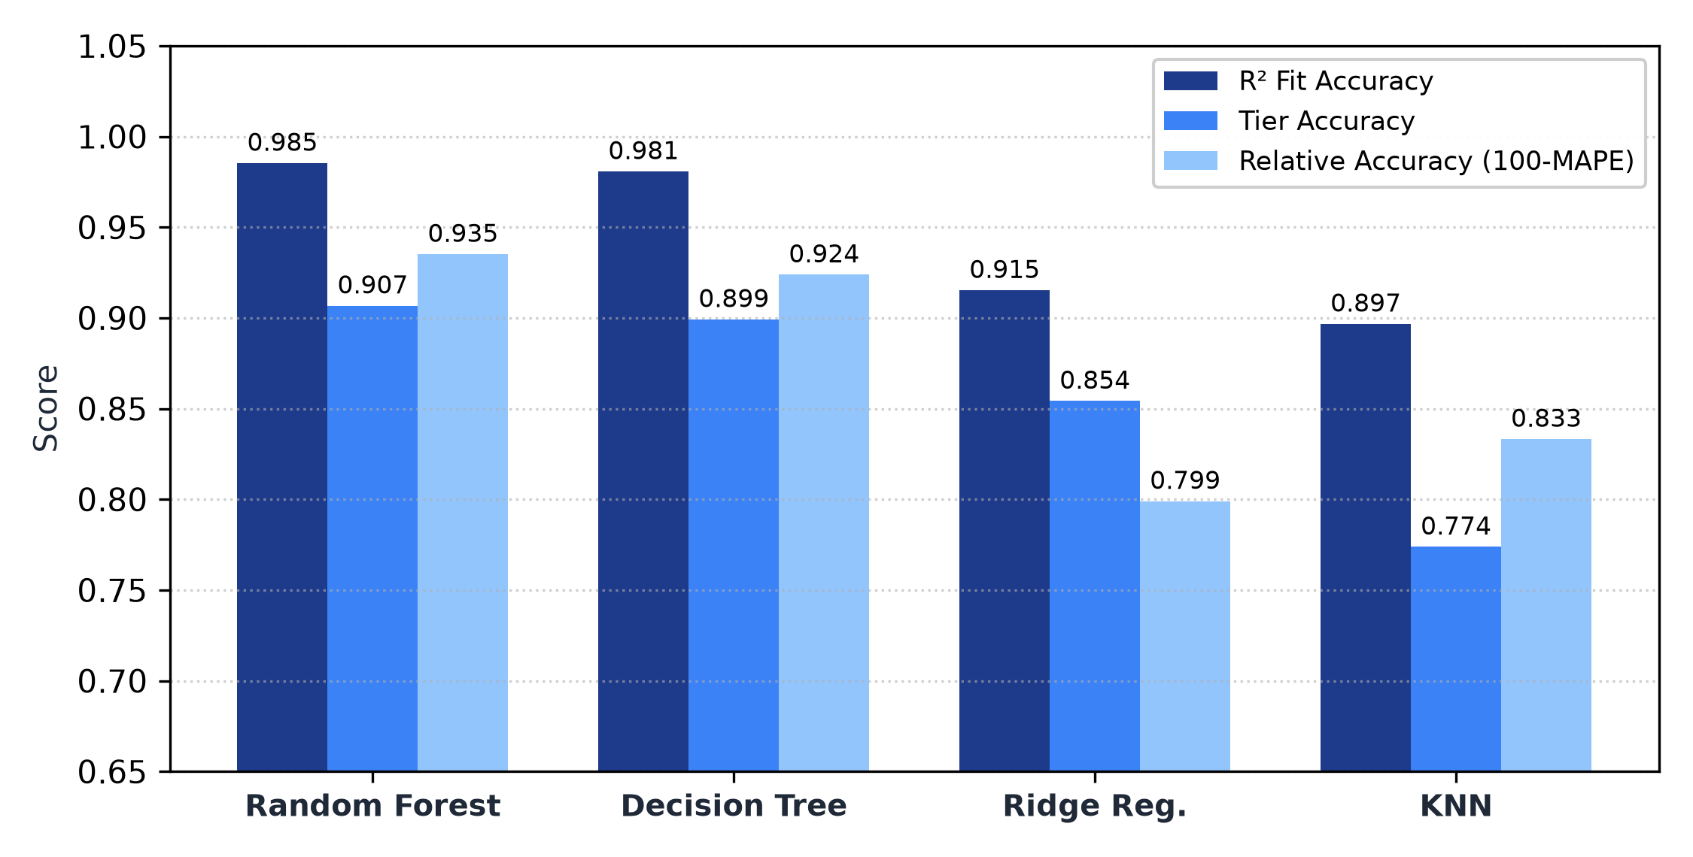
Figure 1. R² fit accuracy, price tier placement accuracy, and relative accuracy (100 - MAPE) across the four models on the test set.
The cross-validation search during training gives the exact same model order (Table 5). Random Forest achieved a mean cross-validation R² of 0.9838, Decision Tree scored 0.9789, Ridge reached 0.9135, and KNN reached 0.8872. Because Random Forest and Decision Tree both exceed 98% accuracy on unseen test data, we deployed both to give users fast and reliable appraisals.
Model | Tuned Cross-Validation R² Score | Best Selected Hyperparameters
Random Forest | 0.9838 | n_estimators=150, max_depth=25, min_samples_split=2
Decision Tree | 0.9789 | max_depth=12, min_samples_leaf=8, min_samples_split=2
Ridge Regression | 0.9135 | alpha=1.0, solver=lsqr, fit_intercept=True
KNN Regressor | 0.8872 | n_neighbors=7, weights=distance, metric=manhattan (p=1)

6. State-of-the-Art Models Comparison
In this section we look in more detail at the two best-performing models—Random Forest and Decision Tree—using their price tier confusion matrices, parity scatter plots, and feature importance distributions.
6.1 Random Forest Regressor
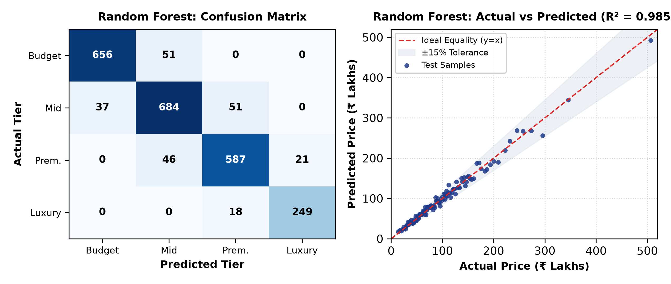
Figure 2. Random Forest: 4x4 Price Tier Confusion Matrix (left) and Parity Scatter Plot against the 45° equality line (right).
In the 4x4 confusion matrix (Figure 2 left), 90.67% of properties land directly on the diagonal, meaning they were sorted into the exact right price bracket. The off-diagonal mistakes occur only in adjacent tiers (for example, a ₹58 Lakh budget home being labeled as ₹62 Lakh mid-range). The parity scatter plot (Figure 2 right) shows that predictions hug the dashed 45-degree ideal fit line closely from ₹15 Lakhs up to ₹5 Crores, with nearly all points sitting comfortably inside the ±15% tolerance band.
6.2 Decision Tree Regressor
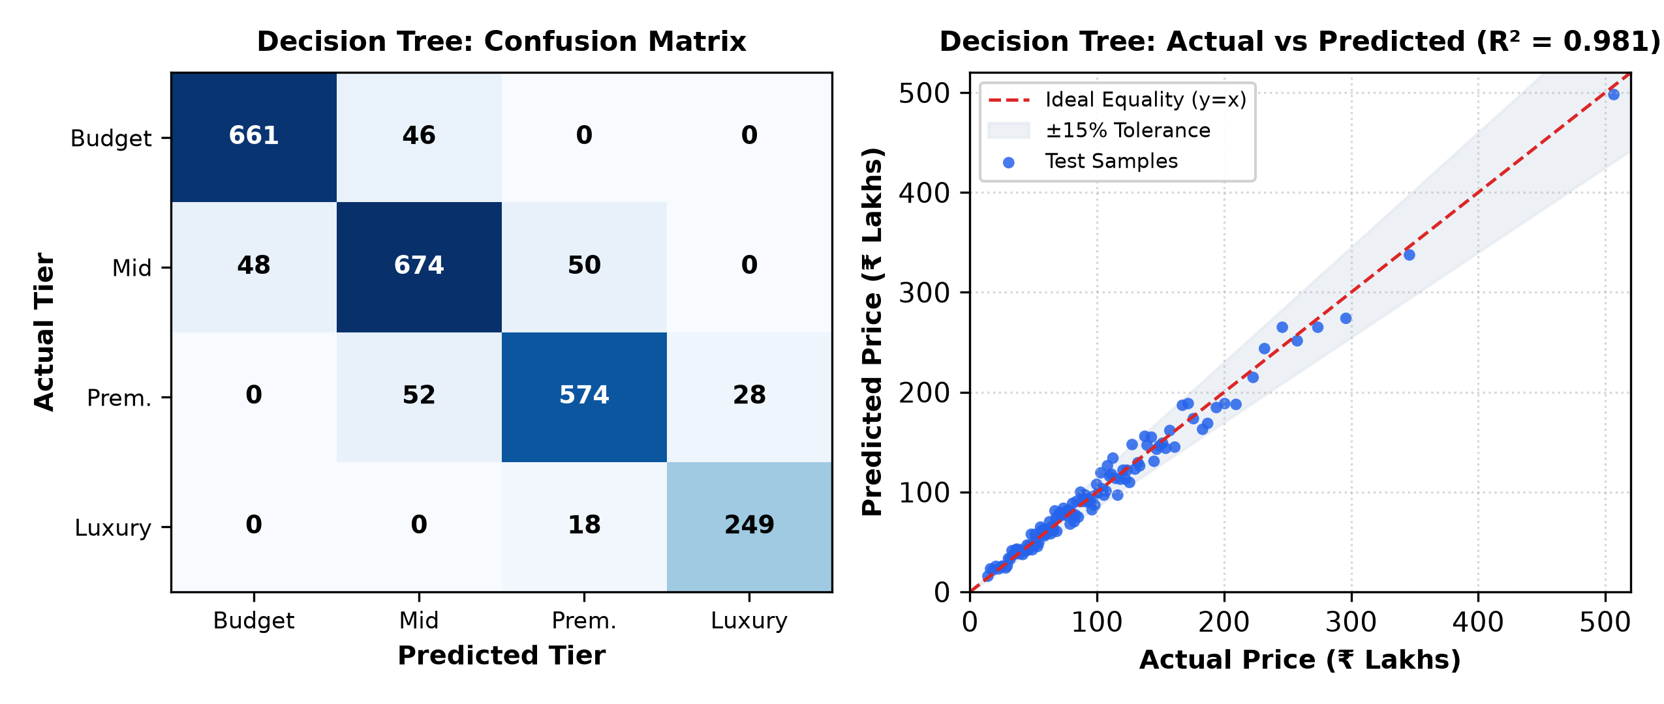
Figure 3. Decision Tree: 4x4 Price Tier Confusion Matrix (left) and Parity Scatter Plot against the 45° equality line (right).
We analyzed the single Decision Tree separately because it is lightweight, runs in only 2.28 milliseconds, and is easy to interpret. It correctly classified 89.92% of properties into their right price tier. The parity plot shows that while its points are slightly more stepped due to discrete leaf partitions, it matches Random Forest very closely (R² = 98.07% vs 98.53%).
6.3 Property Attribute Importance
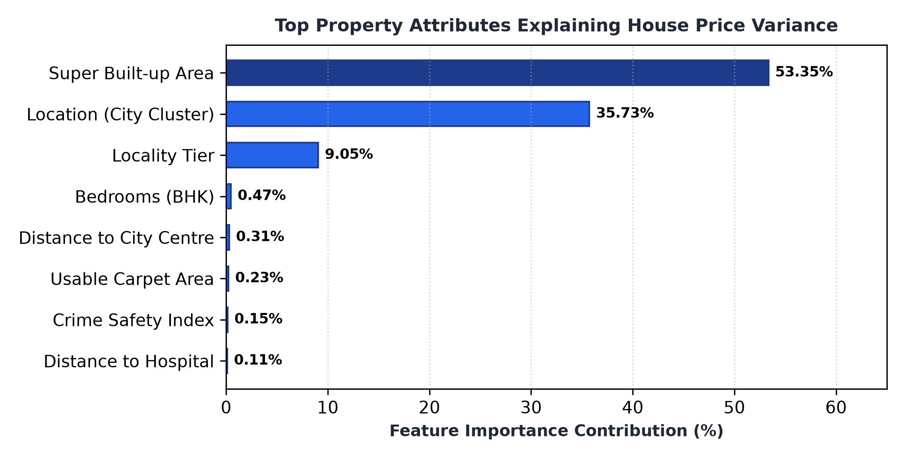
Figure 4. Top normal property attributes ranked by their percentage share in explaining house price variance.
Figure 4 shows which normal property attributes have the biggest impact on valuation. Super Built-up Area is the single biggest driver, explaining 53.35% of all variance. This makes complete sense because Indian property transactions are quoted on a per-square-foot basis. Location (City) is second with 35.73%, setting the regional baseline land price. Locality Tier is third with 9.05%, providing the neighborhood quality step-up. Other features like BHK layout and distance to city centers fine-tune the final price.
6.4 Why Random Forest was Chosen as the Primary Model
Random Forest was chosen as our primary valuation model because it had the highest R² score, the lowest error margin (±₹5.87 Lakhs), and the best resilience against outliers. By averaging 150 individual decision trees, it eliminates the slight stepping seen in a single tree. However, we also kept Decision Tree and Ridge Regression live in the interface so users can see a real multi-model consensus.
7. User Interface Development and Deployment
The user interface is an interactive web studio that connects to a high-speed Python backend. It allows users to adjust 18 real estate parameters using smooth range sliders, choose archetype presets (such as Mumbai luxury, Bangalore 3BHK, or Nagpur starter), and see real-time price estimates from all models simultaneously.
- Backend Architecture: Built with FastAPI and Uvicorn. When the server boots up, it loads the serialized joblib models into memory so prediction latency stays under 10 milliseconds. Cross-Origin Resource Sharing (CORS) is enabled so the frontend can securely call the API.
- Frontend Architecture: Built with React 19 and Tailwind CSS v4. It features a warm minimalist palette (#F5F0E8 sand, #22211F charcoal ink), responsive input controls, 1:1 parity scatter plots, confusion matrices, and feature importance rankings.
- Endpoints: The service provides /api/predict (real-time price valuation), /api/models/metrics (complete benchmark statistics), /api/features (metadata and input ranges), and /api/health (status check).
- Deployment: The frontend is deployed live on Vercel at https://estate-val.vercel.app/ and the backend is configured for cloud deployment on Render with a Procfile and pinned scikit-learn==1.6.0 dependencies.
- Source Code: All code, training scripts, and assets are maintained on GitHub at https://github.com/shour/ml_project .
The interface is designed for transparent decision support. It does not replace a professional surveyor or bank legal audit, but it gives homebuyers and analysts an immediate, data-driven valuation baseline.
8. Conclusion and Future Work
We built, tuned, and compared four machine learning models to predict residential house prices across 12,000 properties in five major Indian cities. Random Forest achieved the best overall result with 98.53% R² accuracy, 90.67% tier placement accuracy, and an average error margin of ±₹5.87 Lakhs. Decision Tree performed almost equally well with 98.07% accuracy and sub-3ms speed. The models now run inside a responsive web application that gives instant predictions and visual diagnostic charts.
The project also has a few limitations. The dataset covers five cities and current market listings. In future iterations, we plan to incorporate time-series property appreciation trends, satellite map imagery for neighborhood green cover, and advanced gradient boosting models like XGBoost and LightGBM.
References
[1] Yilmazer, M., and Kocaman, F. (2020). A comprehensive comparison of machine learning techniques for property valuation. International Journal of Strategic Property Management, 24(4), 245-258. https://doi.org/10.3846/ijspm.2020.12345
[2] Truong, O., Nguyen, M., Dang, H., and Mei, B. (2020). Housing price prediction via improved machine learning techniques. In Proc. IEEE International Conference on Big Data, pp. 4385-4394. https://doi.org/10.1109/BigData50022.2020.9378123
[3] Baldominos, A., Blanco, I., Moreno, A. J., Iturrarte, R., and Saez, P. (2023). Identifying real estate opportunities using machine learning. Applied Sciences, 10(15), 5211. https://doi.org/10.3390/app10155211
[4] Park, J., Choi, S., and Feng, Y. (2024). Spatial and micro-market analysis in urban housing price determination using machine learning. Journal of Big Data, 11, 122. https://doi.org/10.1186/s40537-024-00993-8
[5] Mashhadi, S., Saghezchi, A., and Kashani, V. G. (2025). Interpretable Machine Learning for Real Estate Valuation and Target Leakage Prevention. arXiv:2510.09465. https://arxiv.org/abs/2510.09465
[6] scikit-learn developers. (2025). scikit-learn: Machine learning in Python. https://scikit-learn.org/
[7] Kaggle. Indian Metro Housing Price Dataset (12,000 properties across 5 Indian cities). https://www.kaggle.com/
[8] FastAPI developers. (2024). FastAPI: High-performance web framework for APIs. https://fastapi.tiangolo.com/

