**Homework_1. Kalith M Ismail**

**Trial1:** m1 = 50kg; m2 = 50kg; v1 = 0m/s; v2 = 0m/s; x1=-10m; x2 = 10m, k = 50N/m, x0 = 10, t = 0.01s, T = 100s

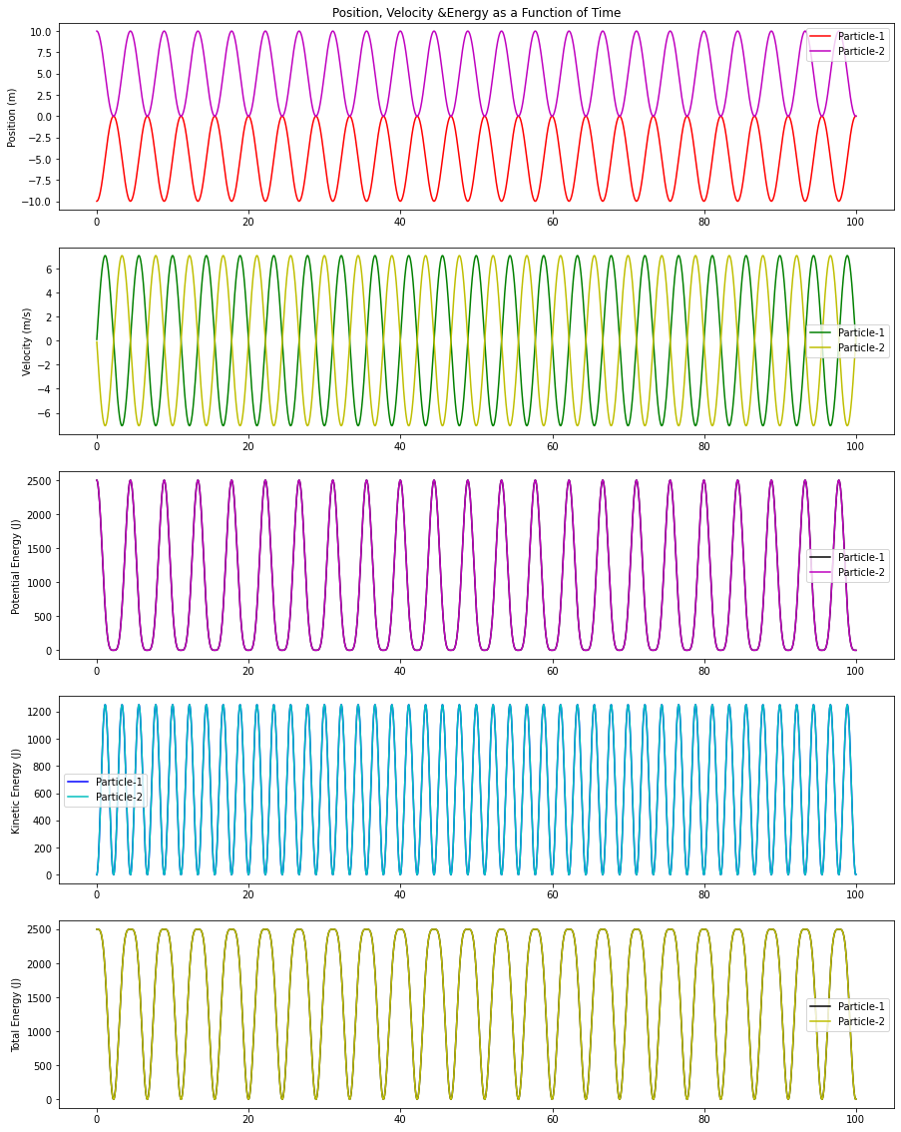

**Trial2:** m1 = 500kg; m2 = 5kg; v1 = 0m/s; v2 = 0m/s; x1=-10m; x2 = 10m, k = 50N/m, x0 = 10, t = 0.01s, T = 100s.

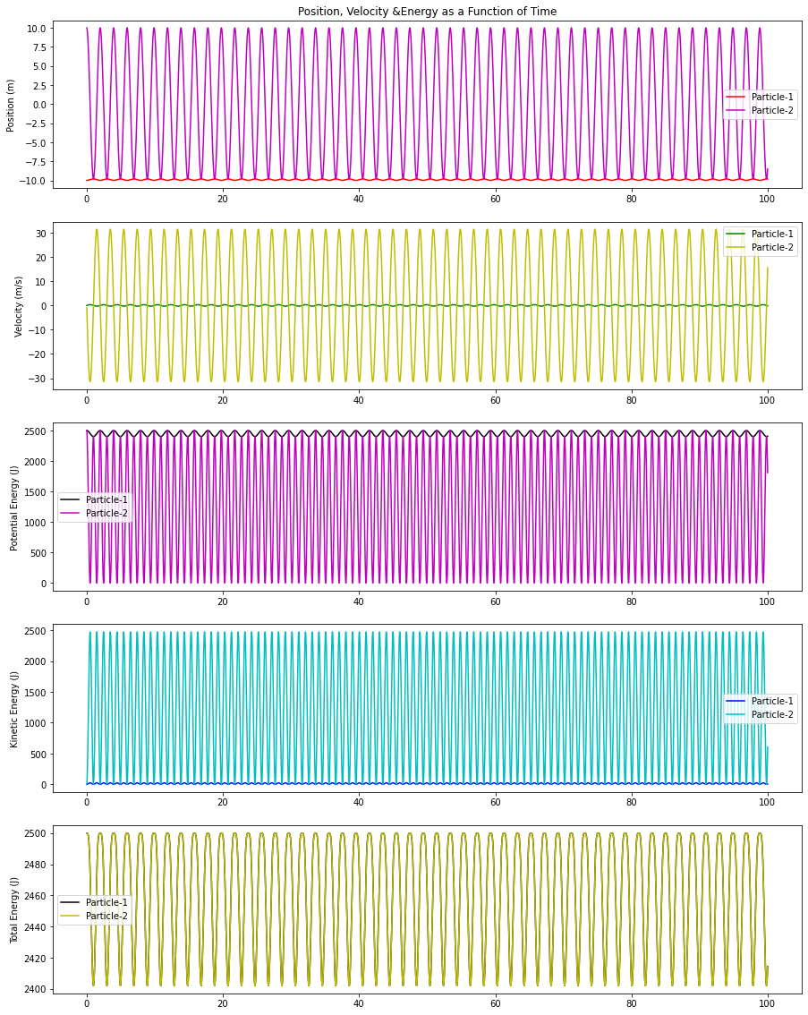

**Trial3:** m1 = 500kg; m2 = 5kg; v1 = 0m/s; v2 = 0m/s; x1=-10m; x2 = 10m, k = 50N/m, x0 = 10, t = 0.01s, T = 10s.

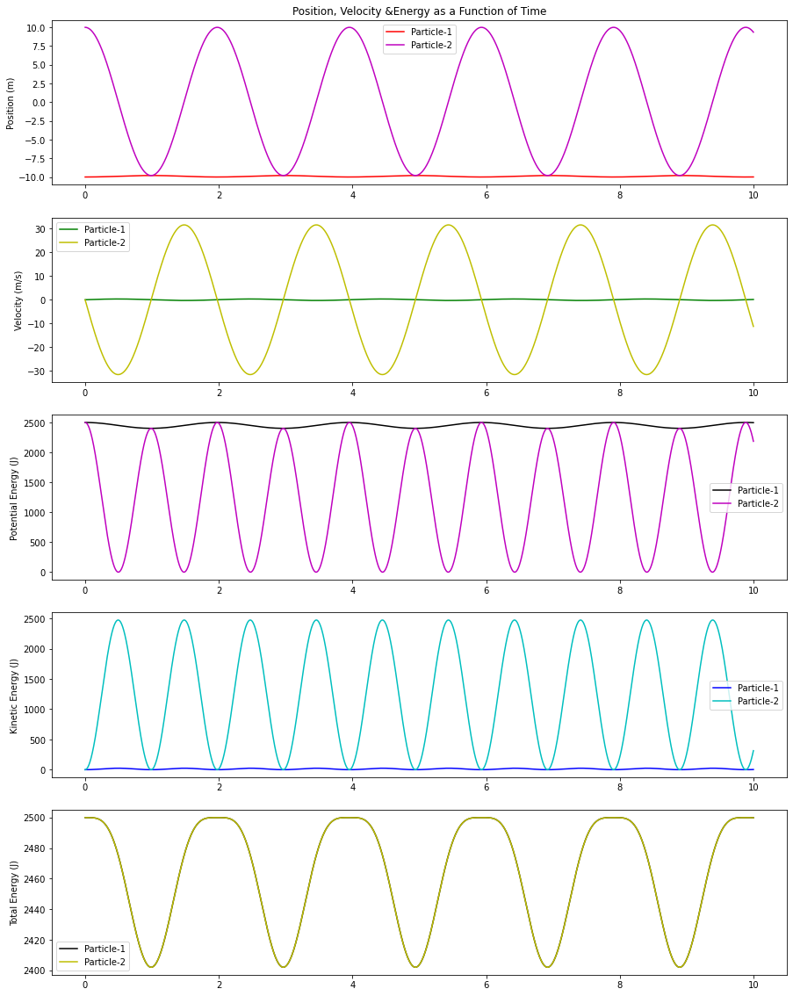

**Observation:**

Considering the simulation in 1-D without the factors of friction, dampers and the gravity the ODE performs a constant response for an infinite period of time, which makes no change in the simulation corresponding to time step change from 100s to 10s.

------------------------------------------------------------------------------------------------