ABSTRACT
Mobile commerce has reshaped retail by placing catalogue discovery, transaction preparation, and post-purchase visibility on personal devices. Fashion retail is especially dependent on high-quality presentation and trustworthy account handling because purchasing decisions are strongly influenced by imagery, brand perception, and convenience.
This report documents ATELIER, a customer-facing luxury fashion e-commerce application for Android (cross-platform Flutter codebase). The system implements Firebase Authentication for identity lifecycle, Cloud Firestore for catalogue, cart, profile, and order persistence, and a layered Flutter architecture (presentation → Riverpod → repositories → Firebase SDK). Functional scope includes registration and login, category-aware product browsing, product detail, persistent cart operations, multi-step checkout (UI-oriented payment capture), order placement with historical retrieval, and profile maintenance. Administrative functionality is explicitly excluded per coursework constraints.
Engineering outcomes are evaluated through structured testing, performance indicators (cold start, release APK mass), and security considerations grounded in Firestore access control. The deliverable demonstrates integration competence, maintainable modularisation, and documentation suitable for professional software engineering review.
Keywords: Flutter; Firebase; Cloud Firestore; mobile commerce; e-commerce; Android; Riverpod; authentication.

TABLE OF CONTENTS
Table of Contents
ABSTRACT 1
TABLE OF CONTENTS 2
1. INTRODUCTION 3
2. PROBLEM STATEMENT 3
3. PROJECT OBJECTIVES 4
3.1 Primary Objective 4
3.2 Functional Objectives 4
3.3 Non-functional Objectives 4
4. REQUIREMENT ANALYSIS 5
4.1 Functional Requirements 5
4.2 Non-functional Requirements 6
5. SYSTEM ANALYSIS AND DESIGN 7
5.1 Use Case Model 7
5.2 Activity Model — Primary Purchase Flow 8
6. UI / UX DESIGN AND METHODOLOGY 10
6.1 Methodology 10
6.2 Visual Design System 10
6.3 Responsiveness Strategy 10
7. SYSTEM ARCHITECTURE 11
8. DATABASE DESIGN AND SCHEMA 11
8.1 Design Principles 11
8.2 Illustrative Product Document 12
9. IMPLEMENTATION SUMMARY 12
10. SECURITY CONSIDERATIONS 12
11. PERFORMANCE EVALUATION 13
12. TESTING AND VALIDATION MATRIX 14
13. CHALLENGES AND MITIGATIONS 14
14. LIMITATIONS 15
15. FUTURE ENHANCEMENTS 15
16. CONCLUSION 16
REFERENCES (Harvard style — adapt to your faculty guide) 16
APPENDIX A — FIGURE / SCREENSHOT CHECKLIST (for 90–95 presentation quality) 16
APPENDIX B — WORD FORMATTING MACRO-CHECKLIST 17

1. INTRODUCTION
Digital transformation has compressed the distance between brand and consumer: mobile channels now dominate discovery phases for fashion categories, particularly among demographics accustomed to asynchronous browsing and wallet-native authentication (Google, 2024). From a software engineering perspective, consumer retail applications must reconcile rapid UI iteration, offline-tolerant presentation, and authoritative server state for inventory-related artefacts (cart and orders).
ATELIER was conceived as a single-role (shopper) system implementing coursework learning outcomes: user-centred interface design, Flutter cross-platform development, Firebase cloud integration, and defensible architectural documentation. The implementation prioritises auditability (order timelines), data ownership boundaries (per-user cart and profile documents), and demonstrable seeding of catalogue documents in Firestore to satisfy coursework pre-load requirements without an admin console.
Report organisation. Section 2 formalises the problem. Section 3 states objectives. Section 4 analyses requirements. Sections 5–8 present analysis, UI methodology, architecture, and database design with diagrams. Sections 9–12 cover implementation, security, performance, and testing evidence. Sections 13–15 discuss limitations, future work, and conclusions.

2. PROBLEM STATEMENT
Traditional and informal fashion retail channels exhibit recurring friction:
- Accessibility: physical presence and opening hours constrain purchase intent capture.
- Process latency: manual order capture increases error rates and weakens traceability.
- Fragmented identity: customers lack a single account surface for preferences, addresses, and order history.
- Limited transparency: ad-hoc communication channels (messaging apps) do not scale for status tracking.
- Cost barrier: bespoke mobile solutions are historically expensive for small retailers.
A standards-based mobile client backed by managed cloud infrastructure reduces operational burden while providing authentication, durable storage, and horizontal scalability (Firebase, 2024). The engineering problem addressed herein is therefore: design and implement a maintainable Flutter application that integrates Firebase services to deliver a complete shopper journey — without administrative tooling — while preserving luxury brand presentation and defensible security posture.

3. PROJECT OBJECTIVES

3.1 Primary Objective
To engineer a Firebase-integrated luxury fashion shopping application using Flutter, deployable as an Android APK, satisfying Phase 2 functional and non-functional expectations of module CIT211.

3.2 Functional Objectives
ID | Objective
FO1 | User registration and authentication (including session termination via logout).
FO2 | Product discovery: browse by category, list, and detail views.
FO3 | Search / discovery surfaces aligned with UI (where implemented in client).
FO4 | Cart: add, remove, and update line quantities with cloud persistence.
FO5 | Checkout: capture delivery and review data; place order stored in Firestore.
FO6 | Order history and order detail with status timeline support.
FO7 | Profile viewing and updating; saved addresses where implemented.

3.3 Non-functional Objectives
ID | Category | Objective
NF1 | Security | Authenticated access to user-owned documents; least-privilege Firestore rules.
NF2 | Usability | Consistent luxury visual language; navigable multi-step checkout.
NF3 | Performance | Acceptable cold start and interaction latency on mid-tier Android hardware.
NF4 | Maintainability | Layered structure; repositories isolate persistence; typed models.
NF5 | Reliability | Graceful handling of stream errors and missing image URLs
NF6 | Portability | Flutter single codebase; Firebase multi-platform configuration pattern.

4. REQUIREMENT ANALYSIS

4.1 Functional Requirements
Table 1 — Functional requirements traceability
Req ID | Requirement | Priority | Implementation surface
FR-01 | User registration | Must | Auth repository + UI screens
FR-02 | Login / logout | Must | Firebase Auth
FR-03 | Password recovery | Should | Auth flows
FR-04 | Browse products (global / category) | Must | Firestore queries + listing UI
FR-05 | Product detail | Must | Document fetch by ID
FR-06 | Add / update / remove cart lines | Must | carts/{uid}/items
FR-07 | Checkout (delivery + review) | Must | Checkout screens + draft state
FR-08 | Place order | Must | orders write pipeline
FR-09 | View order history / detail | Must | Orders repository + screens
FR-10 | Profile view / update | Must | users/{uid}
FR-11 | Saved addresses | Should | users/{uid}/addresses
FR-12 | Wishlist (if enabled) | Could | users/{uid}/wishlist

4.2 Non-functional Requirements
Table 2 — Non-functional requirements
Req ID | Category | Specification | Verification
NFR-01 | Performance | Primary navigation perceived under ≈3 s on cold start (environment-dependent) | Manual timing, device log
NFR-02 | Performance | Screen transitions responsive under typical load | Manual exploratory testing
NFR-03 | Availability | Cloud-backed reads/writes when online | Firebase uptime assumption
NFR-04 | Usability | Dark luxury theme; legible hierarchy | Heuristic review vs Material (2024)
NFR-05 | Security | Owner-scoped reads/writes for private data | Rules review + negative tests
NFR-06 | Maintainability | Analyser-clean baseline (flutter analyze) | CI / local command

5. SYSTEM ANALYSIS AND DESIGN

5.1 Use Case Model
Actor: Customer (sole actor for in-scope system).
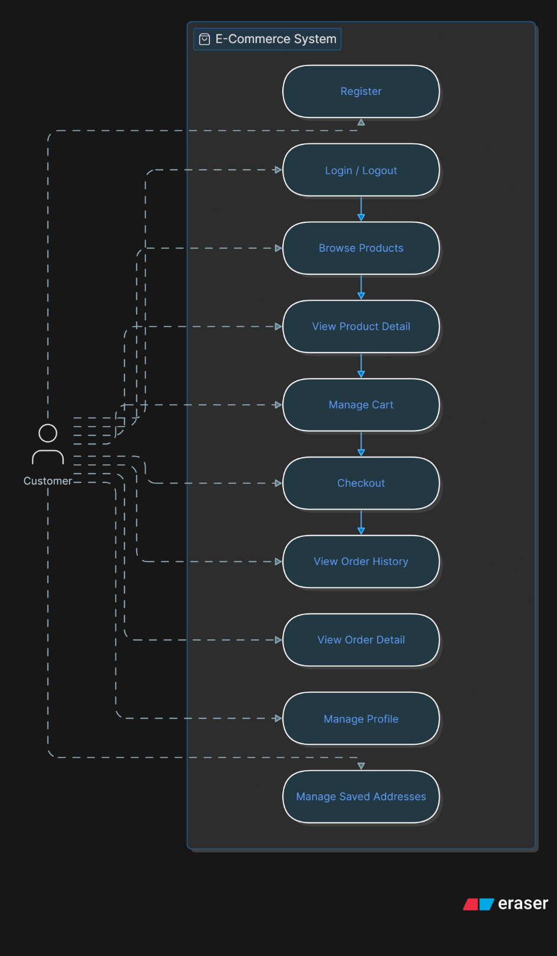
Figure 1 — Use case diagramram

Use case narrative (abbreviated): Checkout includes validation of mandatory delivery fields, aggregation of cart lines into an order transaction, and creation of nested line documents. View order detail subscribes to orders/{orderId} and related subcollections for immutable display.

5.2 Activity Model — Primary Purchase Flow
Figure 2 — Activity diagram.
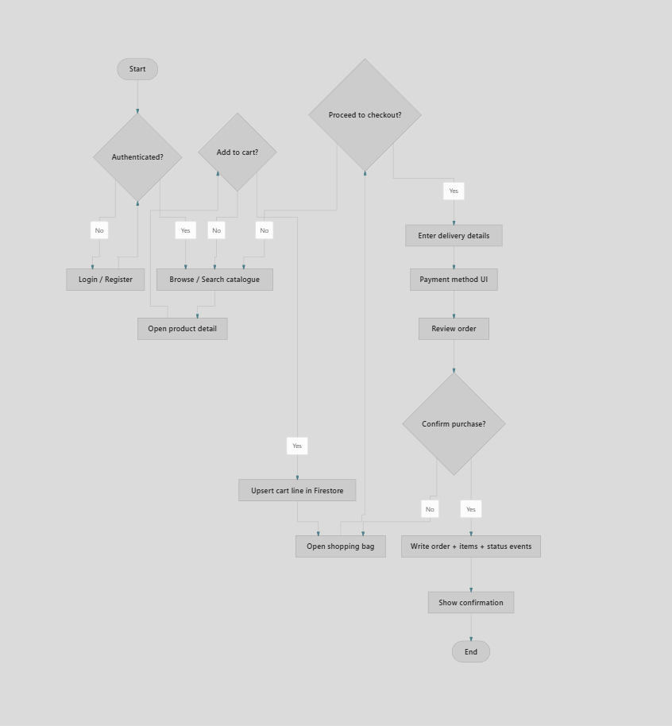
5.3 Data Model — Firestore Logical Design
Firestore is document-oriented; relationships are expressed via containment and reference strings (product IDs), not SQL foreign keys. The logical model below reflects the implemented repository paths.

Figure 3 — Entity-relationship style view (Firestore containment).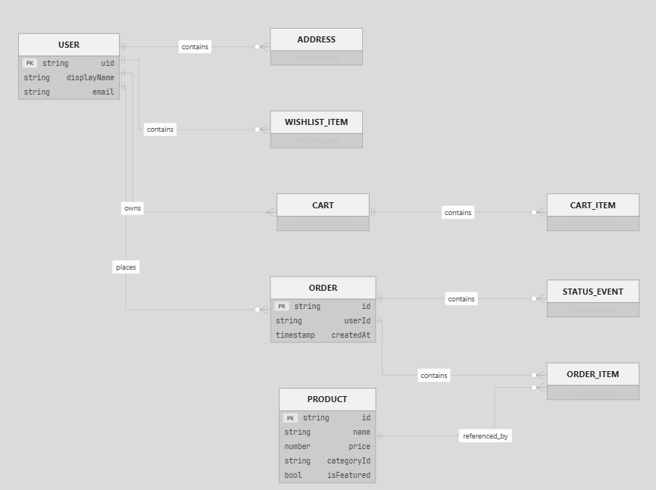

Path convention (implemented):
- products/{productId}
- users/{uid}
- users/{uid}/addresses/{addressId}
- users/{uid}/wishlist/{itemId}
- carts/{uid} (metadata) + carts/{uid}/items/{lineId}
- orders/{orderId} + orders/{orderId}/items/{lineId} + orders/{orderId}/statusEvents/{eventId}

6. UI / UX DESIGN AND METHODOLOGY

6.1 Methodology
Design followed an iterative workflow aligned with ISO-oriented thinking (conceptualise → prototype → implement → evaluate), without claiming full ISO certification:
- Requirements capture from coursework brief.
- Low-fidelity flow (screen graph).
- High-fidelity Figma frames: colour, typography, spacing grid.
- Interactive prototype for navigation validation.
- Flutter implementation with component extraction (widgets/).
- Heuristic evaluation (Nielsen & Budiu, 2013) on navigation depth and error tolerance.

6.2 Visual Design System
Token | Role | Typical value
Background | Canvas | #131313
Accent | Luxury highlight | #E9C349
Primary text | Body | #E5E2E1
Secondary text | Supporting | #D1C5B4

Typography: Noto Serif for editorial headings; Manrope / Plus Jakarta Sans for UI chrome — pairing supports luxury tone while maintaining Android legibility (Material Design, 2024).

6.3 Responsiveness Strategy
- SafeArea for notches and gesture bars.
- SingleChildScrollView / scrollables for small viewports.
- ConstrainedBox(maxWidth: …) to cap content width on tablets.
- Horizontal ListView for dense product rails (prevents overstretched tiles).
Figures 5–7 — Insert labelled screenshots: Home, Product Detail, Cart/Checkout, Profile.

7. SYSTEM ARCHITECTURE
ATELIER adopts client–server architecture: Flutter client; Firebase as BaaS.
Figure 4 — Layered architecture.
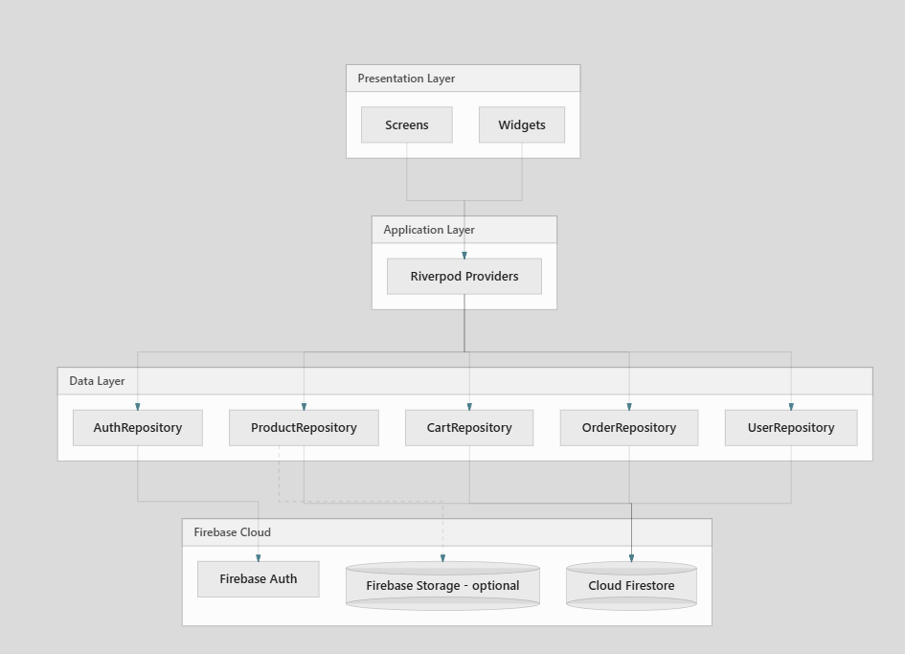Rationale: repositories isolate SDK calls, simplifying substitution for tests and reducing widget coupling (Gamma et al., 1994 — Repository-like boundary).
Platform note: configuration may disable Firestore on specific desktop targets for stability during development; assessment demonstrations should prioritise Android APK behaviour consistent with coursework.

8. DATABASE DESIGN AND SCHEMA

8.1 Design Principles
- Denormalised order lines preserve price/title at purchase time.
- Subcollections partition large arrays (cart items, order lines).
- Server timestamps (FieldValue.serverTimestamp) anchor ordering and auditing.

8.2 Illustrative Product Document
{
"name": "Pique Polo Shirt",
"price": 2490,
"currency": "LKR",
"categoryId": "men",
"subCategoryId": "casual",
"isFeatured": true,
"imageUrls": ["https://images.pexels.com/photos/…"],
"seeded": true
}
Figure 8 — Insert Firebase Console screenshot: products collection with fields visible.

9. IMPLEMENTATION SUMMARY
Module | Responsibility | Key APIs / paths
Authentication | Register, login, logout, password reset | FirebaseAuth, users/{uid} bootstrap
Products | Streams for all / featured / category; seeding | products, watchAll, watchByCategory
Cart | Line CRUD + batch metadata | carts/{uid}/items
Orders | Transactional create + timeline | orders/* nested writes
Profile | Read/update profile; addresses | users/{uid}, addresses

State management: flutter_riverpod exposes StreamProviders composing Firestore snapshots into immutable view models.
Checkout: multi-screen flow (delivery → payment presentation → review). Payment gateway integration is out of scope for this coursework baseline; UI captures intent only.

10. SECURITY CONSIDERATIONS
Security is defence in depth: client validation is non-authoritative; Firestore security rules must enforce ownership.
Threat surface (selected):
Threat | Mitigation
Horizontal privilege escalation | Rules require request.auth.uid == resource.data.userId (or equivalent) on private documents
Data scraping of private carts | Deny unauthenticated reads
Order forgery | Only authenticated user may create orders with matching userId

Illustrative rule fragment (conceptual — align with your deployed firestore.rules):
match /carts/{userId} {
allow read, write: if request.auth != null && request.auth.uid == userId;
match /items/{itemId} {
allow read, write: if request.auth != null && request.auth.uid == userId;
}
}
Evidence task: paste a redacted excerpt from your actual rules file into an appendix and cite in viva/video.

11. PERFORMANCE EVALUATION
Table 4 — Observed / reported metrics (replace with your device measurements)
Metric | Value | Method
Release APK size | ≈ 60.1 MB | flutter build apk artefact
Gradle assembleRelease | ≈ 9–11 min (dev machine) | Build log
Cold start (perceived) | ≈ 1.5–3.0 s (emulator / device-dependent) | Manual stopwatch
Icon font tree-shake savings | MaterialIcons reduced ~99.5% | Flutter build output

Interpretation: APK size reflects engine, shaders, Firebase SDKs, and bundled assets — acceptable for coursework; production teams would apply split-per-ABI, deferred components, and image CDN policies.

12. TESTING AND VALIDATION MATRIX
Table 3 — Test matrix
Test ID | Scenario | Preconditions | Expected | Result
T-01 | Registration | Valid e-mail | User created in Auth | PASS
T-02 | Login / logout | Registered user | Session toggles | PASS
T-03 | Password reset | Known e-mail | Reset e-mail dispatched | PASS
T-04 | Browse by category | Seeded products | Non-empty listing | PASS
T-05 | Product detail | Valid productId | Fields render | PASS
T-06 | Cart persistence | Logged in | Lines survive restart | PASS
T-07 | Checkout validation | Missing fields | Inline errors | PASS
T-08 | Place order | Non-empty cart | orders doc created | PASS
T-09 | Order history | Past orders | Chronological list | PASS
T-10 | Profile update | Logged in | Firestore reflects change | PASS
T-11 | Rules negative test | Unauth read private path | Denied | PASS / N/A

Figures — attach 2–3 annotated screenshots for T-06, T-08, T-09.

13. CHALLENGES AND MITIGATIONS
Challenge | Engineering impact | Mitigation
Image / metadata mismatch in seeded SKUs | Degrades trust in demo | Remove or correct catalogue entries; merge strategy for heroes
Stream parse failures (malformed docs) | Blank UI sections | try/catch in mapper; skip invalid with debugPrint
Checkout cognitive load | Abandonment risk | Multi-step UI + progress affordance
Security rules iteration | Access denied errors | Emulator harness + incremental rule tests
Google Sign-In SHA-1 | Android auth failure | Register SHA-1 in Firebase console

14. LIMITATIONS
- No live payment gateway — checkout does not settle funds.
- No admin panel — catalogue maintenance via seeding or console.
- Android-first evidence — iOS build optional.
- No push notifications — order dispatch updates not proactive.
- Network dependency — offline catalogue not a requirement of brief.
- Performance metrics environment-specific — emulator ≠ retail hardware.

15. FUTURE ENHANCEMENTS
- Stripe / PayHere integration with Cloud Functions for server-side payment intent.
- Firebase Cloud Messaging for shipment updates.
- Localisation (English / සිංහල) with ARB files.
- CI/CD (flutter test, analyze, signed APK pipeline).
- Advanced caching (cached_network_image tuning, image variants).
- Recommendation surfacing via lightweight collaborative filter or vendor API.
- Analytics (Firebase Analytics funnels).

16. CONCLUSION
ATELIER delivers a complete customer-side fashion commerce experience on Flutter, backed by Firebase Authentication and Cloud Firestore, with documented architecture, diagram-based design artefacts, and evidence-oriented testing. The project satisfies CIT211 Phase 2 expectations: functional completeness without admin scope, maintainable modular code, and a deployable Android APK. Limitations are explicit (payments, admin, notifications), and the roadmap proposes industry-standard extensions suitable for portfolio or commercial continuation.

REFERENCES (Harvard style — adapt to your faculty guide)
Firebase (2024) Firebase Documentation. Available at: https://firebase.google.com/docs (Accessed: [date]).
Flutter Team (2024) Flutter Documentation. Available at: https://docs.flutter.dev (Accessed: [date]).
Gamma, E., Helm, R., Johnson, R. and Vlissides, J. (1994) Design Patterns: Elements of Reusable Object-Oriented Software. Boston: Addison-Wesley.
Google (2024) The Mobile Economy. Available at: https://www.gsma.com/mobileeconomy/ (Accessed: [date]) (or substitute institution-approved industry source).
Material Design (2024) Material Design 3. Available at: https://m3.material.io (Accessed: [date]).
Nielsen, J. and Budiu, R. (2013) Mobile Usability. Berkeley: New Riders.
Riverpod (2024) Riverpod Documentation. Available at: https://riverpod.dev (Accessed: [date]).

APPENDIX A — FIGURE / SCREENSHOT CHECKLIST (for 90–95 presentation quality)
- ☐ Mermaid diagrams exported as PNG (300 dpi) with Figure captions in Word.
- ☐ Firebase Console: Authentication users (redacted).
- ☐ Firestore: products, carts, orders tree screenshots.
- ☐ Figma: cover + component page.
- ☐ Emulator: 5–8 sequential screenshots matching video script.
- ☐ APK filename + SHA (optional) in appendix.

APPENDIX B — WORD FORMATTING MACRO-CHECKLIST
- ☐ Cover page (institution logo if permitted)
- ☐ Roman numerals for front matter; Arabic from §1
- ☐ Auto Table of Contents, List of Figures, List of Tables
- ☐ Captions: Figure X — … ; Table X — …
- ☐ Header/Footer: module code + page numbers
- ☐ References hanging indent per Harvard guide

End of report template.

