Diagrama de flujo sobre las instrucciones de un
proceso relacionado con su quehacer laboral
GA5-240202501-AA1-EV01



Isidro J Gallardo Navarro

Ficha:3070299

2025

Tecnología en Análisis y Desarrollo de Software.

ADSO

Introduction
Title: Introduction to the Full-Stack Developer Daily Workflow Flowchart
This document present the flowchart of the Full-Stack Developer Daily Workflow, which outlines the essential introductions and procedures of a profesional day, speaifically focusing on the processes utilized within the PeakU enviroment. The flowchart is a traditional graphic tool employed to visually identify and analize a product or academic process.
The main objetive of this visualization is to accurately represent the sequential flow of tasks, from the morning start to the excecution of assigned developement activities. The process includes key stages such as managing urgent communications, handling meeting conflicts, and executing crucial pre-meeting technical steps, like lauching the Front-end and Back-end on local environment, performing database migrations, and conducting a pull to the main repository.
The diagram is constructed to trace the process with precision and ensure it reflects the most efficent way to conduct daily work. This endeavor emphasizes the application of appropriate technical vocabulary and a correct structure inthe inglish language, as requiered for clear international cummunication.

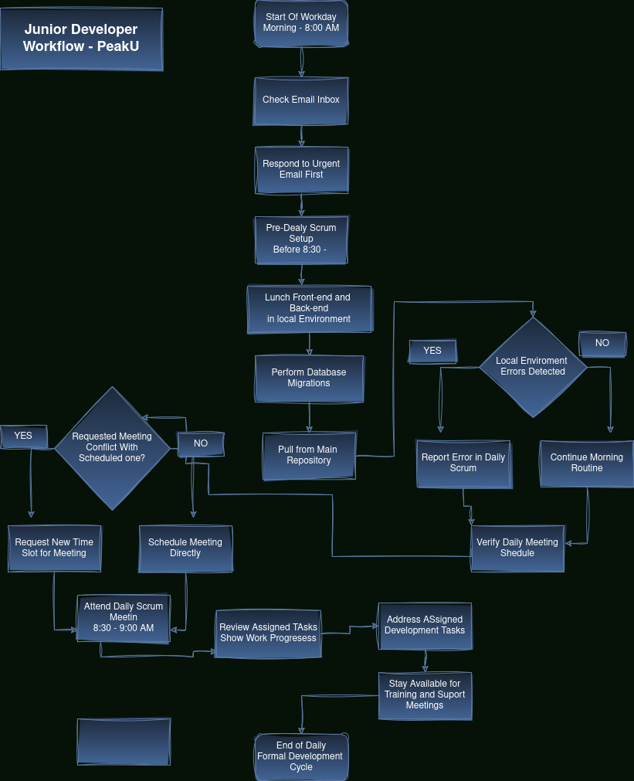

Conclusion
The resulting flowchart serves as an accurate and comprehensive visual summary of the Full-Stack Developer’s daily routine. By mapping the workflow, we have clearly established the chronological order of activities highlighting the integration of communications managent (urgent emails and meeting scheduling) with critical development procedures.
The diagram successfully shows the logical steps necessary to prepare the local enviroment, including the mandatory checks for errors after repository updates, which are reportes during the daily Scrum meeting. This systematic approach ensures efficient task execution and adherence to team methodologies.

In conclusion, the effectivie use of a flowchart, combined with clear, concise messaging and precise technical vocabulary in English, provides a reliable framework for understanding and optimizing the professional workload, facilitating the organized transition from daily preparation to actively addresing assigned development tasks.

