MathCaptcha Service API
This project provides math captcha rest services. There are two rest services available in this application
- getmathcaptcha
This service will provide an object of MatchCaptcha class to the client.
Content type - application/json
It contains a Question and three random numbers. [Random number range and question is configured through application.properties file]. Also it contains a captchaId and sum attributes.
captchaId is an encoded value. Its decoded value is using at the time of result verification. It is used to confirm at the time of verification the question and the answer.
Note: Client should not make any changes in captchaId value while sending it back to the server.
API Endpoind - http://localhost:8080/myapi/getmathcaptcha
Request method – GET
Response:
{
"question": "Please sum the numbers",
"randomNumberOne": 8,
"randomNumberTwo": 9,
"randomNumberThree": 4,
"captchaId": "MjE=",
"sum": 0
}

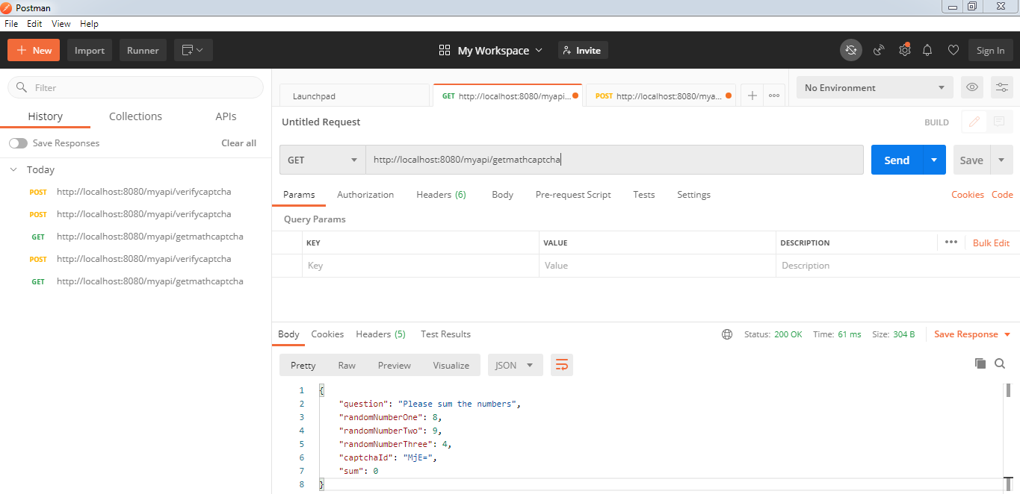
- verifycaptcha
This service will verify the client request. It will verify the sum of random numbers in the client request. Also this decode and verify the captchId for ensure the request has received is previously given to a particular client request. captchId will safeguard the cheating.
API Endpoind - http://localhost:8080/myapi/verifycaptcha
Request method – POST
Put JSON object in the request body with sum of three random numbers.
In post man you can place the previous response JSON in the body part.
And provide the sum of the three random numbers.
{
"question": "Please sum the numbers",
"randomNumberOne": 8,
"randomNumberTwo": 9,
"randomNumberThree": 4,
"captchaId": "MjE=",
"sum": 21
}

Response: Status code 200 for successfully verified request and status code 400 for verification failure.
