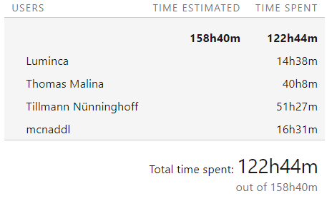**Deminder**

**Team members and working-time:**  
Tillmann Nünninghof   
Natalie Busam  
Lea Wegner  
Thomas Malina

Mail: Tillmann@Nuenninghof.de